Term 2 - 2022
BIOLOGY
(QUESTION PAPER I )
FORM FOUR
TIME: 2 HOURS
Name: …………………………………………………………. Adm No: ……………….
School: ……………………………………………………….. Class: …………………..
Signature: …………………………………………………….. Date……………………..
INSTRUCTIONS
- All Questions are Compulsory
- Write your Answers in the Spaces Provided
- Wrong Spelling of Technical Terms shall be Penalized

Max  Score | Student’s Score
80

- The diagram shown below represents a nuscleus
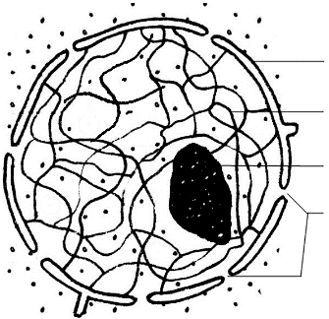
P
Q
- State the role of the organelle labelled Q (1mk
………………………………………………………………………………………………
- Name a Kingdom whose members lack structure labelled P (1mk
………………………………………………………………………………………………
- Which is the general term given to organisms whose cells have structure P?
……………………………………………………………………………………..…(1mk

- a) Name the TWO components of a lipid molecule (1mk
………………………………………………………………………………………………
b) State TWO disadvantages of using fats as respiratory substrates (2mks
………………………………………………………………………………………………
………………………………………………………………………………………………

- a) Name the pigment that protects humans from the negative effect of Ultraviolet lights
……………………………………………………………………………………..….(1mk
b) Explain how sunlight contributes to stronger bones and teeth in human beings (2mks
………………………………………………………………………………………………
………………………………………………………………………………………………

- Name the main target organ of the following hormones: (2mks
- Aldosterone ….. ……………………………………………………………………….
- Insulin ………………………………………………………………………………….

- a) What is asexual reproduction? (1mk
………………………………………………………………………………………………
………………………………………………………………………………………………
b) Give TWO disadvantages of sexual reproduction (2mks
………………………………………………………………………………………………
………………………………………………………………………………………………

- The diagram shown below represents a seeding. Use it to answer questions that follow
- Give a reason why the plant above is a member of Class Dicotyledonae (1mk
………………………………………………………………………………………………
- Explain why the biomass of part labelled A will be lower compared to the one found in the seed stage of the same plant (2mks
………………………………………………………………………………………………………………………………………………………………………………………………

- a) State TWO ways in which blood clotting is important to a human being (2mks
………………………………………………………………………………………………………………………………………………………………………………………………………………………………………………………………………………………………
b) What are the roles of thrombokinase enzyme during blood clotting? (2mks
………………………………………………………………………………………………………………………………………………………………………………………………
- The diagram shown below represents a flower
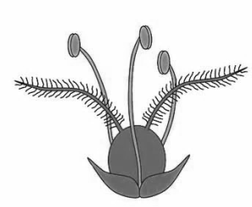
- Name the agent of pollination for the flower shown above (1mk
………………………………………………………………………………………………
- Give TWO reasons for your answer in a) above (2mks
………………………………………………………………………………………………………………………………………………………………………………………………………………………………………………………………………………………………

- State the differences between cones and rods in terms of the following (2mks
Feature | Cone | Rod
Visual acuity
Photochemical

- Use the diagram of a nerve cell shown below to answer questions that follow
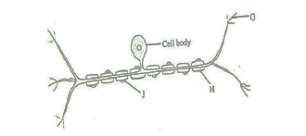
- With a reason, give the identity of the nerve cell (2mks
Identity …………………………………………………………………………………
Reason ………………………………………………………………………………….
- Explain the significance of absence of part labelled H in nerve cells found in the brain.
……………………………………………………………………………………………………………………………………………………………………………………..…(2mks
- Give THREE features that make modern man to be more adaptable to the environment
……………………………………………………………………………………………………………………………………………………………………………………..………………………………………………………………………………………………………………….……………………………………………………………………..………………….….(3mks

- The diagram below represents a living organism
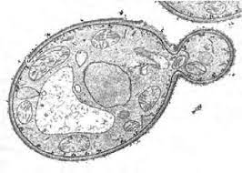
- State TWO economic importance of the above organism in the food industry (2mks
……………………………………………………………………………………………………………………………………………………………………………………………………………………………………………………………………………………..…(2mks
- Why does the rate of respiration reduce under the following conditions? (2mks
i) Low temperature
………………………………………………………………………………………..……………………………………………………………………………………………..
ii) Metabolic poison
………………………………………………………………………………………..……………………………………………………………………………………………..

- State TWO reasons why Biotechnology is important in modern science (2mks
……………………………………………………………………………………………………………………………………………………………………………………..………..………………………………………………………………………………………………

- a) Fill in the table shown below to give differences between continuous and discontinuous variation (2mks
Continuous Variation | Discontinuous Variation

b) Explain how variation is important in the process of evolution? (3mks
……………………………………………………………………………………………………………………………………………………………………………………..……….………………………………………………………………………………………………

- a) Define the term species (1mk
……………………………………………………………………………………………………………………………………………………………………………………..………..

b) State TWO contributions of Carolus Linnaeus (1708 – 1778) to taxonomy (2mks
……………………………………………………………………………………………………………………………………………………………………………………..………..………………………………………………………………………………………………

- a) In an experiment, Peter counted 9 cells along the diameter of field of view of a light microscope measuring 3.0mm. Determine the diameter of one cell in micrometers (3mks
……………………………………………………………………………………………………………………………………………………………………………………..………..……………………………………………………………………………………………………………………………………………………………………………………………………………………………………………………………………………………..………..
b) Why is electron microscope safer to the eye than light microscope during use? (1mk
……………………………………………………………………………………………………………………………………………………………………………………..………..………………………………………………………………………………………………
- The following diagram represents results of an experiment carried out on two sets of germinating seeds.
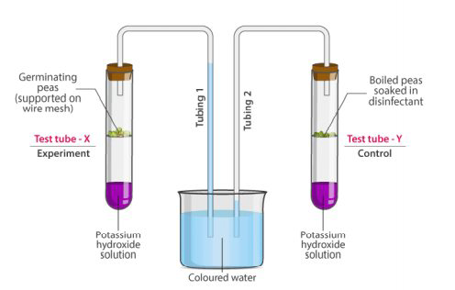
- Account for the result shown in test tube X (2mks
……………………………………………………………………………………………………………………………………………………………………………………..………..………………………………………………………………………………………………
- What is the importance of dipping the boiled seeds in a disinfectant in test tube Y?
……………………………………………………………………………………………………………………………………………………………………………..….………(1mk

- The diagram shown below represents a section of the vertebral column
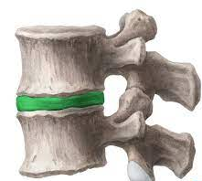
T
S
- Name the part labelled S (1mk
……………………………………………………………………………………..………..
- State TWO ways in which part T is important to movement in human beings (2mks
……………………………………………………………………………………..………..………………………………………………………………………………………………
- Describe how the following cells adapt the structures where they are found to their functions
- Companion cell (2mks
……………………………………………………………………………………..………..………………………………………………………………………………………………
- Schwann cell (2mks
……………………………………………………………………………………..………..………………………………………………………………………………………………

- A mother had a still birth and the expelled foetus showed clear signs of anaemia and jaundice
- Give the name of this disorder (1mk
……………………………………………………………………………………..………..
- Describe how the disorder arose (3mks
……………………………………………………………………………………..………..……………………………………………………………………………………………………………………………………………………………………………………..………..

- The following equation represents a section of the Nitrogen Cycle
Ammonia
Nitrite
X
Process Z
Y

- Name: i) Bacterium labelled Y ……………………………………………….(1mk
ii) Compound X ……………………………………………………….(1mk
- Explain how Process Z affect plant growth in an area? (2mks
……………………………………………………………………………………………………………………………………………………………………………………..………..
- Samson had a road accident resulting in serious head injuries that left him with the following conditions: Loss of balance, low body temperature; poor speech, unregulated breathing and memory loss. Name the part of the brain affected that led to the following:
i) Low body temperature …………………………………………..…………….…,,..(1mk
ii) Memory loss ……………………………………………………..………….……..(1mk
iii) Unregulated breathing ………………………………………….…………………(1mk

- The graph shown below represents effect of substrate concentration on rate of enzymatic reaction
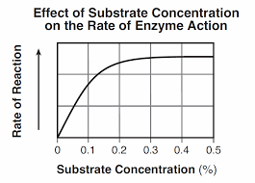
- Account for the rate of enzymatic reaction when the substrate concentration was between 0.3 to 0.5%. (2mks
……………………………………………………………………………………………………………………………………………………………………………………..………..
- Name the substrates for the following enzymes
i) Carbonic anhydrase …………………….………………………………………(1mk
ii) Thrombin ……………………………………………………………………....(1mk

- A tilapia fish has a full length of 300mm but measures 200mm from the mouth tip to its anus. Determine the tail power of the fish (2mks
……………………………………………………………………………………………………………………………………………………………………………………..………..……………………………………………………………………………………………………………………………………………………………………………………..………..

