FORM 4 END OF TERM 2 EXAMINATION

NAME……………………………………… ADM NO………… CLASS…….

BIOLOGY 231/1
BIOLOGY PAPER 1 (THEORY)
AUG/SEPT 2022
TIME 2HRS
INSTRUCTION: ANSWER ALL QUESTIONS IN THE SPACES PROVIDED

1. Some form one students wanted to collect the following animals for study in the laboratory. State the suitable apparatus they should use.
i) Housefly (1 mk)
……………………………………………………………………………………………………..
ii) Scorpion (1 mk)
. ..........................................................................................................................................................
iii) Ants (1 mk)
..........................................................................................................................................................

- A student was viewing a slide preparation of an onion cell under high power of a light microscope and observed that the features of the cell were blurred.
- Name the part of the microscope that the student would use to obtain sharper focus of the features. (1mk)
..........................................................................................................................................................

- State the function of mirror in a light microscope. (1mk)
..........................................................................................................................................................

- (a) Guard cells are specialized epidermal cells. State two structural features which suit them to their function. (2mks)
..........................................................................................................................................................................
..............................................................................................................................................................................................................................................................................................................................................................................................................................................................................................................................

(b) Apart from gaseous exchange, give one other function of stomata. (1mk)
..........................................................................................................................................................

- The diagram below is a specialized mammalian cell.
- Name the parts labeled B and D (2mks)
B..........................................................................................................................................................

D ..........................................................................................................................................................

- State the function of the following
- Part labeled A (1mk)
..........................................................................................................................................................

- The portion marked C (1mk)
..........................................................................................................................................................

- Give two roles of the colon in human digestive system. (2marks)
………………………………………………………………………………………………………………………………………………………………………………………………………………
- Distinguish between dentition and dental formula. (2marks)
………………………………………………………………………………………………………………………………………………………………………………………………………………
- Name a carbohydrate that is abundant in the following;
- Ripe fruits. (1mark)
..........................................................................................................................................................
- Blood of vertebrates. (1mark)
..........................................................................................................................................................

- Apart from photosynthesis identify one other function of chloroplasts in plants. (1mark)
..........................................................................................................................................................

- Study the flow chart below and answer the questions that follow.
- Name the process taking place in step labeled I (1mk)
..........................................................................................................................................................

- Give two reasons why accumulation of substances D in the body leads to an increase in the heart beat. (2mks)
..........................................................................................................................................................

..........................................................................................................................................................
- Identify substance E (1mk)
..........................................................................................................................................................
- In an experiment to investigate a certain physiological process, a student had his experimental set up as shown below.
To ascertain the occurrence of the physiological process investigated he carried out food test on the water in the beaker. Both starch test and reducing sugar test at the beginning of the experiment were negative. After the set up was left undisturbed for 20 minutes, starch test was still negative but that of reducing sugar was positive.
- tate the physiological process which takes place in the human body illustrated by the set up above. (1mk)
..........................................................................................................................................................
- Name the part of the human body where the processes stated in (a) above takes place. (1mk)
..........................................................................................................................................................
- Study the diagram below and answer the following questions.
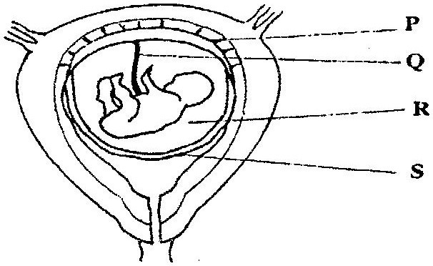
State the function of the part labeled Q. (2marks) ..........................................................................................................................................................
..........................................................................................................................................................
- Identify a hormone produced by part labeled P. (1mark)
..........................................................................................................................................................
- Study the diagram below and answer the questions that follows

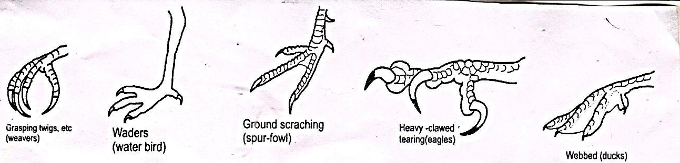
- What type of evolution is illustrated by the limbs (1mk)

……………………………………………………………………………………………………..
- What does the origin of the limbs suggest about the ancestry of these animals (1mk)

-----------------------------------------------------------------------------------------------------------------
(c) (i.) What are vestigial structures? (1mk) ……………………………………………………………………………………………………………………………………………………………
13. An investigation was carried out on a terrestrial ecosystem. The population sizes and species biomass were determined and recorded as shown in the table
Species | Population size | Species biomass
A  B  C  D | 1$×$10³  1$×$10³  1$×$10⁵  1$×$10 | 1$×$10³  1$×$10⁻¹  1$×$10  1$×$10⁴

- If these organisms had feeding relationships, construct a simple food chain involving all the organisms (1mk)
……………………………………………………………………………………………………………………………………………………………
- Construct pyramid of numbers using the data provided above. (2mks)

14 Study the photograph below showing a certain trait in man.
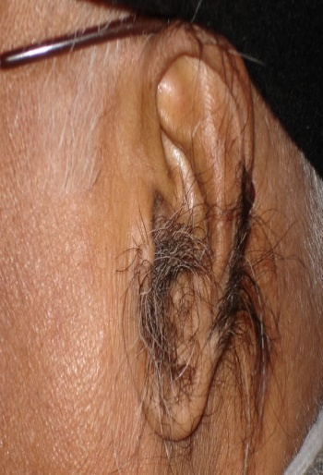
i. Identify the trait exhibited in the photograph above. (1 mark)
…………………………………………………………………………………………
ii. The trait you have identified in (d) (i) above is sex linked. In which chromosome is it contained. (1 mark)
………………………………………………………………………………………
- Name any other sex linked trait in man. (1 mark)
…………………………………………………………………………………………

15 . (a)State one significance of genetics counseling (1mk)
………………………………………………………………………………………
(b) Part of a strand of DNA molecules was found to have the following sequence
A-T-C-G-G-G-A-T-C-T.

What is the sequence?

- Of the complementary strand? (1mk)
…………………………………………………………………………………………
(ii) On a m- RNA strand copied (1mk)
…………………………………………………………………………………………

16. (a) State two significance of myelin sheath. (2mks)
……………………………………………………………………………………………………
………………………………………………………………………………
(b) Name the cell that secretes the myelin sheath. (1mk)
…………………………………………………………………………………………
(c) List the following in order in which they are involved in a simple reflex action. Motor neurone, effectors, stimulus, intermediate (relay) neurone, sensory neuron, impulse, receptor. (1mk)
…………………………………………………………………………………………
17. If the fish is removed from water it dies immediately. Explain why (2mks)
……………………………………………………………………………………………………
………………………………………………………………………………

18 .a) What is seed dormancy (1Mk)
………………………………………………………………………………………………………
………………………………………………………………………………………………………

- Name a growth inhibitor in seed (1Mk)
………………………………………………………………………………

- Differentiate between hypogeal and epigeal germination in seeds (2Mk)
………………………………………………………………………………
………………………………………………………………………………
19. Name the causative agent of the following diseases in man (2Mks)
a) Candidiasis :-…………………………………………………
b) Syphilis:-……………………………………………………….

20. A group of form two students placed a fresh leaf in warm water. They observed that air bubbles formed on the surface of the leaf.
a) What biological process were they investigating? (1mk)
.........................................................................................................................................................................
b) Name the structures from which the air bubbles were coming from. (1mk)
.........................................................................................................................................................................
c) Explain the distribution of the structures named in (b) above on the leaf surfaces of an aquatic plant. (2mks)
.........................................................................................................................................................................
.........................................................................................................................................................................
.........................................................................................................................................................................
21. Differentiate between hydrolysis and condensation. (2mks)
.........................................................................................................................................................................
.........................................................................................................................................................................
22. (a) Which sets of teeth would be used in chewing sugarcane for maximum extraction of sap? (2mks)
.........................................................................................................................................................................
.........................................................................................................................................................................
.........................................................................................................................................................................
23. In an experiment to determine the population of Tilapia fish in a school fish pond, students of Canada school decided to use capture-recapture method.
a) Name three vital tools the students would need for the exercise. (3mks)
.........................................................................................................................................................................
.........................................................................................................................................................................
.........................................................................................................................................................................
.........................................................................................................................................................................
b) State two factors that might affect the accuracy of their results. (2mks)
.........................................................................................................................................................................
.........................................................................................................................................................................
.........................................................................................................................................................................
24. What is the role of the following hormones in human reproduction?
i) Follicle stimulating hormone in male (lmk)
.........................................................................................................................................................................
.........................................................................................................................................................................
ii) Luteinizing hormone during menstrual cycle. (lmk)
.........................................................................................................................................................................
.........................................................................................................................................................................
25. Below is representation of an experiment that was carried out on a tree in Kayombe forest. 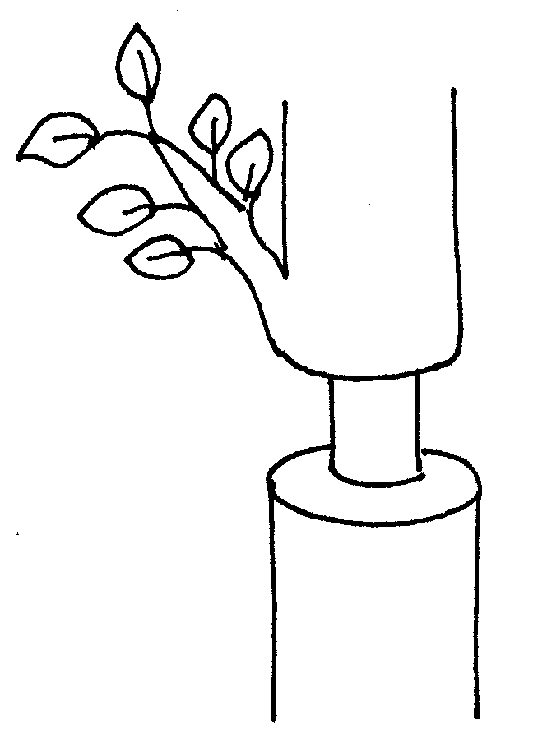
a) Which two tissues are removed in a ring bark experiment? (2mks)
.........................................................................................................................................................................
.........................................................................................................................................................................
b) Removal of the tissues above leads to some effects to the plant. Name these 2 effects. (2mks)
.........................................................................................................................................................................
.........................................................................................................................................................................
.........................................................................................................................................................................
26. Explain why Lamark’s theory of evolution is not accepted by modern scientist. (2mks)
.........................................................................................................................................................................
.........................................................................................................................................................................
.........................................................................................................................................................................
.........................................................................................................................................................................
27. Name the branch of biology that deals with;
a) Relationship between antelopes and gazelles in their environment. (lmk)
.........................................................................................................................................................................
b) Study of Ebola virus. (lmk)
.........................................................................................................................................................................
c) Explain what would happen if a given of living things lose their ability to reproduce. (lmk)
.........................................................................................................................................................................
.........................................................................................................................................................................

28. Study the diagram below and answer the questions that follow.
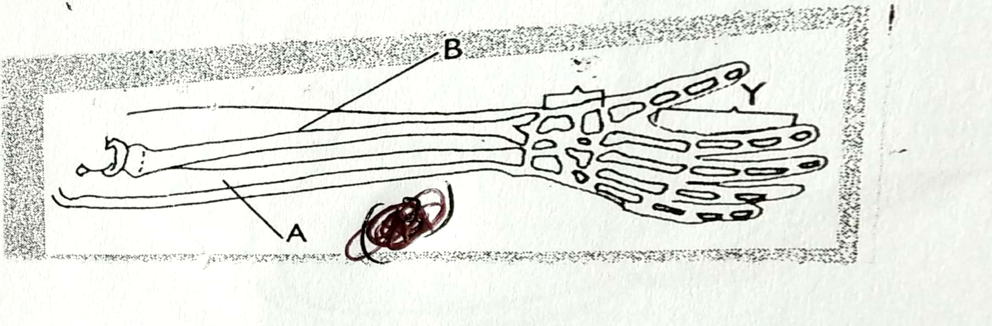

- Identify the bones labelled A and B. (2marks)
A ……………………………………………………………………..
B ……………………………………………………………………..
- Name the joints found in the region labelled Y. (1mark)
……………………………………………………………………….
29.. (a) Explain the role of oxygen in Active transport (1mk)

………………………………………………………………………………………………………………………………………………………………………………………………………………
(b) Name two processes that depend on Active transport in animals (2mks)

