NAME…………………………………………….………..ADM.NO………….….....................………
SCHOOL………………………………………………..CLASS............ SIGN…………....................….
DATE…………………......................………
443/2
AGRICULTURE
PAPER 2
TIME: 2 HOURS
AUGUST-2022
CEKENAS END OF TERM TWO EXAM-2022
FORM FOUR EXAM
Kenya Certificate of Secondary Education. (K.C.S.E)
443/2
AGRICULTURE
PAPER 2

INSTRUCTIONS TO CANDIDATES
- Write your name and admission number in the spaces provided above
- Sign and write date of examination in the space provided.
- This paper consists of three sections A, B and C
- Answer ALL questions in section A and B and any two questions from section C
- Candidates must answer the questions in English.
- All answers should be written in the spaces provided.

SECTION | QUESTION | MAXIMUM SCORE | CANDIDATE’S SCORE
A | 1-17 | 30
B | 18-21 | 20
C |  | 20  20
TOTAL SCORE |  | 90

SECTION A. (30MARKS)
1. State four methods of identification in livestock production. (2mks)
………………………………………………………………………………………………………………
………………………………………………………………………………………………………………
………………………………………………………………………………………………………………
………………………………………………………………………………………………………………
2. Explain the meaning of the following terms as used in livestock health.
i) A notifiable disease. (1mk)
………………………………………………………………………………………………………………
………………………………………………………………………………………………………………
ii) Prophylatics. (1mk)
………………………………………………………………………………………………………………
………………………………………………………………………………………………………………
3. Give two reasons for including roughages in diet of non-ruminants. (1mk)
………………………………………………………………………………………………………………
………………………………………………………………………………………………………………
4. State four equalities of a good grain store. (2mks)
………………………………………………………………………………………………………………
………………………………………………………………………………………………………………
………………………………………………………………………………………………………………
………………………………………………………………………………………………………………
5. Give four ways a farmer would adopt to improve production in indigenous cattle. (2mks)
………………………………………………………………………………………………………………
………………………………………………………………………………………………………………
………………………………………………………………………………………………………………
………………………………………………………………………………………………………………

6. State two factors to consider when formulating livestock ration. (2mks)
………………………………………………………………………………………………………………
………………………………………………………………………………………………………………
7. State three importance of farm buildings. (1½mks)
………………………………………………………………………………………………………………
………………………………………………………………………………………………………………
………………………………………………………………………………………………………………
8. State four symptoms of new castle disease in poultry. (2mks)
………………………………………………………………………………………………………………
………………………………………………………………………………………………………………
………………………………………………………………………………………………………………
………………………………………………………………………………………………………………
9. What is creep feeding in pig production? (1mk)
………………………………………………………………………………………………………………
………………………………………………………………………………………………………………
10. State the use of each of the following tools and equipment. (2mks)
i) Routers
………………………………………………………………………………………………………………
ii) Tinsnips
………………………………………………………………………………………………………………
iii) Wood rasp
………………………………………………………………………………………………………………
iv) Chipping hammer
………………………………………………………………………………………………………………

11. State three methods of treating timber for building construction. (1½mks)
………………………………………………………………………………………………………………
………………………………………………………………………………………………………………
………………………………………………………………………………………………………………
………………………………………………………………………………………………………………
12. State two ways in which feed additives are important in animal nutrition. (2mks)
………………………………………………………………………………………………………………
………………………………………………………………………………………………………………
………………………………………………………………………………………………………………
………………………………………………………………………………………………………………
13. State four predisposing factors for mastitis in dairy cattle. (2mks)
………………………………………………………………………………………………………………
………………………………………………………………………………………………………………
………………………………………………………………………………………………………………
………………………………………………………………………………………………………………
………………………………………………………………………………………………………………
14. Give two examples of a three host tick. (1mk)
………………………………………………………………………………………………………………
………………………………………………………………………………………………………………
15. State four general uses of solar energy. (2mks)
………………………………………………………………………………………………………………
………………………………………………………………………………………………………………
………………………………………………………………………………………………………………
………………………………………………………………………………………………………………
………………………………………………………………………………………………………………
16. Name two causes of bloat in farm animals. (2mks)
………………………………………………………………………………………………………………
………………………………………………………………………………………………………………
17. Name two light breeds of poultry. (1mk)
………………………………………………………………………………………………………………
………………………………………………………………………………………………………………
………………………………………………………………………………………………………………
SECTION B (20MARKS)
Answer ALL questions in this section
18. Study the diagram below of an ox-plough and use it to answer the questions that follow.
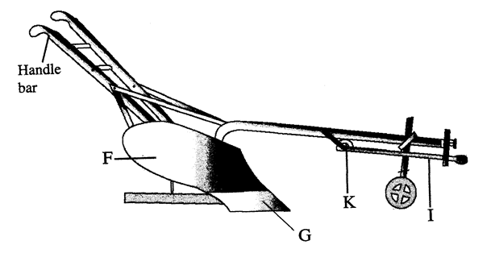
a) Give the functions of parts G and F
G……………………………………………………………………………………………………… (1mark)
F………………………………………………………………………………………………………... (1mark)
b) Name the parts labelled K and I
K ……………………………………………………………………………………………………… (1mark)
I ……………………………………………………………………………………………………… (1mark)
c) Mark on the diagram using letters M and N the two parts used to adjust the depth of ploughing. (1mark)
19. The diagram below shows a hen sitting on eggs. Use it to answer the questions that follow.
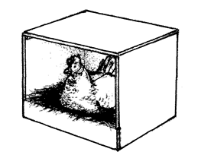

a) Name the method of incubation illustrated above. (1mark)
………………………………………………………………………………………………………………
b) Give two signs that may show that the hen is ready to sit on the eggs. (2marks)
………………………………………………………………………………………………………………
………………………………………………………………………………………………………………
c) State two problems of using the above method to hatch chicks. (2marks)
………………………………………………………………………………………………………………
………………………………………………………………………………………………………………
20.
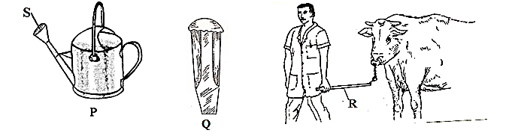
a) Give the identity of tools P and Q.
P (1mark)
………………………………………………………………………………………………………………
Q (1mark)
………………………………………………………………………………………………………………
b) What is the role of part labelled S on diagram P. (1mark)
………………………………………………………………………………………………………………
………………………………………………………………………………………………………………
c) Name another tool used in conjunction with tool R. (1mark)
………………………………………………………………………………………………………………

d) Give one maintenance practice for tool Q. (1mark)
………………………………………………………………………………………………………………
21. The diagram below shows the male reproductive system in cattle. Use it to answer the questions that follow.
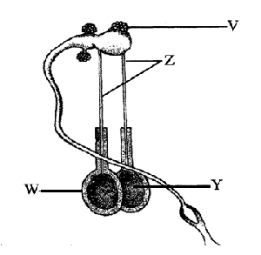
a) Name the parts labelled Z and W
Z (1mark)
………………………………………………………………………………………………………………
W (1mark)
………………………………………………………………………………………………………………
b) State the function of part labelled V and Y
V (1mark)
………………………………………………………………………………………………………………
Y (1mark)
………………………………………………………………………………………………………………
c) How is part W adapted to its function? (1mark)
………………………………………………………………………………………………………………

SECTION C (40MARKS)
22. a) Describe short term tractor servicing. (8marks)
b) Explain the procedure of establishing a fish pond. (5mks)
c) Outline preventive measures for livestock diseases. (7mks)
23. a) Describe brucellosis under the following subheadings:
i) Causal organism (1mark)
ii) Transmission (1mark)
iii) Symptoms (4mks)
iv) Control measures (4mks)
b) State the function of any five parts of a zero grazing unit in dairy farming. (5mks)
c) Explain five factors that should be considered when choosing tools and equipment to use in the farm.
(5mks)
24. a) Explain eight qualities of an ideal broader for a day old chick. (8mks)
b) Describe seven factors that a farmer should consider when sitting a bee hive to prevent swarming of bees.
(7mks)
c) State five functions of water in nutrition. (5mks)
………………………………………………………………………………………………………………
………………………………………………………………………………………………………………
………………………………………………………………………………………………………………
………………………………………………………………………………………………………………
………………………………………………………………………………………………………………
………………………………………………………………………………………………………………
………………………………………………………………………………………………………………
………………………………………………………………………………………………………………
………………………………………………………………………………………………………………
………………………………………………………………………………………………………………
………………………………………………………………………………………………………………
………………………………………………………………………………………………………………
………………………………………………………………………………………………………………
………………………………………………………………………………………………………………
………………………………………………………………………………………………………………
………………………………………………………………………………………………………………
………………………………………………………………………………………………………………
………………………………………………………………………………………………………………
………………………………………………………………………………………………………………
………………………………………………………………………………………………………………
………………………………………………………………………………………………………………
………………………………………………………………………………………………………………
………………………………………………………………………………………………………………
………………………………………………………………………………………………………………
………………………………………………………………………………………………………………
………………………………………………………………………………………………………………
………………………………………………………………………………………………………………
………………………………………………………………………………………………………………
………………………………………………………………………………………………………………
………………………………………………………………………………………………………………
………………………………………………………………………………………………………………
………………………………………………………………………………………………………………
………………………………………………………………………………………………………………
………………………………………………………………………………………………………………
………………………………………………………………………………………………………………
………………………………………………………………………………………………………………
………………………………………………………………………………………………………………
………………………………………………………………………………………………………………
………………………………………………………………………………………………………………
………………………………………………………………………………………………………………
………………………………………………………………………………………………………………
………………………………………………………………………………………………………………
………………………………………………………………………………………………………………
………………………………………………………………………………………………………………
………………………………………………………………………………………………………………
………………………………………………………………………………………………………………
………………………………………………………………………………………………………………
………………………………………………………………………………………………………………
………………………………………………………………………………………………………………
………………………………………………………………………………………………………………
………………………………………………………………………………………………………………
………………………………………………………………………………………………………………
………………………………………………………………………………………………………………
………………………………………………………………………………………………………………
………………………………………………………………………………………………………………
………………………………………………………………………………………………………………
………………………………………………………………………………………………………………
………………………………………………………………………………………………………………
………………………………………………………………………………………………………………
………………………………………………………………………………………………………………
………………………………………………………………………………………………………………
………………………………………………………………………………………………………………
………………………………………………………………………………………………………………
………………………………………………………………………………………………………………
………………………………………………………………………………………………………………
………………………………………………………………………………………………………………
………………………………………………………………………………………………………………
………………………………………………………………………………………………………………
………………………………………………………………………………………………………………
………………………………………………………………………………………………………………
………………………………………………………………………………………………………………
………………………………………………………………………………………………………………
………………………………………………………………………………………………………………
………………………………………………………………………………………………………………
………………………………………………………………………………………………………………
………………………………………………………………………………………………………………
………………………………………………………………………………………………………………
………………………………………………………………………………………………………………
………………………………………………………………………………………………………………
………………………………………………………………………………………………………………
………………………………………………………………………………………………………………
………………………………………………………………………………………………………………
………………………………………………………………………………………………………………
………………………………………………………………………………………………………………
………………………………………………………………………………………………………………
………………………………………………………………………………………………………………
………………………………………………………………………………………………………………
………………………………………………………………………………………………………………
………………………………………………………………………………………………………………
………………………………………………………………………………………………………………
………………………………………………………………………………………………………………
………………………………………………………………………………………………………………
………………………………………………………………………………………………………………
………………………………………………………………………………………………………………
………………………………………………………………………………………………………………
………………………………………………………………………………………………………………
………………………………………………………………………………………………………………
………………………………………………………………………………………………………………
………………………………………………………………………………………………………………
………………………………………………………………………………………………………………
………………………………………………………………………………………………………………
………………………………………………………………………………………………………………
………………………………………………………………………………………………………………
………………………………………………………………………………………………………………
………………………………………………………………………………………………………………
………………………………………………………………………………………………………………
………………………………………………………………………………………………………………
………………………………………………………………………………………………………………
………………………………………………………………………………………………………………
………………………………………………………………………………………………………………
………………………………………………………………………………………………………………
………………………………………………………………………………………………………………
………………………………………………………………………………………………………………
………………………………………………………………………………………………………………
………………………………………………………………………………………………………………
………………………………………………………………………………………………………………
………………………………………………………………………………………………………………
………………………………………………………………………………………………………………
………………………………………………………………………………………………………………
………………………………………………………………………………………………………………
………………………………………………………………………………………………………………
………………………………………………………………………………………………………………
………………………………………………………………………………………………………………
………………………………………………………………………………………………………………
………………………………………………………………………………………………………………
………………………………………………………………………………………………………………
………………………………………………………………………………………………………………
………………………………………………………………………………………………………………
………………………………………………………………………………………………………………
………………………………………………………………………………………………………………
………………………………………………………………………………………………………………
………………………………………………………………………………………………………………
………………………………………………………………………………………………………………
………………………………………………………………………………………………………………
………………………………………………………………………………………………………………
………………………………………………………………………………………………………………
………………………………………………………………………………………………………………
………………………………………………………………………………………………………………
………………………………………………………………………………………………………………
………………………………………………………………………………………………………………
………………………………………………………………………………………………………………
………………………………………………………………………………………………………………
………………………………………………………………………………………………………………
………………………………………………………………………………………………………………
………………………………………………………………………………………………………………
………………………………………………………………………………………………………………
THIS IS THE LAST PRINTED PAGE!

