`NAME…………………………………………….………..INDEX NO………….….....................………
SCHOOL………………………………………………..CANDIDATES SIGN…………....................….
DATE…………………......................………
443/1
AGRICULTURE
PAPER 1
TIME: 2 HOURS
AUGUST-2022
CEKENAS END OF TERM TWO EXAM-2022
FORM FOUR EXAM
Kenya Certificate of Secondary Education. (K.C.S.E)
443/1
AGRICULTURE
PAPER 1

INSTRUCTIONS TO CANDIDATES
- Write your name and admission number in the spaces provided above
- Sign and write date of examination in the space provided.
- This paper consists of three sections A, B and C
- Answer ALL questions in section A and B and any two questions from section C
- Candidates must answer the questions in English.
- All answers should be written in the spaces provided.
SECTION | QUESTION | MAXIMUM SCORE | CANDIDATE’S SCORE
A | 1-17
B | 18-21
C | 22-24

SECTION A (30 MARKS)
Answer ALL Questions in this section
1. List three aspects of light a farmer should consider when deciding on a crop to grow. (1½mks)
…………………………………………………………………………………………………………………...
…………………………………………………………………………………………………………………...
…………………………………………………………………………………………………………………...
2. State four factors which determine the depth of ploughing. (2mks)
…………………………………………………………………………………………………………………...
…………………………………………………………………………………………………………………...
…………………………………………………………………………………………………………………...
…………………………………………………………………………………………………………………...
3. Give four reasons why it is advantageous to use farm yard manure instead of straight fertilizer. (2mks)
…………………………………………………………………………………………………………………...
…………………………………………………………………………………………………………………...
…………………………………………………………………………………………………………………...
…………………………………………………………………………………………………………………...
4. State four methods of reclamation farmers can carry out. (2mks)
…………………………………………………………………………………………………………………...
…………………………………………………………………………………………………………………...
…………………………………………………………………………………………………………………...
…………………………………………………………………………………………………………………...
5. State four benefits of land consolidation. (2mks)
…………………………………………………………………………………………………………………...
…………………………………………………………………………………………………………………...
…………………………………………………………………………………………………………………...
…………………………………………………………………………………………………………………...

6. State four factors that determine the spacing of maize crops. (2mks)
…………………………………………………………………………………………………………………...
…………………………………………………………………………………………………………………...
…………………………………………………………………………………………………………………...
…………………………………………………………………………………………………………………...

7. State four factors which may affect the quality of hay. (2mks)
…………………………………………………………………………………………………………………...
…………………………………………………………………………………………………………………...
…………………………………………………………………………………………………………………...
…………………………………………………………………………………………………………………...
8. State four factors that affect the effectiveness of a pesticide. (2mks)
…………………………………………………………………………………………………………………...
…………………………………………………………………………………………………………………...
…………………………………………………………………………………………………………………...
…………………………………………………………………………………………………………………...
9. List any four types of records a crop farmer should keep. (2mks)
…………………………………………………………………………………………………………………...
…………………………………………………………………………………………………………………...
…………………………………………………………………………………………………………………...
…………………………………………………………………………………………………………………...
10. State four importance of practicing agroforestry. (2mks)
…………………………………………………………………………………………………………………...
…………………………………………………………………………………………………………………...
…………………………………………………………………………………………………………………...
…………………………………………………………………………………………………………………...
11. State four characteristics of a good site for a nursery bed. (2mks)
…………………………………………………………………………………………………………………...
…………………………………………………………………………………………………………………...
…………………………………………………………………………………………………………………...
…………………………………………………………………………………………………………………...
12. Name four methods of farming. (2mks)
…………………………………………………………………………………………………………………...
…………………………………………………………………………………………………………………...
…………………………………………………………………………………………………………………...
…………………………………………………………………………………………………………………...

13. Name four natural factors that may influence soil erosion. (2mks)
…………………………………………………………………………………………………………………...
…………………………………………………………………………………………………………………...
…………………………………………………………………………………………………………………...
…………………………………………………………………………………………………………………...
14. State two conditions that should be observed when harvesting to ensure that cotton picked is of high quality. (2mks)
…………………………………………………………………………………………………………………...
…………………………………………………………………………………………………………………...
15. State four uses of water on the farm. (2mks)
…………………………………………………………………………………………………………………...
…………………………………………………………………………………………………………………...
…………………………………………………………………………………………………………………...
…………………………………………………………………………………………………………………...
16. List three types of surface irrigation in crop production. (1½mks)
…………………………………………………………………………………………………………………...
…………………………………………………………………………………………………………………...
…………………………………………………………………………………………………………………...
17. Differentiate between coppicing and pollarding as used in Agroforestry. (1mk)
…………………………………………………………………………………………………………………...
…………………………………………………………………………………………………………………...
SECTION B (20MARKS)
Answer ALL questions in this section
18. Below are filed practices. Study them carefully and answer the questions that follow.
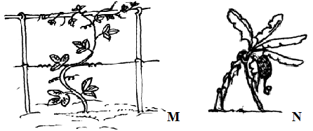
a) Identify the above practices. (2mks)
M
…………………………………………………………………………………………………………………...
N
…………………………………………………………………………………………………………………...
b) State three reasons for carrying out practice M. (3mks)
…………………………………………………………………………………………………………………...
…………………………………………………………………………………………………………………...
…………………………………………………………………………………………………………………...
19. Below are common weeds found on the farm. Use them to answer the questions that follow.
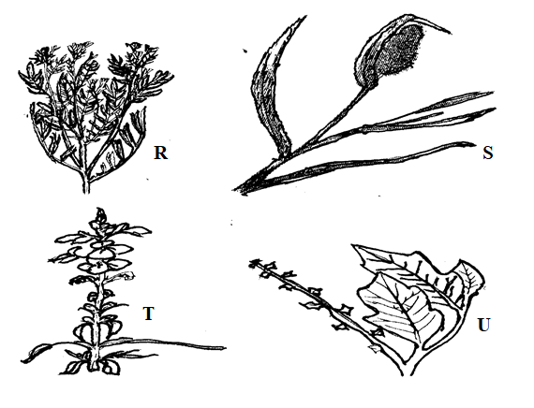
a) Identify the weeds R, S, T, U. (2mks)
R
………………………………………………………………………………………………...................…...
S
…………………………………………………………………………………………………………………...
T
…………………………………………………………………………………………………………………...
U
…………………………………………………………………………………………………………………...

b) State the reason why S and U are difficult to control. (2mks)
S
…………………………………………………………………………………………………………………...
U
…………………………………………………………………………………………………………………...
c) Why is weed R not suitable on dairy animals. (½mk)
…………………………………………………………………………………………………………………...
d) Which weed is parasitic to cereals? (½mk)
…………………………………………………………………………………………………………………...
20. The diagram below shows a silo. Study it carefully and answer the questions that follow.
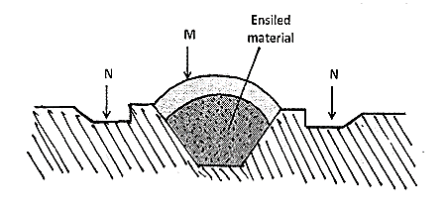
a) Identify the type of silo shown on the diagram. (1mk)
…………………………………………………………………………………………………………………...
b) State the use of the part labelled M and N. (2mks)
M
…………………………………………………………………………………………………………………...
N
…………………………………………………………………………………………………………………...
c) Give two ways of ensuring that anaerobic conditions are achieved during silage making process. (2mks)
…………………………………………………………………………………………………………………...
…………………………………………………………………………………………………………………...

21. The illustrations below represents types of soil structures. Study them carefully and answer the questions that follow.
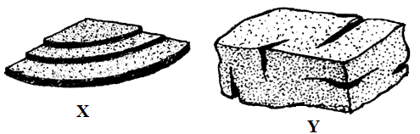
a) Identify the soil structures X and Y shown above. (2mks)
X
…………………………………………………………………………………………………………………...
Y
…………………………………………………………………………………………………………………...
b) Which of the soil structure you have named above is not suitable for growing maize. (1mk)
…………………………………………………………………………………………………………………...
…………………………………………………………………………………………………………………...
c) Give two methods of improving the soil structure you have mentioned in (ii) above. (2mks)
…………………………………………………………………………………………………………………...
…………………………………………………………………………………………………………………...
SECTION C (40 MARKS)
Answer any two questions from this section
22. a) Explain how farmers overcome risks and uncertainties in a farming business. (5mks)
b) Explain how various practices carried out in the field help to control crop diseases. (8mks)
c) Transplanting of seedlings. (7mks)
23. Study the following information which was extracted from Mr. Rono’s farm record on 31st December 2021 and answer the questions below.
Item
Debts receivable 18,000
Loans payable to bank 300,000
Cows 250,000
Chicken 80,000
Goats 30,000
Debts payable to cooperative 20,000
Buildings and structures 600,000
Wages payable to workers 19,000
Cattle feed in store 10,000
Animal drugs in store 4,000
Breakages to repair 30,000
Cash at hand 20,000
Cash in bank 30,000
Farm equipment 12,000
a) Prepare a balance sheet for Rono’s farm using the information above. (10mks)
b) Describe the properties of nitrogenous fertilizers. (15mks)
c) Describe five problems farmers face in marketing of water melon. (5mks)
24. a) Describe cabbage production under the following sub-headings.
i) Ecological requirements. (2mks)
ii) Field management practices. (3mks)
b) State five advantages of using seeds as planting material. (5mks)
c) Describe process of chemical water treatment before storage. (10mks)
…………………………………………………………………………………………………………………...
…………………………………………………………………………………………………………………...
…………………………………………………………………………………………………………………...
…………………………………………………………………………………………………………………...
…………………………………………………………………………………………………………………...
…………………………………………………………………………………………………………………...
…………………………………………………………………………………………………………………...
…………………………………………………………………………………………………………………...
…………………………………………………………………………………………………………………...
…………………………………………………………………………………………………………………...
…………………………………………………………………………………………………………………...
…………………………………………………………………………………………………………………...
…………………………………………………………………………………………………………………...
…………………………………………………………………………………………………………………...
…………………………………………………………………………………………………………………...
…………………………………………………………………………………………………………………...
…………………………………………………………………………………………………………………...
…………………………………………………………………………………………………………………...
…………………………………………………………………………………………………………………...
…………………………………………………………………………………………………………………...
…………………………………………………………………………………………………………………...
…………………………………………………………………………………………………………………...
…………………………………………………………………………………………………………………...
…………………………………………………………………………………………………………………...
…………………………………………………………………………………………………………………...
…………………………………………………………………………………………………………………...
…………………………………………………………………………………………………………………...
…………………………………………………………………………………………………………………...
…………………………………………………………………………………………………………………...
…………………………………………………………………………………………………………………...
…………………………………………………………………………………………………………………...
…………………………………………………………………………………………………………………...
…………………………………………………………………………………………………………………...
…………………………………………………………………………………………………………………...
…………………………………………………………………………………………………………………...
…………………………………………………………………………………………………………………...
…………………………………………………………………………………………………………………...
…………………………………………………………………………………………………………………...
…………………………………………………………………………………………………………………...
…………………………………………………………………………………………………………………...
…………………………………………………………………………………………………………………...
…………………………………………………………………………………………………………………...
…………………………………………………………………………………………………………………...
…………………………………………………………………………………………………………………...
…………………………………………………………………………………………………………………...
…………………………………………………………………………………………………………………...
…………………………………………………………………………………………………………………...
…………………………………………………………………………………………………………………...
…………………………………………………………………………………………………………………...
…………………………………………………………………………………………………………………...
…………………………………………………………………………………………………………………...
…………………………………………………………………………………………………………………...
…………………………………………………………………………………………………………………...
…………………………………………………………………………………………………………………...
…………………………………………………………………………………………………………………...
…………………………………………………………………………………………………………………...
…………………………………………………………………………………………………………………...
…………………………………………………………………………………………………………………...
…………………………………………………………………………………………………………………...
…………………………………………………………………………………………………………………...
…………………………………………………………………………………………………………………...
…………………………………………………………………………………………………………………...
…………………………………………………………………………………………………………………...
…………………………………………………………………………………………………………………...
…………………………………………………………………………………………………………………...
…………………………………………………………………………………………………………………...
…………………………………………………………………………………………………………………...
…………………………………………………………………………………………………………………...
…………………………………………………………………………………………………………………...
…………………………………………………………………………………………………………………...
…………………………………………………………………………………………………………………...
…………………………………………………………………………………………………………………...
…………………………………………………………………………………………………………………...
…………………………………………………………………………………………………………………...
…………………………………………………………………………………………………………………...
…………………………………………………………………………………………………………………...
…………………………………………………………………………………………………………………...
…………………………………………………………………………………………………………………...
…………………………………………………………………………………………………………………...
…………………………………………………………………………………………………………………...
…………………………………………………………………………………………………………………...
…………………………………………………………………………………………………………………...
…………………………………………………………………………………………………………………...
…………………………………………………………………………………………………………………...
…………………………………………………………………………………………………………………...
…………………………………………………………………………………………………………………...
…………………………………………………………………………………………………………………...
…………………………………………………………………………………………………………………...
…………………………………………………………………………………………………………………...
…………………………………………………………………………………………………………………...
…………………………………………………………………………………………………………………...
…………………………………………………………………………………………………………………...
…………………………………………………………………………………………………………………...
…………………………………………………………………………………………………………………...
…………………………………………………………………………………………………………………...
…………………………………………………………………………………………………………………...
…………………………………………………………………………………………………………………...
…………………………………………………………………………………………………………………...
…………………………………………………………………………………………………………………...
…………………………………………………………………………………………………………………...
…………………………………………………………………………………………………………………...
…………………………………………………………………………………………………………………...
…………………………………………………………………………………………………………………...
…………………………………………………………………………………………………………………...
…………………………………………………………………………………………………………………...
…………………………………………………………………………………………………………………...
…………………………………………………………………………………………………………………...
…………………………………………………………………………………………………………………...
…………………………………………………………………………………………………………………...
…………………………………………………………………………………………………………………...
…………………………………………………………………………………………………………………...
…………………………………………………………………………………………………………………...
…………………………………………………………………………………………………………………...
…………………………………………………………………………………………………………………...
…………………………………………………………………………………………………………………...
…………………………………………………………………………………………………………………...
…………………………………………………………………………………………………………………...
…………………………………………………………………………………………………………………...
…………………………………………………………………………………………………………………...
…………………………………………………………………………………………………………………...
…………………………………………………………………………………………………………………...
…………………………………………………………………………………………………………………...
…………………………………………………………………………………………………………………...
…………………………………………………………………………………………………………………...
…………………………………………………………………………………………………………………...
…………………………………………………………………………………………………………………...
…………………………………………………………………………………………………………………...
…………………………………………………………………………………………………………………...
…………………………………………………………………………………………………………………...
…………………………………………………………………………………………………………………...
…………………………………………………………………………………………………………………...
…………………………………………………………………………………………………………………...
…………………………………………………………………………………………………………………...
…………………………………………………………………………………………………………………...
…………………………………………………………………………………………………………………...
…………………………………………………………………………………………………………………...
…………………………………………………………………………………………………………………...
…………………………………………………………………………………………………………………...
…………………………………………………………………………………………………………………...
…………………………………………………………………………………………………………………...
…………………………………………………………………………………………………………………...
…………………………………………………………………………………………………………………...
…………………………………………………………………………………………………………………...
…………………………………………………………………………………………………………………...
…………………………………………………………………………………………………………………...
…………………………………………………………………………………………………………………...
…………………………………………………………………………………………………………………...
…………………………………………………………………………………………………………………...
…………………………………………………………………………………………………………………...
…………………………………………………………………………………………………………………...
…………………………………………………………………………………………………………………...
…………………………………………………………………………………………………………………...
…………………………………………………………………………………………………………………...
THIS IS THE LAST PRINTED PAGE!

