BUNAMFAN CLUSTER EXAMINATION - 2022

Kenya Certificate of Secondary Education
443/2 – AGRICULTURE – Paper 2

June 2022 - 2 hours

Name………………………………………Adm No……
Class…………… Date……………………………
Instruction to candidates.
- Write your name and index number.
- This paper consists of three sections A, B and C.
- Answer all the questions in A and B and two in section C.
- All answers should be written in the spaces provided on the question paper.
FOR EXAMINER’S USE ONLY.
SECTION | QUESTIONS | MAXIMUM SCORE | CANDIDATE SCORE
A | 1-20 | 30
B | 21-24 | 20
C | 25-27 | 40
 | TOTAL | 90

GRAND TOTAL.

SECTION A (30MKS)
Answer all the questions in this section.
- State four causes of stress in poultry. (2mks).
………………………………………………………………………………………………………………………………………………………………………………………………………………
………………………………………………………………………………………………………………………………………………………………………………………………………………
- State four factors that determine the amount of feed an animal consumes (2mks.)
………………………………………………………………………………………………………………………………………………………………………………………………………………………………………………………………………………………………………………………………………………………………………………………………………………………………
3. State four advantages of artificial calf feeding. (2mks.)
………………………………………………………………………………………………………………………………………………………………………………………………………………………………………………………………………………………………………………………………………………………………………………………………………………………………
- Name two methods of service in livestock breeding (1mk).
………………………………………………………………………………………………………………………………………………………………………………………………………………………………………………………………………………………………………………………………………………………………………………………………………………………………
5.Name two species of camel. (1mk).
………………………………………………………………………………………………………………………………………………………………………………………………………………
- State four functions of vitamins in livestock body (2mks.)
………………………………………………………………………………………………………………………………………………………………………………………………………………………………………………………………………………………………………………………………………………………………………………………………………………………………
7.Define the following terms (2mks).
(a) Cockerel-
………………………………………………………………………………………………………
(b) Broiler-
………………………………………………………………………………………………………
(c) Ewe-
………………………………………………………………………………………………………
(d) Kid—
………………………………………………………………………………………………………
8. List two main parts of a farm building. (1mk).
………………………………………………………………………………………………………………………………………………………………………………………………………………
9. State two reasons why lubrication or greasing of farm machines is important (1mk).
………………………………………………………………………………………………………………………………………………………………………………………………………………
10. Give two reasons for seasoning timber before it is used for construction. (1mk).
………………………………………………………………………………………………………………………………………………………………………………………………………………

11. State the functional difference between a drenching gun and a bolus gun. (1mk).
………………………………………………………………………………………………………………………………………………………………………………………………………………
12. Name four tools which a farmer uses for dehorning cattle. (2mks).
………………………………………………………………………………………………………………………………………………………………………………………………………………………………………………………………………………………………………………………………………………………………………………………………………………………………
- List two reasons why bees are fed with syrup (1mk).
………………………………………………………………………………………………………………………………………………………………………………………………………………
- Differentiate between inbreeding and outbreeding (1mk).
………………………………………………………………………………………………………………………………………………………………………………………………………………
15. Identify four abnormalities which can be identified in eggs through candling (2mks).
………………………………………………………………………………………………………………………………………………………………………………………………………………………………………………………………………………………………………………………………………………………………………………………………………………………………
16. Name two dual purpose breeds of sheep (1mk).
………………………………………………………………………………………………………………………………………………………………………………………………………………

17. State four factors which influences the rate of respiration in farm animals (2mks).
………………………………………………………………………………………………………………………………………………………………………………………………………………………………………………………………………………………………………………………………………………………………………………………………………………………………
- Mention four preventive measures farmers uses to control diseases in animals (2mks).
………………………………………………………………………………………………………………………………………………………………………………………………………………………………………………………………………………………………………………………………………………………………………………………………………………………………
- State four harmful effects of lice in sheep. (2mks).
………………………………………………………………………………………………………………………………………………………………………………………………………………………………………………………………………………………………………………………………………………………………………………………………………………………………
- Name two examples of two host ticks. (1mks).

………………………………………………………………………………………………………………………………………………………………………………………………………………

SECTION B (20MKS)
Answer all the questions in this section.
- Study the diagram below and answer the questions that follows.
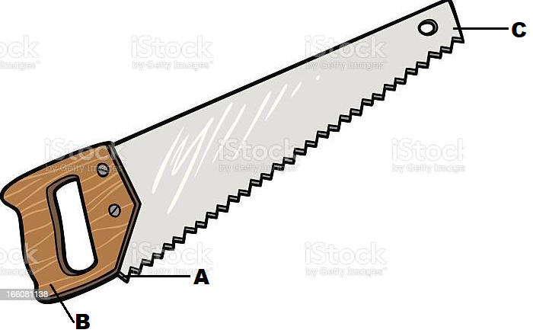
- Identify the tool. (1mk)
………………………………………………………………………………………………………
(b).Name the parts labeled .(3mks).
A ------------------------------------------------------------------------------------------
B ------------------------------------------------------------------------------------------
C ------------------------------------------------------------------------------------------
- State two maintenance practices of the tool above (2mks).
………………………………………………………………………………………………………………………………………………………………………………………………………………
- Using Pearson's square method, compute a 200 kg ration with 20% DCP from oats which contains 10% DCP and sim sim seedcake containing 60%DCP (3mks).

23.Study the illustration below and answer the questions that follow.
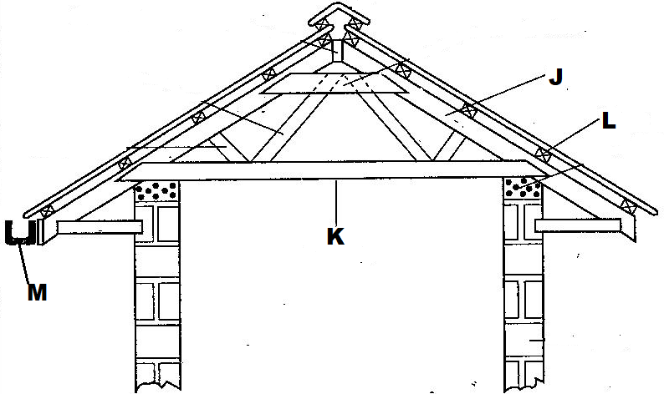
- Identify the parts labeled (2mks).
J ---------------------------------------------------------------------------------------------------
K ---------------------------------------------------------------------------------------------------
L ---------------------------------------------------------------------------------------------------
M ---------------------------------------------------------------------------------------------------
- State one use of the part labelled L. (1mk).
………………………………………………………………………………………………………
(c) State one reason why it is important to have the structure labelled M at the edge of the roofing materials. (1mk).
………………………………………………………………………………………………………

- Below is an illustration of a sheep with parts marked E, F and G.
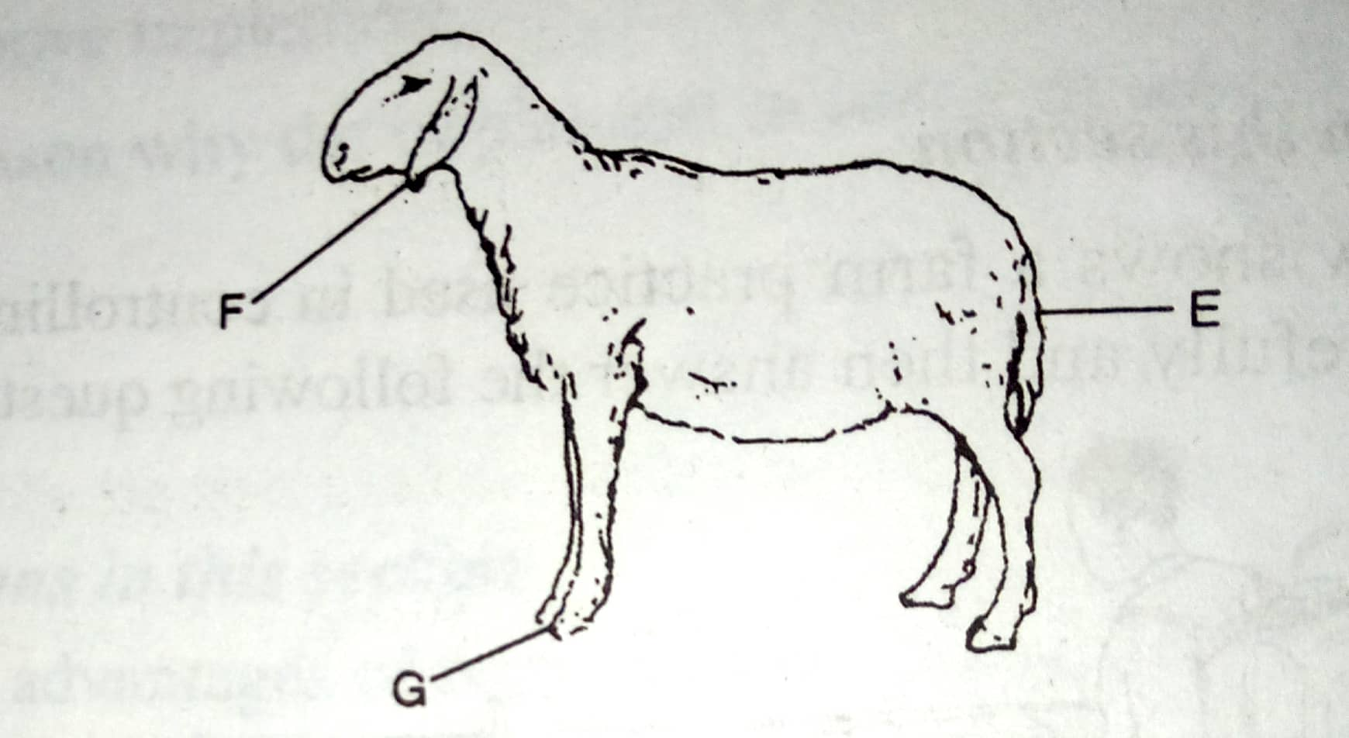
(a)State the operations that are carried out on the parts labelled (2mks).
E-------------------------------------------------------------------------------------------------------
G------------------------------------------------------------------------------------------------------
(b)State two reasons for carrying out the operation identified in E (2mks).
………………………………………………………………………………………………………………………………………………………………………………………………………………
(c) At what age should the operation stated in E be carried out. (1mk).
………………………………………………………………………………………………………
(d).State two methods of carrying out the operation named in E. (2mks).
………………………………………………………………………………………………………………………………………………………………………………………………………………

SECTION C (40MKS)
Answer any two questions from this section in the spaces provided.
- (a).Give nine reasons why the battery cage system of rearing poultry is popular for used by large scale poultry farmers. (9mks.)
………………………………………………………………………………………………………………………………………………………………………………………………………………
………………………………………………………………………………………………………………………………………………………………………………………………………………
………………………………………………………………………………………………………………………………………………………………………………………………………………
………………………………………………………………………………………………………………………………………………………………………………………………………………
- Describe five management practices carried out on a fish pond. (5mks).
………………………………………………………………………………………………………………………………………………………………………………………………………………
………………………………………………………………………………………………………………………………………………………………………………………………………………
………………………………………………………………………………………………………………………………………………………………………………………………………………
- Describe six symptoms observed on a calf heavily infested with internal parasites (6mks).
………………………………………………………………………………………………………………………………………………………………………………………………………………
………………………………………………………………………………………………………………………………………………………………………………………………………………
………………………………………………………………………………………………………………………………………………………………………………………………………………
26.(a)State six advantages of animal power over tractor power in seedbed preparation.(6mks).
………………………………………………………………………………………………………………………………………………………………………………………………………………
………………………………………………………………………………………………………………………………………………………………………………………………………………
………………………………………………………………………………………………………………………………………………………………………………………………………………
(b)Explain nine factors to consider in siting farm structures (9mks).
………………………………………………………………………………………………………………………………………………………………………………………………………………
………………………………………………………………………………………………………………………………………………………………………………………………………………
………………………………………………………………………………………………………………………………………………………………………………………………………………
………………………………………………………………………………………………………………………………………………………………………………………………………………
(c)State five importance's of farm buildings. (5mks).
………………………………………………………………………………………………………………………………………………………………………………………………………………
………………………………………………………………………………………………………………………………………………………………………………………………………………
………………………………………………………………………………………………………………………………………………………………………………………………………………

27.(a).Name two causes of pneumonia in livestock. (2mks)
………………………………………………………………………………………………………………………………………………………………………………………………………………
(b)State four predisposing factors of pneumonia disease in livestock (4mks).
………………………………………………………………………………………………………………………………………………………………………………………………………………
………………………………………………………………………………………………………………………………………………………………………………………………………………
(c).Describe four types of stores that can be found on a farm. (8mks).
………………………………………………………………………………………………………………………………………………………………………………………………………………
………………………………………………………………………………………………………………………………………………………………………………………………………………
………………………………………………………………………………………………………………………………………………………………………………………………………………
………………………………………………………………………………………………………………………………………………………………………………………………………………
(d).State six differences between Petrol and diesel tractor engines. (6mks).
………………………………………………………………………………………………………………………………………………………………………………………………………………
………………………………………………………………………………………………………………………………………………………………………………………………………………
………………………………………………………………………………………………………THIS IS THE LAST PRINTED PAGE

