Instructions to candidates
- Write your name, index number and stream in spaces provided
- Candidates should have the following material for this examination:
  - Drawing paper
  - Drawing instruments
- This paper consists of two sections A and B
- Answer all questions in section A and any FOUR questions in section B.
- Question 15 should be answered on A3 paper provided
- All dimensions are in millimeters unless otherwise stated
- Candidates should not spend more than 15minutes on question 15.
For examiners use only
SECTION | QUESTION | MAXIMUM SCORE | CANDIDATES SCORE
A | 1-10 | 44
B | 11 | 14
 | 12 | 14
 | 13 | 14
 | 14 | 14
 | 15 | 14
 | TOTAL | 100

SECTION A (44Marks)
- Highlight TWO roles of each of the following personnel’s:
- Directorate of civil aviation. (1mark)
........................................................................................................................................................................................................................................................................................................................................................................................................................................................................................................................................................................................................................
- Ram coordinator. (1mark)
........................................................................................................................................................................................................................................................................................................................................................................................................................................................................................................................................................................................................................
- (a) State TWO safety precautions to be observed when working on an aircraft engine.
(2marks)
................................................................................................................................................................................................................................................................................................................................................................................................................................................................................................................................................................................................................................................................................................................................................

(b) Highlight TWO checks to be done on a foam fire extinguishing cylinder.(2marks)
................................................................................................................................................................................................................................................................................................................................................................................................................................................................................................................................................................................................
- (a) By use of sketches illustrate the two principles employed in thrust force generation.
(2marks)

(b) Differentiate between the following types of drag:
(i) Skin friction and form drag. (1mark)
................................................................................................................................................................................................................................................................................................................................................................................................................................................

(ii) Interference and induced drag. (1mark)
................................................................................................................................................................................................................................................................................................................................................................................................................................................

- (a) Highlight four ISA conditions giving their respective SI units. (2marks)
................................................................................................................................................................................................................................................................................................................................................................................................................................................................................................................................................................................................................................................................................................................................................
(b) With the aid of a well labeled diagram show the effect of altitude to temperature and pressure at different atmospheric layers. (2marks)

- (a) Name TWO ways in which airports are classified giving each one example.(2marks)
................................................................................................................................................................................................................................................................................................................................................................................................................................................
(b) Highlight TWO safety practices laid when using a tow bar. (2marks)
................................................................................................................................................................................................................................................................................................................................................................................................................................................

- (a) Briefly explain with the aid of a sketch how propeller type engine operates.(2marks)

....................................................................................................................................................................................................................................................................................................................................................................................................................................................................................

(b) Illustrate the cylinder assembly system stating the function of three labeled parts.
(3marks)

- (a) Name TWO bodies accredited to manufacture standard aircraft hardware. (1mark)
................................................................................................................................................................................................................................................................................................................................................................................................................................................

(b) State TWO reasons why threaded fasteners are preferred for use on an aircraft.
................................................................................................................................................................................................................................................................................................................................................................................................................................................
(c) Sketch the following aircraft hardware’s:
(I) locking plate (1mark)

(ii) Clevis bolt (1mark)

- (a) Name TWO types of rescue equipment that should be carried on an aircraft flying on a bare land. (1mark)
................................................................................................................................................................................................................................................................................................................................................................................................................................................
(b) Highlight two checks to be done on a life jacket. (2marks)
................................................................................................................................................................................................................................................................................................................................................................................................................................................................................................................................................................................................

(c) Explain the function of the equipment named in part 8(a) (1mark)
................................................................................................................................................................................................................................................................................................................................................................................................................................................................................................................................................................................................

- (a) List TWO methods used for joining metal parts in aircraft construction. (1mark)
...............................................................................................................................................................................................................................................................................................................................................................................................................................................

(b) Differentiate between:
(i) Strength and conductivity (1mark)
................................................................................................................................................................................................................................................................................................................................................................................................................................................................................................................................................................................................
(ii) Magnetism and elasticity (1mark)
................................................................................................................................................................................................................................................................................................................................................................................................................................................................................................................................................................................................
(c) Explain case hardening as applied in heat treatment processes. (1mark)
................................................................................................................................................................................................................................................................................................................................................................................................................................................

- In good proportion sketch the following bracket in third angle projection indicating three major dimensions in space below. (5marks)

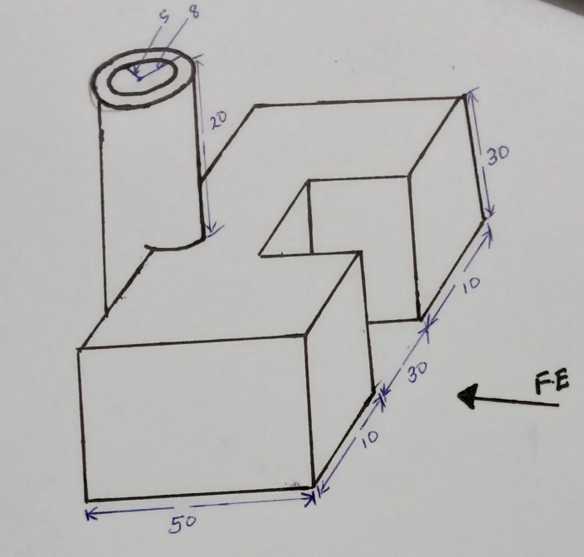

SECTION B (56Marks)
- (a) outline TWO ways of steering the aircraft in the following conditions:
- In flight (2marks)
..............................................................................................................................................................................................................................................................................................................................................................................................................................

- On ground (during flight) (2marks)
.............................................................................................................................................................................................................................................................................................................................................................................................................................
(b) With the aid of a labeled sketch explain how elevators are controlled from the cockpit. (6marks)

................................................................................................................................................................................................................................................................................................................................................................................................................................................

(c) Explain the function of the following types of flaps with the aid of sketches:
(i) Leading edge. (2marks)

................................................................................................................................................................................................................................................................................................................................................................................................................................................................................................................................................................................................
(ii) trailing edge (2marks)

...............................................................................................................................................................................................................................................................................................................................................................................................................................................................................................................................................................................................

- (a) Define fire ordering as applied to propulsion. (1mark)
................................................................................................................................................................................................................................................................................................................................................................................................................................................

(b) State two differences between normal aspirated induction system and turbocharger induction system. (2marks)
................................................................................................................................................................................................................................................................................................................................................................................................................................................................................................................................................................................................

(c) With the aid of a well labeled diagram describe a simple hydraulic system. (8marks)

................................................................................................................................................................................................................................................................................................................................................................................................................................................................................................................................................................................................................................................................................................................................................

(d) Highlight four functions of accumulator (4marks)
................................................................................................................................................................................................................................................................................................................................................................................................................................................................................................................................................................................................................................................................................................................................................

- (a)Explain the importance of the following factors in an organization :
- Good communication (2marks)
..................................................................................................................................................................................................................................................................................................................................................................................................................................................................
- Motivation to workers (2marks)
..................................................................................................................................................................................................................................................................................................................................................................................................................................................................
(b) Describe the following factors that affect personnel performance:
(i) Culture (1mark)
................................................................................................................................................................................................................................................................................................................................................................................................................................................
(ii) Workload (1mark)
................................................................................................................................................................................................................................................................................................................................................................................................................................................
- Interpersonal relationship (1mark)
................................................................................................................................................................................................................................................................................................................................................................................................................................................
- Insecurity (1mark)
................................................................................................................................................................................................................................................................................................................................................................................................................................................
(c) Explain how the following factors affect aviation policies
(i) Government policies (2marks)
................................................................................................................................................................................................................................................................................................................................................................................................................................................
(ii) Natural pandemics (2marks)
................................................................................................................................................................................................................................................................................................................................................................................................................................................

- Hotel industry (2marks)
................................................................................................................................................................................................................................................................................................................................................................................................................................................

- (a) State the importance of flight planning. (1mark)
................................................................................................................................................................................................................................................................................................................................................................................................................................................
(b) Write the following in full:
i). VHF (1mark)
................................................................................................................................................
ii). NDB (1mark)
................................................................................................................................................
(c) Describe the following Q code altimeter settings:
(i) QNH (2marks)
................................................................................................................................................................................................................................................................................................................................................................................................................................................
(ii) QNE (2marks)
................................................................................................................................................................................................................................................................................................................................................................................................................................................
- QFE (2marks)
................................................................................................................................................................................................................................................................................................................................................................................................................................................
(d) Explain the function of the following navigational aids:
(I) Radio magnetic indicator (2 ½ marks)
................................................................................................................................................................................................................................................................................................................................................................................................................................................

(ii) Radar (2 ½ marks)
................................................................................................................................................................................................................................................................................................................................................................................................................................................

- Figure 2 shows an aircraft hinge bracket drawn in isometric projection. Draw full scale in third angle projection the following views:
- Front elevation in the direction of the arrow
- End elevation
- Plan
(Use the A3 or A4 paper provided) (14marks)

Fig.2
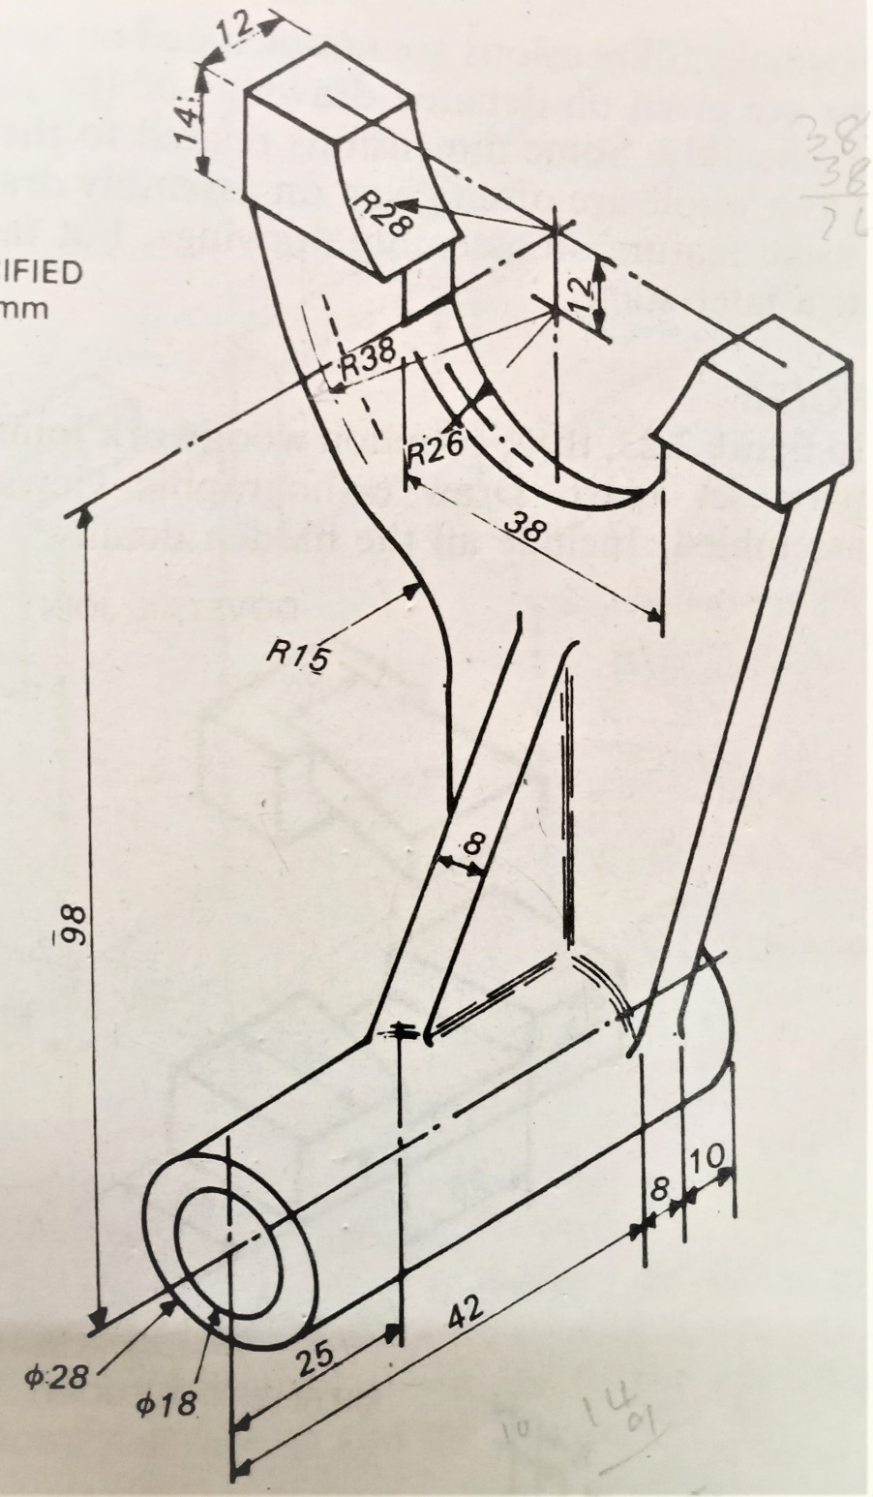 F.E

