NAME……………………………………………………………INDEX NO…….…………….……/……….
SCHOOL……………………………………………………………….………DATE…………………..……….
442/1
ART AND DESIGN
PAPER 1 (Theory)
December 2021
TIME; 1 Hour 30 Minutes.
DECEMBER EXAM 2021
INSTRUCTIONS TO CANDIDATES
(a) Write your name and the index number in the spaces provided above.
(b) Sign and write the date of examination in the spaces provided
( c) Answer all questions in Sections A and B.
(d) Answer any one question in Section C.
(e) All answers must be written in the spaces provided.
(f) Where drawings and illustrations are appropriate, they should be included within the text of your answers.
FOR EXAMINER’S USE ONLY.
SECTION | QUESTION | MAX. SCORES | CANDIDATE SCORE
A | 1 | 20
B | 2 | 5
 | 3 | 5
 | 4 | 5
 | 5 | 5
 | 6 | 5
C |  | 15
 |  | 60
SECTION; A (20 marks)
ANSWER ALL QUESTIONS IN THIS SECTION.
1. Study the Artwork below and answer the questions that follow
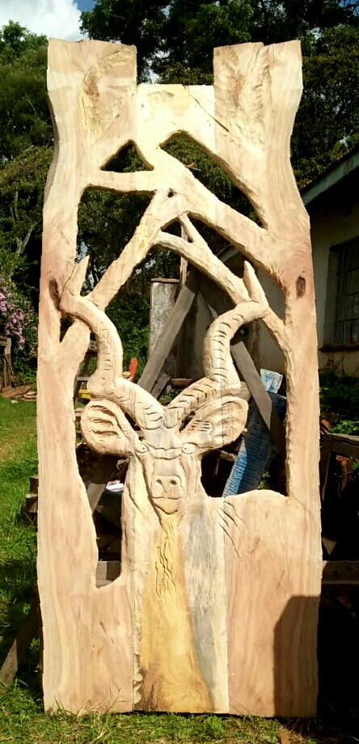 (a) (i) Identify the type of Relief. ( 1 mk)
……………………………………………………………………………………………………………………….
(ii) State the technique of production. ( 1 mk)
………………………………………………………………………………………………………………………
(b) Name One property and One use of Line. ( 1 mk)
………………………………………………………………………………………………………………………..……
…………………………………………………………………………………………………………………………….
( c) State One importance of Rhythm and movement in a composition. ( 1 mk)

…………………………………………………………………………………………………………………………..….
………………………………………………………………………………………………………………………………
(d) Study the picture below, and answer the questions that follow
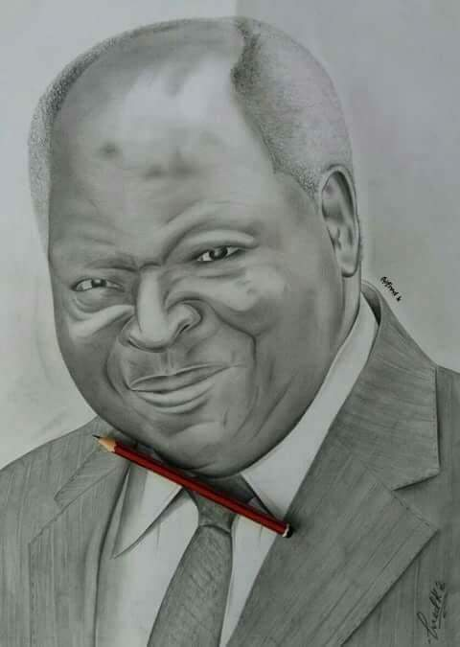
(i) Identify the picture making technique. ( 1 mk)
……………………………………………………………………………………………………………………………..
(ii) Name the potrait view used and style of presentation. ( 1 mk)
……………………………………………………………………………………………………………………………..
……………………………………………………………………………………………………………………………..
(e) Siting any example ,explain the relevance of Art and Design in modern technology. . ( 2 mks)
……………………………………………………………………………………………………………………………..
……………………………………………………………………………………………………………………………..
………………………………………………………………………………………………………………………………
………………………………………………………………………………………………………………………………

(f) The following is a Painting done by a form four student.
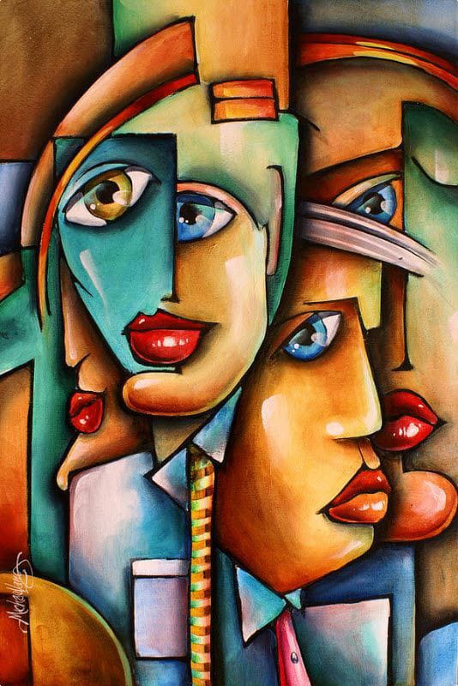
(i) Identify the style used. (1 mk)
………………………………………………………………………………..…………………………………………….
(ii) State the possible title for the painting. ( 1 mk)
………………………………………………………………………………………………………………………………
………………………………………………………………………………………………………………………………
(g) State two similarities between Mosaic and Collage. (2 mks)
………………………………………………………………………………………………………………………………
………………………………………………………………………………………………………………………………
………………………………………………………………………………………………………………………………
………………………………………………………………………………………………………………………………

(h) The picture below shows decorative techniques of clayware.
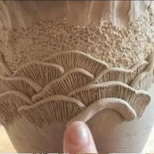
(i) Name two decorative techniques seen above. (1 mk)
…………………………………………………………………………………………………………..…………………
……………………………………………………………………………………………………………..………………
(ii) Name the state of clay in which above decorations are done. (1 mk)
……………………………………………………………………………………………………………………………..
(iii) State the term used to refer to unfired clay articles. (1 mk)
…………………………………………………………………………………………………………………………….
(I) (i) Name any two types of plain weave techniques. (1 mk)
……………………………………………………………………………………………………………………………..
………………………………………………………………………………………………………………………………
(ii) State any two advantages of industrial machine weaving compared to handweaving technique. (2 mks)
………………………………………………………………………………………………………………………………
………………………………………………………………………………………………………………………………
………………………………………………………………………………………………………………………………
………………………………………………………………………………………………………………………………

(j) Explain any two importance of critique in Art. (2 mks)
……………………………………………………………………………………………………………………………
…………………………………………………………………………………………………………………………...
……………………………………………………………………………………………………………………………
……………………………………………………………………………………………………………………………

SECTION B; ( 25 marks)
ANSWER ALL QUESTIONS IN THIS SECTION
2. Study the Art work below, and use it to answer the questions below.
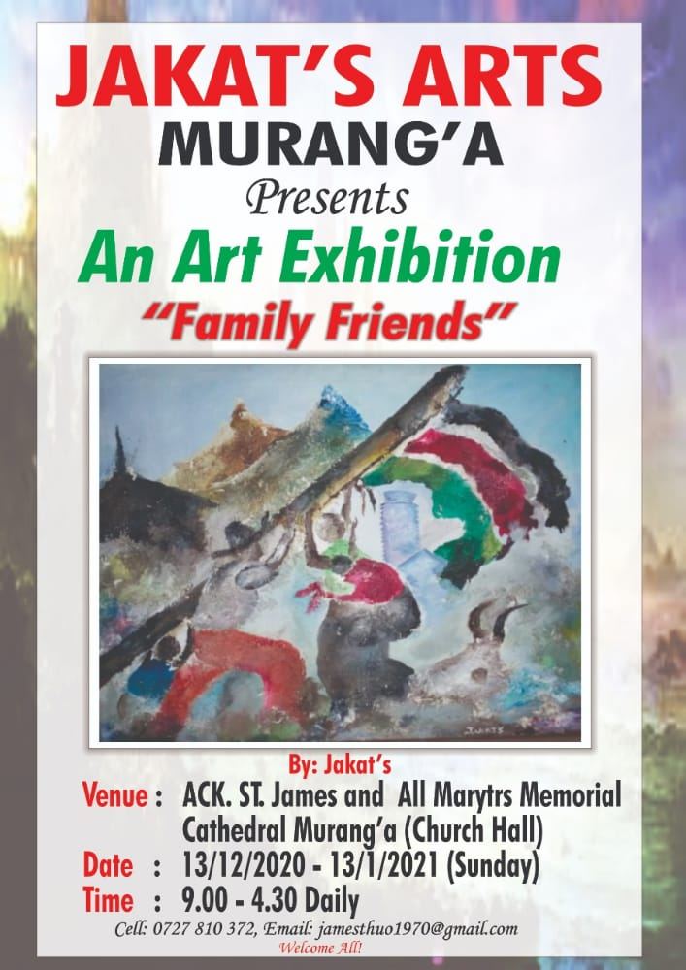
(a) State any two factors that make the above work an effective tool for communication . . ( 2 mks)
………………………………………………………………………………………………………………………………
………………………………………………………………………………………………………………………………
………………………………………………………………………………………………………………………………
7
(b) State any two components of Graphic Design. ( 2 mks)
………………………………………………………………………………………………………………………………
………………………………………………………………………………………………………………………………
(c) Identify the area of design where the above work falls. ( 1 mk)
………………………………………………………………………………………………………………………………
3. The picture below illustrates a form of perspective. Use it to answer the questions that follow.

. 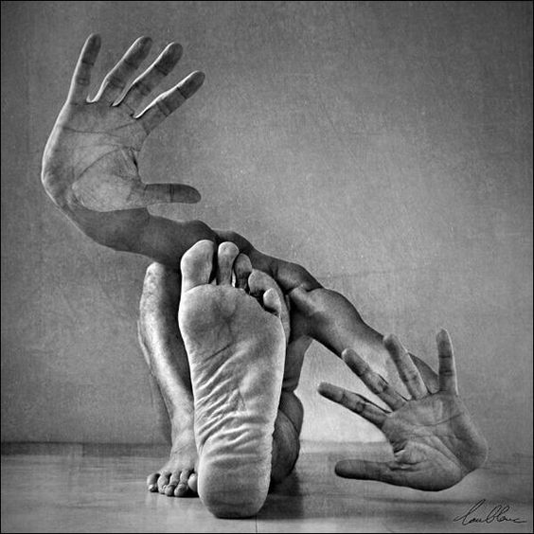
(i) State the name given to this form of perspective. ( 1 mk )
………………………………………………………………………………………………………………………………

(ii) Name the two methods of mounting drawing works . ( 2 mks)
………………………………………………………………………………………………………………………………
………………………………………………………………………………………………………………………………
8
(iii) Describe etching as used in Drawing. ( 2 mks)
……………………………………………………………………………………………………………………………..
………………………………………………………………………………………………………………………………
4. (a) What is Chroma. ( 1 mk)
……………………………………………………………………………………………………………………………..
(b) Explain the term Simultaneous contrast as used in painting. (2 mks)
………………………………………………………………………………………………………………………………
………………………………………………………………………………………………………………………………
(c) Give two reasons for priming surfaces before painting. ( 2 mks)
………………………………………………………………………………………………………………………………
………………………………………………………………………………………………………………………………
………………………………………………………………………………………………………………………………
5. (a) Identify the three types of spacing in the word. (1 ½ mks )
‘ dodly’
…………………………………………………………………………………………………………………………….
…………………………………………………………………………………………………………………………….
…………………………………………………………………………………………………………………………….
……………………………………………………………………………………………………………………………
…………………………………………………………………………………………………………………………….
(b) Name the three parts of lower case letters (1 ½ mks)
………………………………………………………………………………………………………………………………
………………………………………………………………………………………………………………………………
………………………………………………………………………………………………………………………………
c) Explain the meaning of typography as applied in graphics. (2mks)
………………………………………………………………………………………………………………………………
………………………………………………………………………………………………………………………………
………………………………………………………………………………………………………………………………
9
6. Study the picture of a metallic sculpture below and answer the questions that follow .
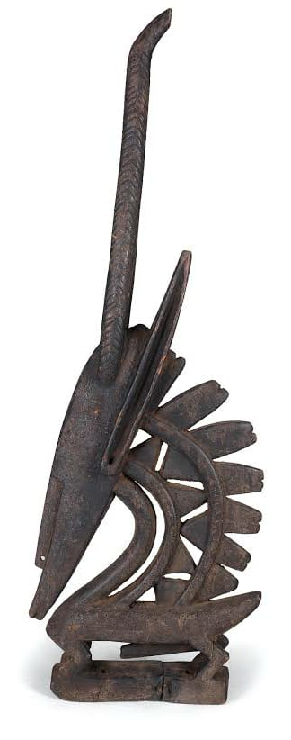
a) Identify the type of sculpture . (1 mk)
………………………………………………………………………………………………………………………………
b) What technique was probably used to make it. (1 mk)
………………………………………………………………………………………………………………………………
c) State three types of relief sculptures . (3 mks)
………………………………………………………………………………………………………………………………
………………………………………………………………………………………………………………………………
………………………………………………………………………………………………………………………………
………………………………………………………………………………………………………………………………

10
SECTION; C (15 marks)
Answer any ONE question in this section. Write your answers in the space provided after question 9.
7. Study the picture below and answer the questions that follow.
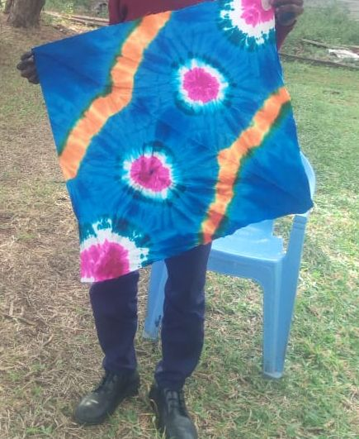

(a) Identify the method used to produce the work displayed above. ( 1 mk)
(b) Name two visible designs in the work. ( 2 mks)
(c) Discuss six roles of Decorated fabrics. s (12 mks)

8. (a) Distinguish between Ornaments and Jewellery . ( 2 mks)
(b) State any three ways of decorating metallic ornaments. ( 3 mks)
(c ) Discuss five processes of making Ornaments. (10 mks)

9.(a) Explain the term Mural. ( 2 mks)
(b) State any three qualities of a good surface for a Mural painting. ( 3 mks)
(c) Discuss any five techniques of painting. (10 mks)

