@West practice papers-2021
Kenya Certificate of Secondary Education-Mock

442/1 - ART AND DESIGN - Paper 1

NOV/DEC.2021
Marking scheme

Name………………………………………………………………………… Index No………………………………………………..
Instructions to candidates

- Write your name and index number in the spaces provided above
- Sign and write the date of the examination in the spaces provided above.
- This paper consists of three sections A, B and C.
- Answer all questions in section A and B.
- Answer any one question in section C
- Answers to all the questions must be written in the spaces provided.
- Where drawings and diagrams are appropriate, they should be included within the text of your answers
- This paper consists of 14 printed pages.
- Candidates should check the question paper to ascertain that all the pages are printed as indicated and that no questions are missing.
- Candidates should answer the questions in English
________________________________________________________________

For Examiner’s Use Only

Section | Question | Maximum score | Score
A | 1 | 20
B | 2 | 05
 | 3 | 05
 | 4 | 05
 | 5 | 05
 | 6 | 05
C |  | 15
Max. Score Paper 1 |  | 60

SECTION A (20 marks)
Answer all the questions in this section in the spaces provided.

- Study the illustration below.
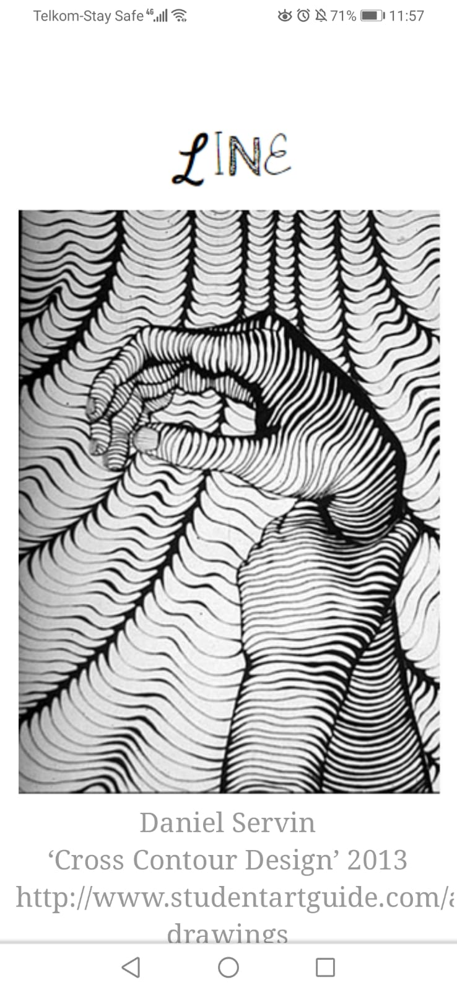

Identify the main two uses of line in the above illustration (2marks)

- To enclose shape
- To define form
- Suggest depth

- Distinguish between visual arts and performing arts. (2marks)

- Visual art refers to art that is tangible and that utilizes a variety of tools and materials to create or express 2D/3D forms for aesthetics or utilitarian purpose, whereas performing arts are the arts that involve individual/group performance to a given audience.

- Define the term ‘sketching’ (1mark)

- A rapidly executed freehand drawing done to capture basic details that are of interest to the artist

- Give the functional similarity between strings and wax in fabric decoration (1mark)

- Both are used to resist dye from penetrating the fabric so as to achieve decorative effects

- Name the two techniques used to mount pictorial compositions in art (2marks)

- Mat mounting
- Window mounting

- The tool illustrated below is used in batik technique of fabric decoration

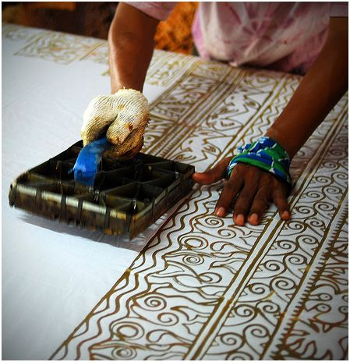

Identify the tool and state its function (2marks)

- Tjap tool
- Used to stamp designs on the fabric using hot wax in batik

- Explain the effect of modeling a huge peppier mache sculpture without an armature (2marks)
- Define fresco painting (2marks)

- It’s a technique of painting executed upon freshly laid lime plaster after which the painting becomes an integral part of the wall upon setting

- State any two factors to consider when developing a mural painting (2marks)

- Theme/function/purpose
- Location
- Target audience
- Nature of surface

- Define lithography (2marks)

- The process of transferring an impression using a flat surface achieved by using the concept that oil and water do not mix where the printing plate is coated to repel ink in some parts to create an impression.

- Distinguish between ornaments and ornamentation (2marks)

- Ornaments are objects that enhance the appearance of a person or an object or environment.

SECTION B (25 marks)
Answer all the questions in this section in the spaces provided.

- Study the poster below and state five components of graphic design that make the poster to communicate effectively (5marks)

- Appropriate illustration
- Suitability of color to set the mood
- Simple and appropriate typography
- Good use of contrast to achieve dominance
- Pleasant layout that is not congested thus pleasing to look at.
- Use of illustration and types that communicate the same message.

- Below is an illustration showing a certain process in art, study it carefully and answer the questions that follow.

- Name the above illustrated process. (1mark)

- Casting/moulding

- State the material and equipment used in the process. (2marks)
- Slip
- Two.piece plaster Moulds

- Give two advantages of using the above technique over the others. (2marks)

- Produces several identical pieces
- Efficient in the production process

- Study the equipment below and answer the questions that follow

- Identify the equipment (1mark)

- Dowel loom

- In the space below explain with aid of illustrations, the difference between twinning and twilling (4marks)

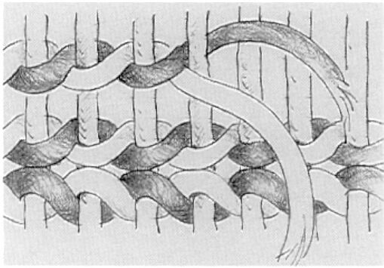

Twinning weave Twill weave

- In the space below, make a quick sketch of a well-positioned athlete ready to start a race. (5marks)

Award marks for

- Good proportions
- Described posture
- Mood expressed

- Study the package design and answer the questions that follow

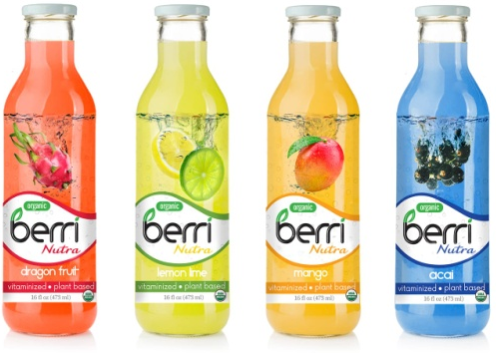

- Give any two functions of packaging design. (2marks)

- Containing and holding the product
- Protecting the product from damage
- Informing the customer about the product
- Creating brand identity to promote and help market the product.

- Analyze the above package designs with reference to
- Color (1mark)
- Eye catching and bold colors
- Color has been used uniquely according to each drink flavor
- Lettering color is consistent across all the different flavours
- Illustrations used influence the use of specific colors

- Layout (1mark)

- There’s vertical layout used in arrangement of characters
- There’s spacious placement of illustrations and types thus creating a balanced layout that is pleasing.
- There’s no congestion of characters.

- Lettering (1mark)

- Simple design of types
- Well spaced types thus enhanced readability
- Bold types thus enhanced legibility
- Correct placement of types at the centre of the design

SECTION C (15 marks)
Answer any one question in the spaces provided after question 9.

- Distinguish between a curved and a constructed sculpture. (4marks)

- In curved sculptures, relatively hard materials are used while constructed sculptures can be made by a combination of different types of materials
- Curved sculptures are continuous with no joints whereas constructed sculptures have several joints where materials are joined.
- Constructed sculpture is fragmented compared to curved which is more compact and whole
- Curving engages a subtractive process whereas construction employs an additive process.
- In curving, one block of material is used while a constructed sculpture employs use of several pieces that are joined.

- Identify five factors to consider in placement of sculptures (5marks)

- Purpose and theme of the sculpture
- Type of material used to make the sculpture
- Type of sculpture
- The size of the sculpture
- Type of audience

- Identify three qualities and three limitations of working with stone as a material for sculpture. (6marks)
Qualities
- Available in different and visually appealing colors
- Readily available in different sizes
- Can allow a wide variety of tools
- Very durable and can withstand harsh weather conditions
- Can allow a number of finishing technique

Limitations
- Stones are too bulky thus posing difficulty in transportation from source to site
- Stones are brittle thus only suitable for closed up forms that don’t have elongated extensions
- Limited to the subtraction process

- Below are three steps illustrated for a certain art printing process.

s
X Y Z
- Name and define the above technique of printing. (2marks)
- Block printing/ relief printing
- The process of transferring an impression to another surface using a raised surface.

- Name and explain the process followed in each of the above stages.
- Stage X (5marks)
- Inking the roller
- At this stage, ink is scooped and smeared and spread on an ink slab.
- Using a spatula,the ink is spread on the ink slab.
- A roller is then rolled through the ink severally so as to achieve an even layer of ink on it.

- Stage Y (4marks)
- Inking the printing block
- In this stage, the inked roller is rolled over the curved printing block
- Pick more ink from the slab using the roller and apply on the block evenly
- Pass the roller over the block surface in different direction to ensure even application of the printing ink.

- Stage Z (4marks)
- Transfer of impression
- At this stage, the block is inked and ready to transfer the impression.
- Take the working surface and lay it over the printing block.
- Using a wooden spoon, press against the back of the working surface in circular motion to ensure complete transfer of the inked impression on the working surface.
- Before removing the working surface from the block, hold it down and check whether the transfer is successful.
- Separate the two surfaces and give the impression time to dry.

- Study the composition below.

Describe how the following pictorial features have been portrayed.
Lines
- Lines have been used to outline shapes
- Lines have been used to define forms in the composition.
- Lines have also been used to create implied textures on forms e.g on the giraffe and the tree stem
Forms
A number of forms have been used to create the composition, these include
The vegetation
The giraffes
The trees
The clouds in the sky

Pattern
In the composition, there’s an exhibition of patterns on the giraffe and the shrub-like vegetation thus creating a rhythmic impression in the composition

Depth
Depth effect has been portrayed in the composition through
Overlap of shapes
Linear perspective where by there’s size reduction of forms that seem to be far from the foreground

Mood
There’s a calm and peaceful mood portrayed in the composition, depicted by the calm weather and the gracious giraffes that gracing .

