@West practice papers-2021
Kenya Certificate of Secondary Education-Mock

442/1 - ART AND DESIGN - Paper 1

NOV/DEC 2021 - 1 ½ hours
_________________________________________

Name………………………………………….………… Index Number…………………….................

Candidate’s signature…………..……..………..…..… Date……………….……………………………
_______________________________________________________________

Instructions to candidates

- Write your name and index number in the spaces provided above
- Sign and write the date of the examination in the spaces provided above.
- This paper consists of three sections A, B and C.
- Answer all questions in section A and B.
- Answer any one question in section C
- Answers to all the questions must be written in the spaces provided.
- Where drawings and diagrams are appropriate, they should be included within the text of your answers
- This paper consists of 12 printed pages.
- Candidates should check the question paper to ascertain that all the pages are printed as indicated and that no questions are missing.
- Candidates should answer the questions in English
________________________________________________________________

For Examiner’s Use Only

Section | Question | Maximum score | Score
A | 1 | 20
B | 2 | 05
 | 3 | 05
 | 4 | 05
 | 5 | 05
 | 6 | 05
C |  | 15
Max. Score Paper 1 |  | 60

SECTION A (20 marks)
Answer all the questions in this section in the spaces provided.

- Study the illustration below.
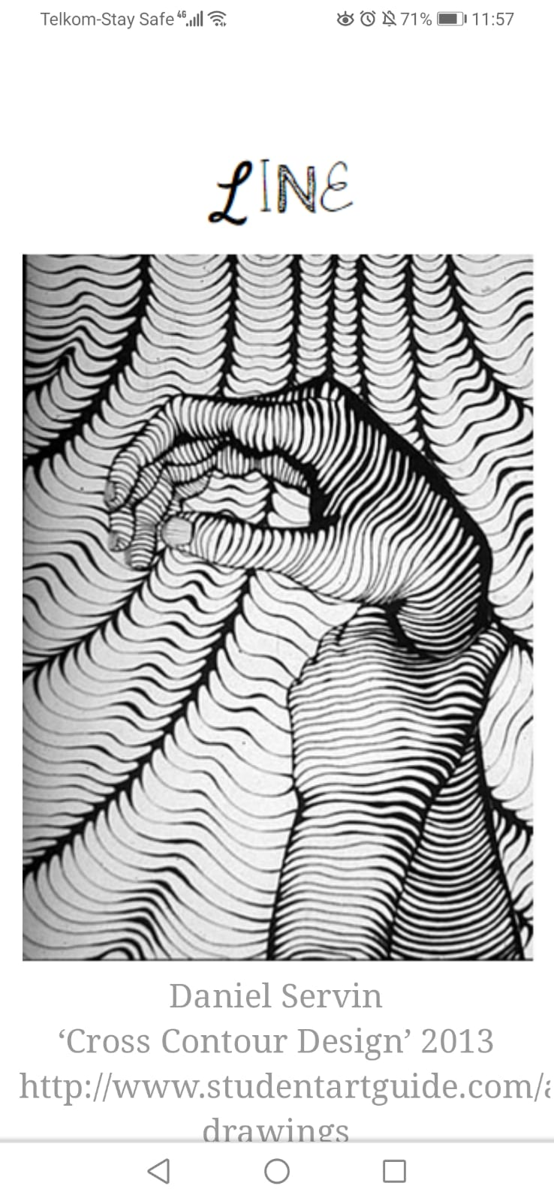

Identify the main two uses of line in the above illustration (2marks)

……………………………………………………………………………………………………………………………………………………………………………
……………………………………………………………………………………………………………………………………………………………………………
……………………………………………………………………………………………………………………………………………………………………………
- Distinguish between visual arts and performing arts. (2marks)

……………………………………………………………………………………………………………………………………………………………………………
……………………………………………………………………………………………………………………………………………………………………………
……………………………………………………………………………………………………………………………………………………………………………
……………………………………………………………………………………………………………………………………………………………………………
- Define the term ‘sketching’ (1mark)

……………………………………………………………………………………………………………………………………………………………………………
……………………………………………………………………………………………………………………………………………………………………………
……………………………………………………………………………………………………………………………………………………………………………
- Give the functional similarity between strings and wax in fabric decoration (1mark)

……………………………………………………………………………………………………………………………………………………………………………
……………………………………………………………………………………………………………………………………………………………………………
……………………………………………………………………………………………………………………………………………………………………………
- Name the two techniques used to mount pictorial compositions in art (2marks)

……………………………………………………………………………………………………………………………………………………………………………
……………………………………………………………………………………………………………………………………………………………………………
……………………………………………………………………………………………………………………………………………………………………………
- The tool illustrated below is used in batik technique of fabric decoration

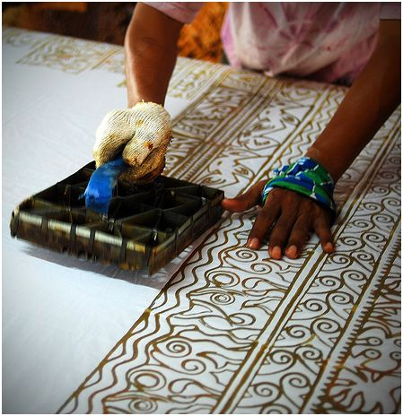

Identify the tool and state its function (2marks)
……………………………………………………………………………………………………………………………………………………………………………
……………………………………………………………………………………………………………………………………………………………………………
……………………………………………………………………………………………………………………………………………………………………………
- Explain the effect of modeling a huge papier mache sculpture without an armature (2marks)

……………………………………………………………………………………………………………………………………………………………………………
……………………………………………………………………………………………………………………………………………………………………………
……………………………………………………………………………………………………………………………………………………………………………
- Define fresco painting (2marks)

……………………………………………………………………………………………………………………………………………………………………………
……………………………………………………………………………………………………………………………………………………………………………
……………………………………………………………………………………………………………………………………………………………………………
……………………………………………………………………………………………………………………………………………………………………………
……………………………………………………………………………………………………………………………………………………………………………

- State any two factors to consider when developing a mural painting (2marks)

……………………………………………………………………………………………………………………………………………………………………………
……………………………………………………………………………………………………………………………………………………………………………
……………………………………………………………………………………………………………………………………………………………………………
……………………………………………………………………………………………………………………………………………………………………………

- Define lithography (2marks)

……………………………………………………………………………………………………………………………………………………………………………
……………………………………………………………………………………………………………………………………………………………………………
……………………………………………………………………………………………………………………………………………………………………………
……………………………………………………………………………………………………………………………………………………………………………

- Distinguish between ornaments and ornamentation (2marks)

……………………………………………………………………………………………………………………………………………………………………………
……………………………………………………………………………………………………………………………………………………………………………
……………………………………………………………………………………………………………………………………………………………………………
……………………………………………………………………………………………………………………………………………………………………………
……………………………………………………………………………………………………………………………………………………………………………
……………………………………………………………………………………………………………………………………………………………………………
SECTION B (25 marks)
Answer all the questions in this section in the spaces provided.

- Study the poster below and state five components of graphic design that make the poster to communicate effectively (5marks)

……………………………………………………………………………………………………………………………………………………………………………
……………………………………………………………………………………………………………………………………………………………………………
……………………………………………………………………………………………………………………………………………………………………………
……………………………………………………………………………………………………………………………………………………………………………
……………………………………………………………………………………………………………………………………………………………………………
……………………………………………………………………………………………………………………………………………………………………………
……………………………………………………………………………………………………………………………………………………………………………
……………………………………………………………………………………………………………………………………………………………………………
……………………………………………………………………………………………………………………………………………………………………………
……………………………………………………………………………………………………………………………………………………………………………
- Below is an illustration showing a certain process in art, study it carefully and answer the questions that follow.

- Name the above illustrated process. (1mark)

……………………………………………………………………………………………………………………………………………………………………………
……………………………………………………………………………………………………………………………………………………………………………
- State the material and equipment used in the process. (2marks)

……………………………………………………………………………………………………………………………………………………………………………
……………………………………………………………………………………………………………………………………………………………………………
……………………………………………………………………………………………………………………………………………………………………………

- Give two advantages of using the above technique over the others. (2marks)

……………………………………………………………………………………………………………………………………………………………………………
……………………………………………………………………………………………………………………………………………………………………………
……………………………………………………………………………………………………………………………………………………………………………
……………………………………………………………………………………………………………………………………………………………………………

- Study the equipment below and answer the questions that follow

- Identify the equipment (1mark)

……………………………………………………………………………………………………………………………………………………………………………
……………………………………………………………………………………………………………………………………………………………………………
- In the space below explain with aid of illustrations, the difference between twinning and twilling (4marks)

- In the space below, make a quick sketch of a well-positioned athlete ready to start a race. (5marks)

- Study the package design and answer the questions that follow

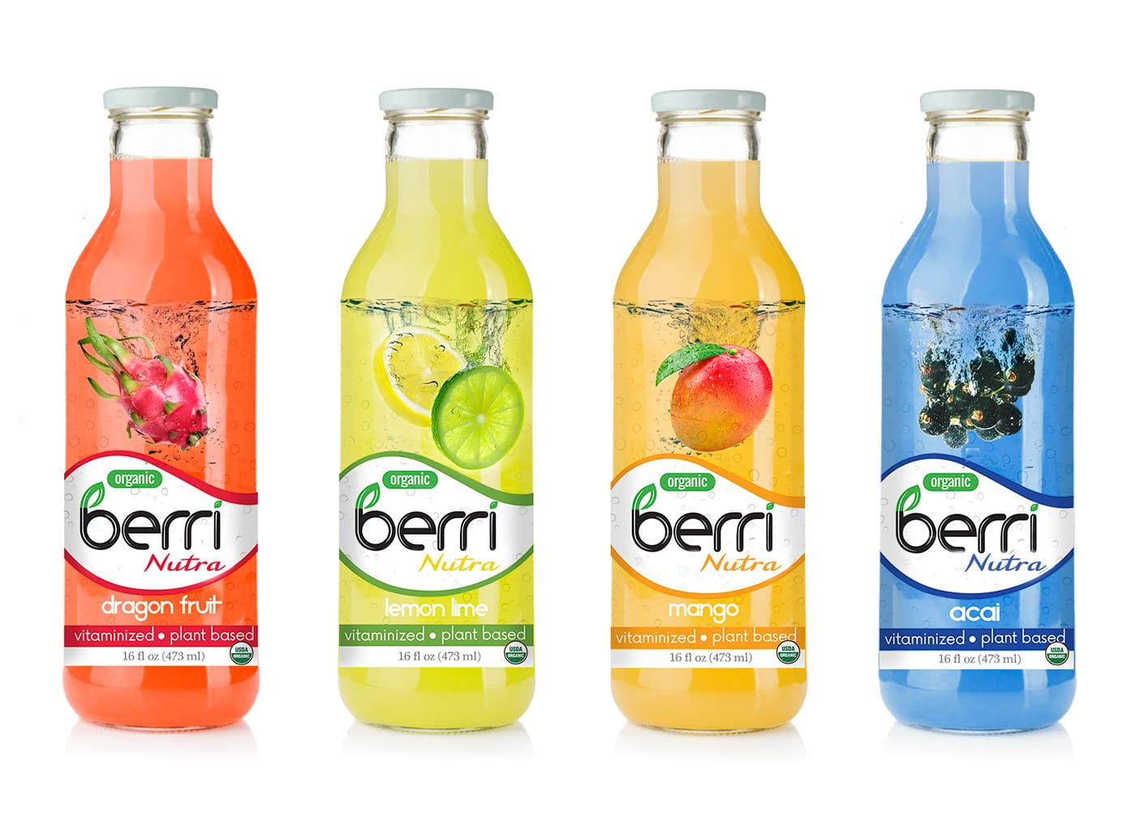

- Give any two functions of packaging design. (2marks)
……………………………………………………………………………………………………………………………………………………………………………
……………………………………………………………………………………………………………………………………………………………………………
……………………………………………………………………………………………………………………………………………………………………………
……………………………………………………………………………………………………………………………………………………………………………
- Analyze the package designs with reference to

- Color (1mark)
……………………………………………………………………………………………………………………………………………………………………………
……………………………………………………………………………………………………………………………………………………………………………
……………………………………………………………………………………………………………………………………………………………………………
- Layout (1mark)

……………………………………………………………………………………………………………………………………………………………………………
……………………………………………………………………………………………………………………………………………………………………………
……………………………………………………………………………………………………………………………………………………………………………
……………………………………………………………………………………………………………………………………………………………………………
- Lettering (1mark)

……………………………………………………………………………………………………………………………………………………………………………
……………………………………………………………………………………………………………………………………………………………………………
……………………………………………………………………………………………………………………………………………………………………………
……………………………………………………………………………………………………………………………………………………………………………

SECTION C (15 marks)
Answer any one question in the spaces provided after question 9.

- Distinguish between a curved and a constructed sculpture. (4marks)
- Identify five factors to consider in placement of sculptures (5marks)
- Identify three qualities and three limitations of working with stone as a material for sculpture. (6marks)

- Below are three steps illustrated for a certain art printing process.

X Y Z
- Name and define the above technique of printing. (2marks)
- Name and explain the process followed in each of the above stages.
- Stage X (5marks)
- Stage Y (4marks)
- Stage Z (4marks)

- Study the composition below.

Describe how the following pictorial features have been portrayed.
- Lines
- Forms
- Pattern
- Depth
- Mood

……………………………………………………………………………………………………………………………………………………………………………
……………………………………………………………………………………………………………………………………………………………………………
……………………………………………………………………………………………………………………………………………………………………………
……………………………………………………………………………………………………………………………………………………………………………
……………………………………………………………………………………………………………………………………………………………………………
……………………………………………………………………………………………………………………………………………………………………………
……………………………………………………………………………………………………………………………………………………………………………
……………………………………………………………………………………………………………………………………………………………………………
……………………………………………………………………………………………………………………………………………………………………………
……………………………………………………………………………………………………………………………………………………………………………
……………………………………………………………………………………………………………………………………………………………………………
……………………………………………………………………………………………………………………………………………………………………………
……………………………………………………………………………………………………………………………………………………………………………
……………………………………………………………………………………………………………………………………………………………………………
……………………………………………………………………………………………………………………………………………………………………………
……………………………………………………………………………………………………………………………………………………………………………
……………………………………………………………………………………………………………………………………………………………………………
……………………………………………………………………………………………………………………………………………………………………………
……………………………………………………………………………………………………………………………………………………………………………
……………………………………………………………………………………………………………………………………………………………………………
……………………………………………………………………………………………………………………………………………………………………………
……………………………………………………………………………………………………………………………………………………………………………
……………………………………………………………………………………………………………………………………………………………………………
……………………………………………………………………………………………………………………………………………………………………………
……………………………………………………………………………………………………………………………………………………………………………
……………………………………………………………………………………………………………………………………………………………………………
……………………………………………………………………………………………………………………………………………………………………………
……………………………………………………………………………………………………………………………………………………………………………
……………………………………………………………………………………………………………………………………………………………………………
……………………………………………………………………………………………………………………………………………………………………………
……………………………………………………………………………………………………………………………………………………………………………
……………………………………………………………………………………………………………………………………………………………………………
……………………………………………………………………………………………………………………………………………………………………………
……………………………………………………………………………………………………………………………………………………………………………
……………………………………………………………………………………………………………………………………………………………………………
……………………………………………………………………………………………………………………………………………………………………………
……………………………………………………………………………………………………………………………………………………………………………
……………………………………………………………………………………………………………………………………………………………………………
……………………………………………………………………………………………………………………………………………………………………………
……………………………………………………………………………………………………………………………………………………………………………
……………………………………………………………………………………………………………………………………………………………………………
……………………………………………………………………………………………………………………………………………………………………………
……………………………………………………………………………………………………………………………………………………………………………
……………………………………………………………………………………………………………………………………………………………………………
……………………………………………………………………………………………………………………………………………………………………………
……………………………………………………………………………………………………………………………………………………………………………
……………………………………………………………………………………………………………………………………………………………………………
……………………………………………………………………………………………………………………………………………………………………………
……………………………………………………………………………………………………………………………………………………………………………
……………………………………………………………………………………………………………………………………………………………………………
……………………………………………………………………………………………………………………………………………………………………………
……………………………………………………………………………………………………………………………………………………………………………
……………………………………………………………………………………………………………………………………………………………………………
……………………………………………………………………………………………………………………………………………………………………………
……………………………………………………………………………………………………………………………………………………………………………
……………………………………………………………………………………………………………………………………………………………………………
……………………………………………………………………………………………………………………………………………………………………………
……………………………………………………………………………………………………………………………………………………………………………
……………………………………………………………………………………………………………………………………………………………………………
……………………………………………………………………………………………………………………………………………………………………………
……………………………………………………………………………………………………………………………………………………………………………
……………………………………………………………………………………………………………………………………………………………………………
……………………………………………………………………………………………………………………………………………………………………………
……………………………………………………………………………………………………………………………………………………………………………
……………………………………………………………………………………………………………………………………………………………………………
……………………………………………………………………………………………………………………………………………………………………………
……………………………………………………………………………………………………………………………………………………………………………
……………………………………………………………………………………………………………………………………………………………………………
……………………………………………………………………………………………………………………………………………………………………………
……………………………………………………………………………………………………………………………………………………………………………
……………………………………………………………………………………………………………………………………………………………………………
……………………………………………………………………………………………………………………………………………………………………………
……………………………………………………………………………………………………………………………………………………………………………
……………………………………………………………………………………………………………………………………………………………………………
……………………………………………………………………………………………………………………………………………………………………………

BLANK PAGE

