TERM 2-2022
ART AND DESIGN
PAPER 1 (THEORY)
FORM FOUR (4)
TIME: 1 ½ HOURS
MARKING SCHEME

Instructions to candidates
- Write your Name, Index No, Class and Date in the spaces provided above.
- Answer all the questions in sections A and B
- Answer only one question in Section C.
- All answers should be written in the spaces provided
- Where drawings and diagrams are appropriate, they should be included within the text of your answer.
- Candidate should answer the questions in English.

SECTION | QUESTION | MAXIMUM MARKS | STUDENT’S SCORE
A | 1 | 20
B | 2-6 | 25
c | 7/8/9 | 15
TOTAL |  | 60

SECTION A: 20MKS
Answer all the questions in the questions in this section.
1. a).
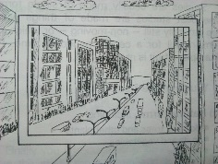
- View finder -To Identify specific area of interest in a composition while drawing
–To Isolate /block part of the composition /scenery the artist doesn’t want to appear in a drawing [2mks]
(ii)-The category of drawing above?-Townscape (1mk)
- Value as a property of colour is the degree of darkness or lightness of a colour. 1mk

- Two serigraphy printing techniques –Screen printing
-stencil [2mks]

- The ceramic decoration technique –slip and graffito, incising{any 1=1mk] 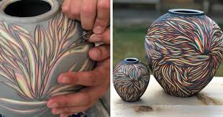
- Two reasons of firing clay items.
- -To make the articles durable and long lasting
-Make them more resistant to chemical factors such as weather
-Reduce porosity
-To enhance aesthetic value/beauty [any 2=2mks] 2mks

- Reasons of boiling wax in a double container
-Wax is flammable-to prevent it from catching fire
-To prevent wax from evaporation
-To maintain wax in a molten form and avoid solidifying
(Any 2=2mks)

- Difference between serif and san serifs in lettering, Using illustration
-Serifs-Sharp edged projection on a letter form
-San serif-letter forms wit flat edges and no sharp projections [3mks]

- Any two properties of clay.
-Hue-Property of colour that makes it differ from other colours
-Intensity-degree of saturation /purity of a colour
-Value-Lightness or darkness of a colour Any 2= 2mks]

- Identify two most outstanding elements in the painting below-Colour, lines [2mks
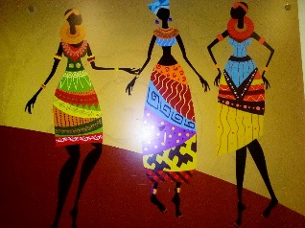

h] Asymmetrical type of balance-the type of balance where elements/objects on either side of the composition along the axis are not identical. [Any well illustrated drawing, apart from the examples below=2mks]

SECTION B
Expected to answer all the questions in the questions in this section.
2. Ornamentry-The art of making objects that enhance/adorn the appearance of a person or an object itself (2mks)
- Four factors to consider when designing ornaments
-Tools and materials
Techniques and processes
Function/purpose
-financial implications/cost/price 4mks
3. Using the word “Key’, Show, on the illustration, the following parts of a letter 2mks
(i) Xh. (ii) ½ xh.

4) The work bellow shows an art work almost in completion,
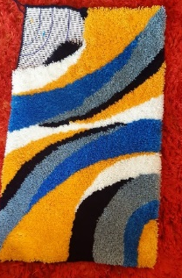

The technique used to create the weave structure above-Ghiordes knot (2mks)
- Any three visual symbols –Road signs
-Sports signs/symbols
-Factory signs
-Handling signs
-Environmental signs [any 3=3mks]

5. a) components and functions of a letterhead
-Company Logo
-Contact address
-company name
-slogan /motto [any 2-2mkss
Functions
-Identification of the company
-An official communication channel for authenticity [2mks]

- Factors to consider when using lettering in Graphic design.
-Uniformity of letter construction
-consistency in letters
-spacing between letters, words and lines
-legibility and simplicity
-suitability and relevance to the graphic communication (4mks)
6a) “wash” in reference to painting –A technique in painting where thin watery paint is applied quickly with large sweeping brush strokes on a surface to reduce absorbency during painting (2mks)
- Types of wash.
-Plain wash
-Graded wash [2mks]

SECTION C-To attempt only one question. (15 mks)
7. [A] Identify the weave structure/techniques labeled A-Horizontal twinning
B-plain/tabby/balanced weave [2mks]
A B
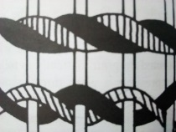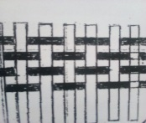

  - Sagging-weaving defect caused by loosened warps and wefts
Waisting - weaving defect on a woven article caused by uneven tension of yarns such as lose warps and too tight wefts.[3mks]

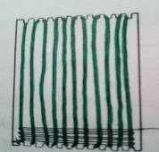

  - (i) The tool above-serrated card loom
  - Function-Used for stretching warps at tension in order to allow wefts pass through and produce a woven fabric. (2mks)
(ii)The process of preparing the device above up to warping stage.
-Obtain a stiff card board or plywood
-Mark the top and bottom edges /margins an interval of ½ a cm.
-Draw straight lines joining the marked intervals on both the top and bottom edges
- Cut the edges in a serrated zigzag form on both the top and bottom margins.
-obtain a strong yarn to be used as a warp thread.
-Tie ta knot at the start and warp the thread up to the last corner
-Tie a knot and start interlacing/weaving with a weft thread until the whole material is complete
-Do finishing techniques such as hemming, tying, knotting, etc. and use the material for its designed purpose.(=8mks)

8. a) sculpture-The art of making 3 forms to express feelings, emotions and ideas.[1mk]
b) Types of relief sculptures

-Projecting--Bas, low, medium and high relief
-Inverse relief/intaglio.
(Any 3 well explained=3mks)

  - Process of making a sculpture using papier mache
-Obtain tools and materials to use such as buckets, water, news prints and papers
-Chop/cut the papers into small sizes and soak them in a container of water for at least b2-3days
-mash /pound to a homogeneous pulp adding glue or worm wheat flour or any other adhesive
-Build/create a support/amateur) and apply the pulp in small amounts on the amateur for support
-Keep building the form until a desired size is achieved
-add details by refining the forms
-leave it to dry under a shade
-apply desired colour and leave it to dry again
-apply varnish [clear transparent vanish] depending on the purpose and leave it to dry
-Exhibit/display for critique/use it for the intended purpose [8mks]

c (ii)molding/mouding-Art and technique used to form clay and other usable objects such as sculptures using a tool-mould in order to produce several identical forms
Modelling -the art of making 3 forms using plastic materials such as clay or plastacine .2mk)

9 The Illustrations bellow represents an art and design techniques
.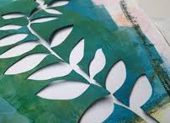 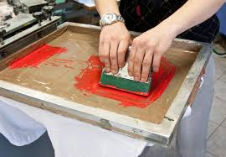
A B
- techniques A –stencil B- screen printing(2mks)
- Process of producing a design using a combination of tie-dye and any one of the above techniques.
–Obtain tools and materials such as fabrics, dyes, water, buckets, gloves, knives, etc.
-Tie the fabric into a desired pattern and technique
-mix a substantive dye to make a dye bath
-dip the fabric into a dye bath after pretreatment
-after it has absorbed enough, remove and leave it to dry under a shade.
-Obtain the stencil/silk screen with a motif of choice
-Untie, stretch and superimpose the motif,
-print the fabric until it is complete
-iron the fabric to fix it it permanently [14mks]

