School: ……………………………………………………………………..…………………….
Name: ……………………………………………………..… Adm. No.……………Class………
Sign: ………………………………. Date: ………………
442/1
ART AND DESIGN
TERM 2
FORM 4
1½HRS.
EVALUATION TEST
Kenya Certificate of Secondary Education
442/1: ART AND DESIGN
2022
1½HRS

INSTRUCTIONS
- Write your Name, Adm. No and Class in the spaces provided above.
- This paper consists of THREE Sections A, B and C.
- Answer ALL the questions in Section A and B.
- Answer any ONE question from Section C.
- All answers should be written in the spaces provided.
- Where drawings and diagrams are appropriate they should be included within the text of you answer.
- Candidate should write their answers in English.

SECTION | QUESTION | MAXIMUM  MARKS | STUDENT’S  SCORE
A | 1 (a-l) | 20
B | 2 | 05
 | 3 | 05
 | 4 | 05
 | 5 | 05
 | 6 | 05
C |  | 15
 | TOTAL | 60

This paper consists of 9 printed pages. Check to ascertain that all the pages are printed.
All the best.

Section A: (20 marks)
(Answer all the questions in the spaces provided)

- a) Study the illustration given and answer the questions that follow.
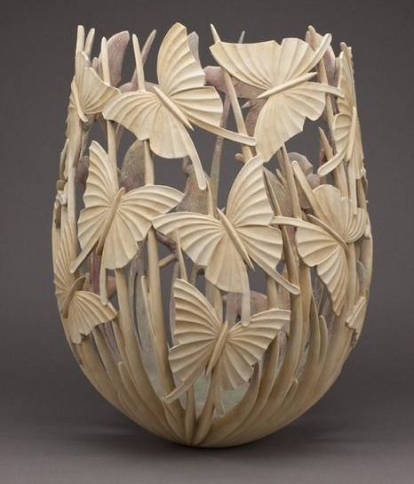

- Mention the appropriate technique that was used to produce it. (1mk)
…………………………………………………………………………………………………………………………………………………………………………………………........

- Mention any one tool and material used. (2mks)
……………………………………………………………………………………………………………………………………………………………………………………………………………………………………………………………………………………………....

b) Explain the smearing technique of drawing forms. (1mk)
………………………………………………………………………………………………………………………………………………………………………………………………………………………………………………………………………………………………………………………………………………………………………………………………………………………………
c) State and explain any material that is used in clay correction during the preparation process. (2mks)
………………………………………………………………………………………………………………………………………………………………………………………………………………………………………………………………………………………………………………………………………………………………………………………………………………………………………………………………………………………………………………………………………

d) How can ornaments be used to preserve a nation’s heritage? (1mk)
………………………………………………………………………………………………………………………………………………………………………………………………………………………………………………………………………………………………………………………………………………………………………………………………………………………………
e) Give any two factors to consider in packaging design. (2mks)
………………………………………………………………………………………………………………………………………………………………………………………………………………………………………………………………………………………………………………………………………………………………………………………………………………………………
f) State any four tools used in weaving. (2mks)
………………………………………………………………………………………………………………………………………………………………………………………………………………………………………………………………………………………………………………………………………………………………………………………………………………………………………………………………………………………………………………………………………
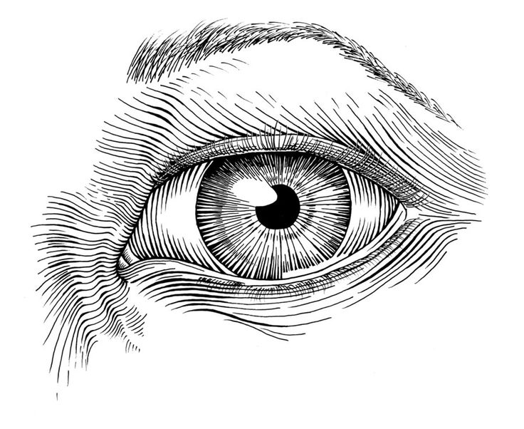
g) Study the diagram below and answer the questions that follow.

i. State the most outstanding element used in the picture. (1mk)
………………………………………………………………………………………………………………………………………………………………………………………………………………
ii. Explain one use of the above-mentioned element. (1mk)
……………………………………………………………………………………………………………………………………………………………………………………………………………………………………………………………………………………………………………………....

h) Distinguish between a monochromatic colour scheme and an analogous colour scheme. (2mks)
………………………………………………………………………………………………………………………………………………………………………………………………………………………………………………………………………………………………………………………………………………………………………………………………………………………………
i) Illustrate and state the importance of a view finder in Art. (2mks)

………………………………………………………………………………………………………………………………………………………………………………………………………………………………………………………………………………………………………………………
j) Explain the 3 techniques of making marks on a surface. (3mks)
………………………………………………………………………………………………………………………………………………………………………………………………………………………………………………………………………………………………………………………………………………………………………………………………………………………………………………………………………………………………………………………………………………………………………………………………………………………………………………………………………………………………………………………………………………………
Section B: 25mks
- a) Identify the stage and approach of drawing the illustration given is. (1mk)
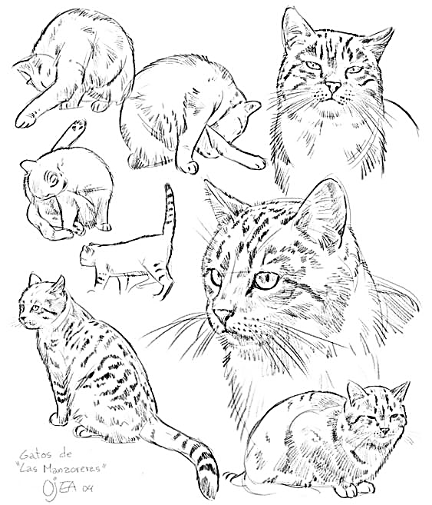

Stage…………………………………………………………………………………………………

Approach…………………………………………………………………………………………….
b) Highlight any two advantages of using the above mentioned approach and 2 disadvantages. (4mks) ………………………………………………………………………………………………………………………………………………………………………………………………………………………………………………………………………………………………………………………………………………………………………………………………………………………………………………………………………………………………………………………………………………………………………………………………………………………………………………………………………………………………………………………………………………………
- a) Differentiate between tritik and discharge technique of decorating fabric in terms of the process. (2mks)
………………………………………………………………………………………………………………………………………………………………………………………………………………………………………………………………………………………………………………………………………………………………………………………………………………………………………………………………………………………………………………………………………………………………………………………………………………………………………………

b) Explain the importance of using shellac on a silk screen as opposed to varnish. (1mk)
………………………………………………………………………………………………………………………………………………………………………………………………………………………………………………………………………………………………………………………

c) Define serigraphy as a printing process and mention two techniques used under the process.
(2mks)
………………………………………………………………………………………………………………………………………………………………………………………………………………………………………………………………………………………………………………………………………………………………………………………………………………………………………………………………………………………………………………………………………………………………………………………………………………………………………………

- a) Identify the types of illustrations shown. (3mks)

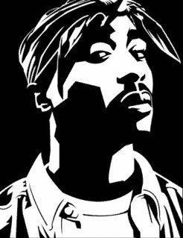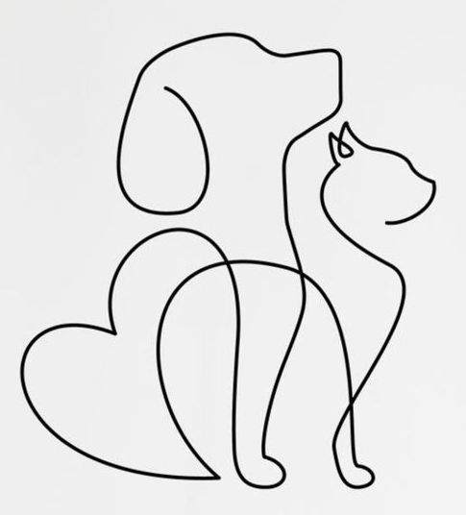

……………………………………………………………………………………………………….

b) Explain the importance of illustrations in a graphic artwork. (2mks)
………………………………………………………………………………………………………………………………………………………………………………………………………………………………………………………………………………………………………………………………………………………………………………………………………………………………

- a) Explain the mosaic technique under the following:
- support (1mk)
………………………………………………………………………………………………………………………………………………………………………………………………

- pasting (1mk)
………………………………………………………………………………………………………………………………………………………………………………………………

- materials (1mk)
………………………………………………………………………………………………………………………………………………………………………………………………
b) Outline the importance of interstices in a Mosaic artwork. (2mks)
………………………………………………………………………………………………………………………………………………………………………………………………………………………………………………………………………………………………………………………………………………………………………………………………………………………………
- a) Differentiate between visual symbols and corporate symbols. (1mk)
………………………………………………………………………………………………………………………………………………………………………………………………………………………………………………………………………………………………………………………………………………………………………………………………………………………………

b) Identify and list four components of a badge. (4mks)
………………………………………………………………………………………………………………………………………………………………………………………………………………………………………………………………………………………………………………………………………………………………………………………………………………………………………………………………………………………………………………………………………………………………………………………………………………………………………………
Section C: (15mks)
(Answer only one question in this section in the space provided after question 9)
- a) Define the batik technique. (1mk)
b) Explain how wax is molten for the batik process. Why? (2mks)
c) Discuss how you would produce a decorated fabric in 3 colours using the batik technique. (10mks)
d) Outline how to finish the fabric. (2mks)

- a) What do you understand by the term printmaking (1mk)
b) Explain the following printing techniques (8mks)
  - Relief printing
  - Intaglio
  - Serigraphy
  - Lithography
c) Mention and explain the tools used in any three techniques mentioned above. (6mks)
9. a) Discuss the following hand building techniques. (12mks)
- Slab
- Pinch
- Scoop
b) Outline the importance of: (3mks)
  - Slaking day
  - Kneading
  - Storing day

Answers.
………………………………………………………………………………………………………………………………………………………………………………………………………………………………………………………………………………………………………………………………………………………………………………………………………………………………………………………………………………………………………………………………………………………………………………………………………………………………………………………………………………………………………………………………………………………………………………………………………………………………………………………………………………………………………………………………………………………………………………………………………………………………………………………………………………………………………………………………………………………………………………………………………………………………………………………………………………………………………………………………………………………………………………………………………………………………………………………………………………………………………………………………………………………………………………………………………………………………………………………………………………………………………………………………………………………………………………………………………………………………………………………………………………………………………………………………………………………………………………………………………………………………………………………………………………………………………………………………………………………………………………………………………………………………………………………………………………………………………………………………………………………………………………………………………………………………………………………………………………………………………………………………………………………………………………………………………………………………………………………………………………………………………………………………………………………………………………………………………………………………………………………………………………………………………………………………………………………………………………………………………………………………………………………………………………………………………………………………………………………………………………………………………………………………………………………………………………………………………………………………………………………………………………………………………………………………………………………………………………………………………………………………………………………………………………………………………………………………………………………………………………………………………………………………………………………………………………………………………………………………………………………………………………………………………………………………………………………………………………………………………………………………………………………………………………………………………………………………………………………………………………………………………………………………………………………………………………………………………………………………………………………………………………………………………………………………………………………………………………………………………………………………………………………………………………………………………………………………………………………………………………………………………………………………………………………………………………………………………………………………………………………………………………………………………………………………………………………………………………………………………………………………………………………………………………………………………………………………………………………………………………………………………………………………………………………………………………………………………………………………………………………………………………………………………………………………………………………………………………………………………………………………………………………………………………………………………………………………………………………………………………………………………………………………………………………………………………………………………………………………………………………………………………………………………………………………………………………………………………………………………………………………………………………………………………………………………………………………………………………………………………………………………………………………………………………………………………………………………………………………………………………………………………………………………………………………………………………………………………………………………………………………………………………………………………………………………………………………………………………………………………………………………………………………………………………………………………………………………………………………………………………………………………………………………………………………………………………………………………………………………………………………………………………………………………………………………………………………………………………………………………………………………………………………………………………………………………………………………………………………………………………………………………………………………………………………………………………………………………………………………………………………………………………………………………………………………………………………………………………………………………………………………………………………………………………………………………………………………………………………………………………………………………………………………………………………………………………………………………………………………………………………………………………………………………………………………………………………………………………………………………………………………………………………………………………………………………………………………………………………………………………………………………………………………………………………………………………………………………………………………………………………………………………………………………………………………………………………………………………………………………………………………………………………………………………………………………………………………………………………………………………………………………………………………………………………………………………………………………………………………………………………………………………………………………………………………………………………………………………………………………………………………………………………………………………………………………………………………………………………………………………………………………………………………………………………………………………………………………………………………………………………………………………………………………………………………………………………………………………………………………………………………………………………………………………………………………………………………………………………………………………………………………………………………………………………………………………………………………………………………………………………

