TERM 2-2022
ART AND DESIGN (QUESTION PAPER)
FORM FOUR
TIME 1 ½ HRS.
PAPER 1
Name………………………………………………………………… Adm No………………………………..
School…………………………………………………………………. Class…………………………………….
Signature……………………………………………………………….. Date………………………………………
Instructions to candidates:
- Write your name and index number in the spaces provided
- This paper consists of THREE sections A, B and C.
- Answer ALL the questions in section A and B.
- Answer any ONE question in section C.
- Answers to all questions must be written in the spaces provided.
- Where drawings/diagrams are appropriate, they should be included within the context of your answers.
- The candidates should ensure that the question paper has all printed pages and no missing questions.
- Answer the questions in English

For Examiner’s use only
Section | Questions | Maximum score | Candidate’s score.
A | 1 | 20
B | 2 | 05
 | 3 | 05
 | 4 | 05
 | 5 | 05
 | 6 | 05
C |  | 15
 |  | 60

SECTION A (20MARKS)

(1) a (i) Identify the subject matter of the artwork below. (1mark)

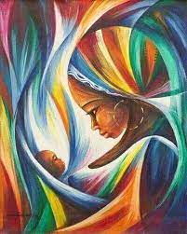
…………………………………………………………………………………………………………………..

(ii) Name the most outstanding element and principle in the art work above. (2mark)
………………………………………………………………………………………………………………………………………………………………………………………………………………………………………………………………………………………………………………………………………
(b)Differentiate tinting from shading as used in Art and Design (2mks).
………………………………………………………………………………………………………………………………………………………………………………………………………………………………………………………………………………………………………………………………………………………………………………………………………………………………………………………………………………………………………………………………………………………………………………

(c) (i)Identify the type of eye level/view in the diagram bellow. (1mark)
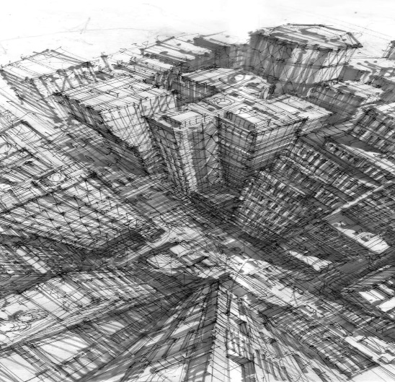

(d) Name the primary and secondary sources of Colour? (2mark)

(e) Name the art work bellow with reference to technique. (1 mark)
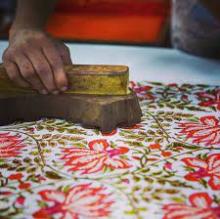………………………………………………………………………………………………………………
(f)Define a mordant and its function (2mks)
………………………………………………………………………………………………………………………………………………………………………………………………………………………………………………………………………………………………………………………………………………………………………………………………………………………………………………………………………………………………………………………………………………………………………………
(g) What differentiates shapes and forms? (2marks)
………………………………………………………………………………………………………………………………………………………………………………………………………………………………………………………………………………………………………………………………………………………………………………………………………………………………………………………………
(h) Describe the art work technique of photomontage (1marks)
……………………………………………………………………………………………………………………………………………………………………………………………………………………………
(i)what is grouting and under which art technique is it used?[1mk]………………………………………………………………………………………………………………………………………………………………………………………………………………………………

(j) In the space bellow, illustrate using letter T showing serif and san serif (2mks)

(k) Give two causes of pinholes (2marks)
………………………………………………………………………………………………………………………………………………………………………………………………………………………………

l. What is a view finder? (1mk)……………………………………………………………

…………………………………………………………………………………………………………………..

SECTION B (25MARKS)
Answer all questions from this section in the spaces provided.

2(a) Name the artwork below and identify the source of inspiration (2marks)
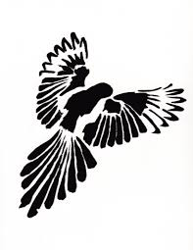
……………………………………………………………………….

……………………………………………………………………….

(b) Using the artwork above, create a mirror image in the space above (3nmks)

3(i) Name 2 ways of spacing in typography (2mks)
…………………………………………………………………………………………………………………………………………………………………………………………………………………………………………………………………………………………………………………………………………… (ii) Using any relevant drawing, create any three typographic illustrations in the space bellow (3marks)

- Study the art work composition below and answer the questions that follow:

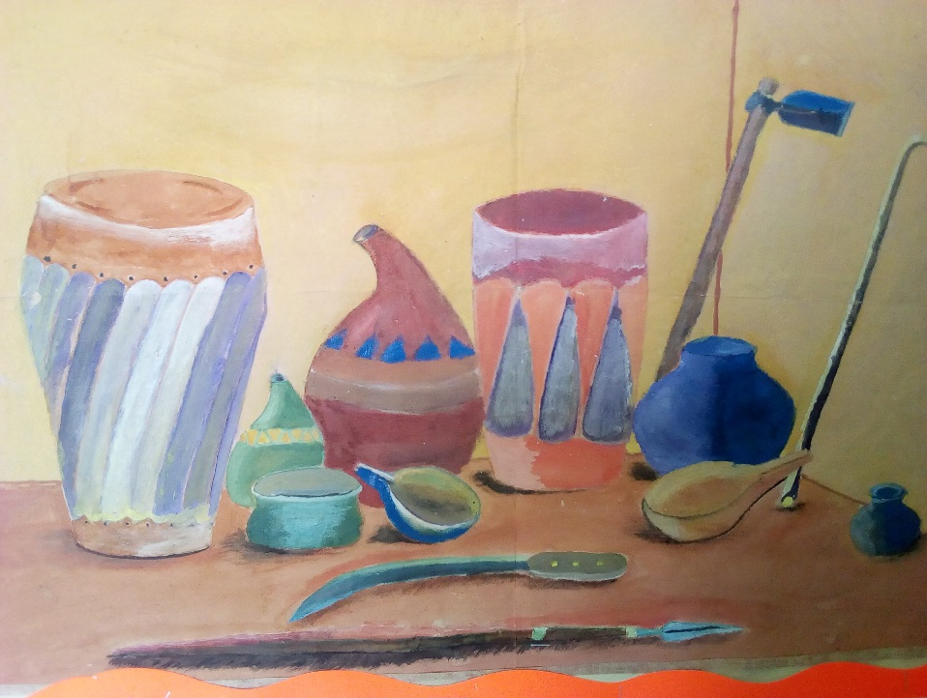

- Critique the painting with reference to elements and principles(3mks)
……………………………………………………………………………………….............
...……………………………………………………………………………………… …………………………………………………………………………………………………………………………………………………………………………………………
(b)Identify any one psychological impression and characteristics of cool and worm colours.(2mks) cool.....................................................................................................................................................................................................................................................................................................
Warm.............................................................................................................................................................

5(a) what is printing? .........................................................................................................................................................................................................................................................................................................................................................................................................................................................................................(2mark)

(b) Explain registration with reference to screen printing. (3marks)……………………………………………………………………………………………………………………………………………………………………………………………………………………………………………………………………………………………………………………………………

6. Study the art process bellow:

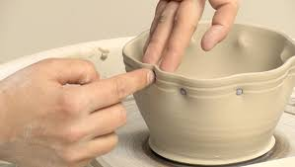
(i)Identify the decoration technique (1marks)

(ii)What is the significance of firing clay items when born dry?(2mks)…………………………………………………………………………………………………………………………………………………………………………………………………………………………………………………………………………………………
(iii)Differentiate grog from Slip(2mks)……………………………………………………………………………………………………………………………………………………………………………………………………………………………………………………………………………………………

SECTION C (15 MARKS)
Answer any one question from this section.
Write your answers in spaces provided at the back

7. (a) Differentiate warp and weft faced fabrics (4mks)
(b)What causes wasting and sagging in a weaving process (4mks)
(c)Give four ways of achieving firmness on a fabric while weaving (4mks)
(d) Give three finishing techniques in a woven mat (3mks)

8. The illustration below represents an art activity in progress
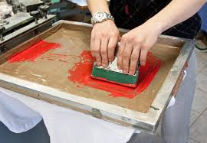
(a) State the activity illustrated/technique above. (1mark)
(b)Describe the process of producing and using the above technique (14mks)

9(a) what is a design brief? (3mks)
(b)State and describe the aspects under the following design processes:
(i) Research (4mks)
(ii) Layout (4)
(iii)Client presentation (4mks)

………………………………………………………………………………………………………………………………………………………………………………………………………………………………………………………………………………………………………………………………………………………………………………………………………………………………………………………………………………………………………………………………………………………………………………………………………………………………………………………………………………………………………………………………………………………………………………………………………………………………………………………………………………………………………………………………………………………………………………………………………………………………………………………………………………………………………………………………………………………………
………………………………………………………………………………………………………………………………………………………………………………………………………………………………………………………………………………………………………………………………………………………………………………………………………………………………………………………………………………………………………………………………………………………………………………………………………………………………………………………………………………………………………………………………………………………………………………………………………………………………………………………………………………………………………………………………………………………………………………………………………………………………………………………………………………………………………………………………………………………………………………………………………………………………………………………………………………………………………………………………………………………………………………………………………………………………………………………………………………………………………………………………………………………………………………………………………………………………………………………………………………………………………………………………………………………………………………………………………………………………………………………………………………………………………………………………………………………………………………………………………………………………………………………………………………………………………………………………………………………………………………………………………………………………………………………………………………………………………………………………………………………………………………………………………………………………………………………………………………………………………………………………………………………………………………………………………………………………………………………………………………………………………………………………………………………………………………………………………………………………………………………………………………………………………………………………………………………………………………………………………………………………………………………………………………………………………………………………………………………………………………………………………………………………………………………………………………………………………………………………………………………………………………………………………………………………………………………………………………………………………………………………………………………………………………………………………………………………………………………………………………………………………………………………………………………………………………………………………………………………………………………………………………………………………………………………………………………………………………………………………………………………………………………………………………………………………………………………………………………………………………………………………………………………………………………………………………………………………………………………………………………………………………………………………………………………………………………………………………………………………………………………………………………………………………………………………………………………………………………………………………………………………………………………………………………………………………………………………………………………………………………………………………………………………………………………………………………………………………………………………………………………………………………………………………………………………………………………………………………………………………………………………………………………………………………………………………………………………………………………………………………………………………………………………………………………………………………………………………………………………………………………………………………………………………………………………………………………………………………………………………………………………………………………………………………………………………………………………………………………………………………………………………………………………………………………………………………………………………………………………………………………………………………………………………………………………………………………………………………………………………………………………………………………………………………………………………………………………………………………………………………………………………………………………………………………………………………………………………………………………………………………………………………………………………………………………………………………………………………………………………………………………………………………………………………………………………………………………………………………………………………………………………………………………………………………………………………………………………………………………………………………………………………………………………………………………………………………………………………………………………………………………………………………………………………………………………………………………………………………………………………………………………………………………………………………………………………………………………………………………………………………………………………………………………………………………………………………………………………………………………………………………………………………………………………………………………………………………………………………………………………………………………………………………………………………………………………………………………………………………………………………………………………………………………………………………………………………………………………………………………………………………………………………………………………………………………………………………………………………………………………………………………………………………………………………………………………………………………………………………………

