ART AND DESIGN (442/1)
PAPER 1
TERM 1– 2023 OPENER
FORM FOUR (4)
TIME: 2 HOURS

NAME: ………………………………………………………...ADM NO: ……………….
SIGNATURE: ……………………………………………………..DATE: …………………...

Instructions
- Write your name and index number in the spaces provided
- This paper consists of THREE sections A, B and C.
- Answer ALL the questions in section A and B.
- Answer any ONE question in section C.
- Answers to all questions must be written in the spaces provided.
- Where drawings and diagrams are appropriate, they should be included within the context of your answers.
- The candidates should ensure that the question paper has all printed pages and no missing questions.
- Answer the questions in English

Question |  | Candidate’s score | Max Score.
SECTION A |  |  | 20mks
B |  |  | 25mks
C |  |  | 15mks
 | TOTAL SCORE |  | 60 mks

SECTION A (20MARKS)
- (a) Name the most outstanding element in the drawing below (1mk)
……………………………………………………………
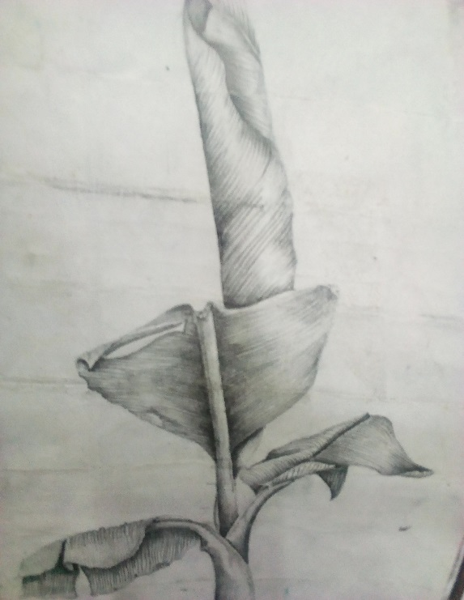

(b)Identify any two shading techniques used to create the texture depicted in the illustration above. (2marks)
…………………………………………………………………….
…………………………………………………………………….

(c) Explain the technique used to create texture on the art works bellow. (2marks)
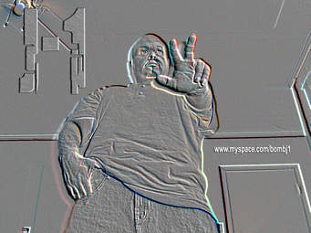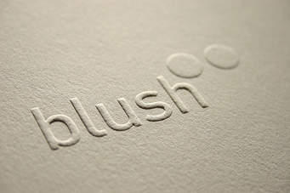
(d) State the primary and secondary sources of Colour. (1marks)

(e) Explain the collage technique with reference to materials and process. (2 marks)
………………………………………………………………………………………………………………………………………………………………………………………………………………………………………………………………………………………………………………………………………………………………………………………………………………………………………………………………
(f) State three main factors to consider when making ornaments. (3marks)
………………………………………………………………………………………………………………………………………………………………………………………………………………………………………………………………………………………………………………………………………………………………………………………………………………………………………………………………(g) Using an illustration, Distinguish between a logo and a monogram. (3marks)
………………………………………………………………………………………………………………………………………………………………………………………………………………………………………………………………………………………………………………………………………………

(h) Name the ceramic hand building techniques A and B in the process bellow (2mks) 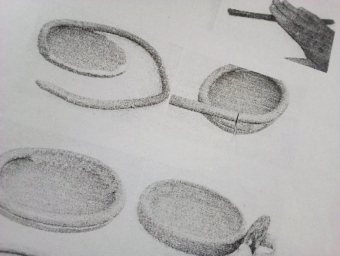 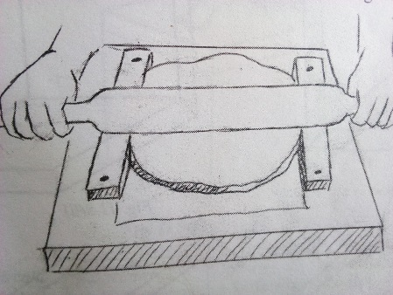
A B
………………………………… ……………………………………

(i) Identify four ceramic decoration techniques. (4marks)
………………………………………………………………………………………………………………………………………………………………………………………………………………………………………………………………………………………………………………………………………………………………………………………………………………………………………………………………

SECTION B (25MARKS)
Answer all questions from this section in the spaces provided.

- Identify the most outstanding element and principle in the illustration below. (2marks)
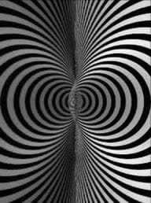

3. With the aid of well labeled illustrations, differentiate between crumpling and pleating as fabric decoration techniques (4marks)
………………………………………………………………………………………………………………………………………………………………………………………………………………………………………………………………………………………………………………………………………………………………………………………………………………………………………………………………………………………………………………………………………………………………………………………………………………………………………………………………………………………………………………………………………………………………………………………………………………………………………………………………………………………………………………………………………………………………………………………………………………………………………………………………………………………………………………………………………………………………
4. (i)Identify the type of repeat illustrated below: (1mark)
……………………………………………………………………………………………………………..
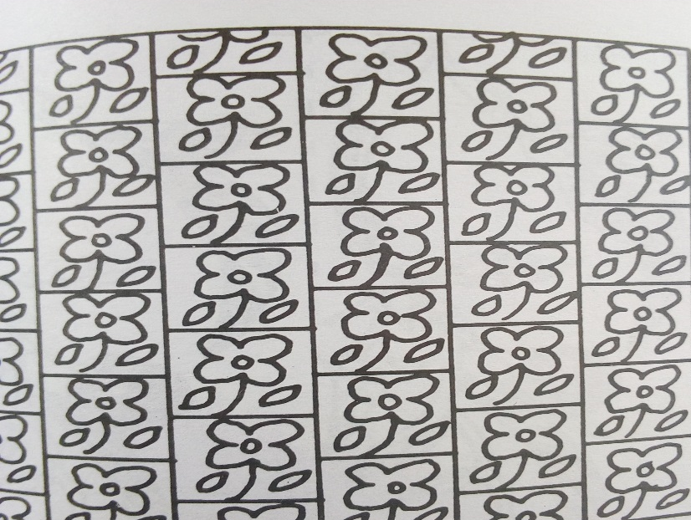
(ii)Name any other two types of repeat apart from the one named in 4(i) above. (2mks)
…………………………………………………………… …………………………………………..
(iii) In the box bellow, sketch the illustration bellow as it would appear for on a block for printing.(3mks)

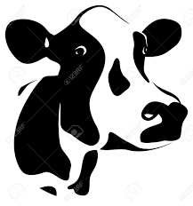

5 Differentiate symmetrical and asymmetrical balance, using relevant illustration(s) (4marks)
…………………………………………………………………………………………………………………………………………………………………………………………………………………………………………………………………………………………………………………………………………………………………………………………………………………………………………………………….

6. Study the two paintings bellow.
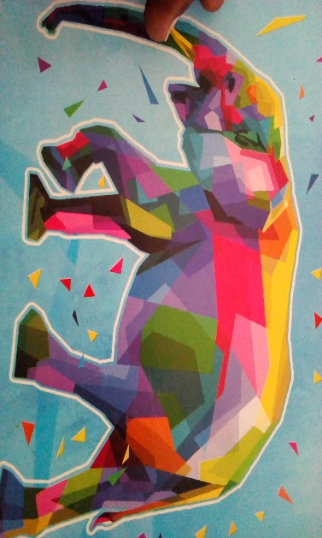
A B
- Identify and name the types of paintings A and B (2mks) ………………………………………………………………………………………………………………………………………………………………………………………………………………
- In relation to colour, State and explain the colour choice and usage that has been employed in painting B (2mks) …………………………………………………………………………………………………………………………………………………………………………………………………………………………………………………………………………………………………………………
7. a] What do you understand by the term fabric decoration? (1mks)
………………………………………………………………………………………………………………………………………………………………………………………………………………………………………………………………………………………………………………………………………………(b) Explain any four functions of decorated fabrics. (4marks)
………………………………………………………………………………………………………………………………………………………………………………………………………………………………………………………………………………………………………………………………………………………………………………………………………………………………………………………………………………………………………………………………………………………………………………………………………………………………………………………………………………………………………………………………………………………………………………………………………………………………………………………………………………………………………………………………………………………………………………………………………………………………………………………………………………………………………………………………………………………………

SECTION C (15 MARKS)
Answer any one question from this section.
Write your answers in spaces provided after question 10.

- The illustration below is an art work.
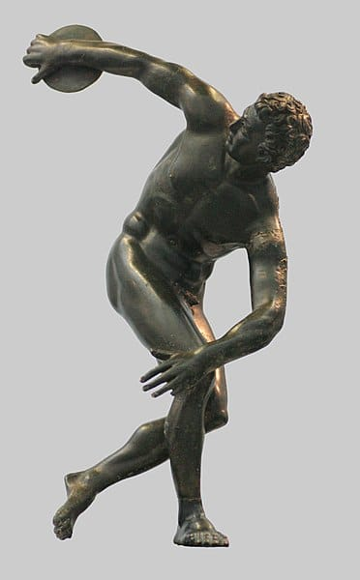
(a) Name the type of art work. (1mark)
(b) .Name any other types of the same art work apart from the one above (2marks)
(c) Name any four techniques that can be used to create the art work above (3mks)
(d) Describe the process of building up a form using the technique either papier mache of fibre. (9marks)

- (a)Define serigraphy (2marks)
(b) Briefly explain the process of block printing (5mks)
(c)Explain any two serigraphy technique of printing: (8mks)

10. a] Explain throwing as a ceramic hand building technique (5mks)
b] Describe how pyro metric cones work in firing clay items using an electric kiln (4mks)
c] Outline the process of firing bone dry clay items using the open firing process. (6mks)

………………………………………………………………………………………………………………………………………………………………………………………………………………………………………………………………………………………………………………………………………………………………………………………………………………………………………………………………………………………………………………………………………………………………………………………………………………………………………………………………………………………………………………………………………………………………………………………………………………………………………………………………………………………………………………………………………………………………………………………………………………………………………………………………………………………………………………………………………………………………
………………………………………………………………………………………………………………………………………………………………………………………………………………………………………………………………………………………………………………………………………………………………………………………………………………………………………………………………………………………………………………………………………………………………………………………………………………………………………………………………………………………………………………………………………………………………………………………………………………………………………………………………………………………………………………………………………………………………………………………………………………………………………………………………………………………………………………………………………………………………………………………………………………………………………………………………………………………………………………………………………………………………………………………………………………………………………………………………………………………………………………………………………………………………………………………………………………………………………………………………………………………………………………………………………………………………………………………………………………………………………………………………………………………………………………………………………………………………………………………………………………………………………………………………………………………………………………………………………………………………………………………………………………………………………………………………………………………………………………………………………………………………………………………………………………………………………………………………………………………………………………………………………………………………………………………………………………………………………………………………………………………………………………………………………………………………………………………………………………………………………………………………………………………………………………………………………………………………………………………………………………………………………………………………………………………………………………………………………………………………………………………………………………………………………………………………………………………………………………………………………………………………………………………………………………………………………………………………………………………………

