TERM 1-2023 END TERM EXAM

442/1 - F3 ART AND DESIGN. - PAPER 1
NAME....................................................................... ADMIN NO............................................................
Candidate’s signature………..………………………………Date………………………..…………….......
PAPER 1-THEORY
1 ½ HRS.
Instructions to candidates:
- Write your name and index number in the spaces provided
- This paper consists of THREE sections A, B and C.
- Answer ALL the questions in section A and B.
- Answer any ONE question in section C.
- Answers to all questions must be written in the spaces provided.
- Where drawings/diagrams are appropriate, they should be included within the context of your answers.
- The candidates should ensure that the question paper has all printed pages and no missing questions.
- Answer the questions in English

For Examiner’s use only
Section | Questions | Maximum score | Candidate’s score.
A | 1 | 20
B | 2 | 05
 | 3 | 05
 | 4 | 05
 | 5 | 05
 | 6 | 05
C |  | 15
 |  | 60

SECTION A (20MARKS)
- (a) Differentiate drawing and painting. (2marks)
………………………………………………………………………………………………………………………………………………………………………………………………………………………………………………………………………………………………………………………………………………………………………………………………………………………………………………………………………………………………………………………………………………………………………………
(b) (i) Identify the drawing principle depicted in the illustration below. (1mark)

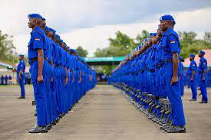

(ii) Give any other two techniques that can be used in showing depth/illusion apart from one above (2mark)
………………………………………………………………………………………………………………………………………………………………………………………………………………………………………………………………………………………………………………………………………………
(c) Explain any two types of relief sculpture. (2marks)
………………………………………………………………………………………………………………………………………………………………………………………………………………………………………………………………………………………………………………………………………………………………………………………………………………………………………………………………………………………………………………………………………………………………………………
(d) What are primary Colours? (1mark)

(e) Explain the art work bellow with reference to technique and process. (2 marks)
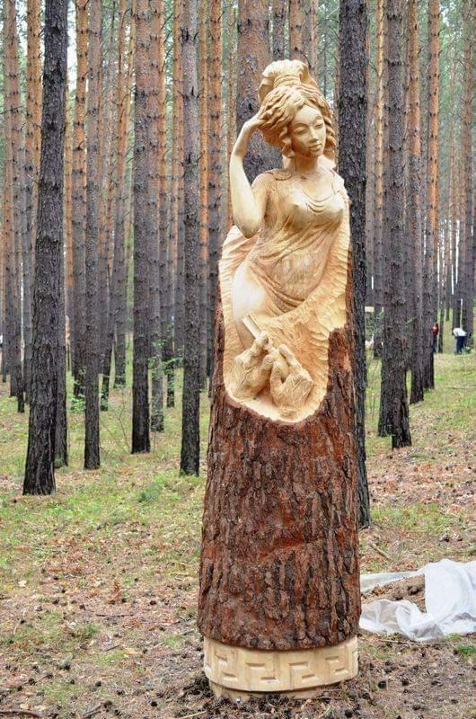………………………………………………………………………………………………………………………………………………………………………………………………………………………………………………………………………………………………………………………………………………………………………………………………………………………………………………………………
(f) State three factors to consider when placing the art work above. (1½ marks)
………………………………………………………………………………………………………………………………………………………………………………………………………………………………………………………………………………………………………………………………………………………………………………………………………………………………………………………………
(g) What differentiates burnishing from embossing as ceramic decoration techniques? (2marks)
………………………………………………………………………………………………………………………………………………………………………………………………………………………………………………………………………………………………………………………………………………………………………………………………………………………………………………………………
(h) Distinguish between “mosaic and collage”. (2marks)
………………………………………………………………………………………………………………………………………………………………………………………………………………………………………………………………………………………………………………………………………………………………………………………………………………………………………………………………
(i) With the aid of illustrations, differentiate between X, and 1 ½ xh.in lettering (1 ½ marks)

(j) What is a print. (1mark)
………………………………………………………………………………………………………………………………………………………………………………………………………………………………………………………………………………………………………………………………………………………………………………………………………………………………………………………………
(k) Name two techniques of tie and dye as a fabric decoration technique. (2 mark)
………………………………………………………………………………………………………………………………………………………………………………………………………………………………………………………………………………………………………………………………………………………………………………………………………………………………………………………………

SECTION B (25MARKS)
Answer all questions from this section in the spaces provided.

- (i)The illustration bellow shows a type human figure drawing. Create a mirror image to show symmetrical balance. (4marks)
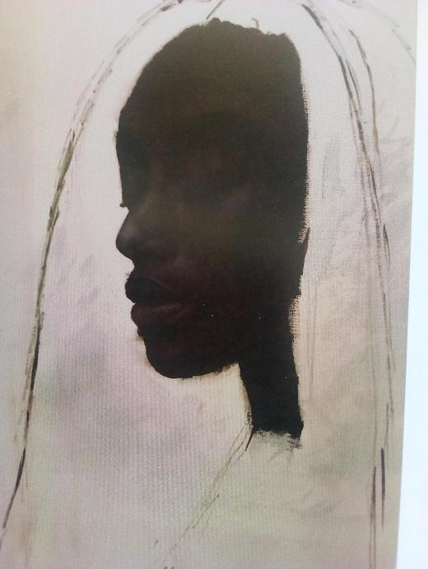
(ii) Using any illustration, show any other one type of balance apart from the one answered above (2marks)

- Study the art work illustration below and answer the questions that follow:
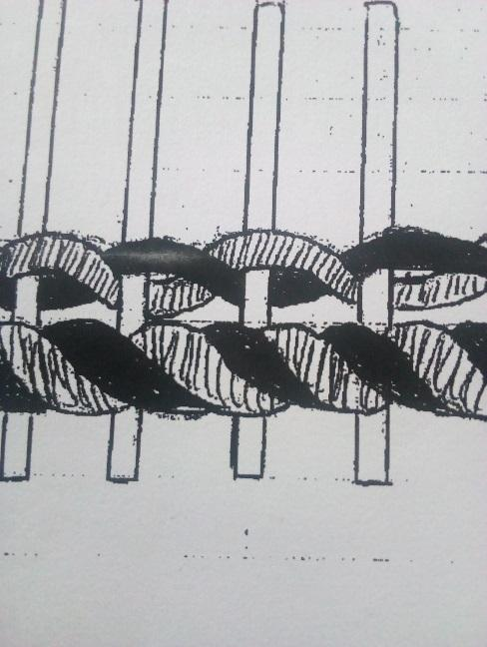
- Identify the art work ………………………………………………………………………………………........ (1mark)
- Specify the technique ………………………………………………………………………………………(1mark)
- List any other two techniques that can be used in the same art work (2mks) ..........................................................................................................................................................................................................................................................................................................................................................................................................................................................
……………………………………………………………………………… (2mark)
(iii)What is a loom? ..................................................................................................................................................................................................................................................................................................................................(1mk)

- Using Illustratioins,draw and label the elements of a sculpture.(6marks)

(b) What is an adze and in which art work/activity is it used’ (2marks)
………………………………………………………………………………………………………………………………………………………………………………………………………………………………………………………………………………………………………………………………………………………………………………………………………………………

- Study the artwork bellow and answer the questions(5marks)
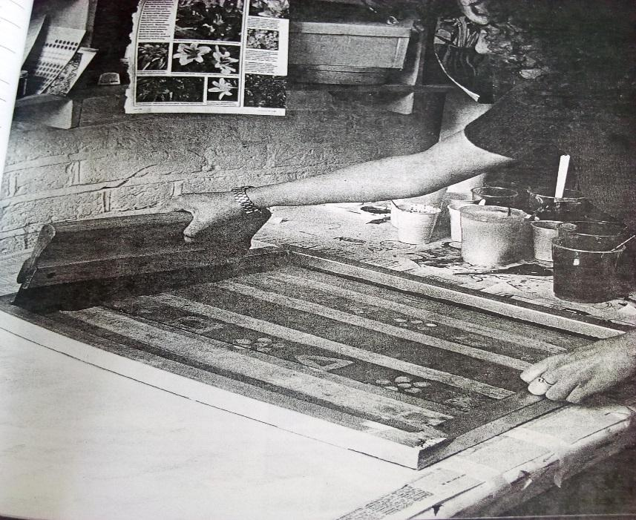
(i) Identify the activity and art work above (2marks) ………………………………………………………………………………………………………………………………………………………………………………………………………………………………………………………………………………………………………………………………………………………………………………………………………………………………………………………………
(ii)Identify and explain any other one fabric decoration techniques in same the art work above (1marks)
…………………………………………………………………………………………………………………………………………………………………………………………………………………………………………………………………………………………………………………………………………………………………………………………………………………………………………………………………………………………………………………………………………………………………………………………………………………………………………………………………………………………… .(iii)Give one Aesthetic function of decorated fabrics. (1mark) ………………………………………………………………………………………………………………………………………………………………………………………………………………………………

- (a) Using the space provided on the last page/back page, draw “a lady admiring her beauty in a mirror”. (10marks)

SECTION C (15 MARKS)
Answer any one question from this section.
Write your answers in spaces provided after question 9.

7. The illustration below represents an activity within the process of hand building technique.
(a) Identify the technique that could have been used. (1mark)
(b)Give the reasons why the material used appears cracked. (4marks)
(c) Give different steps how the above problem could have been avoided(5mks)
(d)Beginning with ready prepared clay, describe the process of building up a form using the technique above (5marks)
8(a) Define weaving. (2marks)
(b) Briefly explain three techniques of weaving. (3marks)
(c) Clearly explain the processes involved preparation of.
(i) A serrated card loom. (6marks)
(ii) Frame loom.
(4marks)
9. Define fabric decoration (1mk)
(b) List any 6 fabric decoration techniques (3mks)
(c) Explain the process of batik (9mks)
(d) List any three utilitarian functions of batik as a decorated fabric (3mks)

………………………………………………………………………………………………………………………………………………………………………………………………………………………………………………………………………………………………………………………………………………………………………………………………………………………………………………………………………………………………………………………………………………………………………………………………………………………………………………………………………………………………………………………………………………………………………………………………………………………………………………………………………………………………………………………………………………………………………………………………………………………………………………………………………………………………………………………………………………………………
………………………………………………………………………………………………………………………………………………………………………………………………………………………………………………………………………………………………………………………………………………………………………………………………………………………………………………………………………………………………………………………………………………………………………………………………………………………………………………………………………………………………………………………………………………………………………………………………………………………………………………………………………………………………………………………………………………………………………………………………………………………………………………………………………………………………………………………………………………………………………………………………………………………………………………………………………………………………………………………………………………………………………………………………………………………………………………………………………………………………………………………………………………………………………………………………………………………………………………………………………………………………………………………………………………………………………………………………………………………………………………………………………………………………………………………………………………………………………………………………………………………………………………………………………………………………………………………………………………………………………………………………………………………………………………………………………………………………………………………………………………………………………………………………………………………………………………………………………………………………………………………………………………………………………………………………………………………………………………………………………………………………………………………………………………………………………………………………………………………………………………………………………………………………………………………………………………………………………………………………………………………………………………………………………………………………………………………………………………………………………………………………………………………………………………………………………………………………………………………………………………………………………………………………………………………………………………………………………………………………………………………………………………………………………………………………………………………………………………………………………………………………………………………………………………………………………………………………………………………………………………………………………………………………………………………………………………………………………………………………………………………………………………………………………………………………………………………………………………………………………………………………………………………………………………………………………………………………………………………………………………………………………………………………………………………………………………………………………………………………………………………………………………………………………………………………………………………………………………………………………………………………………………………………………………………………………………………………………………………………………………………………………………………………………………………………………………………………………………………………………………………………………………………………………………………………………………………………………………………………………………………………………………………………………………………………………………………………………………………………………………………………………………………………………………………………………………………………………………………………………………………………………………………………………………………………………………………………………………………………………………………………………………………………………………………………………………………………………………………………………………………………………………………………………………………………………………………………………………………………………………………………………………………………………………………………………………………………………………………………………………………………………………………………………………………………………………………………………………………………………………………………………………………………………………………………………………………………………………………………………………………………………………………………………………………………………………………………………………………………………………………………………………………………………………………………………………………………………………………………………………………………………………………………………………………………………………………………………………………………………………………………………………………………………………………………………………………………………………………………………………………………………………………………………………………………………………………………………………………………………………………………………………………………………………………………………………………………………………………………………………………………………………………………………………

