ART AND DESIGN (442/1)
PAPER 1
TERM 1– 2023 OPENER
FORM FOUR (4)
TIME: 2 HOURS
MARKING SCHEME

Instructions
- Write your name and index number in the spaces provided
- This paper consists of THREE sections A, B and C.
- Answer ALL the questions in section A and B.
- Answer any ONE question in section C.
- Answers to all questions must be written in the spaces provided.
- Where drawings and diagrams are appropriate, they should be included within the context of your answers.
- The candidates should ensure that the question paper has all printed pages and no missing questions.
- Answer the questions in English
Total marks/60

SECTION A (20 MARKS)
- (a) The most outstanding element in the drawing bellow (1mk)
……Tone/value
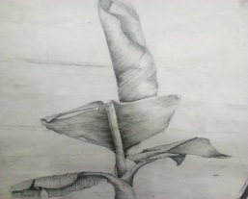

(b)Two shading techniques used to create the texture depicted in the illustration above.
Hatching
Smooth/soft/Blok shading
Smudging. (Any 2=2marks)

(c) The technique used to create texture on the art works bellow. Embossing-a relief item of the same design is pressed/stamped heavily on the surface being designed to come up with the impressions (2marks)
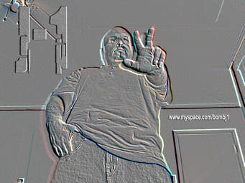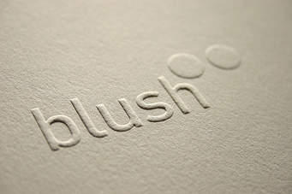
(d) Primary and secondary sources of Colour.
Primary-light
Secondary-pigment (1/2 =1marks)

(e) Explain the collage technique with reference to materials and process. (2 marks)
…Collage is a decorative technique of artwork where composition is created by different textured materials pasted onto the support with a strong adhesive.

(f) Three main factors to consider when making ornaments.
Function/purpose
Tools and materials
Techniques and processes (3marks)

(g) Using an illustration, Distinguish between a logo and a monogram. (3marks)
…Logo is a symbol or design adopted/used by an organization to identify itself/its products and distinguish from others, e.g. NTV, TBC, Standard Chartered bank’s SC, Volks wagon logo, etc.
While a monogram is extracted from initial persons abbreviated/interwoven and interlocked names/letters e.g. BMW.

(h) The ceramic hand building techniques A and B in the process bellow (2mks) 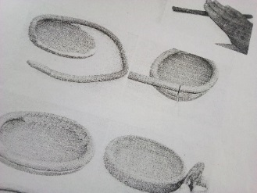 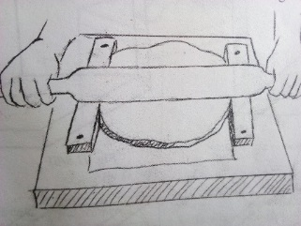
A B
Coiling Slab

- Four ceramic decoration techniques.
Inlaying, Incising Excising, Sgarffito
Burnishing, Embedding, Slip trailing (Any 4=4marks)

SECTION B (25 MARKS)
Required to answer all questions from this section in the spaces provided.

- The most outstanding element and principle in the illustration below. (2marks)
Rhythm and movement
3. With the aid of well labeled illustrations, differentiate between crumpling and pleating as fabric decoration techniques (4marks)
Crumpling-the fabric is folded and marbled in a careless manner and tied, dyed to produce marbled effect while in pleating, the fabric is planned and folded at regular lined intervals
4. (i)The type of repeat illustrated below: (1mark)
Half drop repeat.
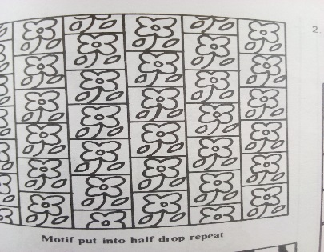
(ii)Name any other two types of repeat apart from the one named in 4(i) above
Full drop,
Full repeat
Inverse . (Any 2=2mks)
(iii) In the box bellow, sketch the illustration bellow as it would appear for on a block for printing. (3mks)

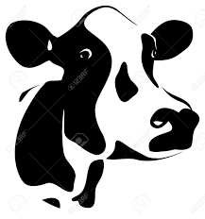
The above shape/motif should be facing to the left,
Preferable positive spaces(Black)shaded while negative unshaded since they are scooped on the block

5 Differentiate symmetrical and asymmetrical balance, using relevant illustration(s) (4marks)
…Elements on either side of the axis are balanced in an identical manner in a mirror image while in asymmetrical balance, the elements on either sides are not identical.

e.g.

Symmetrical Asymmetrical
6 .The type of paintings bellow:
. 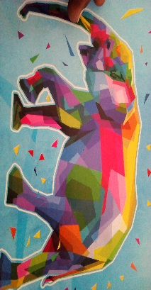
Silhouette painting Abstract painting. (2marks)
b] Subjective colours..-Own choice colours with one’s own interpretation, and opinion not necessarily as it appears in real life. E.g. painting a real life elephant would be gray or somewhat blackish., here, own choice of abstract colours have been employed, eg painting an ocean red when in real life its blue, grass pink or purple when its green, etc.[stating subjective-1mk,well explained-1mk =2mks]
7. a] what do you understand by the term fabric decoration? (1mks)
…The patterning of an essentially plain fabric to render it more appealing in order to serve a particular purpose.
(b) Explain any four functions of decorated fabrics.
…Aesthetics-Beauty and decoration, Religious; Economic. Cultural, Political, Social, Professional [any 4 well explained=4mks]

SECTION C (15 MARKS)
Students to answer any one question from this section.

- The illustration below is an art work.
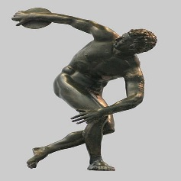
(a) The type of art work. Sculpture in round (1mark)
(b) Any two types of the same art work apart from the one above- Relief sculpture-Projecting,-high relief, low, bas, inverse, etc. (1mark)
(c) Any 4 techniques that can be used to create the art work above
-Casting
Molding
Construction
Curving (4mks)
(d) The process of building up a form using the technique either papier mache of fibre. (9marks)
-Obtain the necessary tools and materials-buckets, news prints and other soft papers and magazines
-Soak the papers in a bucket of water and let them stay for two-three days
-Construct an armature for supporting the sculptural form
-Drain the water and Mash the pulp to paste consistency
-Add a strong adhesive such as wheat flour or glue
-Apply the news print using glue onto the armature as a base
-Apply the mashed pulp following the form and considering the elements and principles such as voids, solids, contours, balance, proportions, etc
-continue building up the form up to completion
-Leave it dry under shade
-Apply any other finishing techniques necessary such as varnishing, painting, etc
-Mount and place to the required location. [9 mks]

- (a)Serigraphy-Printing technique where an image is transferred from a surface through cut out stencils/screen to another surface (2marks)

(b) Briefly explain the process of block printing
-Get the tools and materials-chisels, knives and blades, linoleum blocks, rubbers
-Design the motifs to be used
-Transfer the design on to the block in a reverse [left side right]
-cut out the negative spaces leaving the positives projecting
-Obtain the printing surface
-Apply ink/paints on to the cut out block using a roller
-Print the image onto the surface to obtain the required design [5mks]

(c) Explain any two serigraphy technique of printing: (8mks)
Either silk screen printing or
Stencil, The student explains clearly the chronological order of the technique picked from the motif up to transfer on to the stencil/screen up to the printing process
[Well explained steps and stages=8mks]
- a] Explain throwing as a ceramic hand building technique (5mks)
-Ready prepared clay is placed on a rotating device (Potter’s wheel) by centering it
-A pinch is done in the center of clay either using a thumb, fist or elbow depending on the size to be worked on.
-Either a kick wheel or electric powered, it is rotated in between the hands where thickness is regulated by thumbs
-pulling helps in building up the item as it rotates while pushing it down widens it.
-Regularly it is smoothened using a sponge or any wet material to reduce on friction between the hand sand clay items being worked on.
-Any further designs and decoration techniques can be made as the piece is complete
-It is then removed from the base of the potter’s wheel using either a thin wedging wire or sharp tool like a knife and left to dry.[Well stated =5ms]

b] Describe how pyro metric cones work in firing clay items using an electric kiln (4mks)
Pyro metric cones are triangular-like devices inside an electric kiln used to determine the readiness of ceramic items being fired,
When temperatures rise in the oven/kiln, the first cone bends, showing firing in progress
-As the ceramic articles get fired and ready, the 2nd cone also bends, warning the potter of the article’s readiness
-this then means the articles are ready and heat should be turned off from the source
-The third cone shouldn’t be left to bend lest the articles overfired and burn completely. [4mks]

c] Outline the process of firing bone dry clay items using the open firing process.
-Dig a shallow pit
-Arrange wood/stick/twigs/straws/dry grass in the pit
-Arrange the clay items starting with the big ones, pile up as you put the small ones.
-Cover the clay items with grass/twigs
-Light the fire and let it burn till all the firewood is consumed
-Let it cool, remove from the pit. [6mks]

