TERM 1-2023

442/1 - F3 ART AND DESIGN. - PAPER 1
MARKING SCHEME
END OF TERM 1-2023
PAPER 1-THEORY
1 ½ HRS.
Instructions to candidates:
- Write your name and index number in the spaces provided
- This paper consists of THREE sections A, B and C.
- Answer ALL the questions in section A and B.
- Answer any ONE question in section C.
- Answers to all questions must be written in the spaces provided.
- Where drawings/diagrams are appropriate, they should be included within the context of your answers.
- The candidates should ensure that the question paper has all printed pages and no missing questions.
- Answer the questions in English

For Examiner’s use only
Section | Questions | Maximum score | Candidate’s score.
A | 1 | 20
B | 2 | 05
 | 3 | 05
 | 4 | 05
 | 5 | 05
 | 6 | 05
C |  | 15
 |  | 60

SECTION A (20MARKS)
- (a) Difference between drawing and painting. (2marks)
Drawing-the technique of producing images on a surface y making marks using tools such as graphite pencil, crayons, charcoal, chalk, etc. while
Painting is the art and technique of producing images using color pigments usually wet paints to express ideas, emotions and feelings
(b) (i) The drawing principle depicted in the illustration below Perspective (illusion of depth created by distance). (1mark)

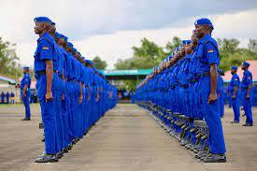

(ii)Give any other two techniques that can be used in showing depth/illusion apart from one above. (2mark)
Foreshortening,
Overlapping features,
(c) Explain any two types of relief sculpture. (2marks)
-Projecting relief-rises from the base outwards
-Inverse/sunken relief (Intaglio)-the impression is scooped/cured inwards into the base.
(d) primary Colours (1mark)
The first three colors in the core of the color wheel that are pure and original and can’t be obtained by mixing any other colors.
(e) Explain the art work bellow with reference to technique and process. (2 marks)
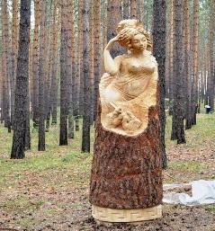-Sculpture in the round-created by curving as a technique.
(f) Three factors to consider when placing the art work above. (1½ marks)
-The materials used
-The function/purpose of the sculpture
-The target audience/population
-The location-should be visible (complimentary to the surrounding environs and not hidden/contrasting/ camouflaged.
(g) Difference of burnishing from embossing as ceramic decoration techniques (2marks)Burnishing is the use of smooth textured object to rub and decorate the leather hard ceramic articles while embossing is pressing into a leather hard ceramic article with a relief/raised design to create the same impression onto the ceramic article
…
(h) Distinguish between “mosaic and collage”. (2marks)
Mosaic-a decorative art work/technique of pasting/embedding cutout pieces tesseraes of the same type) on a surface sing an adhesive to create a composition
Collage-using tesseraes of different types to create a composition.
(i) With the aid of illustrations, differentiate between X, and 1 ½ xh.in lettering (1 ½ marks)
boy xh the descenders and ascenders above the two lines occupy ½ xh.

(j) a print (1mark)
_ A duplicated image/a mark made on a surface.
(k) Name two techniques of tie and dye as a fabric decoration technique. (2 mark)
Pleating, crumpling, circles, embroidery/stitching, bound objects, etc (any 2-2mks)
SECTION B (25MARKS)
Answer all questions from this section in the spaces provided.

- (i)The illustration bellow shows a type human figure drawing. Create a mirror image to show symmetrical balance. (4marks)-The image should be inverted to the right in an identical size and shape.
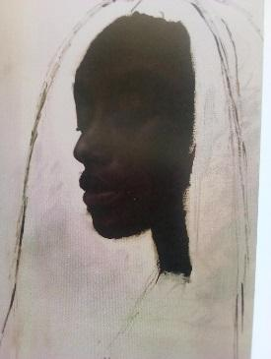
(ii) Using any illustration, show any other one type of balance apart from the one answered above (2marks)-Illustration for either asymmetrical or radial balance (2mks)

- Study the art work illustration below and answer the questions that follow:
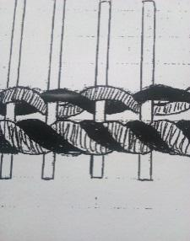
- Identify the art work ……weaving(1mark)
- Specify the technique …Horizontal tinning(1mark)
- Any other two techniques that can be used in the same art work ...Plain/tabby weave, Ghiordes knot, circular twinning, twilling/twill weave.( any 2-2mark)
(iii)A loom .a weaving tool/device through which warp threads ae stretched at tension in order to allow weft threads pass through and produce a woven fabric(1mk)
- Using Illustratioins,draw and label the elements of a sculpture.(6marks)
Well drawn abstract/semi abstract showing the elements of voids, solids, contours, planes and texture (6mrks)
(b) An Adze and in which artwork is it used?’ (2marks)-A mattock-shaped like tool used in sculpture in curing
- Study the artwork bellow and answer the questions(5marks)
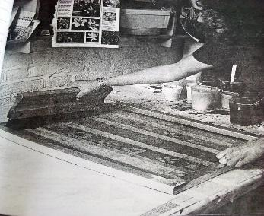
(i) Identify the activity and art work above (2marks) Silk screen printing.
(ii)Identify and explain any other one fabric decoration techniques in same the art work above (1marks) Stencil printing-using cutout stenciled material and using it to print., Block printing-curving in/out the impression on a Lino or rubber block and the impression used for printing.… .
(iii) one Aesthetic function of decorated fabrics. (1mark)
Decoration, wall hanging, curtains,(any other relevant aesthetic value-1mk)
- (a) Using the space provided on the last page/back page, draw “a lady admiring her beauty in a mirror”. (10marks)
Shape/form-3mks
Proportions and posture-in a mirror-3mks
General Use of elements/principles-balance, texture, tone-3mks
Personal quality and neatness-1mk

SECTION C (15 MARKS)
Answer any one question from this section.
Write your answers in spaces provided after question 9.

7. The illustration below represents an activity within the process of hand building technique.
(a) The technique used. (1mark)Pinching
(b)reasons why the material used appears cracked. (4marks)
Poor and low quality/ type of clay
Poor and substandard preparation processes
Presence of other foreign bodies like stones, leaves, grass and roots
Instant exposure to heat and sun
- different steps how the above problem could have been avoided(5mks)
Proper Slaking, mixing, kneading/wedging and storing.
(d)Beginning with ready prepared clay, description of the process of building up a form using the technique above (5marks)
-take a lump of wedged and kneaded clay and roll it into a required size
-hold the lump into the thumb and push a thumb into the middle of the lump of clay to create a hollow
-gently shape the clay into a required form making sure the walls of the hollow remain even.
-continue making the form until the required shape and form is achieved.
-put the completed form aside and not exposed to direct sunlight to avoid sporadic drying as it will crack
-when partially dry but still at the leather hard state, decorate
-allow it to completely dry before firing
-fire the article in a kiln.
8(a) Weaving.-the process of interlacing a set of vertical threads (warps) with another set of horizontal threads (wets) to form a fabric (2marks)
- Briefly explain three techniques of weaving.
Twinning, twilling, Ghiordes knot, Taby/pain (any three ell explained-(3marks)
(c) the processes involved preparation of.
(i) A serrated card loom.
-measure a stiff card of the required size
-Draw the boarders on the top and bottom edges of the card
-Mark the intervals depending on the type of yarn/threads to use the top and bottom edges with the warp thread and cut the top and bottom edges to form serrated edges
-secure the warp thread from the first serrated point to the last, connecting the top to the bottom
-Continue with the process until the hole card is secured with the warp/vertical thread and tie a knot at the end point.
-start interlacing with the weft thread until the fabric is complete.
-trim and complete the process, (6marks)
(ii) Frame loom.
-make a study frame
-drill holes or nails into the top and bottom bars at required interval depending on the yarns to use
-secure the warp threads on the first hole/nail on the top bar
-wind the thread on the nail/hole down and top the bars until the whole frame is secured
-start interlacing with the weft thread
-Continue until the process is complete maintaining reasonable tension to avoid waisting and sagging.
(4marks)
9. fabric decoration
-the patterning of an essentially plain fabric to render it more appealing in order to serve a particular function (1mk)
(b) any 6 fabric decoration techniques
Printing, tie and dye, batik, embroidery, tritik, quilting, painting, applique, etc (3mks)
- Explain the process of batik
-wash the fabric to distarch it and let it dry and iron
-raw the design on the fabric
-heat the wax in a double container for it is flammable
-wax the fabric in outlined areas you wish the dye not to penetrate
-immerse the fabric in a dye bath of desired colour for some time
- In case of multicolored batik, always begin with a lighter shade of colour
-remove the fabric from the dye bath and allow it to dry
-dewax the fabric by either using soapy water or ironing between news print/clean papers,
-put the decorated fabric to use it was intended for.
(9mks)
(d) Any three utilitarian functions of batik as a decorated fabric
-Religious, social, cultural, ritual, political, educational,-any three expounded- (3mks)

THE END

