MARKING SCHEME.
442/1-ART AND DESIGN
FORM TWO
Instructions:
* Answer all questions.
*Write your name and admin No clearly in the spaces provided above.
*Use relevant illustrators and diagrams as required.
FOR EXAMINER’S USE ONLY
SECTION | QUESTIONS | CANDIDATES’ SCORE
A | 20
B  TOTAL SCORE | 50
 | 70

SECTION A (ANSWER ALL QUESTIONS)
1. Visual texture Type of texture experienced by sense of sight. (2mks)
(b) What is another name for symmetrical and asymmetrical balance? (2mks)
Symmetrical-Passive/informal
Asymmetrical-active/formal

(c) 3 properties of colour (3mks)
Hue, intensity, value
(d) Warm colors are brilliant colours that advance, they depict a situation of heat, anger, violence and tend to advance.
Cool colours are colours that depict calmness coldness, life and they tend to recede
(e)Two examples of each of the colours above. (2mks)
Worm-Red, yellow, orange
Cool-green, purple, blue
(f) Difference between aesthetic and utilitarian functions of art works (2mks)
Aesthetic functions are meant for beauty and decoration while utilitarian are for functional uses/being put to use.
(g) Identify the type of art bellow (2mks)
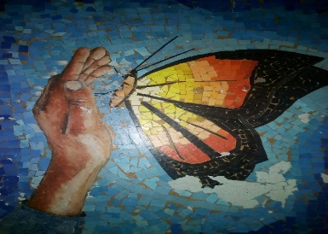
Mosaic
(g)Three ways of creating Rhythm and movement (3mks)
Repetition, progression, alteration.
(h) Name given to the following (2mks)
(i)Small network of spaces left between the cut out pieces in mosaic work.
Interstices
(ii) Small cubes of papers, colored glass or stones embedded on a support to create a composition Tesseraes
SEC B
(2)(a) Identify and name the tool bellow (1mk)
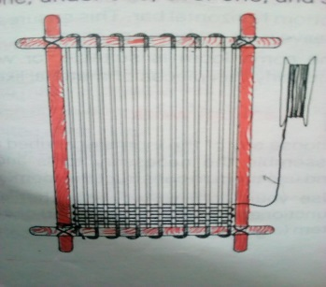 Loom/Frame loom
(b) process of warping using the tool above.
-make a study frame
-drill nails into the top and bottom bars at required interval depending on the yarns to use
-secure the warp threads on the first hole/nail on the top bar
-Tie the first knot on the corner of the bar
-wind the thread down and top the bars until the whole frame is secured
-Continue until the process is complete maintaining reasonable tension (any 5 chronologically arranged-5mks)
(c) Any other two types of tools that can be used to substitute the function apart from the one above (1mk)
Paper loom, dowel loom, serrated card loom
3(a) Difference between shading from tinting (2mks)
Shading-the process of introducing a dark medium on a surface/in a colour.
Tinting-the process of introducing a light medium on a surface/in a colour.
(b)Any four shading techniques that create texture and 3D effect on a shape/form. (6mks)-The student is supposed to use an illustration of their choice to illustrate the techniques of Hatching, crosshatching, pointillism/dot shading, block shading, scribbling.

3) Ornamentry. (2 mks)The artwork/ technique of making items/objects that enhance the appearance of a person/objects themselves.
[ii]Any 4 factors to consider when designing ornaments [4mks)
-Function/purpose
-style/technique
- Process
-Tools and materials to use-Any 4 well explained-4mks

(iii) Any 4 functions of ornaments (4mks)
Religious, economic, cultural, ritual, political, aesthetic
[iv] Any 4 beadwork work techniques (4 mks)

Strung beaded, strung knotted, stop stitched, massai collar.
………………………………………………………………………………………………………….

(v)The process of beadwork using papier mache (6mks)………………………………………………………………………………-Obtain enough soft paper such as news print,-Soak them in a bucket of water for a day or two until they are soft enough,-drain the water and marsh them to paste,-add le or wheat flour, and –pick a lump sum and mould them into required size and shapes,-let them dry,-paint to required colour/.perforate with a greased wire when they are still soft, varnish and use after they have dried.
4. Mosaic xcteristics-2D art work, juxtaposed tesseraes, presence of interstices and shimmering effect, color is the main element, it’s a Monomedia art work
Collage xcteristics-Sperimposed tesseraes 3D art work, texture is the main element, it’s a multimedia art work, no shimmering effect but raised textre.5.
In the space bellow, draw an “stretched arm” [10mks-
Definition of forms and shapes-4mks, foreshortening to show perspective-2mks,-completion-2mks. Neatness-2mks

