NAME: …………………………………….ADM NO: …………CLASS: ………….…
SCHOOL…………………………………….STREAM……………………………………

442/1
ART & DESIGN (THEORY)
PAPER 1
SEPT 2022
TIME: 1 ½ HOURS

MINCKS GROUP OF SCHOOLS
KENYA CERTIFICATE OF SECONDARY EDUCATION
END OF TERM EXAMS
TERM 2 2022
THEORY

INSTRUCTIONS TO CANDIDATES
Write your name, index number, date and sign in the spaces provided above.
This paper consists of three sections A, B and C.
Answer all the questions in sections A and B and one question in section C.
Answers should be written in the spaces provided.
For Examiner’s Use Only
Section | Question | Candidates Score
A | 1
B | 2
 | 3
 | 4
 | 5
 | 6
C
Total Score
This paper consists of 12 printed Pages
Candidates should check the question paper to ensure that all the pages are printed as indicated and no questions are missing

SECTION A (20 MARKS)

Answer ALL questions in this section in the spaces provided.

- Describe Atmospheric perspective. (1 mark)
____________________________________________________________________________________________________________________________________________________________________________________________________________________________________
- Explain how Poetry is related to Art and Design. (1 mark)
____________________________________________________________________________________________________________________________________________________________________________________________________________________________________
- Describe “Landscaping” as a career related to Art and Design. (1 mark)
________________________________________________________________________________________________________________________________________________________________________________________________________________________________________________________________________________________________________________
- Give two sets of triadic colours combinations on the colour wheel with focus on tertiary colours. (2 marks)
__________________________________________________________________________________________________________________________________________________________________________________________________________________________________

(e) Study the picture below and use it to answer the questions below.

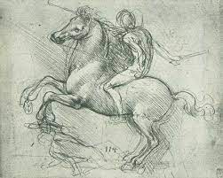

Explain how line has been used in the picture above. (1 mark)
____________________________________________________________________________________________________________________________________________________________________________________________________________________________________

(f) Study the illustration below;
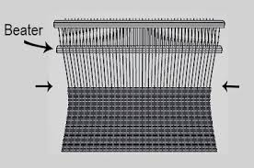
Identify the weaving defect above and explain how you would correct it in weaving process. (2 marks)
____________________________________________________________________________________________________________________________________________________________________________________________________________________________________

(g) Explain the main importance of contrast in a composition. (1 mark)
____________________________________________________________________________________________________________________________________________________________________________________________________________________________________
(h) Explain the term “cap height” as used in graphic design. (1 mark)
____________________________________________________________________________________________________________________________________________________________________________________________________________________________________

(i) Describe an “easel” and explain its use in Art and Design activities. (2 marks)
____________________________________________________________________________________________________________________________________________________________________________________________________________________________________
(j) Describe the gravure printing technique. (1 mark)
___________________________________________________________________________________________________________________________________________________________________________________________________________________________________
(k) Study the sculpture shown below;

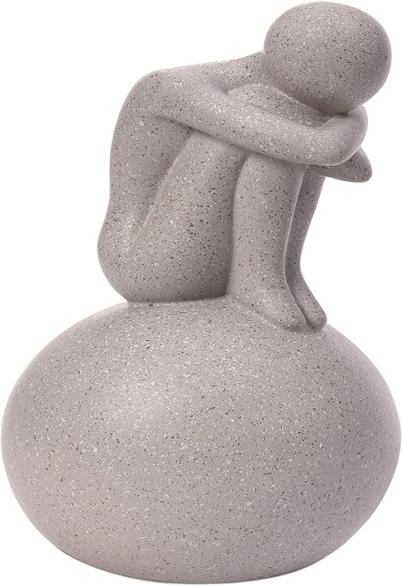

(i) Identify the type of sculpture shown above. (1 mark)

____________________________________________________________________________________________________________________________________________________________________________________________________________________________________

(i) Describe the nature of the planes used in the sculpture above. (2 marks)
____________________________________________________________________________________________________________________________________________________________________________________________________________________________________________________________________________________________________________________________________________________________________________________________
(l) Explain the cause of shimmering effect in a mosaic art work. (1 mark)
____________________________________________________________________________________________________________________________________________________________________________________________________________________________________
(m) Distinguish between the terms “montage” and “photomontage”. (2 marks)
________________________________________________________________________________________________________________________________________________________________________________________________________________________________________________________________________________________________________________________________________________________________________________________________________________________________________________________________________

(n) Explain the term “refractoriness” as used in pottery. (1 mark)
____________________________________________________________________________________________________________________________________________________________________________________________________________________________________

SECTION B (25 MARKS)

Answer ALL questions in this section in the spaces provided.

2.
(a) What is foreshortening as used in drawing? (1 mark)
________________________________________________________________________________________________________________________________________________________

(b) In the space provided, draw the clenched fist below, viewed from the direction of the arrow. (4 marks)

3. Outline the procedure of window mounting. (5 marks)
________________________________________________________________________________________________________________________________________________________________________________________________________________________________________________________________________________________________________________________________________________________________________________________________________________________________________________________________________
4. Study the pottery form below.

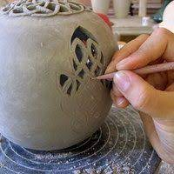

(a) Identify the pottery decorative technique used. (1 mark)
________________________________________________________________________________________________________________________________________________________
(b) Describe the technique in 4 (a) above. (4 marks)
________________________________________________________________________________________________________________________________________________________________________________________________________________________________________________________________________________________________________________________________________________________________________________________________________________________________________________________________________________________________________________________________________________________________________________________________________________________________

5. Highlight the steps of making paper collage. (5 marks)
________________________________________________________________________________________________________________________________________________________________________________________________________________________________________________________________________________________________________________________________________________________________________________________________________________________________________________________________________________________________________________________________________________________________________________________________________________________________
6. Study the weaving technique shown below.
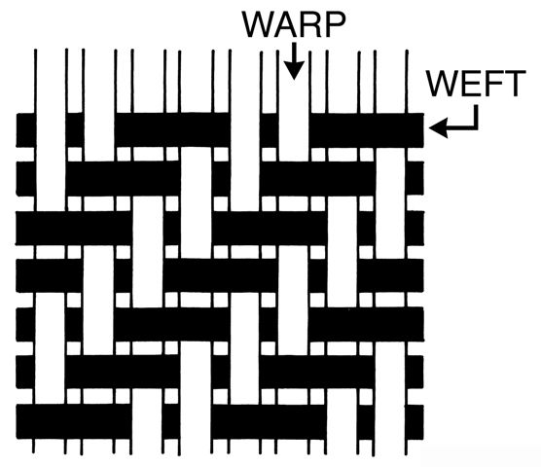

(a) Identify the weave structure above. (1 mark)
________________________________________________________________________________________________________________________________________________________

(b) Give the structure reading of the above weave structure from left. (3 marks)

1st row
________________________________________________________________________________________________________________________________________________________

2nd row
________________________________________________________________________________________________________________________________________________________
3rd row
________________________________________________________________________________________________________________________________________________________
(c) In relation to weaving, explain the meaning of the word shed? (1 mark)
________________________________________________________________________________________________________________________________________________________________________________________________________________________________________________________________________________________________________________
SECTION C (15 MARKS)
Answer ANY ONE question from this section in space provided after question 9.

7. Study the composition below.

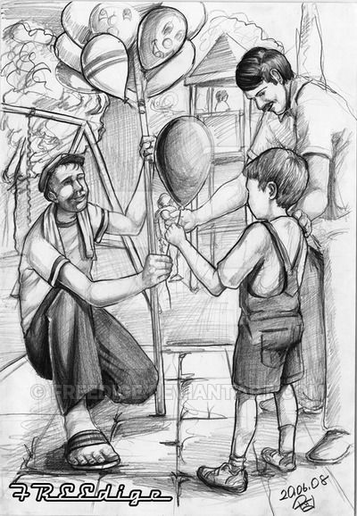

Analyse the use of the following principles in the composition above.
(i) Proportion (3 marks)
(ii) Dominance (2 marks)
(iii) Balance (3 marks)
(iv) Rhythm (3 marks)
(v) Contrast (3 marks)
8. Identify and describe three types of traffic control signs giving one example for each, its shape and colour. (15 marks)

9. (a) Explain the use of the following tools in mosaic work. (5 marks)
(b) Describe two methods of mounting tesserae on the support in process of making mosaic art work. (4 marks)
(c) Outline the procedure of making a glass mosaic. (6 marks)

………………………………………………………………………………………………………………………………………………………………………………………………………………………………………………………………………………………………………………………………………………………………………………………………………………………………………………………………………………………………………………………………………………………………………………………………………………………………………………………………………………………………………………………………………………………………………………………………………………………………………………………………………………………………………………………………………………………………………………………………………………………………………………………………………………………………………………………………………………………………………………………………………………………………………………………………………………………………………………………………………………………………………………………………………………………………………………………………………………………………………………………………………………………………………………………………………………………………………………………………………………………………………………………………………………………………………………………………………………………………………………………………………………………………………………………………………………………………………………………………………………………………………………………………………………………………………………………………………………………………………………………………………………………………………………………………………………………………………………………………………………………………………………………………………………………………………………………………………………………………………………………………………………………………………………………………………………………………………………………………………………………………………………………………………………………………………………………………………………………………………………………………………………………………………………………………………………………………………………………………………………………………………………………………………………………………………………………………………………………………………………………………………………………………………………………………………………………………………………………………………………………………………………………………………………………………………………………………………………………………………………………………………………………………………………………………………………………………………………………………………………………………………………………………………………………………………………………………………………………………………………………………………………………………………………………………………………………………………………………………………………………………………………………………………………………………………………………………………………………………………………………………………………………………………………………………………………………………………………………………………………………………………………………………………………………………………………………………………………………………………………………………………………………………………………………………………………………………………………………………………………………………………………………………………………………………………………………………………………………………………………………………………………………………………………………………………………………………………………………………………………………………………………………………………………………………………………………………………………………………………………………………………………………………………………………………………………………………………………………………………………………………………………………………………………………………………………………………………………………………………………………………………………………………………………………………………………………………………………………………………………………………………………………………………………………………………………………………………………………………………………………………………………………………………………………………………………………………………………………………………………………………………………………………………………………………………………………………………………………………………………………………………………………………………………………………………………………………………………………………………………………………………………………………………………………………………………………………………………………………………………………………………………………………………………………………………………………………………………………………………………………………………………………………………………………………………………………………………………………………………………………………………………………………………………………………………………………………………………………………………………………………………………………………………………………………………………………………………………………………………………………………………………………………………………………………………………………………………………………………………………………………………………………………………………………………………………………………………………………………………………………………………………………………………………………………………………………………………………………………………………………………………………………………………………………………………………………………………………………………………………………………………………………………………………………………………………………………………………………………………………………………………………………………………………………………………………………………………………………………………………………………………………………………………………………………………………………………………………………………………………………………………………………………………………………………………………………………………………………………………………………………………………………………………………………………………………………………………………………………………………………………………………………………………………………………………………………………………………………………………………………………………………………………………………………………………………………………………………………………………………………………………………………………………………………………………………………………………………………………………………………………………………………………………………………………………………………………………………………………………………………………………………………………………………………………………………
THIS IS THE LAST PRINTED PAGE!

