MARKING SCHEME- FORM 4 P1

442/1
ART & DESIGN (THEORY)
PAPER 1
SEPT 2022
TIME: 1 ½ HOURS

INSTRUCTIONS TO CANDIDATES
Write your name , index number, date and sign in the spaces provided above.
This paper consists of three sections A, B and C.
Answer all the questions in sections A and B and one question in section C.
Answers should be written in the spaces provided.

For Examiner’s Use Only

Section | Question | Candidates Score
A | 1
B | 2
 | 3
 | 4
 | 5
 | 6
C
Total Score

This paper consists of 12 printed Pages
Candidates should check the question paper to ensure that all the pages are printed as indicated and no questions are missing
SECTION A (20 MARKS)

Answer ALL questions in this section in the spaces provided.

1. (a) Describe Atmospheric perspective. (1 mark)
- This is the effect the atmosphere has on the appearance of objects when you look at them from a distance. Objects further back into the distance are seen less clearly and their colour changes in value, saturation and hue.
(b) Explain how poetry is related to Art and Design. (1 mark)
- they are both used for expression purposes where creativity is key. art uses images while poetry uses words.
(c) Describe “Landscaping” as a career related to Art and Design. (1 mark)
- Addition of plants, manipulation of terrain and construction of structures planning them in a given space to make it appealing.

(d) Give two tertiary triad colour combinations on the colour wheel. (2 marks)
- RED ORANGE, YELLOW GREEN, BLUE PURPLE
- BLUE GREEN, YELLOW ORANGE, RED PURPLE
(e) Study the picture below and use it to answer the questions below.

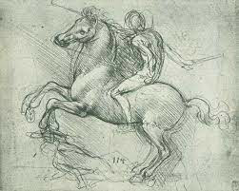

Explain the use of lines in the picture above. (1 mark)
    - Enclose shape - The shapes of the horse and human figure below have been enclosed by lines.
    - Define form - lines have been used to create texture and shade on the surfaces of human form used and the horse.
    - Suggest movement - lines have been used to take the direction of movement of the horse.

(f) Study the illustration below;

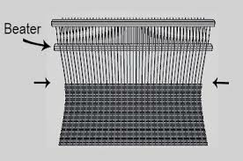

Identify the weaving defect above and explain how you would correct it in weaving process. (2 marks)
    - Waisting
    - By stretching the warps on the loom tightly.
    - Avoid pulling the wefts too tightly
    - Securing the selvedges on the loom.
(g) Explain the main importance of contrast in a composition. (1 mark)
- To enable the main forms to stand out/dominate the scene to bring out dominance in a composition.
(h) Explain “cap height” as used in graphic design. (1 mark)
- the guideline in graphic design which indicates where the capital letters will reach.
(i) Describe an “easel” and explain its use in Art and Design activities. (2 marks)
- A wooden frame for holding an artist’s work while it is being painted or drawn.
- The picture plane is mounted on it to be able to stand upright to be worked on easily.
(j) Describe the gravure printing technique. (1 mark)
- a printing technique where the image is broken down to thousands of dots and etched on a plate which is embedded onto a roller forming the printing plate.

(k) Study the sculpture shown below;
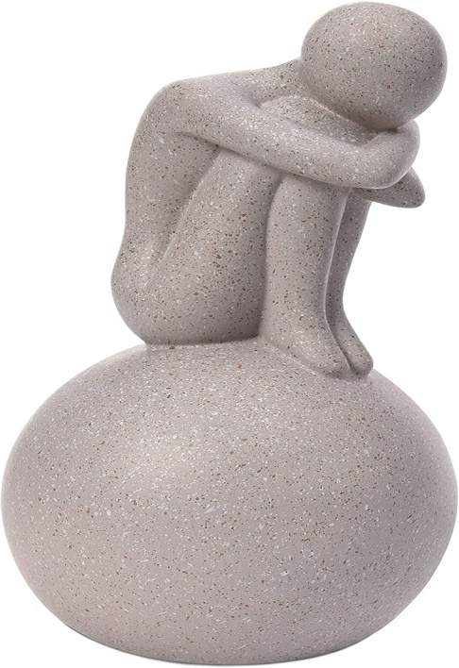

(i) Identify the type of sculpture shown above. (1 mark)

Sculpture in the round.

(i) Describe the nature of the planes used in the sculpture above. (2 marks)
- The planes of the human form are majorly curved, apart from the back which looks flat. The spherical form has one continuous convex plane.
(l) Explain the cause of shimmering effect in a mosaic art work. (1 mark)
- Reflection of light on the tessarae that are cube like and are arranged forming a network of interstices.
(m) Distinguish between the terms “montage and photomontage”. (2 marks)

(n) Explain the term “refractoriness” as used in pottery. (1 mark)
- Capacity of clay to withstand high temperatures without deforming/high degree of resistance to heat.

SECTION B (25 MARKS)

Answer ALL questions in this section in the spaces provided.

2. (a) What is foreshortening as used in drawing? (1 mark)
- It is the apparent reduction of length of a form due to projection either towards or away from the viewer.

(b) In the space provided, draw the clenched fist below, viewed from the direction of the arrow. (4 marks)

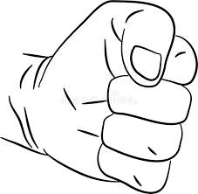

3. Outline the procedure of window mounting. (5 marks)
- Trim the mounting board to the size you want for mounting.
- Trim the picture you want to mount.
- Draw a window on the board slightly smaller in dimensions than the picture.
- Cut the small frame on the board.
- Mount the picture on the reverse so that it is seen through the window.

4. Study the pottery form below.

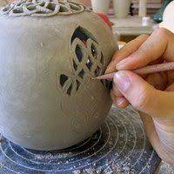

(a) Identify the pottery decorative technique used. (1 mark)
- Excising
(b) Describe the technique in 4 (a) above. (4 marks)
- Draw your design on paper.
- Transfer your design on the leather hard pot
- Cut the design sinking them through the walls of the pot
- Cut out the shapes of the design from the pot leaving open space designs.
5. Highlight the steps of making textile collage. (5 marks)
  - Prepare a suitable support to hold the collage.
  - Draw a composition and work out the areas to have the textile materials – choose different types of textiles and cut, tear, roll, fold or twist and paste them to the support according to the composition – if required, paint or draw on areas of the collage – Frame the collage and hang it.
6. Study the weaving technique shown below.
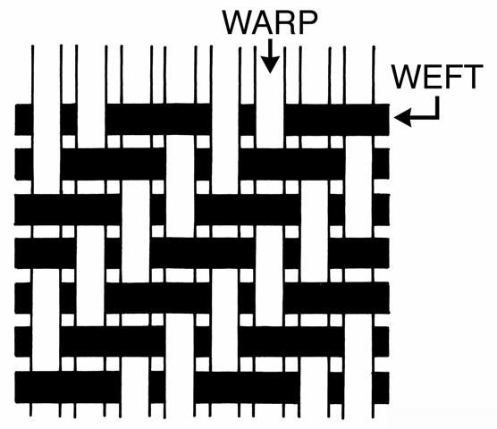

(a) Identify the weave structure above. (1 mark)
- 2/2 Twill weave structure.
(b) Give the structure reading of the above weave structure from left. (3 marks)

1st row
Over two, under two, over two, under two.

2nd row
Under one, over two, under two, over two, under one.
3rd row
Under two, over two, under two, over two.
(c) What is a shed as used in weaving? (1 mark)
- The space created by picking alternate warps through which wefts are passed for interlacing.

SECTION C (15 MARKS)

Answer ANY ONE question from this section in space provided after question 9.

7. Study the composition below.

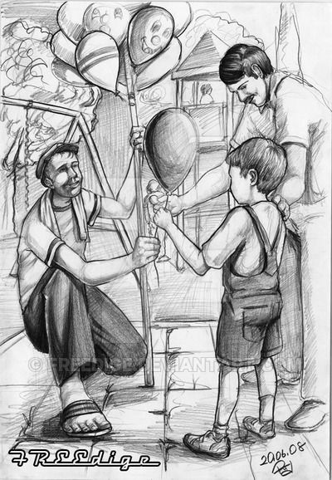

Analyse the use of the following principles in the composition above.
(i) Proportion (3 marks)
The grown up human forms look bigger than the child, they are the right sizes in relation to each other.
Parts of humans beings are depicted with right sizes, they relate well with the human forms.
Human forms appear too big and going out of the space used. Too big for the available space.

(ii) Dominance (2 marks)
Human forms are dominating the scene.
They have both grouped together and therefore stand out as a unit.
They have been shaded dark to make them stand out from the background.

(iii) Balance (3 marks)
The balance used is asymmetrical balance.
One man with balances is balanced with another man with a child on the other side if the axis.
In the background there is a guard’s shed balanced with clouds as the other side of the axis.

(iv) Rhythm (3 marks)
Repeated forms of balloons on the holder creates a flowing repeated movement.
Progression has been used to create rhythm-forms in the background are getting smaller.
The paved ground is also getting smaller from the foreground.

(v) Contrast (3 marks)
Use of dark shaded human forms against a faint background.
Use of bold and light lines.
Use of rough and smooth textures.
8. Identify and describe three types of traffic control signs giving one example for each, its shape and colour. (15 marks)

9. (a) Explain the use of the following tools in mosaic work. (5 marks)
(i) Nippers
(ii) Trowel
(iii) Sealer can
(iv) Tweezers
(v) Spatula

(b) Describe two methods of mounting tesserae on the support in process of making mosaic art work. (4 marks)

(c) Outline the procedure of making a glass mosaic. (6 marks)

