MUMIAS WEST SUB COUNTY
JOINT EVALUATION EXAMINATION
AGRICULTURE PAPER II
443/2 (THEORY)
TERM I 2022
2 HOURS

NAME …………………………………………. INDEX NO: ………………………..
SCHOOOL …………………………………….. DATE ………………

INSTRUCTIONS
- This paper consists of three sections; A, B and C.
- Answer all questions in section A and B in the spaces provided.
- Answer any TWO questions in section C.

FOR EXAMINERS USE ONLY
Section | Question score | Maximum score | Candidate score
A | 1-13 | 30
B | 14-17 | 20
C |  | 20
 |  | 20
TOTAL SCORE

SECTRION A (30mks)
Answer all questions in the spaces provided.
- List the tool used for each of the following:
- Tightening barbed wires during fencing (½mk)

- Smoothening concrete floors during plastering ($\frac{1}{2}$mk)

- (a) State two characteristics of goats that make them adapted to arid areas of Kenya (1mk)

(b) Give four majors features of exotic beef breeds (2mks)

- Give four ways in which diseases can spread from on animal to the other within the farm (2mks)

- (a) Which livestock disease is transmitted by each of the following ticks? (1mk)
- Blue tick (Boophilus decoloratus)

- Brown ear tick ( Rhipicephalous appendiculatus)

(b) Name the intermediate host for the following internal parasites in livestock (1mk)
- Tape worm (Taenia solium)

- Liver fluke (Fasciola hepatica)

- State four disadvantages of natural mating as a method of breeding in cattle production (2mks)

- (a) What is the name given to the practice of trimming wool around the sheath of a ram to facilitate mating ($\frac{1}{2}m$k)

(b) Use the diagram below to answer questions that follows:

C
PARTURITIONNN
A

WEANING
MATING

B

Identify the type of special feeding shown by the letters A, B and C ($1\frac{1}{2}$mks)
A –
B –
C –

- (a) Give two reasons for treating timber to be used in construction of farm buildings. (1mk)

(b) Outline two routine maintenance practices carried out on water tanks. (1mk)

- (a) Name two notifiable diseases in cattle. (1mk)

(b) Give two signs that would indicate that animal has died of anthrax. (1mk)

- (a) Give three methods of controlling cannibalism in a flock of poultry. ($1\frac{1}{2}mk$)

(b) State three conditions that reduce the quality for hatching ($1\frac{1}{2}$mks)

(c) State four observations on the behavior of chicks which would indicate that the temperature of the brooder is too high (2mks)

- (a) Explain three characteristics that make colostrum suitable for newly born calves. ($1\frac{1}{2}$mks)

(b) State three qualities of clean milk ($1\frac{1}{2}$ mks)

- (a) Give the function of each of the following parts of a mowed board plough (1mk)
- Frog

- Landslide

(b) State two methods of increasing ploughing depth when using a disc plough (1mk)

- (a) State three ways in which a production ration can be utilized by cattle ($1\frac{1}{2}$ mks)

(b) Name three products of fermentation in the rumen of a ruminant. ($1\frac{1}{2}$ mks)

- Give uses of a screen in the inlet pipe of a fish pond. (1mk)

SECTION B (20MKS)
Answer all questions in this section in the spaces provided.

- A farmer in Lusheya village wanted to prepare a 200kg of calf rearing ration containing 20% DCP. Using the Pearson’s Square Method, calculate the amount of maize containing 10% DCP and sunflower containing 35% DCP the farmer would need to prepare in the ration. (show your working) (5mks)

- The diagrams below represent farm tools used in agricultural production

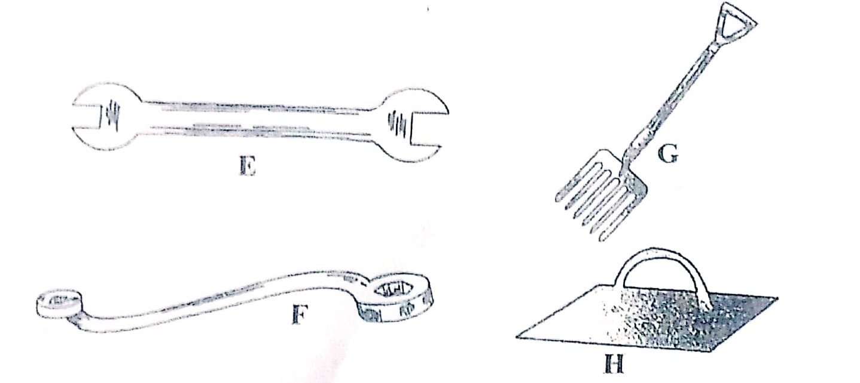

- Identify the tools labelled E and F (2mks)
E –
F –

- State one use of the tools labelled F and G (2mks)
F –
G -
- State one advantage of the tool F has over tool E (1mk)

- The diagram below represents parts of a roof

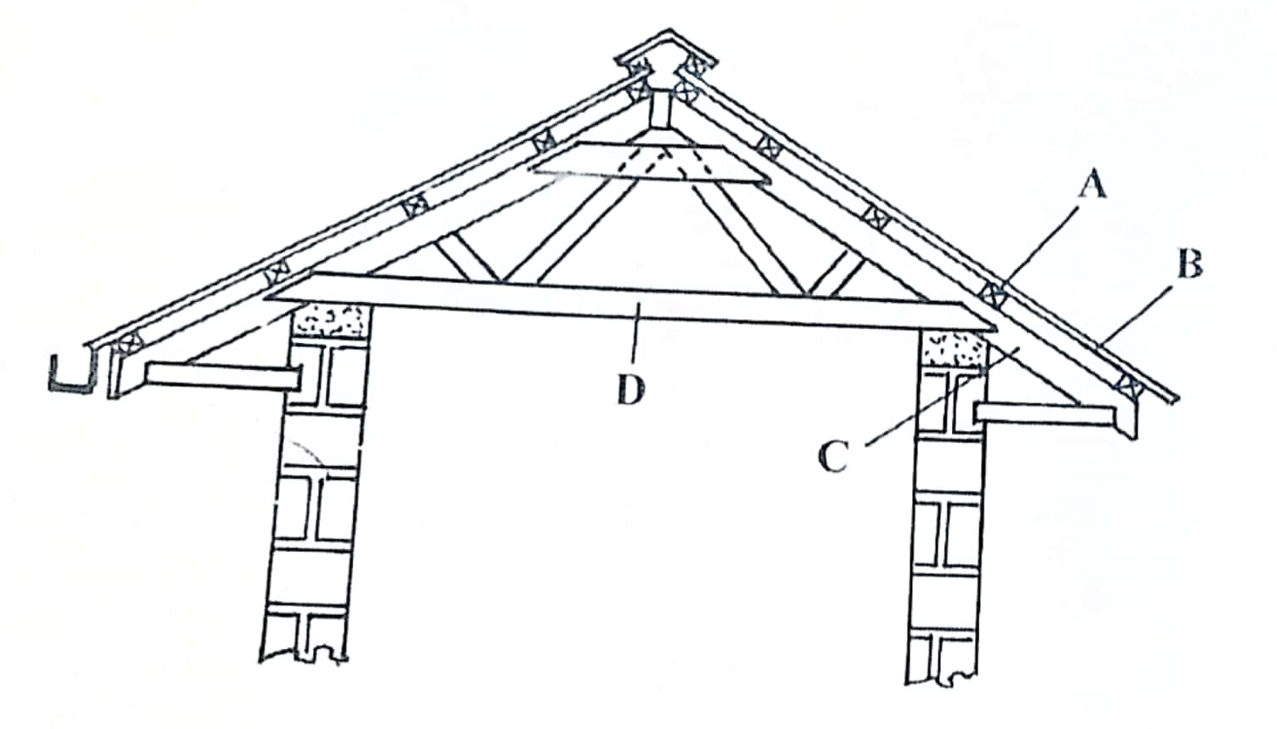
- Identify the parts labelled A and C
A - (1mk)
C- (1mk)

- State two types of materials that may be used for the parts labelled D. (2mks)

- Give one disadvantage of using thatch for part labelled B. (1mk)

- The diagram below illustrates a tractor drawn implement
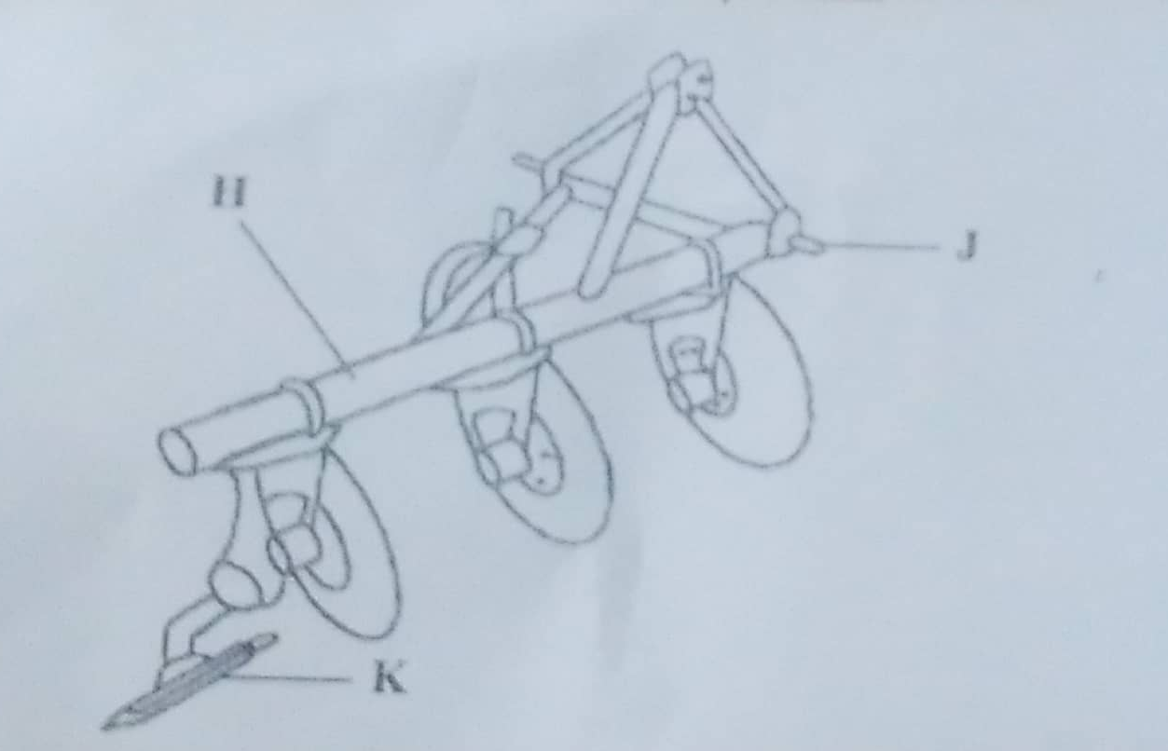
- Identify the implement (1mk)

- Name the part labelled
H - (1mk)
J - (1mk)

- State two functions of the part labelled K (2mks)

SECTION C (40MKS)
Answer only two questions in this section.
- (a) Explain five reasons for maintaining livestock healthy (5mks)

(b) Describe the life cycle of a three-host tick. (8mks)

(c) Describe the factors a farmer should consider when selecting a young female pig (Gilt) for breeding (7mks)

- (a) State five management practice in fish rearing. (5mks)

(b) Describe the procedure of erecting wooden posts for fencing. (5mks)

(c) Describe Brucellosis disease in cattle under the following sub-headings;
- Causal organism (1mk)

- Signs of attack (4mks)

- Control measures (5mks)

- (a) Describe the artificial rearing of layer chicks from a day old up to the end of brooding. (8mks)

(b) Describe the use of Seven material/ equipment required for hand milking (7mks)

(c) Describe the functions of the gear box of a tractor. (5mks)

