443/2

NAME…………………………………………….……. INDEX NO………..…………………..
SIGNATURE……………………………….………………DATE……………………………..
ASUMBI GIRLS HIGH SCHOOL
POST -MOCK 1
AUGUST/SEPTEMBER
2022

AUGUST / SEPTEMBER - 2022
AGRICULTURE
PAPER 2
2 HOURS
INSTRUCTIONS TO CANDIDATES
1.Write your name and ADM. Number in the spaces provided above.
2. Sign and write the date of examination in the spaces provide above.
3. This paper consist of three sections A, B and C.
4. Answer all the questions in section A and B.
5.Answer any two questions in section C.
6.All answers should be written in the spaces provided.
8. All answers must be written in English.
9.This paper consist of 10 printed pages.
10. Candidates must check to ascertain that all the pages are printed as indicated and that no question is missing.
FOR EXAMINER’S USE ONLY
SECTION | QUESTIONS | MAXIMUM SCORE | CANDIDATE SCORE
A | 1-16 | 30
B | 17 -20 | 20
C |  | 40
TOTAL SCORE |  | 90

SECTION A 30 MARKS
ANSWER ALL THE QUESTIONS IN THIS SECTION IN THE SPACES PROVIDED
1.Name four beef breeds of cattle. (2 marks)
........................................................................................................................................................................................................................................................................................................................................................................................................................................................................................................................................................................................................................................................................................................................................................................................................................................................................
2.Name the most appropriate tools used in the following operations(1¹/₂marks)
a) Removing metal chipping in files
........................................................................................................................................................................................................................................................................................................................
b) Cutting wood along the grains
........................................................................................................................................................................................................................................................................................................................
c) Branding
........................................................................................................................................................................................................................................................................................................................
3.Give four practices carried out on fish before preservation. (2 marks)
............................................................................................................................................................................................................................................................................................................................................................................................................................................................................................................................................................................................................................................................................................................................................................................................................
4.Outline four reasons for steaming up a gestating a cow. (2 marks)
............................................................................................................................................................................................................................................................................................................................................................................................................................................................................................................................................................................................................................................................................................................................................................................................................
5.List four factors considered when selecting eggs for marketing. (2 marks)
..........................................................................................................................................................................................................................................................................................................................................................................................................................................................................................................................................................................................................................................................................................................................................................................................................
6.State three qualities of a good livestock ration. (1¹/₂marks)
................................................................................................................................................................................................................................................................................................................................................................................................................................................................................................................................................................................................................................................
7.Sate four advantages of carrying out raddling in sheep management. (2 marks)
.....................................................................................................................................................................................................................................................................................................................................................................................................................................................................................................................................................................................................................................................................................................................................................................................................................................................................................................................................................................
8.State four disadvantages of using a spray race in the farm. (2 marks)
..............................................................................................................................................................................................................................................................................................................................................................................................................................................................................................................................................................................................................................................
9.List four causes of sterility in dairy cows. (2 marks)
............................................................................................................................................................................................................................................................................................................................................................................................................................................................................................................................................................................................................................................................................................................................................................................................................
10.List four effects of ticks on livestock bodies. (2marks)
............................................................................................................................................................................................................................................................................................................................................................................................................................................................................................................................................................................................................................................................................................................................................................................................................
11.State four factors that influence selection of construction materials. (2 marks)
........................................................................................................................................................................................................................................................................................................................................................................................................................................................................................................................................................................................................................................................................................................................................................................................................................................................................................................................................................................
12.Name three farm implements operated by the tractor’s P.T.O shaft. (1¹/₂marks)
................................................................................................................................................................................................................................................................................................................................................................................................................................................................................................................................................................................................................................................
13.State four reasons for debeaking in poultry production. (2 marks)
...............................................................................................................................................................................................................................................................................................................................................................................................................................................................................................................................................................................................................................................
14.Name three breeding diseases controlled through the use of artificial insemination. (1¹/₂marks)
................................................................................................................................................................................................................................................................................................................................................................................................................................................................................................................................................................................................................................................
15.Give four characteristics of a good vaccine. (2 marks)
........................................................................................................................................................................................................................................................................................................................................................................................................................................................................................................................................................................................................................................................................................................................................................................................................................................................................................................................................................................
16.State four advantages of Kenya top bar hive in bee keeping. (2 marks)
............................................................................................................................................................................................................................................................................................................................................................................................................................................................................................................................................................................................................................................................................................................................................................................................................
SECTION B 20 MARKS
ANSWER ALL THE QUESTIONS IN THIS SECTION IN THE SPACES PROVIDED
17.The diagram illustrated below shows a petrol engine fuel system. Study it carefully and answer the questions that follow.
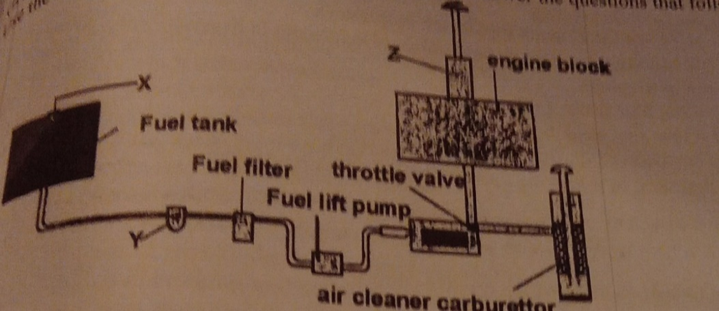

a) Name the parts labelled X, Y and Z. (3 marks)
X.........................................................................................................................................................
Y.........................................................................................................................................................Z.........................................................................................................................................................
b) State the maintenance practice of the following parts;(2 marks)
i) Fuel tank cap
....................................................................................................................................................................................................................................................................................................................................................................................................................................................................................
ii)The carburetor
....................................................................................................................................................................................................................................................................................................................................................................................................................................................................................
18.The diagram below shows two methods of handling livestock in the farm. Study them and answer the questions that follow.

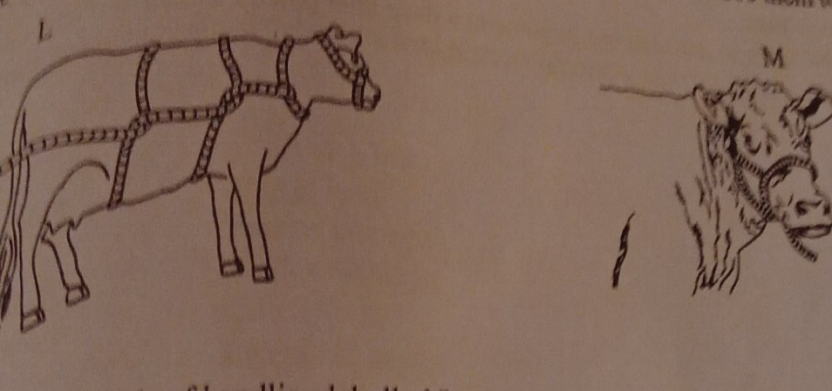

a) Identify the methods of handling livestock labelled L and M. (1 marks)
L.........................................................................................................................................................
M........................................................................................................................................................
b) Give two occasions when it may be necessary to carry out the practice labelled L above. (2 marks)
...................................................................................................................................................................................................................................................................................................................................................................................................................................................................................
c) Give two animal conditions under which method L above cannot be used. (2 marks)
....................................................................................................................................................................................................................................................................................................................................................................................................................................................................................
19.Below is structure used in poultry production. Use it to answer the questions that follow.

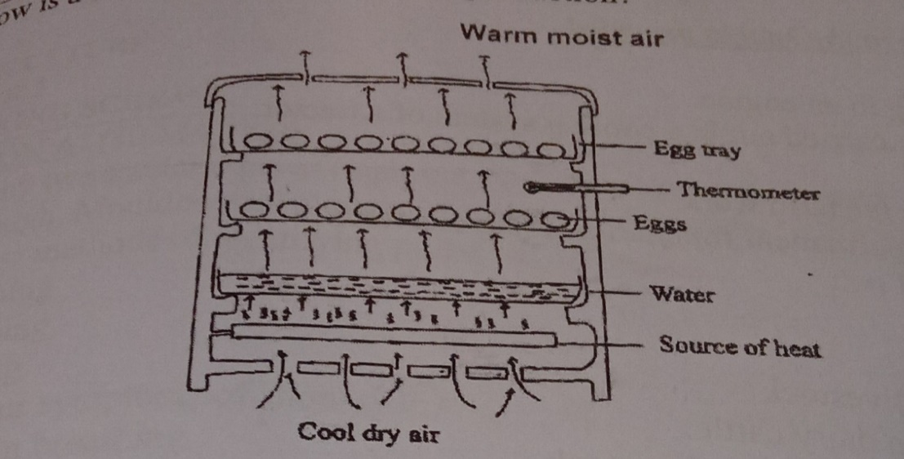

a) Identify the structure illustrated above. (1 mark)
.......................................................................................................................................................................................................................................................................................................................
b) State the main function of the structure illustrated above. (1 mark)
........................................................................................................................................................................................................................................................................................................................
c)Give the main function of the following in the structure (3 marks)
i)Water
......................................................................................................................................................................................................................................................................................................................
ii)Source of heat
........................................................................................................................................................................................................................................................................................................................
iii) Thermometer
........................................................................................................................................................................................................................................................................................................................
20.The diagrams illustrated below shows tools used in the farm. Study the carefully and answer the questions that follow.

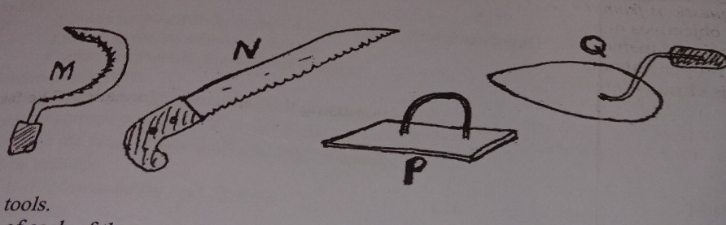

a) Identify the tools labelled P and Q. (2 marks)
P.........................................................................................................................................................
Q.........................................................................................................................................................
b) State the use of the tools labelled M and N. (2 marks)
M........................................................................................................................................................
N.......................................................................................................................................................
c)Give two ways in which the tools illustrated above depreciate in value. (1 mark)
...................................................................................................................................................................................................................................................................................................................................................................................................................................................................................
SECTION C 40 MARKS
ANSWER ONLY TWO QUESTIONS IN THIS SECTION IN THE SPACES PROVIDE AFTER THE QUESTIONS
21.a) Explain ten advantages of battery cage system in poultry rearing. (10 marks)
b) Outline the procedure of training a calf for bucket feeding. (5 marks)
c) Outline five signs of tapeworm infestation. (5marks)
22.a) Explain the functional differences between a disc plough and a mould board plough. (8 marks)
b) Explain eight factors considered when siting farm structures. (8 marks)
c)Outline four ways in which infectious diseases can spread in livestock production. (4 marks)
23.a) Describe foot rot under the following sub-heading;
i)Animals affected (1 mark)
ii)causal organism (1mark)
iii)Symptoms of attack (4marks)
iv)Control measures (4marks)
b) Describe the function of various parts of a plunge dip.(10 marks)

