MOKASA JOINT EXAMINATION
Kenya Certificate of Secondary Education
443/1
AGRICULTURE
(Theory)
August/September 2022 – 2 hours
Name …………………………………………………Adm. Number ………… Class……
Instructions to candidates
Answer all the questions in sections A and B and Any 2 questions in section C.
For examiner’s use only
SECTION | Question | Maximum Score | Candidate’ Score
A | 1-18 | 30
B | 19-22 | 20
C |  | 20
 |  | 20
TOTAL SCORE |  | 90

SECTION A (30 Marks)
Answer all questions in this section in the space provided.
- Outline four ways in which biotic factors affect crop production (2marks)
………………………………………………………………………………………………………………………………………………………………………………………………………………………………………………………………………………………………………………………………………………………………………………………………
- Give two importance of a shed in nursery bed of pest control. (1mark)
………………………………………………………………………………………………………………………………………………………………………………………………
- State four benefits of using vegetative propagation in orange production.(2marks)
………………………………………………………………………………………………………………………………………………………………………………………………………………………………………………………………………………………………………………………………………………………………………………………………

- List four features of fertile soil (2marks)
………………………………………………………………………………………………………………………………………………………………………………………………………………………………………………………………………………………………………………………………………………………………………………………………
- State four reasons why a farmer prepares a seedbed early. (2marks)
……………………………………………………………………………………………………………………………………………………………………………………………………………………………………………………………………………………………………………………………………………………………………………………………
- Give four reasons for keeping breeding records. (2marks)
………………………………………………………………………………………………………………………………………………………………………………………………………………………………………………………………………………………………………………………………………………………………………………………………
- Outline four importance of a good soil structure to crop production. (2marks)
………………………………………………………………………………………………………………………………………………………………………………………………………………………………………………………………………………………………………………………………………………………………………………………………
- Give two importance of earthing up crops (1mark)
………………………………………………………………………………………………………………………………………………………………………………………………
- Give four ways of breaking seed dormancy. (2marks)
………………………………………………………………………………………………………………………………………………………………………………………………………………………………………………………………………………………………………………………………………………………………………………………………
- State four disadvantages of using plastic pipes to convey water. (2marks)
………………………………………………………………………………………………………………………………………………………………………………………………………………………………………………………………………………………………………………………………………………………………………………………………
- Give three forms in which water is available in the soil. (1¹/₂ mark)
………………………………………………………………………………………………………………………………………………………………………………………………………………………………………………………………………………………………

- State three roles of organic matter in sandy soils. (1 ½ mark)
………………………………………………………………………………………………………………………………………………………………………………………………………………………………………………………………………………………………
- What is the name given to the point where supply and demand curves intersect? ( ½ mark)
………………………………………………………………………………………………………………………………………………………………………………………………
- Give four advantages of using herbicides to control weeds. (2marks)
………………………………………………………………………………………………………………………………………………………………………………………………………………………………………………………………………………………………………………………………………………………………………………………………
- a) Give two functions of sulphur in crops. (1mark)
………………………………………………………………………………………………………………………………………………………………………………………………
(b) State two characteristics of phosphatic fertilizers on crop growth. (1 mark)
………………………………………………………………………………………………………………………………………………………………………………………………
- State three advantages of drip irrigation. (1 ½ mark)
………………………………………………………………………………………………………………………………………………………………………………………………………………………………………………………………………………………………
- (a) Give two advantages of planting cereal crops in rows instead of broadcasting.
………………………………………………………………………………….…(1mark)………………………………………………………………………………………………………………………………………………………………………………………………
(b) State two reasons for planting crops at correct spacing. ( 1 mark)
………………………………………………………………………………………………………………………………………………………………………………………………
- Give four methods of classifying herbicides. (2marks)
………………………………………………………………………………………………………………………………………………………………………………………………………………………………………………………………………………………………………………………………………………………………………………………………
SECTION B (20MKS)
Answer all the questions in this section.
- Study the illustrations of a crop rotation programme below.
2nd year plot B
Peas
1st year plot A
Irish potatoes

4th year plot Rhode grass
3rd year plot
C
Maize

- Identify the crop rotation programme illustrated above. (1mark)
…………………………………………………………………………………………
- Explain two reasons why it is appropriate to plant peas in year 2. (1mark)
……………………………………………………………………………………………………………………………………………………………………………………
- Name one weed species that can be controlled using crop rotation program illustrated above. (1mark)
…………………………………………………………………………………………
- Identify one disease in Irish potatoes that can be controlled by the above rotation program. (1mark)
…………………………………………………………………………………………
- Give two reasons why grass ley should come last in the rotation program ………………………………………………………………………………(2 marks)
………………………………………………………………………………………………………………………………………………………………………………………………………………………………………………………………………………………..…………….
- The diagram below illustrates an experiment on soil. Study it carefully and answer the questions that follow.
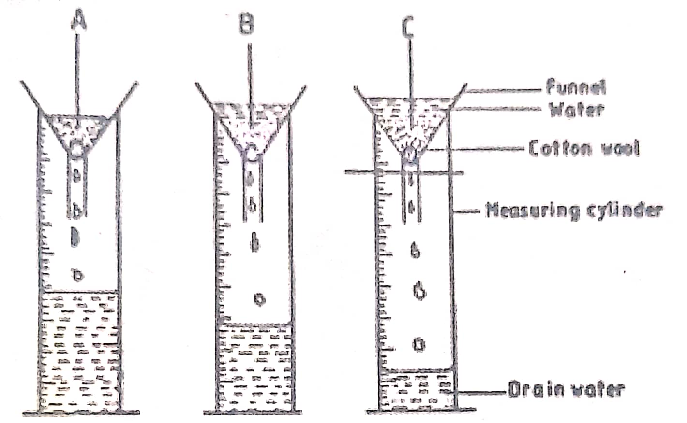
- State the aim of the experiment.
(1mark)
……………………………………………………………………………………………………………………………………………………………………………………………………………………………………………………………………………..
- If the volume of water illustrated in the measuring cylinders was observed after one hour, identify the soil samples labelled A and B.
(2marks)
A………………………………………………………………………………………
B………………………………………………………………………………………

- State two ways in which the soil structure of the soil sample labelled C above can be improved. (2marks)
……………………………………………………………………………………………………………………………………………………………………………………………………………………………………………………………………………….
- The following illustration show different production curves in agricultural economics. Study them and answer the questions that follow.
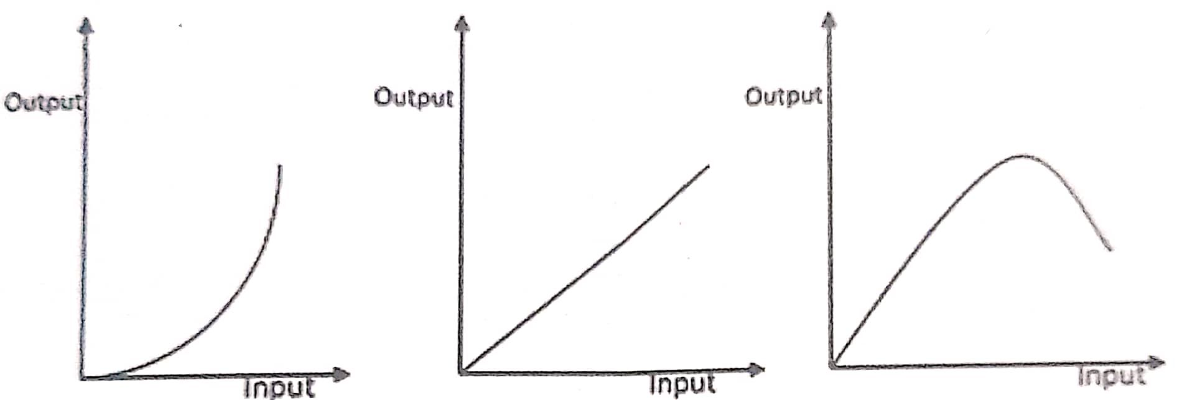
F
E
D
- Identify the production curves labelled D and E.
(2marks)
D………………………………………………………………………………………
E………………………………………………………………………………………
- What does the law derived from the production function labelled F state?
(1mark)
……………………………………………………………………………………………………………………………………………………………………………………
- i. Which one of the three production curves is rare in agriculture?
(1mark)
…………………………………………………………………………………………………………………………………………………………………………………….
ii. Give a reason for your answer in (c) (i) above.
(1mark)
……………………………………………………………………………………………………………………………………………………………………………………
- The diagram below illustrates a type of soil erosion.

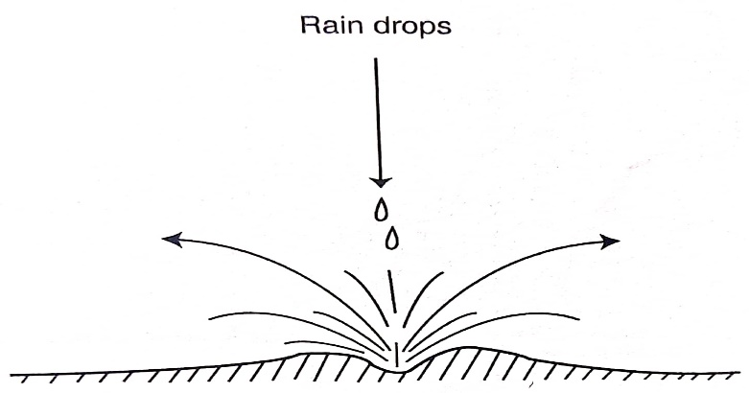
- Identify the type of soil erosions. (1mark)
……………………………………………………………………………………………………………………………
- How does the type of erosion shown above occur? (2marks)
………………………………………………………………………………………………………………………………………………………………………………………………
………………………………………………………………………………………………………………………………………………………………………………………………
- How does cover cropping help to control the type of erosion shown above.
(2mks)
…………………………………………………………………………………………………………………………………………………………………………………………………………………………………………………………………………
………………………………………………………………………………………………………………………………………………………………………………………………

SECTION C ( 40 marks)
Answer any two questions in this section in the spaces provided after the last questions
- (a) Explain the marketing functions of oranges on the farm. (10 marks)
(b) The following is a farm record of Mr. Juma he had kept as 30th June 2022. Study it and carefully answer the questions that follow.
Cash in bank 6,000/=
Cash in hand 4,000/=
Debtors 40,000/=
Creditors 20,000/=
Havested potatoes 50,000/=
Loan 500,000/=
Bank overdraft 100,000/=
Land 1,600,000/=
Milking machine 100,000/=

- Prepare a balance sheet from the above information for Mr. Juma’s farm. ( 8 marks)
- State two benefits of balance sheet to Mrs Sanda:
24(a) Describe the production of onions under the following sub-headings.
- Seedbed preparation (3marks)
- Field management (6marks)
- Harvesting (3marks)
- Outline eight farming activities which may encourage soil erosion. (8marks)
25. (a) State and explain causes of land fragmentation in Kenya . (5mark)
(b) Explain seven ways in which government policy improves agriculture production. (7marks)
(c) Outline eight factors that determine the number of secondary tillage operations when preparing a seed bed. (8marks) ………………………………………………………………………………………………………………………………………………………………………………………………………………………………………………………………………………………………………………………………………………………………………………………………………………………………………………………………………………………………………………………………………………………………………………………………………………………………………………………………………………………………………………………………………………………
……………………………………………………………………………………………………………………………………………………………………………………………………………………………………………………………………………………………………………………………………………………………………………………………………………………………………………………………………………………………………………………………………………………………………………………………………………………………………………………………………………………………………………………………………………………………………………………………………………………………………………………………………………………………………………………………………………………………………………………………………………………………………………………………………………………………………………………………………………………………………………………………………………………………………………………………………………………………………………………………………………………………………………………………………………………………………………………………………………………………………………………………………………………………………………………………………………………………………………………………………………………………………………………………………………………………………………………………………………………………………………………………………………………………………………………………………………………………………………………………………………………………………………………………………………………………………………………………………………………………………………………………………………………………………………………………………………………………………………………………………………………………………………………………………………………………………………………………………………………………………………………………………………………………………………………………………………………………………………………………………………………………………………………………………………………………………………………………………………………………………………………………………………………………………………………………………………………………………………………………………………………………………………………………………………………………………………………………………………………………………………………………………………………………………………………………………………………………………………………………………………………………………………………………………………………………………………………………………………………………………………………………………………………………………………………………………………………………………………………………………………
………………………………………………………………………………………………………………………………………………………………………………………………………………………………………………………………………………………………………………………………………………………………………………………………………………………………………………………………………………………………………………………………………………………………………………………………………………………………………………………………………………………………………………………………………………………………………………………………………………………………………………………………………………………………………………………………………………………………………………………………………………………………………………………………………………………………………………………………………………………………………………………………………………………………………………………………………………………………………………………………………………………………………………………………………………………………………………………………………………………………………………………………………………………………………………………………………………………………………………………………………………………………………………………………………………………………………………………………………………………………………………………………………………………………………………………………………………………………………………………………………………………………………………………………………………………………………………………………………………………………………………………………………………………………………………………………………………………………………………………………………………………………………………………………………………………………………………………………………………………………………………………………………………………………………………………………………………………………………………………………………………………………………………………………………………………………………………………………………………………………………………………………………………………………………………………………………………………………………………………………………………………………………………………………………………………………………………………………………

