443/1
NAME…………………………………………….……. INDEX NO………..…………………..
SIGNATURE……………………………….………………DATE……………………………..

ASUMBI GIRLS HIGH SCHOOL
POST -MOCK 1
AUGUST/SEPTEMBER
2022

AUGUST / SEPTEMBER - 2022
AGRICULTURE
PAPER 1
2 HOURS
INSTRUCTIONS TO CANDIDATES
1.Write your name and ADM. Number in the spaces provided above.
2. Sign and write the date of examination in the spaces provide above.
3. This paper consist of three sections A, B and C.
4. Answer all the questions in section A and B.
5.Answer any two questions in section C.
6.All answers should be written in the spaces provided.
8. All answers must be written in English.
9.This paper consist of 14 printed pages.
10. Candidates must check to ascertain that all the pages are printed as indicated and that no question is missing.
FOR EXAMINER’S USE ONLY
SECTION | QUESTIONS | MAXIMUM SCORE | CANDIDATE SCORE
A | 1-16 | 30
B | 17 -20 | 20
C |  | 40
TOTAL SCORE |  | 90

SECTION A 30 MARKS
ANSWER ALL THE QUESTIONS IN THIS SECTION IN THE SPACES PROVIDED
1.State three ways in which crop rotation improves soil fertility. (1¹/₂marks)
................................................................................................................................................................................................................................................................................................................................................................................................................................................................................................................................................................................................................................................
2.List four methods of farming. (2 marks)
............................................................................................................................................................................................................................................................................................................................................................................................................................................................................................................................................................................................................................................................................................................................................................................................................
3.Give four importance of cost as used in agricultural economics. (2 marks)
............................................................................................................................................................................................................................................................................................................................................................................................................................................................................................................................................................................................................................................................................................................................................................................................................
4.List four factors a farmer considers when siting a nursery bed. (2 marks)
........................................................................................................................................................................................................................................................................................................................................................................................................................................................................................................................................................................................................................................................................................................................................................................................................................................................................................................................................................................
5. State four ways in which government policy contributes to agriculture. (2 marks)
............................................................................................................................................................................................................................................................................................................................................................................................................................................................................................................................................................................................................................................................................................................................................................................................................
6.State four disadvantages of concession land tenure. (2 marks)
............................................................................................................................................................................................................................................................................................................................................................................................................................................................................................................................................................................................................................................................................................................................................................................................................
7.Give four reasons why cereal grains should be dried before storage. (2 marks)
............................................................................................................................................................................................................................................................................................................................................................................................................................................................................................................................................................................................................................................................................................................................................................................................................
8.State three importance of cutting back in pyrethrum. (1¹/₂marks)
...............................................................................................................................................................................................................................................................................................................................................................................................................................................................................................................................................................................................................................................
9.Outline four observable indicators of economic growth of a country. (2 marks)
............................................................................................................................................................................................................................................................................................................................................................................................................................................................................................................................................................................................................................................................................................................................................................................................................
10.State four solutions that can help solve the problem of perishability in horticultural crops. (2 marks)
............................................................................................................................................................................................................................................................................................................................................................................................................................................................................................................................................................................................................................................................................................................................................................................................................
11.Give four disadvantages of using organic manures in crop production. (2 marks)
............................................................................................................................................................................................................................................................................................................................................................................................................................................................................................................................................................................................................................................................................................................................................................................................................

12.State four ways in which chemical kills the weeds in the crop field. (2 narks)
............................................................................................................................................................................................................................................................................................................................................................................................................................................................................................................................................................................................................................................................................................................................................................................................................
13.State four management practices that promote high herbage yields in pasture production. (2 marks)
............................................................................................................................................................................................................................................................................................................................................................................................................................................................................................................................................................................................................................................................................................................................................................................................................
14.Distinguish between seed dressing and seed inoculation. (2marks)
............................................................................................................................................................................................................................................................................................................................................................................................................................................................................................................................................................................................................................................................................................................................................................................................................
15.State four agriculture support services available to a crop farmer (2 marks)
........................................................................................................................................................................................................................................................................................................................................................................................................................................................................................................................................................................................................................................................................................................................................................................................................................................................................................................................................................................
16.State two precautions to be taken when harvesting cotton. (1 mark)
...................................................................................................................................................................................................................................................................................................................................................................................................................................................................................
SECTION B 20 MARKS
ANSWER ALL THE QUESTIONS IN THIS SECTION IN THE SPACES PROVIDED
17.The diagram illustrated below shows a method of grafting. Study it carefully and answer the questions that follow.

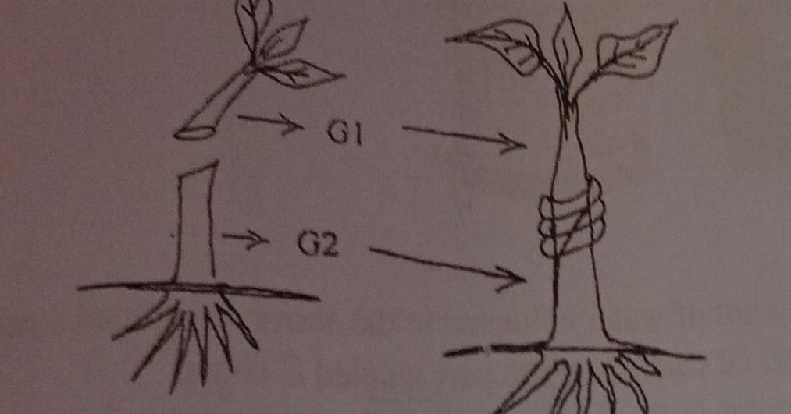

a) Identify the type of grafting illustrated above. (1 mark)
........................................................................................................................................................................................................................................................................................................................
b) Name the parts named G1 and G2. (1 mark)
G1.......................................................................................................................................................
G2.......................................................................................................................................................
c)State three advantages of grafting in agroforestry. (3 marks)
...............................................................................................................................................................................................................................................................................................................................................................................................................................................................................................................................................................................................................................................
18.The diagram illustrated below shows a DAP fertilizer bag. Study it carefully and answer the questions that follow.
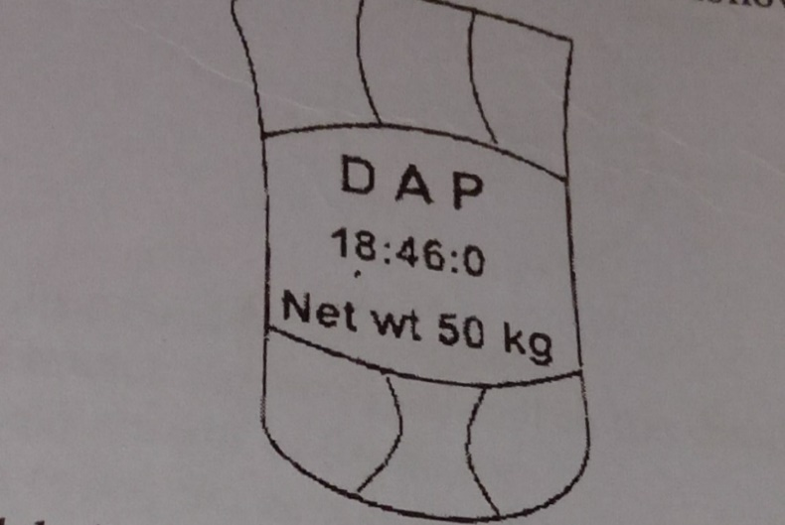

a) What do the figures labelled on the diagram stand for. (1 mark)
...............................................................................................................................................................................................................................................................................................................................................................................................................................................................................................................................................................................................................................................
b) With a reason name the class of inorganic fertilizer that DAP belong. (2 marks)
........................................................................................................................................................................................................................................................................................................................
c) Calculate the amount of filler material in 200 kg of DAP with a fertilizer grade of 18:46:0. (2 marks)
..........................................................................................................................................................................................................................................................................................................................................................................................................................................................................................................................................................................................................................................................................................................................................................................................................
19.The diagrams illustrated below shows common weeds. Use them to answer the questions that follow.
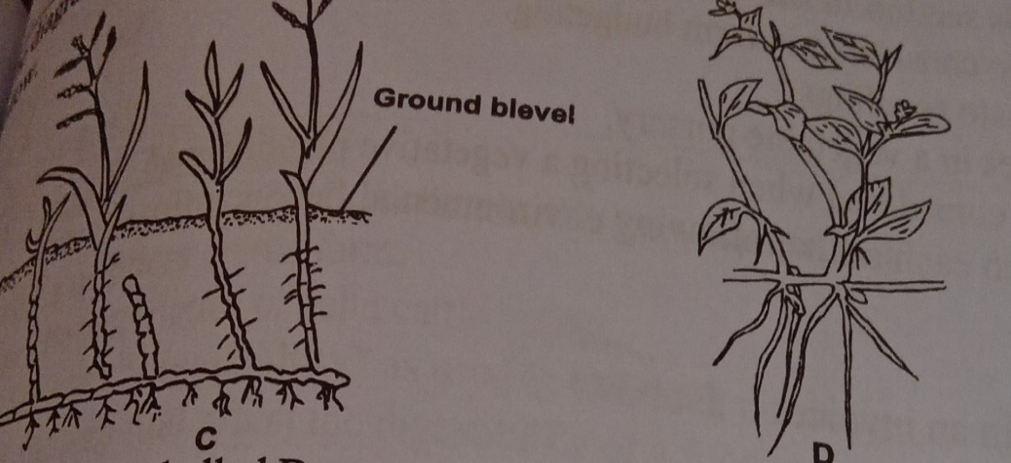
a) Identify the weeds labelled C and D. (2 marks)
C.........................................................................................................................................................
D........................................................................................................................................................
b) Classify the weed labelled C according to plant morphology. (1 mark)
........................................................................................................................................................................................................................................................................................................................
c) Give one reason why it is difficult to control the weed labelled D. (1 mark)
........................................................................................................................................................................................................................................................................................................................
d) Name the appropriate category of herbicide used to the control weed labeled C.(1 mark)
........................................................................................................................................................................................................................................................................................................................
20.The diagram illustrated below shows an activity carried out in agroforestry. Study it carefully and answer the questions that follow.
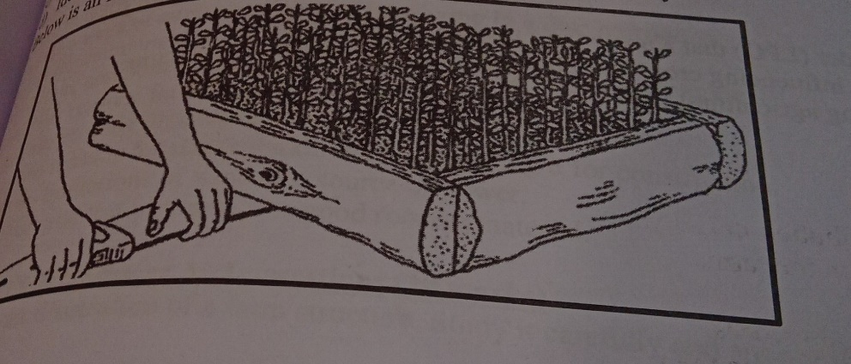
a) Identify the activity illustrated above. (1 mark)
........................................................................................................................................................................................................................................................................................................................
b) Sate two reasons for carrying out the activity identified above. (2 marks)
...................................................................................................................................................................................................................................................................................................................................................................................................................................................................................
c) Name two tools that may be used to carry out the activity illustrated above. (2 marks)
....................................................................................................................................................................................................................................................................................................................................................................................................................................................................................

SECTION C 40 MARKS
ANSWER ONLY TWO QUESTIONS IN THIS SECTION IN THE SPACES PROVIDED AFTER THE QUESTIONS
21. a) The following information was found in Mr. Kamau’s farm record for the year ending December 2014. Study it carefully and answer the questions that follow.
Bought goats 4,000
Bought poultry 15,000
Bought dairy meal 25,000
Bought pasture seeds 50,000
Transportation of farm produce 15,000
Paid casual workers 12,000
Hired an ox-plough 10,000
Opening valuation 150,000
Sale of mohair 75,000
Sale of rabbits 36,000
Sold dairy cow 70,000
Received cash from the sale of wheat 100,000
Sold cabbages 20,000
Received money from the sale of eggs 15,000
Closing valuation 200,000
i)Prepare a profit and loss account for Mr. kamau’s farm. (7 marks)
ii)Did he make a profit or loss. (1 mark)
iii) Calculate the percentage profit or loss that Mr. Kamau made. (2 marks)
b) Outline five functions of Kenya National Federation of producers in Kenya. (5 marks)
c)Explain five effects of solifluction. (5 marks)
22.a) Explain eight factors that influence the type of irrigation to be used in a farm. (8 marks)
b) Outline five importance of draining agricultural land. (5 marks)
c)Explain seven safety precautions observed when spraying herbicides. (7 marks)
23a) Explain ten functions of marketing. (10 marks)
b) Explain five factors that should be considered when deciding the depth of planting seeds. (5 marks)
c) Outline five characteristics of a green manure crop. (5 marks)
................................................................................................................................................................................................................................................................................................................................................................................................................................................................................................................................................................................................................................................................................................................................................................................................................................................................................................................................................................................................................................................................................................................................................................................................................................................................................................................................................................................................................................................................................................................................................................................................................................................................................................................................................................................................................................................................................................................................................................................................................................................................................................................................................................................................................................................................................................................................................................................................................................................................................................................................................................................................................................................................................................................................................................................................................................................................................................................................................................................................................................................................................................................................................................................................................................................................................................................................................................................................................................................................................................................................................................................................................................................................................................................................................................................................................................................................................................................................................................................................................................................................................................................................................................................................................................................................................................................................................................................................................................................................................................................................................................................................................................................................................................................................................................................................................................................................................................................................................................................................................................................................................................................................................................................................................................................................................................................................................................................................................................................................................................................................................................................................................................................................................................................................................................................................................................................................................................................................................................................................................................................................................................................................................................................................................................................................................................................................................................................................................................................................................................................................................................................................................................................................................................................................................................................................................................................................................................................................................................................................................................................................................................................................................

