AGRICULTURE
FORM 4 PP2
END TERM 2 2021

SECTION A
Answer all the questions in the space provided
Name:…………………………………………………………………ADM;……………………….
- State four advantages of using artificial incubation when hatching chicks 2mk)

- State four reasons why livestock should be weighed at weaning stage. 2mk)

- Outline four factors that affect the digestibility of a feed 2mk)

- A) Give three practices that can be carried out on wooden fences to make them durable. 1 ½)

b) Outline three disadvantages of using hedges on the farm. 1 ½)

- List four safety precautions which should be considered when using farm tools 2mk)

- Outline four factors that lower the quality of concrete. 2mk)

- State four factors that would accelerate depreciation of farm machinery. 2mk)

- Give four products of microbial digestion in the rumen of cattle 2mk)

- State four factors a farmer should consider when selecting gilt for breeding. 2mjk)

- Name the breeding system involved in each of the following cases.
- A Friesian sire from Kenya mated with a Friesian dam from Holland. 1mk)

- A Z ebu sire (father) mated with a Zebu daughter. 1mk)

- Give the functions of the following hormones in livestock.
- Oxytocin 1mk)

- Stilbesterol 1mk)

- State four advantages of a spray race over a plunge dip. 2mk)

- The dressed weight of a beef animal is 450kg and its kill out percentage is 75. Calculate its live weight. 2mk)

- Give the meaning of the following terms as used in livestock management. 11/2mk)
- Bullock

- Pullet

- Sow

- State three reasons why steaming up is done in dairy cattle. 1 1/2mk)

SECTION B
Answer all the questions in the space provided.
- The diagram below shows a cross section of brooder. Use it to answer the questions that follows

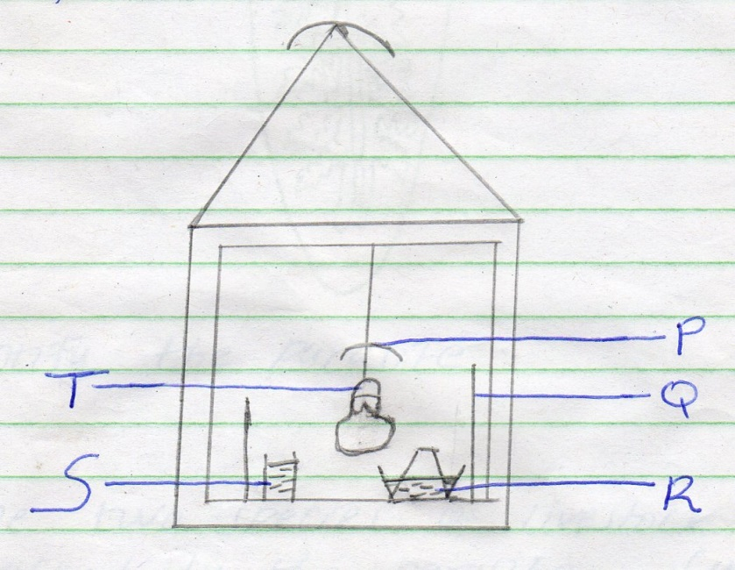

- Identify the parts labeled P,Q , R, S and T. 2MK)

- What is the purpose of the part labeled Q . 1mk)

- State two ways by which temperature in the brooder may be raised. 1mk)

- Name any material that would be suitable for use as litter in the brooder. (1/2 mk)

- The diagram below shows a livestock parasite.

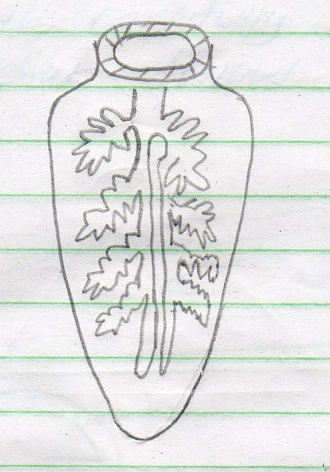

- Identify the parasite 1mk)

- Name the species of livestock commonly attacked by the parasite. 1mk)

- In which organ in the parasite found. 1mk)

- Give four symptoms of attack in livestock by the above parasite. 2mk)

- The diagram below shows a Kenya top bar hive. Study it carefully and answer the questions that follow.

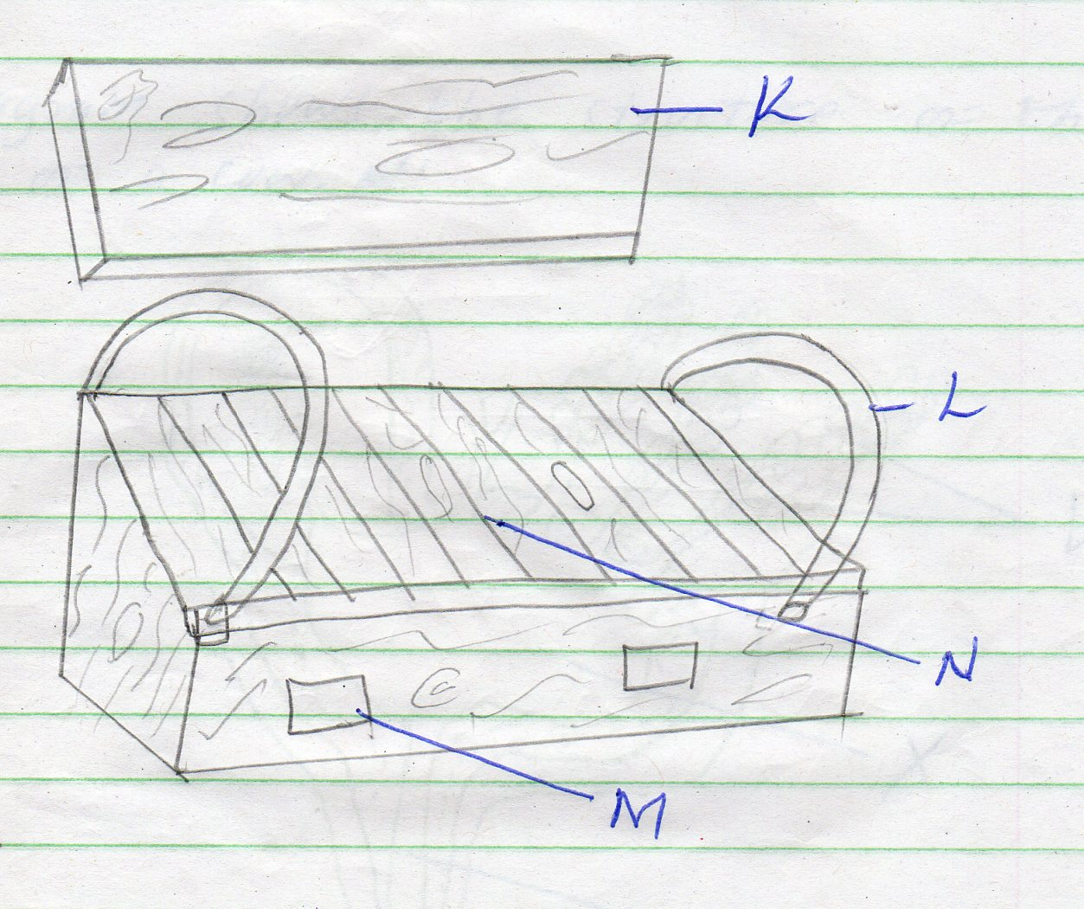

- Identify the parts labelled L and M.1mk)

- State the functions of the parts labelled K, L and N 1 ½mk)

- Name the tool used to detach honey combs from the hive during honey harvesting. 1/2mk)

- State two maintenance practices carried out on the hive. 1mk)

- How can Bees be made to colonize a new hive? 1mk)

- The diagram shows the structure of the udder of a cow.
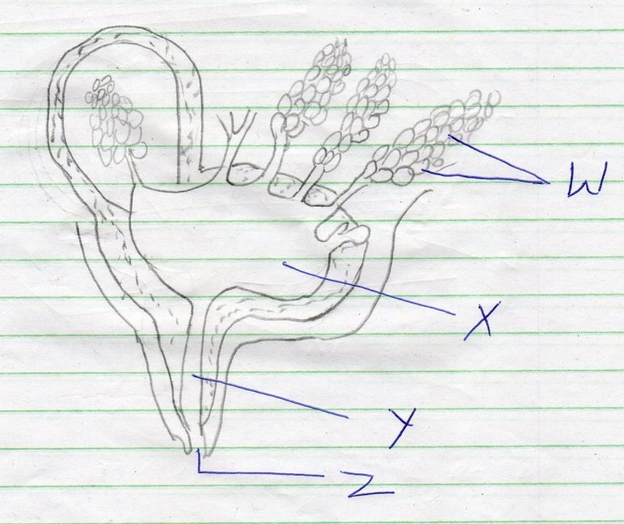

- Name the parts labelled W, X, Y and Z. 2MK)

- What is milk let down. 1mk)

- Name two hormones that control milk let down in a dairy cow. 1mk)

- What is dry cow therapy? 1mk)

SECTION C
Answer all the questions in the space provided.

- a) Described the use of the various tools required in the construction of a rabbit hutch. 10mk)

b) Describe the advantages of battery cage system of rearing layers. 10mk)

- a) Outline the methods used to control internal parasites in livestock. 7mk)

b) Discuss contagious abortion (brucellosis) under the following sub headings
- Animal species attacked. 2mk)

- Mode of trans mission 3mk)

- Symptoms 4mk)

- Control measures. 4mk)

- A)Explain the process of egg formation in the reproductive system of poultry.
10 mk)

b)describe the maintenance practices carried out on a tractor before it is put to daily use. 10mk)

