Name……………………………………………………………………….Index Number………………………………Class.………
443/2 AdmNo………………………Date………………………….
AGRICULTURE Candidates Signature…………………………
PAPER 1
2 Hours
MOKASA II EXAMINATION
Instructions to candidates
Write your name and Index number in the spaces provided. Date and signature also be filled in the spaces provided.
The paper consist with three sections A , B and C. Answer all questions in sections A and B and any Two questions in Section C. All answers be written in the spaces provided after each question. The paper has 16 printed pages.
FOR Examiner’s Use Only
Section | Question | Maximum Score | Candidate’s Score
A | 1 - 17 | 30
B | 18 - 21 | 20
C |  | 20
 |  | 20
 | Total Score | 90

SECTION A ( 30 MARKS)
Answer all the questions in this section in the spaces provided

- Give four uses of health records kept in the farm (2mks)
………………………………………………………………………………………………………………………………………………………………………………………………………………………………………………………………………………………………………………………………………………………………………………………………
- State three effects of soil organism which benefit crop growth (1¹/2mks)
………………………………………………………………………………………………………………………………………………………………………………………………………………………………………………………………………………………………
- Outline three conditions which necessitate the use of basin irrigation (1¹/2mks)
………………………………………………………………………………………………………………………………………………………………………………………………………………………………………………………………………………………………
- State four functions of 4-K clubs (2mks)
………………………………………………………………………………………………………………………………………………………………………………………………………………………………………………………………………………………………………………………………………………………………………………………………
- State three types of records that a maize farmer would keep in the farm (1¹/2mks)
………………………………………………………………………………………………………………………………………………………………………………………………………………………………………………………………………………………………
- Give three reasons why timely ploughing is important in crop production. (1¹/2mks)
………………………………………………………………………………………………………………………………………………………………………………………………………………………………………………………………………………………………
- List any three physical agents of weathering (1¹/2mks)
………………………………………………………………………………………………………………………………………………………………………………………………………………………………………………………………………………………………

- State three reasons for mulching in crop production. (1¹/2mks)
………………………………………………………………………………………………………………………………………………………………………………………………………………………………………………………………………………………………………………………………………………………………………………………………

- Distinguish between the terms
- Intercropping and mixed cropping (1mk)
……………………………………………………………………………………………………………………………………………………………………………………
- Why is gapping carried out in a field of crops? (¹/2mks)

……………………………………………………………………………………………………………………………………………………………………………………
- State four factors that contribute to the competitive ability of weeds. (2mks)
………………………………………………………………………………………………………………………………………………………………………………………………………………………………………………………………………………………………………………………………………………………………………………………………
- Outline three factors that affect the effectiveness of a pesticide (1¹/2mks)
………………………………………………………………………………………………………………………………………………………………………………………………………………………………………………………………………………………………
- Give three disadvantages of commercial land tenure system. (1¹/2mks)
………………………………………………………………………………………………………………………………………………………………………………………………………………………………………………………………………………………………
- Outline three farming practices that may lead to soil erosion. (1¹/2mks)
………………………………………………………………………………………………………………………………………………………………………………………………………………………………………………………………………………………………
- Give three reasons for conserving forage. (1¹/2mks)
………………………………………………………………………………………………………………………………………………………………………………………………………………………………………………………………………………………………

- List four methods used to drain farm land. (2mks)
………………………………………………………………………………………………………………………………………………………………………………………………………………………………………………………………………………………………………………………………………………………………………………………………

- (a) State three qualities that should be considered when selecting seeds for planting.
(1¹/2mks)
………………………………………………………………………………………………………………………………………………………………………………………………………………………………………………………………………………………………

(b) A crop is planted at a spacing of 30cm by 10cm.
Calculate the plant population in a plot of land measuring 12m by 9m
(2mks)

- List four factors that determine the depth of planting. (2mks)
………………………………………………………………………………………………………………………………………………………………………………………………………………………………………………………………………………………………………………………………………………………………………………………………

SECTIONS B (20MARKS)
Answer all questions provided in this section in the spaces provided.

- The diagrams labelled A and B below illustrates some of methods used to propagate some field crops. Study them and answer questions that follow.

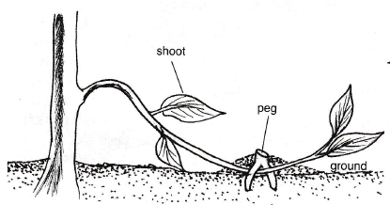

A

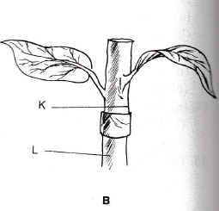

- Name the methods of propagation.
A……………………………………………………………………….. (1mk)

B……………………………………………………………………… (1mk)

- Name one crop that can be propagated using methods A and B
A…………………………………………………………………….. (¹/2mk)

B……………………………………………………………………… (¹/2mk)

- Name the parts labelled K and L in B above
K…………………………………………………………………… (1mk)

L…………………………………………………………………………(1mk)

- The diagram below illustrates common weeds in arable land. Study them well and answer questions that follow.

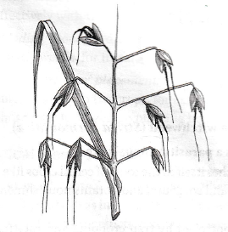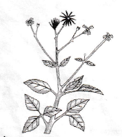
C
D

- Identify the weeds labelled C and D
C……………………………………………………………………… (1mk)

D………………………………………………………………………. (1mk)

- State two harmful effects of weed D. (2mks)
……………………………………………………………………………………………………………………………………………………………………………………
- Classify weed C according to plant morphology (1mk)
………………………………………………………………………………………….
- Study the table below and answer the questions that follow.

Land (ha) | NPK fertilizer  Inputs (kg) | Total maize  Production (90kg/bag) | Marginal  Product (90kg/bag)
1 | 0 | 10 | 0
1 | 40 | 17 | 7
1 | 80 | 33 | 16
1 | 120 | 52 | 19
1 | 160 | 64 | 12
1 | 200 | 70 | 6
1 | 240 | 73 | 3
1 | 280 | 75 | 2
1 | 320 | 75 | 0
10 | 360 | 68 | -7

- Calculate the marginal product from the table (2¹/2mks)

- At what point of fertilizer input does the law of diminishing return start to operate. (¹/2mk
……………………………………………………………………………………………………………………………………………………………………………………
- State the law of diminishing returns (1mk)
……………………………………………………………………………………………………………………………………………………………………………………
- Differentiate between variable input and fixed input. (1mk)
………………………………………………………………………………………………………………………………………………………………………………………………………………………………………………………………………………
- The diagram below illustrates a feature observed after digging the soul several meters deep. Study it carefully and answer the questions that follow.

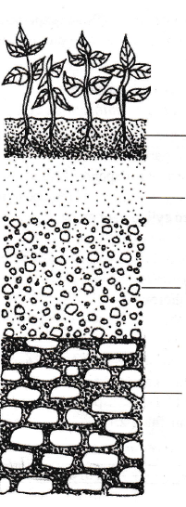
B
D
C
A
Superficial layer

- Identify the feature that the diagram above represents in the study of soil.
(1mk)
……………………………………………………………………………………………………………………………………………………………………………………

- Name the part of the diagram labelled C. (1mk)
……………………………………………………………………………………………………………………………………………………………………………………
- Identify the parts of the diagram that,
- Is a source of minerals in the soil (1mk)
……………………………………………………………………………………………………………………………………………………
- Is referred to as a layer of accumulation and roots penetration.
(1mk)
……………………………………………………………………………………………………………………………………………………
- Contain most of the plant nutrients due to the presence of living organisms. (1mk)

……………………………………………………………………………………………………………………………………………………
SECTION C (40 MARKS)
Answer any two questions from this section in the spaces provided.
- (a) Explain four ways in which trees are harvested in agroforestry (8mks)
………………………………………………………………………………………………………………………………………………………………………………………………………………………………………………………………………………………………………………………………………………………………………………………………
………………………………………………………………………………………………………………………………………………………………………………………………………………………………………………………………………………………………………………………………………………………………………………………………
………………………………………………………………………………………………………………………………………………………………………………………………………………………………………………………………………………………………………………………………………………………………………………………………
………………………………………………………………………………………………………………………………………………………………………………………………………………………………………………………………………………………………………………………………………………………………………………………………

(b) Explain seven roles of a farm manager in agricultural production. (7mks)
………………………………………………………………………………………………………………………………………………………………………………………………………………………………………………………………………………………………………………………………………………………………………………………………
………………………………………………………………………………………………………………………………………………………………………………………………………………………………………………………………………………………………………………………………………………………………………………………………
………………………………………………………………………………………………………………………………………………………………………………………………………………………………………………………………………………………………………………………………………………………………………………………………
…………………………………………………………………………………………………………………………………………………………………………………....................
………………………………………………………………………………………………………………………………………………………………………………………………………………………………………………………………………………………………………………………………………………………………………………………………
………………………………………………………………………………………………
- Describe the effects of soil erosion. (5mks)
………………………………………………………………………………………………………………………………………………………………………………………………………………………………………………………………………………………………………………………………………………………………………………………………
………………………………………………………………………………………………………………………………………………………………………………………………………………………………………………………………………………………………………………………………………………………………………………………………
………………………………………………………………………………………………………………………………………………………………………………………………………………………………………………………………………………………………………………………………………………………………………………………………
………………………………………………………………………………………………………………………………………………………………………………………………
- (a) Describe the ten problems encountered in marketing Agricultural produce
(10mks)
………………………………………………………………………………………………………………………………………………………………………………………………………………………………………………………………………………………………………………………………………………………………………………………………
………………………………………………………………………………………………………………………………………………………………………………………………………………………………………………………………………………………………………………………………………………………………………………………………
………………………………………………………………………………………………………………………………………………………………………………………………………………………………………………………………………………………………………………………………………………………………………………………………
………………………………………………………………………………………………………………………………………………………………………………………………………………………………………………………………………………………………………………………………………………………………………………………………
………………………………………………………………………………………………………………………………………………………………………………………………………………………………………………………………………………………………………………………………………………………………………………………………
………………………………………………………………………………………………………………………………………………………………………………………………………………………………………………………………………………………………………………………………………………………………………………………………
(b) State five negative effects of strong wings on crops. (5mks)
………………………………………………………………………………………………………………………………………………………………………………………………………………………………………………………………………………………………………………………………………………………………………………………………
………………………………………………………………………………………………………………………………………………………………………………………………………………………………………………………………………………………………………………………………………………………………………………………………
(c) Describe five roles of agricultural based women groups in farming. (5mks)
………………………………………………………………………………………………………………………………………………………………………………………………………………………………………………………………………………………………………………………………………………………………………………………………
………………………………………………………………………………………………………………………………………………………………………………………………………………………………………………………………………………………………………………………………………………………………………………………………

- (a) Describe the field production of irrigated rice under the following sub-headings.
- Land preparation (4mks)
…………………………………………………………………………………………………………………………………………………………………………………………………………………………………………………………………………………………………………………………………………
………………………………………………………………………………………………………………………………………………………………………………………………………………………………………………………
- Water control (3mks)
…………………………………………………………………………………………………………………………………………………………………………………………………………………………………………………………………………………………………………………………………………
(b) Explain the precautions observed during harvesting of cotton. (3mks)
…………………………………………………………………………………………………………………………………………………………………………………………………………………………………………………………………………………………………………………………………………………………………………………………………………………………..
…………………………………………………………………………………………………………………………………………………………………………………………………………………………………………………….

(c) Explain five various land tenure system practised in Kenya. (10mks)
………………………………………………………………………………………………………………………………………………………………………………………………………………………………………………………………………………………………………………………………………………………………………………………………
………………………………………………………………………………………………………………………………………………………………………………………………………………………………………………………………………………………………………………………………………………………………………………………………
………………………………………………………………………………………………………………………………………………………………………………………………………………………………………………………………………………………………………………………………………………………………………………………………
………………………………………………………………………………………………………………………………………………………………………………………………………………………………………………………………………………………………………………………………………………………………………………………………
………………………………………………………………………………………………………………………………………………………………………………………………………………………………………………………………………………………………………………………………………………………………………………………………
………………………………………………………………………………………………………………………………………………………………………………………………………………………………………………………………………………………………………………………………………………………………………………………………

