Name: .......................................................................................... Index Number ……...………
School: ................................................................... Candidate’s Signature ……………………
Date…………………………

443/1
AGRICULTURE PAPER 1

August/September, 2022.
Time: 2 hours

AGRICULTURE PAPER 443/1

ARISE AND SHINE TRIAL EXAMINATIONS
Kenya Certificate of Secondary Education (KCSE)

Instructions to Candidates
- Write your name, index number in the spaces provided.
- This paper has three sections A, B and C.
- Answer all the questions in section A and B in the spaces provided.
- Answer any two questions in section C

For Examiner’s Use Only

SECTION | QUESTIONS | MAXIMUM  SCORE | CANDIDATE’S  SCORE
A | 1 – 19 | 30
B | 20-23 | 20
C | 24-26 | 40
 | Total Score | 90

SECTION A (30 MARKS)
Answer All the Questions in This Section in the Spaces Provided

- State four farming activities that may improve soil structure. (2 marks)

............................................................................................................................................................
............................................................................................................................................................
............................................................................................................................................................
..........................................................................................................................................................
- Name three types of legume trees used as fodder. (1½ marks)
............................................................................................................................................................
............................................................................................................................................................
............................................................................................................................................................
- State three effects of low temperature on crop production. (1½ marks)
............................................................................................................................................................
............................................................................................................................................................
............................................................................................................................................................
- Give three reasons for drying grains to 21% moisture content after harvesting. (2 marks)

............................................................................................................................................................
............................................................................................................................................................
............................................................................................................................................................
- State four parameters of national economic development. (2 marks)

................................................................................................................................................................................................................................................................................................................................................................................................................................................................................................................................................................................................................................................
- Outline two conditions that favors nomadic pastoralism in Kenya. (2 marks)

............................................................................................................................................................
............................................................................................................................................................
- State three factors that determine the depth of planting seeds. (1½ marks)

............................................................................................................................................................
............................................................................................................................................................
............................................................................................................................................................

- State three factors that will determine the selectivity of herbicide in chemical weed control. (1 ½ mark)
............................................................................................................................................................
............................................................................................................................................................
...........................................................................................................................................................
- Outline four factors that affect the quality of farmyard manure. (2 marks)

............................................................................................................................................................
............................................................................................................................................................
............................................................................................................................................................
............................................................................................................................................................
- Name three basic concepts of economics (1½ marks)

............................................................................................................................................................
............................................................................................................................................................
............................................................................................................................................................
- State four importance of tissue culture. (2 marks)

............................................................................................................................................................
............................................................................................................................................................
............................................................................................................................................................
............................................................................................................................................................
- Give two methods used to drain farmland. (1 mark)

............................................................................................................................................................
............................................................................................................................................................
- State four factors to consider when designing a sound farm plan. (2 marks)

....................................................................................................................................................................................................................................................................................................................................................................................................................................................................................
............................................................................................................................................................
- Nam four improper farming methods that increase the rate of soil erosion. (2 marks)

..........................................................................................................................................................
............................................................................................................................................................

- Outline four pieces of information contained in a land title deed. (2 marks)

............................................................................................................................................................
....................................................................................................................................................................................................................................................................................................................................................................................................................................................................................
- Differentiate between a nursery bed and a seedbed. (1 mark)
............................................................................................................................................................
....................................................................................................................................................................................................................................................................................................................................................................................................................................................................................
- Name three macro nutrients whose deficiency symptoms is chlorosis. (1½ marks)
............................................................................................................................................................
............................................................................................................................................................
………………………………………………………………………………………………………
- Define Agriculture. (½ mark)

........................................................................................................................................................................................................................................................................................................................
............................................................................................................................................................
- Give two reasons for sub soiling (1 mark)
………………………………………………………………………………………………………………………………………………………………………………………………………………

SECTION B (20 MARKS)
Answer All the Questions in the Spaces Provided

- After soil sampling and testing a farmer was advised to apply 200kg of nitrogen per hectare in his 2 hectare farm. If the farmer has only diammonium phosphate (D.A.P) 18:46:0 at his disposal;
- Calculate the amount of D.A.P he would require (1½ marks)

- Calculate the amount of P205 he will have applied per hectare. (1½ marks)

- State two symptoms the farmer would have observed on the maize crops if he applied excess nitrogen. (2 marks)
.......................................................................................................................................................
.......................................................................................................................................................
- The diagram below shows a common weed plant.
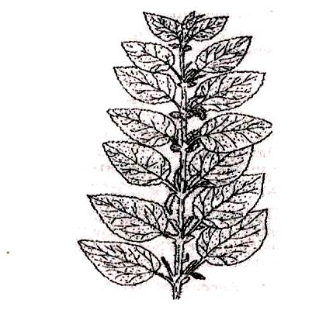
- Identify the weed………………………………………………………………………(1 mark)
- Why is it difficult to eradicate the above weed? (1 mark)
............................................................................................................................................................
............................................................................................................................................................
- Name two biological weed control methods. (2 marks)
............................................................................................................................................................
............................................................................................................................................................
- Name one economic importance of the above weed. (1 mark)
………………………………………………………………………………………………………
- The diagram below show a method of crop propagation. Study it and answer the question that follows:
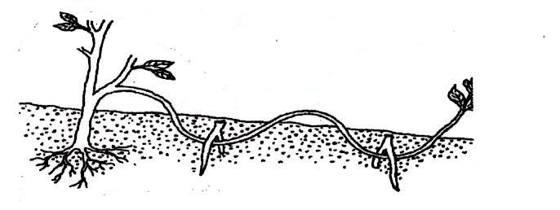

- Identify the method. (1 mark)
............................................................................................................................................................
- State one advantage of the above method over the other methods of crop propagation. (2 marks)
...........................................................................................................................................................
….………………………………………………………………………………………………….
- State three factors which influence the rooting of cutting in vegetable propagation (3 marks)
............................................................................................................................................................
………………………………………………………………………………………………………
............................................................................................................................................................
- The diagram below shows a tomato fruit affected by a pest. Study it carefully then answer the questions that follow.
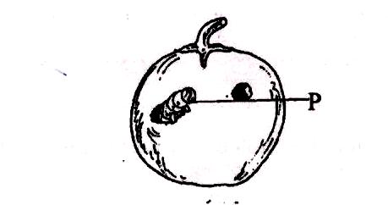
- Identify the pest labeled P. (1 mark)
……………………………………………………………………………………………………
- State two methods used to control the pest. (2 marks)
…………………………………………………………………………………………………………………………………………………………………………………………………………
- State any two factors to consider when selecting tomato fruits for marketing. (2 marks)
…………………………………………………………………………………………………………………………………………………………………………………………………………

SECTION C (40 MARKS)
Answer Any Two Questions From This Section In The Spaces Provided.

- (a) Outline the various uses of water in a mixed farm. (10 marks)
(b) Describe five methods of draining water from a marshy land. (10 marks)
- (a) Describe five field management practices carried out in tomatoes production. (10 marks)
(b) Describe five cultural practices used in soil and water conservation (10 marks)

- (a) Explain five factors that would influence the spacing of a particular crop in the field. (10 marks)
(b) Describe five practices that a farmer should carry out to ensure uniform germination of seeds (5 marks)
(c) State five factors that determine the stages of harvesting crops. (5 marks)
………………………………………………………………………………………

………………………………………………………………………………………

………………………………………………………………………………………

………………………………………………………………………………………

………………………………………………………………………………………

………………………………………………………………………………………

………………………………………………………………………………………

………………………………………………………………………………………

………………………………………………………………………………………

………………………………………………………………………………………

………………………………………………………………………………………

………………………………………………………………………………………

………………………………………………………………………………………

………………………………………………………………………………………

………………………………………………………………………………………

………………………………………………………………………………………

……………………………………………………………………………………….

………………………………………………………………………………………………………

………………………………………………………………………………………………………

………………………………………………………………………………………

……………………………………………………………………………………
………………………………………………………………………………………

………………………………………………………………………………………

………………………………………………………………………………………

………………………………………………………………………………………

………………………………………………………………………………………

………………………………………………………………………………………

………………………………………………………………………………………

………………………………………………………………………………………

………………………………………………………………………………………

………………………………………………………………………………………

………………………………………………………………………………………

………………………………………………………………………………………

………………………………………………………………………………………

………………………………………………………………………………………

………………………………………………………………………………………

……………………………………………………………………………………….

………………………………………………………………………………………………………

………………………………………………………………………………………………………

………………………………………………………………………………………
……………………………………………………………………………………

………………………………………………………………………………………

………………………………………………………………………………………

………………………………………………………………………………………

………………………………………………………………………………………

………………………………………………………………………………………

………………………………………………………………………………………

………………………………………………………………………………………

………………………………………………………………………………………

………………………………………………………………………………………

………………………………………………………………………………………

………………………………………………………………………………………

………………………………………………………………………………………

………………………………………………………………………………………

………………………………………………………………………………………

………………………………………………………………………………………

……………………………………………………………………………………….

………………………………………………………………………………………………………

………………………………………………………………………………………………………

……………………………………………………………………………………

………………………………………………………………………………………

………………………………………………………………………………………

………………………………………………………………………………………

………………………………………………………………………………………

………………………………………………………………………………………

………………………………………………………………………………………

………………………………………………………………………………………

………………………………………………………………………………………

………………………………………………………………………………………

………………………………………………………………………………………

………………………………………………………………………………………

………………………………………………………………………………………

………………………………………………………………………………………

………………………………………………………………………………………

………………………………………………………………………………………

……………………………………………………………………………………….

………………………………………………………………………………………………………

………………………………………………………………………………………………………

………………………………………………………………………………………

……………………………………………………………………………………

………………………………………………………………………………………

………………………………………………………………………………………

………………………………………………………………………………………

………………………………………………………………………………………

………………………………………………………………………………………

………………………………………………………………………………………

………………………………………………………………………………………

………………………………………………………………………………………

………………………………………………………………………………………

………………………………………………………………………………………

………………………………………………………………………………………

………………………………………………………………………………………

………………………………………………………………………………………

………………………………………………………………………………………

………………………………………………………………………………………

……………………………………………………………………………………….

………………………………………………………………………………………………………

………………………………………………………………………………………………………

………………………………………………………………………………………
..……………………………………………………………………………………

………………………………………………………………………………………

………………………………………………………………………………………

………………………………………………………………………………………

………………………………………………………………………………………

………………………………………………………………………………………

………………………………………………………………………………………

………………………………………………………………………………………

………………………………………………………………………………………

………………………………………………………………………………………

………………………………………………………………………………………

………………………………………………………………………………………

………………………………………………………………………………………

………………………………………………………………………………………

………………………………………………………………………………………

………………………………………………………………………………………

………………………………………………………………………………………

………………………………………………………………………………………

………………………………………………………………………………………

………………………………………………………………………………………

………………………………………………………………………………………

………………………………………………………………………………………

………………………………………………………………………………………

………………………………………………………………………………………

………………………………………………………………………………………

