Name ………………………..……………………………… Index No…………………………..

School ………………………………………………... Sign………………………………..

LONDIANI SUB COUNTY JOINT EXAM
443/1
AGRICULTURE
AUGUST/SEPTEMBER 2022
Paper 1
Time: 2 Hours

INSTRUCTION TO CANDIDATES
- Write your name and index number in the spaces provided above.
- Sign and write the date of Examination in the space provided.
- This paper consists of three sections A, B and C.
- Answer ALL the questions in section A and B.
- Answer TWO questions in section C in the spaces provided.

FOR EXAMINER’S USE ONLY.
SECTION | QUESTIONS | MAXIMUM SCORE | CANDIDATES SCORE
A | 1 – 16 | 30
B | 17 – 20 | 20
C | 21 – 23 | 20  20
TOTAL SCORE |  | 90

SECTION A(30 MARKS)
Answer ALL questions in this section
1.Name four advantages of organic farming (2marks)
…………………………………………………………………………………………………………………………………………………………………………………………………………………………………………………………………………………………………………………………………………………………………………………………………………………………………………
2.Name four categories of livestock farming (2marks) …………………………………………………………………………………………………………………………………………………………………………………………………………………………………………………………………………………………………………………………………………………………………………………………………………………………………………
3.Name three forms of horticulture practiced in Kenya (1½ marks) ………………………………………………………………………………………………………………………………………………………………………………………………………………………………………………………………………
4. Name the part harvested for each of the following crops
a) Onions (½ mark) ………………………………………………………………………………………………………… b) Carrots (½ mark) ………………………………………………………………………………………………………… c) Coffee (½ mark) …………………………………………………………………………………………………………
5.State four disadvantages of broadcasting of seed s during planting (2marks) …………………………………………………………………………………………………………………………………………………………………………………………………………………………………………………………………………………………………………………………………………………………………………………………………………………………………………
6.Name four ways in which land reforms can be implemented in Kenya (2marks) …………………………………………………………………………………………………………………………………………………………………………………………………………………………………………………………………………………………………………………………………………………………………………………………………………………………………………
7.State four factors that determine the choice of water pipes used in the farm (2marks) …………………………………………………………………………………………………………………………………………………………………………………………………………………………………………………………………………………………………………………………………………………………………………………………………………………………………………
8.State four ways in which mulching conserve water (2marks) …………………………………………………………………………………………………………………………………………………………………………………………………………………………………………………………………………………………………………………………………………………………………………………………………………………………………………
9.Name four records that should be kept in a poultry farmer (2marks) …………………………………………………………………………………………………………………………………………………………………………………………………………………………………………………………………………………………………………………………………………………………………………………………………………………………………………
10.State four reasons for applying phosphatic fertilizers during planting (2marks) …………………………………………………………………………………………………………………………………………………………………………………………………………………………………………………………………………………………………………………………………………………………………………………………………………………………………………
11.State four characteristics of a good site of a nursery bed (2marks) …………………………………………………………………………………………………………………………………………………………………………………………………………………………………………………………………………………………………………………………………………………………………………………………………………………………………………
12.State four ways in which crop pest can be classified (2marks) …………………………………………………………………………………………………………………………………………………………………………………………………………………………………………………………………………………………………………………………………………………………………………………………………………………………………………
13.State four classes of weeds (2marks) …………………………………………………………………………………………………………………………………………………………………………………………………………………………………………………………………………………………………………………………………………………………………………………………………………………………………………
14.State four management practices undertaken to improve natural pastures (2marks) …………………………………………………………………………………………………………………………………………………………………………………………………………………………………………………………………………………………………………………………………………………………………………………………………………………………………………
15.State four disadvantages of using organic manure on crop production (2marks) …………………………………………………………………………………………………………………………………………………………………………………………………………………………………………………………………………………………………………………………………………………………………………………………………………………………………………
16.What is meant by the term preference and choice as used in agricultural economics? (1mark) ………………………………………………………………………………………………………………………………………………………………………………………………………………………………………………………………………………………………………………………………

SECTION B (20MARKS)
Answer ALL questions in this section
17.The diagrams below illustrate some field practices carried out on certain crops
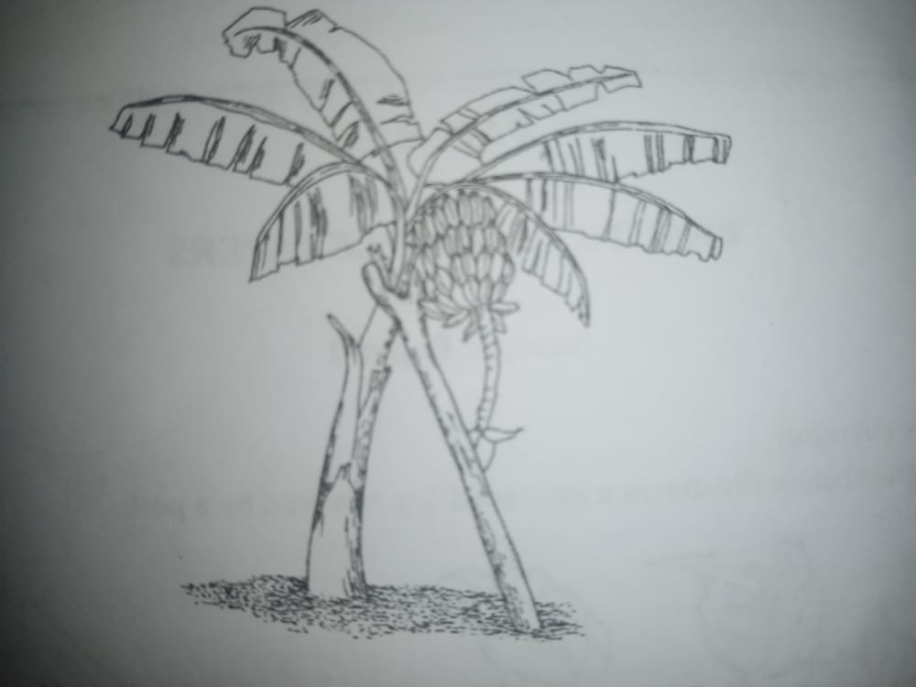
A B
- Identify the practices illustrated in diagram A and B
A………………………………………………………………………………………… (1mark)
B……………………………………………………………………………………… (1mark)
- State two problems faced by the farmers who do not carry out practice B (2marks) ……………………………………………………………………………………………………………………………………………………………………………………………………
- Explain pruning practices of a banana stool (1mark) ………………………………………………………………………………………………………………………………………………………………………………………………………………………………………………………………………………………………………

18.The diagram below illustrates a soil profile
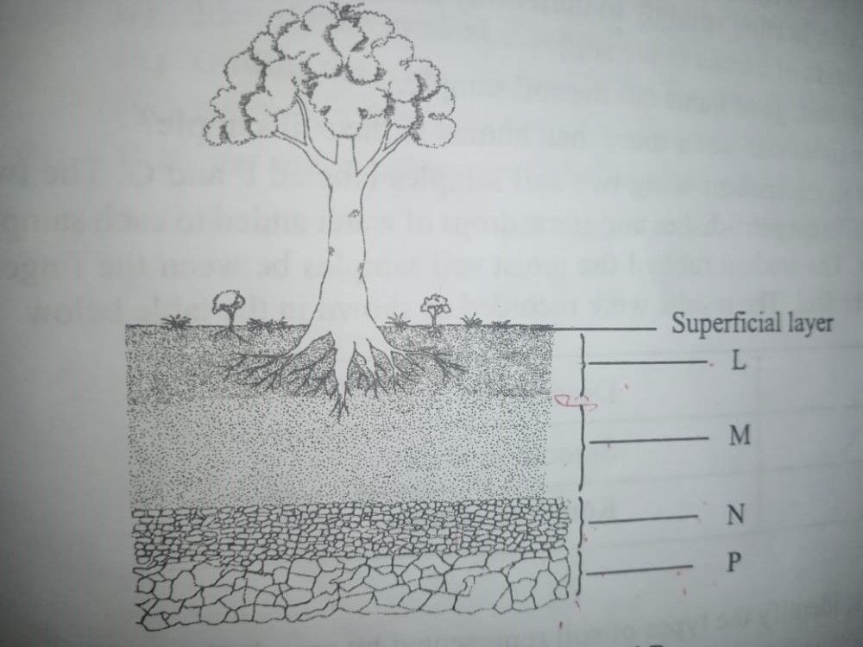
a)Identify the layers labelled M,N and P
M…………………………………………………………………………….. (1mark)
N…………………………………………………………………………….. (1mark)
P …………………………………………………………………………….. (1mark)
b) State one characteristic of the layer labelled L (1mark) …………………………………………………………………………………………………………
c) Name the zone found between two adjoining layers(horizons) (1mark) …………………………………………………………………………………………………………
19.The diagram illustrates a certain property of different types of soils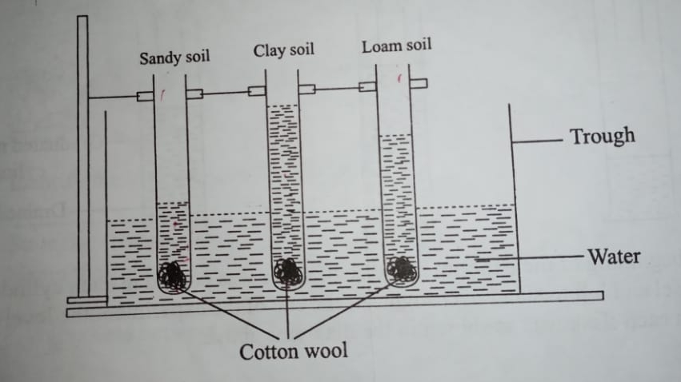
a)State the property investigated in the diagram (1mark) …………………………………………………………………………………………………………
b) In which of the three soils would water rise very fast at the beginning of the experiment and the rise stop within hours. (1mark) …………………………………………………………………………………………………………
c) From the diagram what conclusion would be made in regard to the three soil types and the property being investigated? (3marks) …………………………………………………………………………………………………………………………………………………………………………………………………………………………………………………………………………………………………………………………………………………………………………………………………………………………………………

20.In a maize production enterprise carried out over a period of eight years, a farmer used one hectare of land each time and applied different quantities of DAP fertilizer.DAP fertilizer costs ksh.2500 per 50kgs bag and the harvested maize is sold at ksh.3000 per 90kg bag. The quantities of DAP fertilizer applied and maize harvested are as shown in thus table below.

DAP fertilizer input in 50kg bag | Maize yield in 90kg bags | Total revenue khs | Total cost kshs | Marginal revenue Kshs | Marginal cost kshs
0 | 15.0 | 45000 | 0 | 0 | 0
1 | 35.6
2 | 52.0
3 | 68.5
4 | 71.0
5 | 71.5
6 | 71.5
7 | 68.5
a)complete the table by determining the values of total revenue, total cost, marginal revenue and marginal cost (2marks)
b)From the information in your table, how can the farmer determine the level of production at which profit is maximum? (1mark)
…………………………………………………………………………………………………………
…………………………………………………………………………………………………………
c)At the production level that yield maximum profit, what was the value of each of the following?
i)DAP fertilizer input (1mark) …………………………………………………………………………………………………………
ii)Marginal revenue (1mark) …………………………………………………………………………………………………………

SECTION C(40MARKS)
Answer TWO questions from this section
21.a) Describe cultural methods of controlling soil erosion (8marks)
b)Describe harvesting of tea (7marks)
c)Give five reasons for land registration (5marks)
22.a) State five ways of improving labour productivity in the farm (5marks)
b) State five roles if magnesium in crop production (5marks)
c) Describe five reasons why early defoliation is discouraged in pasture utilization. (5marks)
d) Describe five harmful effects of crop pest (5marks)
23.a) Explain importance of irrigation farming (5marks)
b) State five characteristics of variable inputs (5marks)
c) Describe the harvesting and marketing of bulb onions (5marks)
d) State five disadvantages of communal land tenure system (5marks)
……………………………………………………………………………………………………………………………………………………………………………………………………………………………………………………………………………………………………………………………………………………………………………………………………………………………………………………………………………………………………………………………………………………………………………………………………………………………………………………………………………………………………………………………………………………………………………………………………………………………………………………………………………………………………………………………………………………………………………………………………………………………………………………………………………………………………………………………………………………………………………………………………………………………………………………………………………………………………………………………………………………………………………………………………………………………………………………………………………………………………………………………………………………………………………………………………………………………………………………………………………………………………………………………………………………………………………………………………………………………………………………………………………………………………………………………………………………………………………………………………………………………………………………………………………………………………………………………………………………………………………………………………………………………………………………………………………………………………………………………………………………………………………………………………………………………………………………………………………………………………………………………………………………………………………………………………………………………………………………………………………………………………………………………………………………………………………………………………………………………………………………………………………………………………………………………………………………………………………………………………………………………………………………………………………………………………………………………………………………………………………………………………………………………………………………………………………………………………………………………………………………………………………………………………………………………………………………………………………………………………………………………………………………………………………………………………………………………………………………………………………………………………………………………………………………………………………………………………………………………………………………………………………………………………………………………………………………………………………………………………………………………………………………………………………………………………………………………………………………………………………………………………………………………………………………………………………………………………………………………………………………………………………………………………………………………………………………………………………………………………………………………………………………………………………………………………………………………………………………………………………………………………………………………………………………………………………………………………………………………………………………………………………………………………………………………………………………………………………………………………………………………………………………………………………………………………………………………………………………………………………………………………………………………………………………………………………………………………………………………………………………………………………………………………………………………………………………………………………………………………………………………………………………………………………………………………………………………………………………………………………………………………………………………………………………………………………………………………………………………………………………………………………………………………………………………………………………………………………………………………………………………………………………………………………………………………………………………………………………………………………………………………………………………………………………………………………………………………………………………………………………………………………………………………………………………………………………………………………………………………………………………………………………………………………………………………………………………………………………………………………………………………………………………………………………………………………………………………………………………………………………………………………………………………………………………………………………………………………………………………………………………………………………………………………………………………………………………………………………………………………………………………………………………………………………………………………………………………………………………………………………………………………………………………………………………………………………………………………………………………………………………………………………………………………………………………………………………………………………………………………………………………………………………………………………………………………………………………………………………………………………………………………………………………………………………………………………………………………………………………………………………………………………………………………………………………………………………………………………………………………………………………………………………………………………………………………………………………………………………………………………………………………………………………………………………………………………………………………………………………………………………………………………

