443/1
AGRICULTURE PAPER 1 – MARKING SCHEME
TRIAL 1 - SEPTEMBER 2022
SECTION A (30 MARKS)
Answer All the Questions in This Section in the Spaces Provided

- State four farming activities that may improve soil structure. (2 marks)
- Mulching
- Intercropping
- Minimum tillage.
- Fallow cropping.
- Organic faming
- Agroforestry
- Cover cropping
- Name three types of legume trees used as fodder. (1½ marks)
- Leucaenea leucocephala
- Sesbania sesban
- Calliandia callothyrsus
- State three effects of low temperature on crop production. (1½ marks)
- Reduces rate of growth
- Lowers quality of crops like pyrethrum.
- Lowers quality of fruits e.g. citrus, pineapple.
- Increases incidence of fungal diseases.
- Give three reasons for drying grains to 21% moisture content after harvesting. (2 marks)
- Prevent sprouting while in store. – prevent attack by Aflatoxin fungi
- Reduce incidence of attack by boring pest.
- Prevent rotting.
- State four parameters of national economic development. (2 marks)
- National income
- Per capita income
- Literacy level
- Gender parity
- Level of technology
- Quality of life
- Outline two conditions that favors nomadic pastoralism in Kenya. (2 marks)
- Presence of large tracks of grassland
- Communal land ownership
- Large size of household herds
- Large size of household land
- State three factors that determine the depth of planting seeds. (1½ marks)
- Size of the seeds
- Type of soil
- Amount of soil moisture
- Type of germination.
- State three factors that will determine the selectivity of herbicide in chemical weed control. (1 ½ mark)
- Stage of growth of the plant.
- Plant morphology.
- Plant anatomy
- Mode of action of herbicide.
- Weather condition.
- Herbicide formulation.
- Outline four factors that affect the quality of farmyard manure. (2 marks)
- Type of animal used.
- Type of food eaten.
- Type of litter used
- Method of storage.
- Age of farmyard.
- Name three basic concepts of economics (1½ marks)
- Scarcity
- Preference and choice
- Opportunity cost.
- State four importance of tissue culture. (2 marks)
- Mass production of propagules.
- Establish pathogen free plants.
- Establish fast.
- Requires less space.
- Give two methods used to drain farmland. (1 mark)
- Open ditches
- Underground drain pipes.
- French drains.
- Cambered beds.
- Pumping.
- Planting trees.
- State four factors to consider when designing a sound farm plan. (2 marks)
- Size of the farm
- Farmer’s objectives and preferences
- Environmental factors
- Security
- Government policy
- Market conditions
- Availability of inputs.
- Nam four improper farming methods that increase the rate of soil erosion. (2 marks)
- Ploughing up and down the hill.
- Continuous cropping.
- Growing annual crops in steep areas.
- Clean weeding.
- Deforestation.
- Burning of vegetation
- Overstocking.
- Outline four pieces of information contained in a land title deed. (2 marks)
- Date of registration
- Number of title deed.
- Size of the land.
- Condition of ownership if any.
- Type of ownership.
- Seal and signature of issuing officer.
- Differentiate between a nursery bed and a seedbed. (1 mark)
- Nursery bed is a special type of seedbed prepared to raise seedlings before transplanting while seedbed is a piece of land which has been prepared ready to receive planting materials.
- Name three macro nutrients whose deficiency symptoms is chlorosis. (1½ marks)
- Nitrogen
- Magnesium
- Sulphur
- Potassium
- Define Agriculture. (½ mark)
- Agriculture is the art and science of crops and livestock production.
- Give two reasons for sub soiling (1 mark)
- To facilitate drainage.
- Bring up leached nutrients to the surface.
- Increase aeration of soil.
- Improve root penetration.

SECTION B (20 MARKS)
Answer All the Questions in the Spaces Provided

- After soil sampling and testing a farmer was advised to apply 200kg of nitrogen per hectare in his 2 hectare farm. If the farmer has only diammonium phosphate (D.A.P) 18:46:0 at his disposal;
- Calculate the amount of D.A.P he would require (1½ marks)

100kg of D.A.P contains 18kg of Nitrogen
Xkg of D.A.P X 200kg of Nitrogen (½ mark)

X = 200 X100 X 2 ha (½ mk)
18
= 2222.2kg of D.A.P (½ mark)

- Calculate the amount of P205 he will have applied per hectare. (1½ marks)

100kg of D.A.P contains 46kg of P₂ O₅

1111.1kg of D.A.P contains X of P₂ O₅ (½ mark)

1,111.1 kg DAPx 46kgP₂O₅ ( ½ )
100kg DAP
= 511kg P₂O₅
- State two symptoms the farmer would have observed on the maize crops if he applied excess nitrogen. (2 marks)
  - Scorching of the leaves.
  - Wreak stem/lodging of the crop
  - Delayed flowering/maturity.
  - Excessive foliage.

- The diagram below shows a common weed plant.
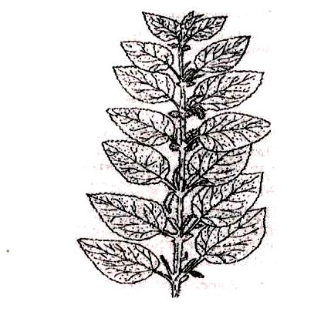
- Identify the weed - Stinging nettle/urtica massaica (1 mark)
- Why is it difficult to eradicate the above weed? (1 mark)
- It irritates the workers thus reducing the efficiency in which they are controlled.
- They have underground horizontal root stems (Rhizomes)

- Name two biological weed control methods. (2 marks)
- Use of livestock/ goats to graze and control the growth of weeds in plantation crops e.g. coconuts and cashew nuts.
- Use of certain weed eating fish to control aquatic weeds.
- Use of moths to control cactus.
- Name one economic importance of the above weed. (1 mark)
- Increases cost f production.
- Has medicinal value
- Used as vegetable
- The diagram below show a method of crop propagation. Study it and answer the question that follows:

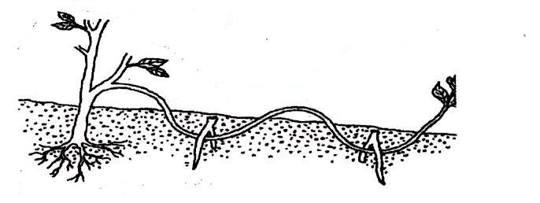
- Identify the method. (1 mark)
- Compound layering /serpentive layering.

- State one advantage of the above method over the other methods of crop propagation. (2 marks)
- More than one planting materials can be obtained from one branch.
- State three factors which influence the rooting of cutting in vegetable propagation (3 marks)
- Relative humidity
- Temperature
- Oxygen supply
- Light.
- Chemicals e.g. hormones

- The diagram below shows a tomato fruit affected by a pest. Study it carefully then answer the questions that follow.
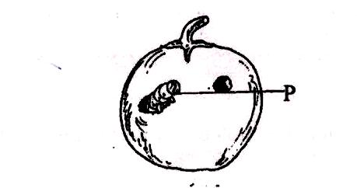
- Identify the pest labeled P. (1 mark)
- American bollworm.
- State two methods used to control the pest. (2 marks)
- Chemical method.
- Early planting
- Rogueing.
- Trap-cropping
- State any two factors to consider when selecting tomato fruits for marketing. (2 marks)
- Degree of ripening
- Colour
- Size
- Shape
- Wholesomeness
- Whether processing or fres market variety.

SECTION C (40 MARKS)
Answer Any Two Questions From This Section In The Spaces Provided.

- (a) Outline the various uses of water in a mixed farm. (10 marks)
- Used for irrigation.
- Watering livestock.
- Domestic use
- Processing farm produce.
- Rearing aquatic organisms such as fish.
- Recreational purposes
- Building and construction.
- Washing farm tools and equipment.
- Cooling engines.
- Generating electricity.
- Driving machines such as water pumps (hydram).

(b) Describe five methods of draining water from a marshy land. (10 marks)
- Use of open ditches; channels are dug in the field, excess water from the adjacent soil drains into the ditch/ channels and then into a water way/river.
- Use of cambered beds; these are raised beds with a trench on either side, excess water drains from the raised soil into the trenches.
- Pumping; excess water is lifted using a mechanical force (pump) into a water way/river.
- Planting trees that use a lot of water; those absorb the excess water and loose it into the atmosphere.
- Use of French drains; these are ditches filled with stones then covered with soil, excess water drains from the soil into the ditch. Crops can be grown on top of the ditches.
- Use of porous pipes; these are put in the soil slanting towards a river, excess water drains from the soil into the pipe through the perforations.

- (a) Describe five field management practices carried out in tomatoes production. (10 marks)
- Pests and disease control using appropriate methods.
- Irrigation during the dry periods, morning and evening.
- Control weeds timely and appropriately.
- Regular pruning.
- Gapping;
- apply nitrogenous fertilizer at the right stage and amount.
- Staking; provide support to tall varieties using appropriate methods.

(b) Describe five cultural practices used in soil and water conservation (10 marks)
- Grass strips; these are strips of land along the contours planted with grass.
- Cover cropping; practice of growing crop that provide ample soil cover.
- Contour farming; this is where all farming practices are done along the contours.
- Strip cropping; this is where strips of crops with poor soil cover are alternated with those of crops with good soil cover.
- Mulching; this is the practice of placing organic/inorganic materials on the soil surface.
- Planting of trees; practice of planting trees in deforested areas or where they never existed.
- (a) Explain five factors that would influence the spacing of a particular crop in the field. (10 marks)
- Number of seeds per whole; the higher the number the wider the spacing.
- Soil moisture content; the higher the soil moisture content the closer the spacing.
- Growth habit of the crop; spreading varieties require wider spacing compared to non-spreading varieties.
- Level of soil nutrients; the higher the level of soil nutrients, the closer the spacing.
- Machinery to be used; in case machines are to be used in subsequent operations, wider spacing is advisable.
- Intended use of the crop; crops grown for human food requires wider spacing than for other uses.

(b) Describe five practices that a farmer should carry out to ensure uniform germination of seeds (5 marks)
- Pre-germinating the seeds.
- Leveling the seedbed.
- Uniform depth of planting.
- Use of certified seeds/proper seed selection.
- Uniform irrigation.
(c) State five factors that determine the stages of harvesting crops. (5 marks)
- Purpose of the crop.
- Concentration of required chemicals.
- Moisture content of the crop.
- Prevailing weather conditions.
- Market demand of the crop.

