AGRICULTURE PAPER 1 END OF TERM 2 2021
SECTION A 30MARKS
1. Give two positive effects of wind in agriculture. 1mk

2. Give a reason why nitrogenous fertilizers should be applied on a wet soil; 1mk

3. State two reasons for drying grains before storage. 1mk

4. State three disadvantages of planting seeds using broadcasting method. 1 ½ mks

5. Differentiate between apiculture and aquaculture. 1mk

6. State two excellent adaptations of weeds to their environment. 1mk

7. Give three reasons as to why earthing up is done in crop production. 1 ½ mks

8. Name four roles played by trees in soil and water conservation. 2mks

9. List three methods applied in clearing land before ploughing. 1 ½ mks

10. State three advantages of using tissue culture in crop production. 1 ½ mks

11. State three factors which influence the efficiency of pesticides. 1/ ½ mks

12. Give four disadvantages of land fragmentation in farming. 2mks

13. List three characteristics that should be met by plants to be used for green manure making. 1 ½ mks

14. State three disadvantages of metallic water pipes. 1 ½ mks

15. Name two ways through which overhead irrigation is carried out in the farm. 1mk

16. Name three diseases that attack tomato plants. 1 ½ mks

17. State three benefits of large scale farming. 1 ½ mks

18. List four farm records kept by a dairy cattle farmer. 2mks

19. State three reasons why burning of vegetation is not recommended during land preparation. 3mks

20. Give three conditions that limit the use of mulch in crop production. 1 ½ mks

SECTION B 20 MARKS
21. Below is a diagram of a nursery for raising tomato seedlings.

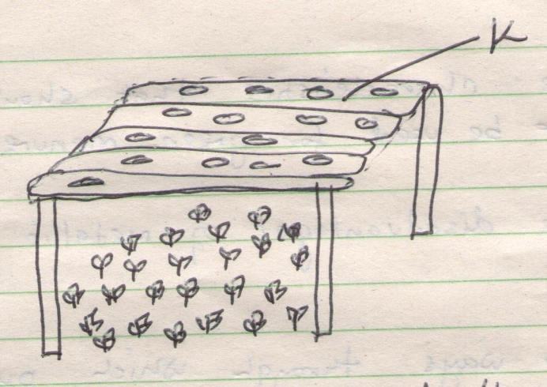

i. Name the part labeled K. 1mk

ii. State two advantages of part labelled K. 2mks

iii. Give three management practices that should be carried on the nursery from the time seedlings emerge to the stage of transplanting. 3mks

22. The diagram below shows a physiological condition in tomatoes. Use it to answer the questions that follow.

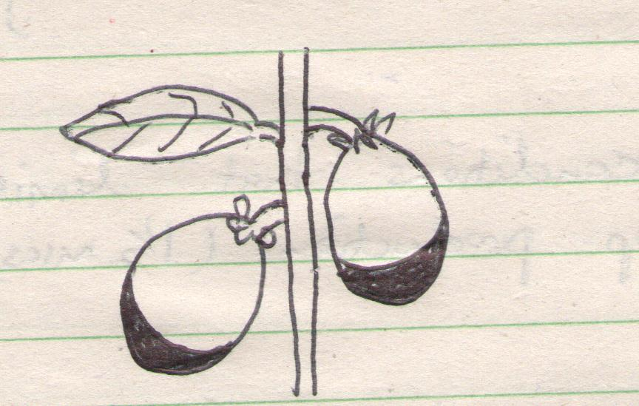

a. Identify the condition. 1mk

b. Give three causes of the condition identified in (a). 3mks

23. The illustrations labelled S and T below show some structural methods used in soil and water conservation.
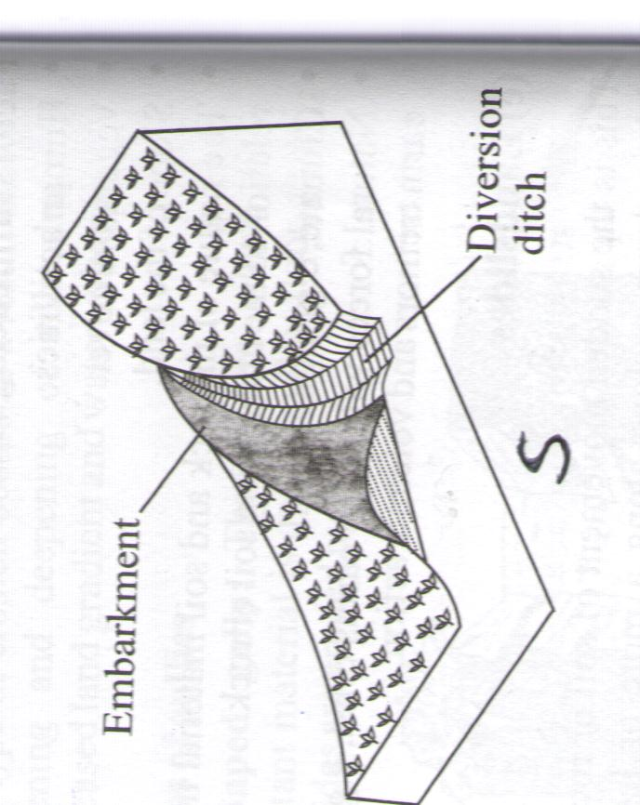
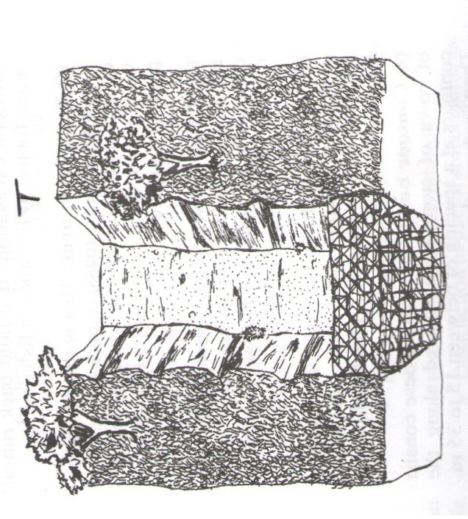

i. Identify the structures S and T. 1mk

ii. State the function of the embarkment in the diagram S. 1mk

iii. State two ways in which structure T help to control soil erosion. 1mk

iv. State four methods of harvesting water on the farms. 2mks

24. The diagram below shows a method of drainage. Study it and answer the questions that follow.
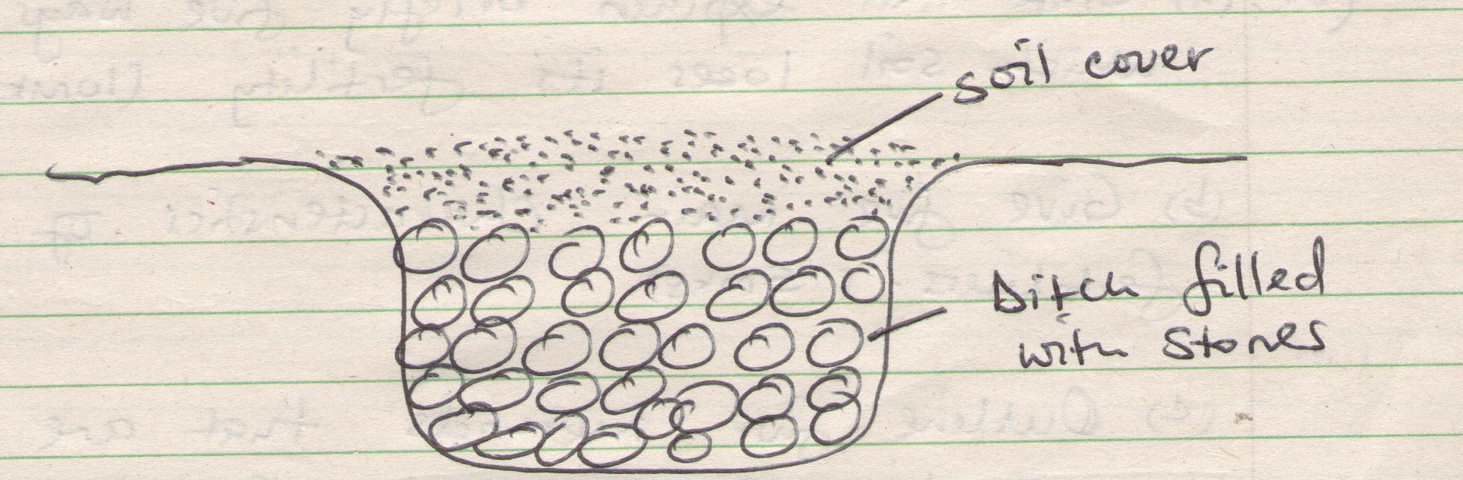

a. Identify the method of drainage shown above. 1mk

b. Other than the method shown in (a, list four other methods used in draining farmland. 2mks
c. Outline four reasons for draining farmland. 2mks

SECTION C - ANSWER ANY TWO QUESTIONS FROM THIS SECION. 40 MARKS
25.a) Discuss maize production under the following sub heading.
i. Seedbed preparation . 3mks

ii. Planting of maize

iii. Field management practices. 6mks

iv. Preparation of maize before storage. 2mks

b. Discuss three methods used to treat seeds in order to break seed dormancy. 6mks

26.a) State and explain briefly five ways through which soil loses its fertility. 10mks

b. Give five main characteristics of nitrogenous fertilizers. 5mks

c. Outline five methods that are used in application of inorganic fertilizer. 5mks

27.a) Discuss the advantages of land consolidation and registration. 8mks

b. Discuss the cultural methods of pest control in crops. 12mks

End

