NAME:……………………………………………………………………ADM NO……………….
DATE: ………………….
443/2
AGRICULTURE
FORM FOUR
TIME : 2 HOURS
MID TERM 1 2022
MAY 2022 EXAMINATION

INSTRUCTIONS TO CANDIDATES:
- This paper consists of three sections; A, B and C
- Answer ALL the questions in sections A and B
- Answer any TWO questions in section C
- All answers to be written in English

FOR OFFICIAL USE ONLY
SECTION | QUESTION | MAX. SCORE | CANDIDATE SCORE
A | 1 – 18 | 30
B | 19 – 22 | 20
C | 23 – 25 | 40
 | TOTAL | 90

SECTION A (30 MARKS)
Answer all the questions in this section in the spaces provided.
- Name causal agent of anaplasmosis disease in cattle (1/2 mk)

- State four reasons for castration in pigs (2 mks)

- State four characteristics of roughage livestock feeds (2 mks)

- State four roles of worker bee in a colony (2 mks)

- State one function for each of the following
- Shovel (1/2 mk)

- Strip cup (1/2 mk)

- Give three ways in which infectious diseases can spread from one livestock to another within a farm. (1 ½ mk)

- Name three methods that are used in selection of breeding stock in livestock production. (1 ½ mk)

- Name one livestock disease that is transmitted by each of the following parasites
- Blue ticks (1/2 mk)

- Brown ear ticks (1/2 mk)

- Tsetse flies (1/2 mk)

- State four methods of controlling round worms (Ascaris sp) in livestock (2 mks)

- Apart from hides, name the raw materials obtained from each of the following livestock for the textile industry.
- Goat (1/2 mk)

- Sheep (1/2 mk)

- Rabbit (1/2 mk)

- Name two nutritional diseases of cattle (1 mk)

- State four signs of infestation by external parasites in goats (2 mks)

- Give four disadvantages of inbreeding in livestock. (2 mks)

- Name four parts of a farm building that can be reinforced using concrete (2 mks)

- State four advantages of fish farming in Kenya (2 mks)

- State four disadvantages of using plunge dips in tick control (2 mks)

- Name the complementary tool for each of the following tools named below.
- Trochar (1/2 mk)

- Hand – drill (1/2 mk)

- Hypodermic needle (1/2 mk)

- (a). Name two livestock diseases controlled through embryo transplant (1 mk)

(b). Give the meaning of the following terms as used in livestock breeding
(i) Close breeding (1/2 mk)

(ii) Line breeding (1/2 mk)

SECTION B (20 MARKS)
Answer all the questions in this section in the spaces provided.
- Below is a diagram illustrating the reproductive system of a bull. Study it and answer the questions that follow.

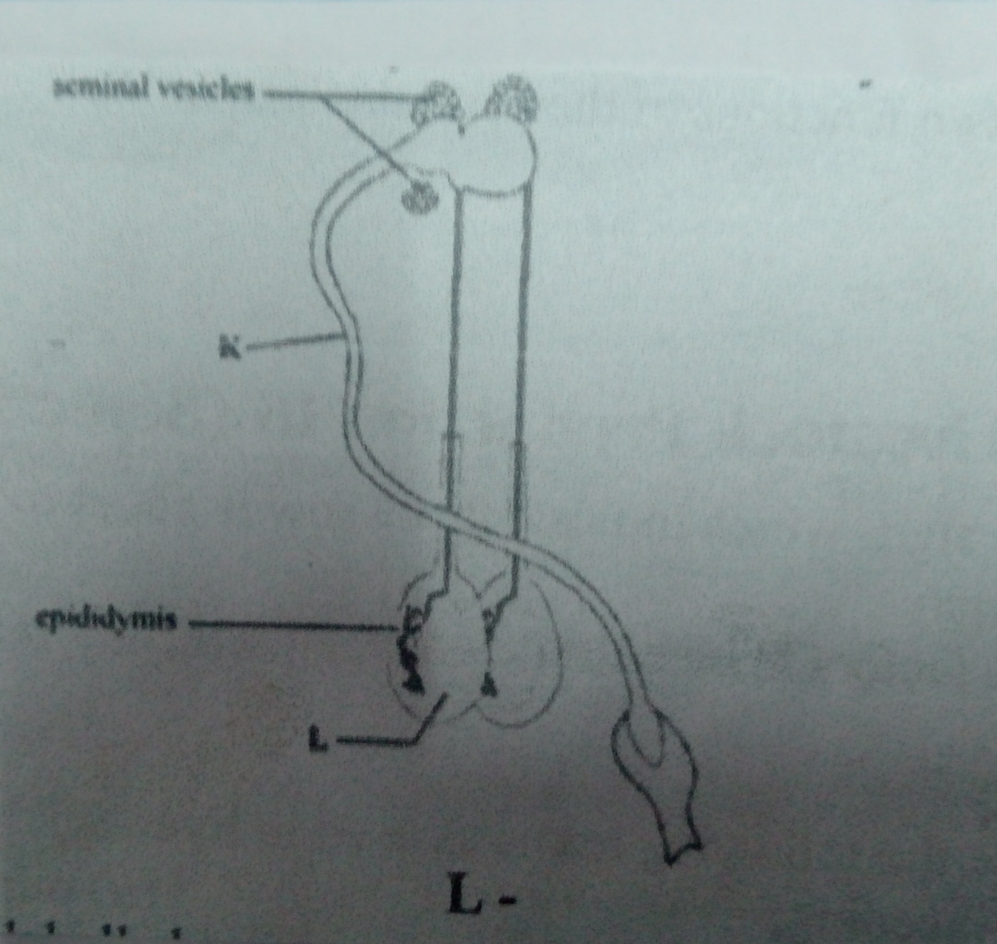

(a). Identify the parts labelled
K (1 mk)

L (1 mk)
(b). State the functions of the part labelled
Epididymis (1 mk)

Seminal vesicles (1 mk)

(c ) Name the tool used to collect semen from the livestock (1 mk)

- The illustration below shows a cross section of a cattle dip.

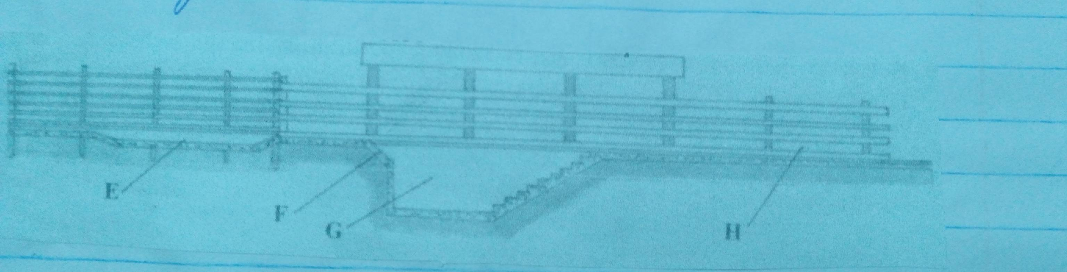

(a). Name the parts labelled E and G
E (1 mk)

G (1 mk)

(b). State one use for each of the parts labelled E, F and H
E (1 mk)

F (1 mk)

H (1 mk)

- The diagram below represents farm tools and equipment. Study them and answer the questions that follow.

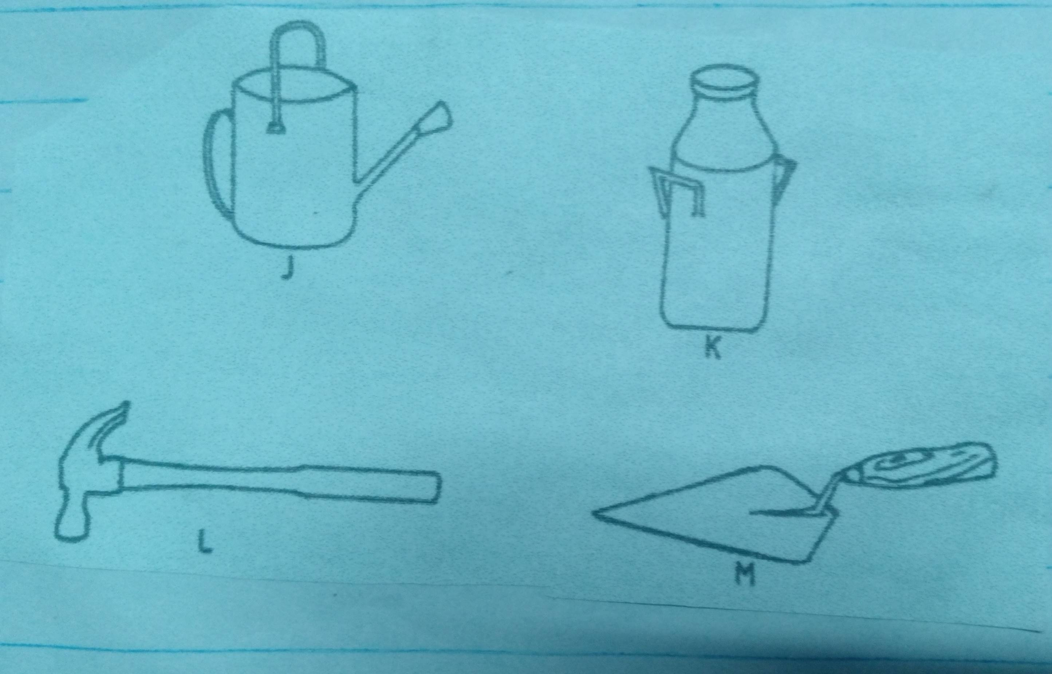

(a). Identify the tool/equipment labelled M and J
M (1 mk)

J (1 mk)

(b). State one use for each of the tool/ equipment labelled K and L.
K (1 mk)

L (1 mk)

(c). Give two maintenance practices for the equipment labelled K (1 mk)

- The diagram below represents livestock parasites

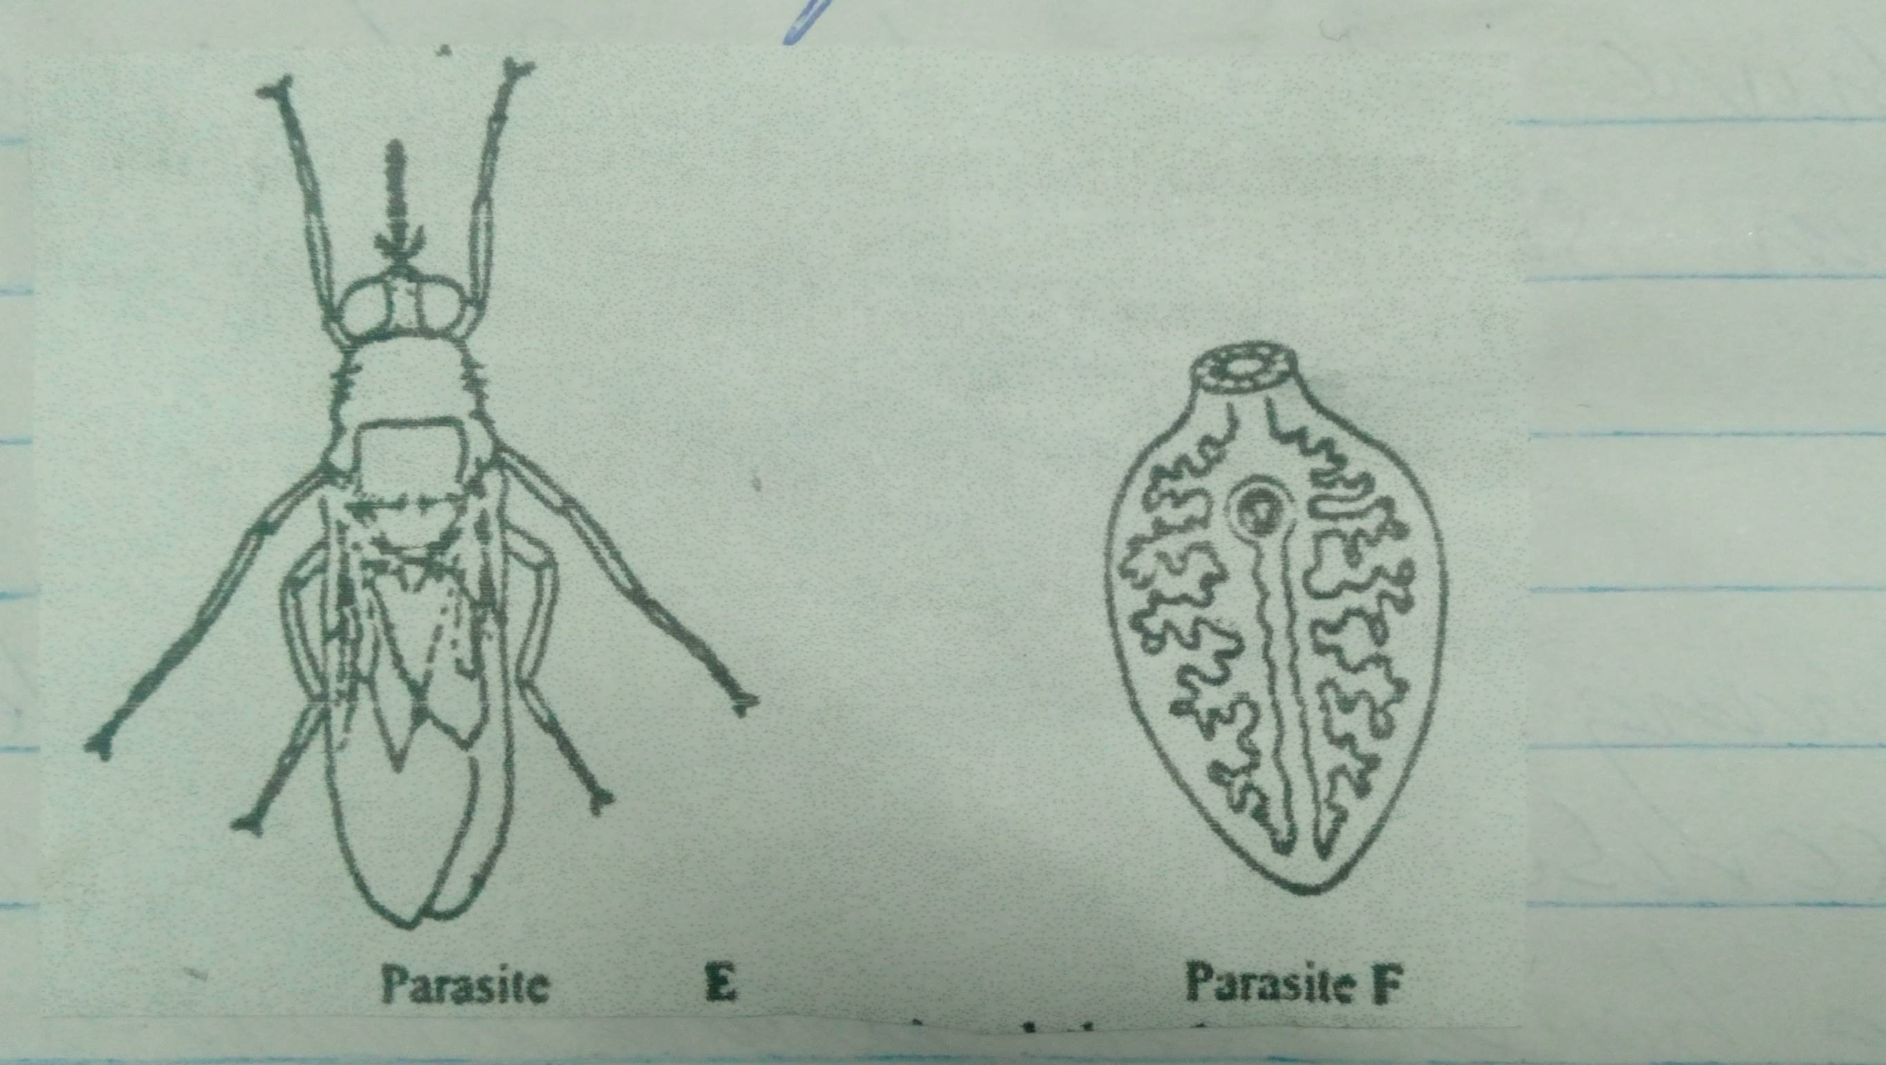
(i). Identify parasite E (1/2 mk)

(ii). State three symptoms that may be observed in an animal that has been attacked by parasite F. (3 mks)

(iii). Name the intermediate host for parasite F. (1/2 mk)

(iv). Give one control measure of each parasite. (1 mk)

SECTION C (40 MARKS)
Answer any two questions from this section in the spaces provided after question 25.
- (a). Describe the uses of fences on the farm (10 mks)
(b). Explain the factors considered when culling livestock. (5 mks)
(c). Give five harmful effects of liver flukes in sheep rearing. (5 mks)

- (a). Giving a relevant example in each case, describe the role of the various components of a balanced diet in livestock nutrition. (10 mks)
(b). Outline the general characteristics of indigenous cattle (5 mks)
(c ). Explain hoe physiological factors are used as a sign of ill or good health. (5 mks)
- (a). Describe East Coast Fever under the following sub – headings.
(i). Livestock affected (1 mk)
(ii). Vector and causal organisms (2 mks)
(iii). Signs of attack (5 mks)
(iv). Control measures (2 mks)
(b). Outline the procedure followed when hand spraying cattle to ensure effective use of acaricides to control ticks. (10 mks)

………………………………………………………………………………………………………………………………………………………………………………………………………………………………………………………………………………………………………………………………………………………………………………………………………………………………………………………………
………………………………………………………………………………………………………………………………………………………………………………………………………………………………………………………………………………………………………………………………………………………………………………………………………………………………………………………………
………………………………………………………………………………………………………………………………………………………………………………………………………………………………………………………………………………………………………………………………………………………………………………………………………………………………………………………………
………………………………………………………………………………………………………………………………………………………………………………………………………………………………………………………………………………………………………………………………………………………………………………………………………………………………………………………………
………………………………………………………………………………………………………………………………………………………………………………………………………………………………………………………………………………………………………………………………………………………………………………………………………………………………………………………………
………………………………………………………………………………………………………………………………………………………………………………………………………………………………………………………………………………………………………………………………………………………………………………………………………………………………………………………………
………………………………………………………………………………………………………………………………………………………………………………………………………………………………………………………………………………………………………………………………………………………………………………………………………………………………………………………………
………………………………………………………………………………………………………………………………………………………………………………………………………………………………………………………………………………………………………………………………………………………………………………………………………………………………………………………………
………………………………………………………………………………………………………………………………………………………………………………………………………………………………………………………………………………………………………………………………………………………………………………………………………………………………………………………………
………………………………………………………………………………………………………………………………………………………………………………………………………………………………………………………………………………………………………………………………………………………………………………………………………………………………………………………………
………………………………………………………………………………………………………………………………………………………………………………………………………………………………………………………………………………………………………………………………………………………………………………………………………………………………………………………………
………………………………………………………………………………………………………………………………………………………………………………………………………………………………………………………………………………………………………………………………………………………………………………………………………………………………………………………………
………………………………………………………………………………………………………………………………………………………………………………………………………………………………………………………………………………………………………………………………………………………………………………………………………………………………………………………………
………………………………………………………………………………………………………………………………………………………………………………………………………………………………………………………………………………………………………………………………………………………………………………………………………………………………………………………………
………………………………………………………………………………………………………………………………………………………………………………………………………………………………………………………………………………………………………………………………………………………………………………………………………………………………………………………………
………………………………………………………………………………………………………………………………………………………………………………………………………………………………………………………………………………………………………………………………………………………………………………………………………………………………………………………………
………………………………………………………………………………………………………………………………………………………………………………………………………………………………………………………………………………………………………………………………………………………………………………………………………………………………………………………………
………………………………………………………………………………………………………………………………………………………………………………………………………………………………………………………………………………………………………………………………………………………………………………………………………………………………………………………………
………………………………………………………………………………………………………………………………………………………………………………………………………………………………………………………………………………………………………………………………………………………………………………………………………………………………………………………………
THIS IS THE LAST PRINTED PAGE.

