AGRICULTURE - GRADE 7 EXAMS TERM 1 2023
- Different devices that can be made to keep off wild animals from destroying crops and harming domestic animals are called (1mk)
- What is a seedbed? (2mks)
- List down two ways of controlling soil erosion. (2mks)
- Identify the type of seedbed mainly used to conserve moisture (1mk)
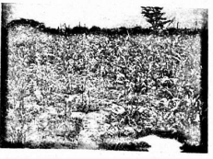
- State two factors to consider when sorting and preparing seeds as planting materials (2mks)
- List two routine practices when rearing small domestic animals. (2mks)
- What is organic gardening? (2mks)
- Identify the gardening practice that involves replacing dead seedlings in the seedbed (1mk)
- Zani a Grade six pupil at Tewa Primary school listed importance of ornamental gardening. Name two of them. (2mks)
- Identify two causes of soil pollution in the agricultural environment (2mks)
- List two ways of practicing safe soil pollution control measures. (2mks)
- Grade 7 pupils from Gedi Junior Secondary school visited a nearby farm. They noted the farm had a shallow depression filled with water. The water conservation method is known as __________________ (1mk)
- What do you understand by the term surface run-off. (2mks)
- List one importance of small wild animals. (1mk)
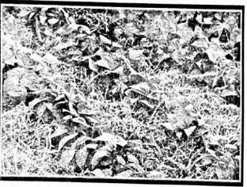
- The gardening practice from the diagram above is __________________ (1mk).
- State the meaning of Agroforestry. (1mk)
- List two ways in which farm tools and equipment are maintained. (2mks)
- Identify one minimum tillage practice. (1mk)
- Give an example of an indigenous vegetable. (1mk)
- Describe one precaution observed during construction of a water retention pit. (1mk)

MARKING SCHEME
- Deterrent
- This is permanent home for the seedling where they grow to maturity

  - Strip farming
  - contour ploughing
  - terracing
  - building of gabions
  - cover cropping and mulching.
- Shallow pits
- Size, health, free from diseases and pests

  - vaccination
  - feeding balanced diet (any other correct)
- Organic gardening refers to a system of growing crops using natural farming techniques and materials instead of artificial chemicals.
- Gapping

  - Source of food
  - for beauty
  - source of fresh air
  - source of income e.t.c

  - Oil spillage
  - Poor disposal of plastic bags
  - Excessive use of fertilisers e.t.e

  - Minimal use of fertilisers
  - Proper disposal of plastic bags
- Earth basin
- Water on the ground after heavy rainfall
- Source of revenue
- Mulching
- This is the practice of growing crops together with trees.

  - Sharpening
  - Oiling
  - Proper storage e.t.c

  - slashing
  - uprooting
  - mulching
- Pigweed

  - A fence should be constructed around the retention pit
  - Should not be extremely deep.

