COMPETENCY BASEDCURRICULUM
GRADE 5 TERM 1 2023 – AGRICULTURE ACTIVITIES

- a. Name the three types of soil (3 marks)

  - State two characteristics of clay soil (2 marks)

  - Name the type of soil suitable for farming (1 mark)

  - Outline 3 uses of soil (3 marks)

- a. Give an example of a plant that can be grown in the following types of soil
- Clay soil (1 mark)
- Sandy Soil ( 1 mark)

- Loam Soil (1 mark)
- Describe any two methods used in watering seedlings (2 marks)

- Explain the meaning of the term weed. (2 marks)

- Why is mulching Important? (1 mark)

- Below is demonstration of the ability of soil to hold water.
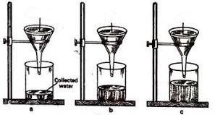
Name soil:
- a (1 mark)
- b (1 mark)
- c (1mark)

- a. You are provide with the following materials
- old sack
- sewing thread
- dry grass
- buttons
- hanging pole
Use the above materials and construct a scarecrow or model the scarecrow. (10 marks)

b. Show three uses of water in farming (3 marks)

c. Mention 3 tools that are used to prepare a seedbed (3 marks)

- a. Differentiate between a seed and seedling (2 marks)

b. Explain the reason why we dry seeds before putting them in seedbed. (2 mark)

(TOTAL 40 marks)

