NAME: …………………………………………………….. SCHOOL……………............

ADM NO:………………………… DATE:……………….. SIGNATURE………….……

443/2
AGRICULTURE
THEORY
PAPER 2
FORM FOUR
TIME: 2 Hours

CATHOLIC DIOCESE OF KAKAMEGA EVALUATION TEST.
AUG/SEPT EXAM 2022,

INSTRUCTIONS TO CANDIDATES
1. Write your name and index number in the spaces provided above
2. Sign and write the date of examination in the spaces provided.
3. This paper consists of THREE sections; A, B, and C.
4. Answer all questions in sections A and B.
5. Answer any TWO questions in section C.
6. All the questions should be answered in the spaces provided

For Examiners’ Use Only

Section | Questions | Maximum Score | Candidates score
A | 1-12 | 30
B | 13-16 | 20
C |  | 20
 |  | 20
TOTAL SCORE |  | 90

SECTION A: (30 MARKS) Answer ALL questions in this section

1. (a) Name three factors that dictate distribution of livestock in Kenya. (1½ mks)

………………………………………………………………………………………………………

………………………………………………………………………………………………………

………………………………………………………………………………………………………

………………………………………………………………………………………………………

(b) Name a breed of goats that is brown in colour with two white stripes running from the eyes to the nose. (1/2 mks)

………………………………………………………………………………………………………

2. (a) Give two reasons why proper storage of tools is important. (1mk)

………………………………………………………………………………………………………

………………………………………………………………………………………………………

(b) Name two tools that are recommended for layout and marking. (1mk)

………………………………………………………………………………………………………

………………………………………………………………………………………………………

3. (a) How does a vaccine work? (1mk)

………………………………………………………………………………………………………

………………………………………………………………………………………………………

……………………………………………………………………………………………………

(b) What causes the following conditions in livestock?
(i) Osteomalacia (½ mk)

………………………………………………………………………………………………………

(ii) Parturient paresis (milk fever) (1/2 mk)

………………………………………………………………………………………………………

4. Name four tick borne diseases in livestock. (2mks)

………………………………………………………………………………………………………

………………………………………………………………………………………………………

………………………………………………………………………………………………………

………………………………………………………………………………………………………
5. (a) What is the function of esophageal groove in a ruminant (1mk)

………………………………………………………………………………………………………

(b) List two methods of ration computation. (2mks)

………………………………………………………………………………………………………

………………………………………………………………………………………………………

6. State four advantages of using contemporary comparison as a method of selection in livestock. (2mks)

………………………………………………………………………………………………………

………………………………………………………………………………………………………

………………………………………………………………………………………………………

………………………………………………………………………………………………………

7. (a) What is a notifiable disease? (1/2mks)

………………………………………………………………………………………………………

(b) List three examples of notifiable diseases. (1½mks)

………………………………………………………………………………………………………

………………………………………………………………………………………………………

………………………………………………………………………………………………………

8. Give four causes of high mortality in Piglets. (2mks)

………………………………………………………………………………………………………

………………………………………………………………………………………………………

………………………………………………………………………………………………………

………………………………………………………………………………………………………

9. (a) State two disadvantages of using metal frames in construction of farm building. (1mk)

………………………………………………………………………………………………………

………………………………………………………………………………………………………

(b) List any two wood preservatives. (1mk)

………………………………………………………………………………………………………

………………………………………………………………………………………………………
10. (a) State four factors to consider when selecting eggs for incubation. (2mks)

………………………………………………………………………………………………………

………………………………………………………………………………………………………

………………………………………………………………………………………………………

………………………………………………………………………………………………………

(b) State four functions of the egg shell. (2mks)

………………………………………………………………………………………………………

………………………………………………………………………………………………………

………………………………………………………………………………………………………

………………………………………………………………………………………………………

11. (a) State four qualities of colostrum which make it suitable for feeding newly born calf. (2mks)
………………………………………………………………………………………………………

………………………………………………………………………………………………………

………………………………………………………………………………………………………

………………………………………………………………………………………………………

(b) What is dry cow therapy? (1mk)

………………………………………………………………………………………………………

………………………………………………………………………………………………………

………………………………………………………………………………………………………

12. (a) State four field conditions under which a disc plough is preferred instead of mouldboard plough. (2mks)

………………………………………………………………………………………………………

………………………………………………………………………………………………………

………………………………………………………………………………………………………

………………………………………………………………………………………………………

(b) Name four implements that are operated by the power take off (P.T.O) shaft. (2mks)

………………………………………………………………………………………………………

………………………………………………………………………………………………………

………………………………………………………………………………………………………

………………………………………………………………………………………………………

SECTION B (20 MARKS)
Answer ALL questions in this section

13. The diagram below shows an auger bit. Use it to answer questions that follow:

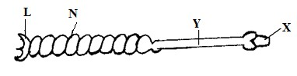

(a) Name the part labelled X and Y. (2mks) X:……………………………………………………………………………………..

Y:………………………………………………………………………………………

(b) Give the function of the part labelled N. (1mk)

N……………………………………………………………………………………………

(c) List two other bits other than the one shown above. (2mks)

………………………………………………………………………………………………………

………………………………………………………………………………………………………

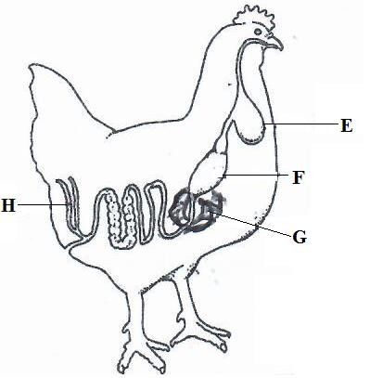14. The diagram below shows the digestive system in poultry. Use it to answer the following questions.

(a) Name the parts labelled E and H. (2mks)

E:…………………………………………H:…………………………………………
(b) Give the function of part F. (1mk)

………………………………………………………………………………………………………

………………………………………………………………………………………………………

(c) State two ways in which the part labelled G is adapted to its function. (2mks)

………………………………………………………………………………………………………

………………………………………………………………………………………………………

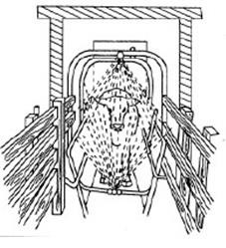15. The diagram below shows a routine practice being carried out on an animal. Study it and answer the questions that follow.

(a) Identify the practice. (1mk)

………………………………………………………………………………………………………

(b) Name the structure in which the practice is being carried out. (1mk)

………………………………………………………………………………………………………

(c) State three advantages of using the above structure instead of plunge dip. (3mks)

………………………………………………………………………………………………………

………………………………………………………………………………………………………

………………………………………………………………………………………………………
16. Study the picture of the system of rearing poultry and use it to answer questions that follow:

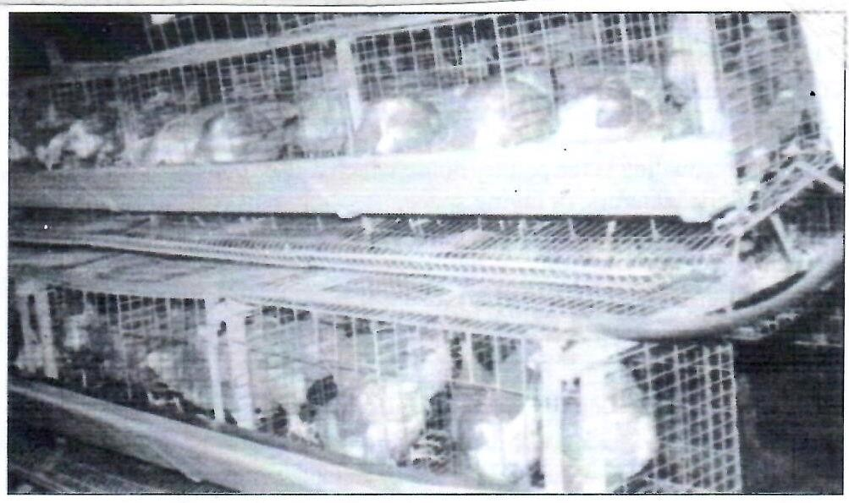

(a) Identify the system of poultry rearing shown above. (1mk)

………………………………………………………………………………………………………

(b) Name two other systems of rearing poultry apart from the one shown above. (2mks)

………………………………………………………………………………………………………

………………………………………………………………………………………………………

(c) State two advantages of using the above system. (2mks)

………………………………………………………………………………………………………

………………………………………………………………………………………………………
SECTION C (40 MARKS)
Answer ANY TWO questions from this section

17. (a) Describe gumboro disease under the following sub-headings
(i) | Animals affected | (1mk)
(ii) | Causal organism | (1mk)
(iii) | Incubation | (1mk)
(iv) | Symptoms of attack | (5mks)
(v) | Control | (2mks)

………………………………………………………………………………………………………

………………………………………………………………………………………………………

………………………………………………………………………………………………………

………………………………………………………………………………………………………

………………………………………………………………………………………………………

………………………………………………………………………………………………………

………………………………………………………………………………………………………

………………………………………………………………………………………………………

………………………………………………………………………………………………………

………………………………………………………………………………………………………

………………………………………………………………………………………………………

………………………………………………………………………………………………………

………………………………………………………………………………………………………

………………………………………………………………………………………………………

………………………………………………………………………………………………………

………………………………………………………………………………………………………

………………………………………………………………………………………………………

(b) Describe five characteristic of Romney marsh dual purpose sheep. (5mks)

………………………………………………………………………………………………………

………………………………………………………………………………………………………

………………………………………………………………………………………………………

………………………………………………………………………………………………………

………………………………………………………………………………………………………

………………………………………………………………………………………………………

………………………………………………………………………………………………………

………………………………………………………………………………………………………

(c) State five functions of the lubrication system. (5mks)

………………………………………………………………………………………………………

………………………………………………………………………………………………………

………………………………………………………………………………………………………

………………………………………………………………………………………………………

………………………………………………………………………………………………………

………………………………………………………………………………………………………

………………………………………………………………………………………………………

………………………………………………………………………………………………………

………………………………………………………………………………………………………

………………………………………………………………………………………………………

………………………………………………………………………………………………………

………………………………………………………………………………………………………

………………………………………………………………………………………………………

………………………………………………………………………………………………………
18. (a) Describe how natural incubation is carried out and managed. (8mks)

………………………………………………………………………………………………………

………………………………………………………………………………………………………

………………………………………………………………………………………………………

………………………………………………………………………………………………………

………………………………………………………………………………………………………

………………………………………………………………………………………………………

………………………………………………………………………………………………………

………………………………………………………………………………………………………

………………………………………………………………………………………………………

………………………………………………………………………………………………………

………………………………………………………………………………………………………

………………………………………………………………………………………………………

………………………………………………………………………………………………………

………………………………………………………………………………………………………

………………………………………………………………………………………………………

………………………………………………………………………………………………………

………………………………………………………………………………………………………
………………………………………………………………………………………………………

………………………………………………………………………………………………………

………………………………………………………………………………………………………

………………………………………………………………………………………………………

(b) Explain seven mechanical methods of controlling ticks. (7mks)

………………………………………………………………………………………………………

………………………………………………………………………………………………………

………………………………………………………………………………………………………

………………………………………………………………………………………………………

………………………………………………………………………………………………………

………………………………………………………………………………………………………

………………………………………………………………………………………………………

………………………………………………………………………………………………………

………………………………………………………………………………………………………

………………………………………………………………………………………………………

………………………………………………………………………………………………………

………………………………………………………………………………………………………

(c)State five advantages of embryo transplant. (5mks)

………………………………………………………………………………………………………

………………………………………………………………………………………………………

………………………………………………………………………………………………………

………………………………………………………………………………………………………

………………………………………………………………………………………………………

………………………………………………………………………………………………………

………………………………………………………………………………………………………

………………………………………………………………………………………………………

………………………………………………………………………………………………………

………………………………………………………………………………………………………

………………………………………………………………………………………………………

19. (a) Describe the procedure of training a calf for bucket feeding. (7mks)

………………………………………………………………………………………………………

………………………………………………………………………………………………………

………………………………………………………………………………………………………

………………………………………………………………………………………………………

………………………………………………………………………………………………………

………………………………………………………………………………………………………

………………………………………………………………………………………………………

………………………………………………………………………………………………………

………………………………………………………………………………………………………

………………………………………………………………………………………………………

………………………………………………………………………………………………………

………………………………………………………………………………………………………

………………………………………………………………………………………………………

………………………………………………………………………………………………………

………………………………………………………………………………………………………

………………………………………………………………………………………………………

(b) Describe Eight measures to be observed when handling bees. (8mks)

………………………………………………………………………………………………………

………………………………………………………………………………………………………

………………………………………………………………………………………………………

………………………………………………………………………………………………………

………………………………………………………………………………………………………

………………………………………………………………………………………………………

………………………………………………………………………………………………………

………………………………………………………………………………………………………

………………………………………………………………………………………………………

………………………………………………………………………………………………………

………………………………………………………………………………………………………

………………………………………………………………………………………………………

………………………………………………………………………………………………………

(c) State five signs of ill-health observed on the animal’s skin and coat. (5mks).

………………………………………………………………………………………………………

………………………………………………………………………………………………………

………………………………………………………………………………………………………

………………………………………………………………………………………………………

………………………………………………………………………………………………………

………………………………………………………………………………………………………
………………………………………………………………………………………………………

………………………………………………………………………………………………………

………………………………………………………………………………………………………

………………………………………………………………………………………………………

………………………………………………………………………………………………………

………………………………………………………………………………………………………

