Name: ……………………………………………………………Index No.:………......………….........
School.: …………………………… Class…………………….Candidate’s Sign:…………………….
Date: …..………………………......………
443/2
AGRICULTURE
PAPER 2
JUNE-2022
TIME: 2HOURS
CEKENAS END OF TERM ONE EXAM-2022
FORM FOUR
Kenya Certificate of Secondary Education. (K.C.S.E)
AGRICULTURE
PAPER 2
TIME: 2 HOURS
INSTRUCTIONS TO THE CANDIDATES
- Write your name and index number in the spaces provided above.
- This paper consists of three sections;-A, B and C.
- Answer all questions in section A and B and any two questions in section C
- All answers must be written in the spaces provided.
- This paper consist of 12 printed pages.
- Candidates should check the question papers to ascertain that all the pages are printed as indicated and that no questions are missing.
- Candidates should answer the questions in English.

For Examiners Use Only
Section | Questions | Maximum Score | Candidates Score
A | 1-16 | 30
B | 17-20 | 20
C | 21 | 20
 | 22 | 20
 | 23 | 20
Total score |  | 90

SECTION A (30MARKS)
ANSWER ALL QUESTIONS IN THIS SECTION

1. Name the breed of goat kept for hair production (1mk) …………………………………………………………………………………………
2. State two ways in which barbed wire fence may be reinforced in the farm 1mk)
………………………………………………………………………………………… …………………………………………………………………………………………
3. Broadly classify two causes of infertility in a herd of cattle (1mk)
…………………………………………………………………………………………
…………………………………………………………………………………………
4. Name the tool that is used together with the following as a pair (1mk) a) Hypodermic needle ……………………………………………………
b) Elastrator ……………………………………………………
5. Name four signs of anthrax observed in carcass of cattle (2mks)
…………………………………………………………………………………………
…………………………………………………………………………………………
…………………………………………………………………………………………
…………………………………………………………………………………………
6. Name four ways by which cannibalism in poultry could be avoided (2mks)
…………………………………………………………………………………………
…………………………………………………………………………………………
…………………………………………………………………………………………
…………………………………………………………………………………………
7. Name the intermediate host of the following parasites (1mk)
a) Tapeworm ……………………………………….
b) Liver fluke ……………………………………….
8. a) List down two groups of cattle that are susceptible to milk fever (1mk)
…………………………………………………………………………………………
…………………………………………………………………………………………
b) Give two situations which may necessitate the preparation of artificial
colostrum (1mk)
…………………………………………………………………………………………
…………………………………………………………………………………………
c) Give two uses of gears in a tractor. (1mk)
…………………………………………………………………………………………
…………………………………………………………………………………………
9. a) List two tools used for laying concrete blocks when constructing a wall (1mk)
…………………………………………………………………………………………
…………………………………………………………………………………………
b) List four characteristics of clean, high quality milk (2mks)
…………………………………………………………………………………………
…………………………………………………………………………………………
…………………………………………………………………………………………
…………………………………………………………………………………………
10. a) What is the cause of grass staggers in animals (1mk)
…………………………………………………………………………………………
…………………………………………………………………………………………
b) Give the meaning of the following terms as used in livestock health (2mks)
i) Incubation period
…………………………………………………………………………………………
…………………………………………………………………………………………
ii) Mortality rate
…………………………………………………………………………………………
…………………………………………………………………………………………
11. a) Write down two common examples of chemical causes of diseases among
livestock (2mks)
…………………………………………………………………………………………
…………………………………………………………………………………………
…………………………………………………………………………………………
…………………………………………………………………………………………
b) Name two main parts of a farm buildings (1mk)
…………………………………………………………………………………………
…………………………………………………………………………………………
c) Name the breed rabbit with black nose, ears and tail but the body is white
(1mk)
…………………………………………………………………………………………
12. a) State two uses of a footbath in a cattle dip (1 mk)
…………………………………………………………………………………………
…………………………………………………………………………………………
b) What is hybrid vigour or heterosis in breeding? (1mk)
…………………………………………………………………………………………
…………………………………………………………………………………………
13. a) What is the difference between a tenon and crosscut saw (1mk)
…………………………………………………………………………………………
…………………………………………………………………………………………
b) State two qualities of marketable size eggs (1mk)
…………………………………………………………………………………………
…………………………………………………………………………………………
14. a) Give one reason for housing calves singly (1mk)
…………………………………………………………………………………………
…………………………………………………………………………………………
b) State two uses of a drawbar in a tractor (1mk)
…………………………………………………………………………………………
…………………………………………………………………………………………
15. State two functions of corner posts in barbed wire fences (1mk)
…………………………………………………………………………………………
…………………………………………………………………………………………
16. State the difference between crutching and radddling (1mk)
…………………………………………………………………………………………
…………………………………………………………………………………………

SECTION B (20MKS)
ANSWER ALL QUESTIONS IN THIS SECTION
17. The illustration below shows part of the digestive system of a cow. Study it carefully and answer the questions that follow.

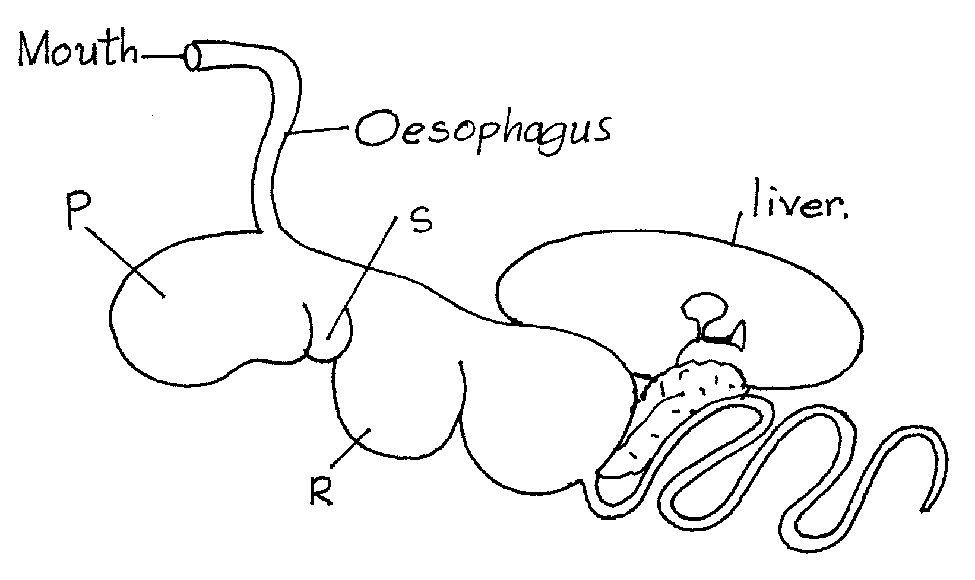

- Identify the part labelled R on the diagram (1 mark)
…………………………………………………………………………………………
b) Which of the parts labelled is also referred to as:
i) The “book” or “many plies” (¹/₂mk)
…………………………………………………………………………………………
…………………………………………………………………………………………
ii) The “honey comb” (¹/₂mk)
…………………………………………………………………………………………
…………………………………………………………………………………………
c) State two microbial activities that take place in the chamber labeled P? (2mks)
…………………………………………………………………………………………
…………………………………………………………………………………………
d) State the role of esophageal groove in ruminants (1mk)
…………………………………………………………………………………………
…………………………………………………………………………………………

18. The diagram E below illustrates an activity carried out by a farmer. Study the diagram and answer the questions that follow.
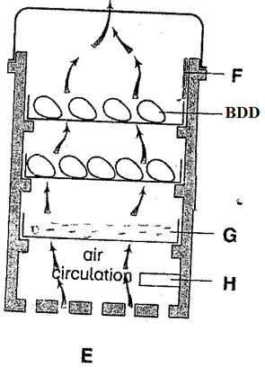
- Identify the activity carried out in the structure labelled E above (1mark)
…………………………………………………………………………………………
b) Name the parts labelled F and H in the structure E above (2mks)
F…………………………………………………………………
H…………………………………………………………………
c) State two conditions apart from air circulation in E above which are necessary for a successful activity being carried out (2mks)
…………………………………………………………………………………………

19. The diagram below illustrates a stroke in a four stroke cycle engine. Study it then answer the questions that follow. The arrows show the direction of motion of the piston
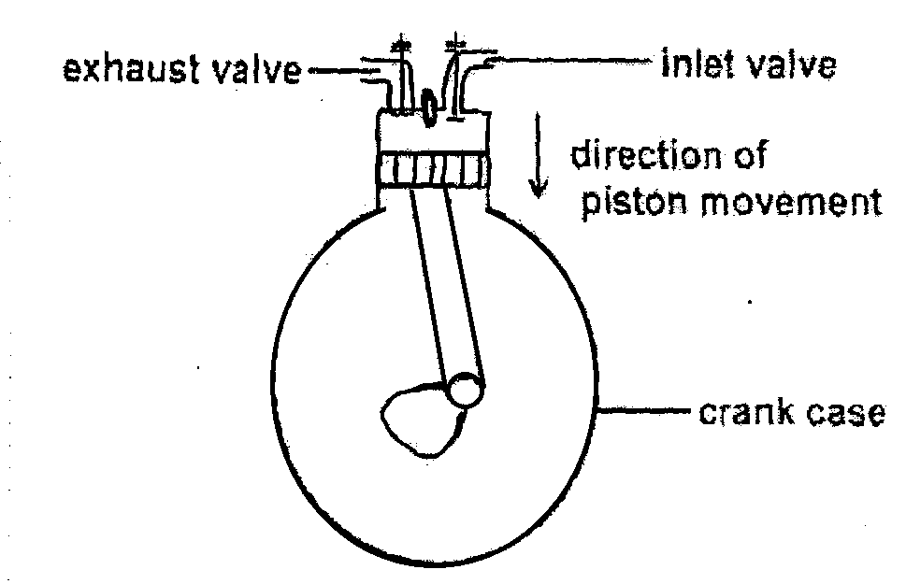
- Identify the stroke illustrated by the diagram (1 mark)
…………………………………………………………………………………………
- Identify the type of tractor engine illustrated in the diagram on the basis of type of fuel it uses (1 mark)
…………………………………………………………………………………………
c) Give a reason for your answer in (b) above (1 mark)
…………………………………………………………………………………………
…………………………………………………………………………………………
d) Name in the correct order the next two strokes which follow the one illustrated above (2mks)
…………………………………………………………………………………………
…………………………………………………………………………………………
20. Diagram Q and R below illustrates a practice carried out on livestock. Study the diagrams and answer the questions that follow:

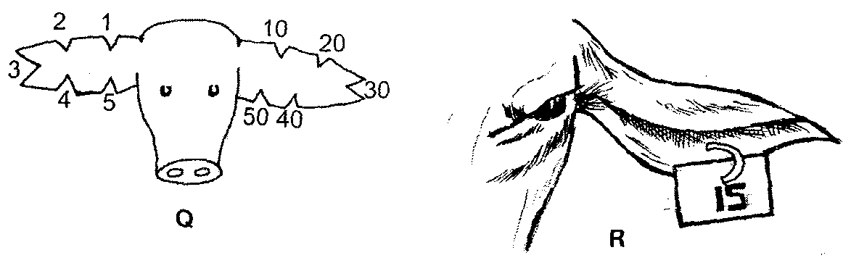
- Identify the practice in Q and R (1mk)
…………………………………………………………………………………………
- Name the method carried out in Q and R (1mk)
Q ………………………………………………………………………
R ………………………………………………………………………
- State one advantage of R over Q (1mk)
…………………………………………………………………………………………
- Give two reasons of carrying out the practice Q and R (2mks)
…………………………………………………………………………………………
…………………………………………………………………………………………
SECTION C (40 MARKS)
ATTEMPT ANY TWO QUESTIONS IN THE SPACE PROVIDED

21. a) Discuss the general methods of controlling livestock diseases (10mks)
b) Give five advantages of four-stroke cycle engines (5 marks)
c) State five disadvantages of natural mating (5 marks)
22. a) Explain five factors to be considered when selecting a breeding stock (10mks)
b) Describe the essentials of clean milk production in dairy farming (5 marks)
c) Outline the disease predisposing factors in livestock (5 marks)
23. a) State five symptoms of East Coast Fever (5 marks)
b) Give five advantages of using animal power (5 marks)
c) Give five characteristics of beef cattle breed (5 marks)
d) Describe the reasons why bees may abscord from a beehive (5 marks)
…………………………………………………………………………………………………………………………………………………………………………………………………………………………………………………………………………………………………………………………………………………………………………………………………………………………………………………………………………………………………………………………………………………………………………………………………………………………………………………………………………………………………………………………………………………………………………………………………………………………………………………………………………………………………………………………………………………………………………………………………………………………………………………………………………………………………………………………………………………………………………………………………………………………………………………………………………………………………………………………………………………………………………………………………………………………………………………………………………………………………………………………………………………………………………………………………………………………………………………………………………………………………………………………………………………………………………………………………………………………………………………………………………………………………………………………………………………………………………………………………………………………………………………………………………………………………………………………………………………………………………………………………………………………………………………………………………………………………………………………………………………………………………………………………………………………………………………………………………………………………………………………………………………………………………………………………………………………………………………………………………………………………………………………………………………………………………………………………………………………………………………………………………………………………………………………………………………………………………………………………………………………………………………………………………………………………………………………………………………………………………………………………………………………………………………………………………………………………………………………………………………………………………………………………………………………………………………………………………………………………………………………………………………………………………………………………………………………………………………………………………………………………………………………………………………………………………………………………………………………………………………………………………………………………………………………………………………………………………………………………………………………………………………………………………………………………………………………………………………………………………………………………………………………………………………………………………………………………………………………………………………………………………………………………………………………………………………………………………………………………………………………………………………………………………………………………………………………………………………………………………………………………………………………………………………………………………………………………………………………………………………………………………………………………………………………………………………………………………………………………………………………………………………………………………………………………………………………………………………………………………………………………………………………………………………………………………………………………………………………………………………………………………………………………………………………………………………………………………………………………………………………………………………………………………………………………………………………………………………………………………………………………………………………………………………………………………………………………………………………………………………………………………………………………………………………………………………………………………………………………………………………………………………………………………………………………………………………………………………………………………………………………………………………………………………………………………………………………………………………………………………………………………………………………………………………………………………………………………………………………………………………………………………………………………………………………………………………………………………………………………………………………………………………………………………………………………………………………………………………………………………………………………………………………………………………………………………………………………………………………………………………………………………………………………………………………………………………………………………………………………………………………………………………………………………………………………………………………………………………………………………………………………………………………………………………………………………………………………………………………………………………………………………………………………………………………………………………………………………………………………………………………………………………………………………………………………………………………………………………………………………………………………………………………………………………………………………………………………………………………………………………………………………………………………………………………………………………………………………………………………………………………………………………………………………………………………………………………………………………………………………………………………………………………………………………………………………………………………………………………………………………………………………………………………………………………………………………………………………………………………………………………………………………………………………………………………………………………………………………………………………………………………………………………………………………………………………………………………………………………………………………………………………………………………………………………………………………………………………………………………………………………………………………………………………………………………………………………………………………………………………………………………………………………………………………………………………………………………………………………………………………………………………………………………………………………………………………………………………………………………………………………………………………………………………………………………………………………………………………………………………………………………………………………………………………………………………………………………………………………………………………………………………………………………………………………………………………………………………………………………………………………………………………………………………………………………………………………………………………………………………………………………………………………………………………………………………………………………………………………………………………………………………………………………………………………………………………………………………………………………………………………………………………………………………………………………………………………………………………………………………………………………………………………………………………………………………………………………………………………………………………………………………………………………………………………………………………………………………………………………………………………………………………………………………………………………………………………………………………………………………………………………………………………………………………………………………………………………………………………………………………………………………………………………………………………………………………………………………………………………………………………………………………………………………………………………………………………………………………………………………………………………………………………………………………………………………………………………………………………………………………………………………………………………………………………………………………………………………………………………………………………………………………………………………………………………………………………………………………………………………………………………………………………………………………………………………………………………………………………………………………………………………………………………………………………………………………………………………………………………………………………………………………………………………………………………………………………………………………………………………………………………………………………………………………………………………………………………………………………………………………………………………………………………………………………………………………………………………………………………………………………………………………………………………………………………………………………………………………………………………………………………………………………………………………………………………………………………………………………………………………………………………………………………………………………………………………………………………………………………………………………………………………………………………………………………………………………………………………………………………………………………………………………………………………………………………………………………………………………………………………………………………………………………………………………………………………………………………………………………………………………………………………………………………………………………………………………………………………………………………………………………………………………………………………………………………………………………………………………………………………………………………………………………………………………………………………………………………………………………………………………………………………………………………………………………………………………………………………………………………………………………………………………
THIS IS THE LAST PRINTED PAGE!

