MINCKS GROUP OF SCHOOLS
AGRICULTURE
FORM FOUR
443/1
END OF TERM TWO 2022

NAME: _________________________________________STREAM: ______
ADM NO: ________ SCHOOL: ______________________DATE: ________
INDEX NUMBER: ________________________

INSTRUCTIONS TO CANDIDATES
- This paper consists of three sections, A, B & C.
- Answer all questions in section A & B and only two in section C

SECTION | QUESTIONS | MAXIMUM SCORE | STUDENT SCORE
A | 1-16 | 30
B | 17-20 | 20
C | 21-23 | 40
TOTAL SCORE |  | 90
For examiners use only

- Give four reason why farmers are encouraged to practice organic farming (2mks)
________________________________________________________________________________________________________________________________________________________________________________________________________________________________________________________________________________________
- Name the routine filed practice done by;
- Removal of extra suckers in banana stool (¹/₂mk)
__________________________________________________________________Removal of old stems down to level of top foliage in pyrethrum (¹/₂mk)
__________________________________________________________________
- Removal of suckers from coffee bushes (¹/₂mk)
__________________________________________________________________
- Distinguish between GDP and GNP (2mks)
__________________________________________________________________
____________________________________________________________________________________________________________________________________________
- What meant by the following terms
i) Seed inoculation (1mk)
________________________________________________________________________________________________________________________________________________
ii) Seed dressing (1mk)

________________________________________________________________________________________________________________________________________________
- Name four types of terraces (2mks)

____________________________________________________________________________________________________________________________________________
- State three characteristics of phosphatic fertilizers (¹/₂ mk)
__________________________________________________________________________________________________________________________________________________________________________________________________________________

- Explain the relationship between scarcity and choice as used in agricultural economics (2mks)
____________________________________________________________________________________________________________________________________________
- Outline four ways by which crop pest are classified (2mks)
________________________________________________________________________________________________________________________________________________________________________________________________________________________________________________________________________________________
- State four advantages of land consolidation (2mks)

________________________________________________________________________________________________________________________________________________________________________________________________________________________________________________________________________________________
- Outline four benefits derived from trees used in agroforestry (2mks)

________________________________________________________________________________________________________________________________________________________________________________________________________________________________________________________________________________________
- Give four advantages of overhead irrigation in crop production (2mks)

________________________________________________________________________________________________________________________________________________________________________________________________________________________________________________________________________________________
- State four practices which improve light intensity in crop production (2mks)

________________________________________________________________________________________________________________________________________________________________________________________________________________________________________________________________________________________

- a) Give two factors that influence the quality of hay (1mk)

____________________________________________________________________________________________________________________________________________

b) Outline two other methods of conserving forage in the farm (1mk)
____________________________________________________________________________________________________________________________________________
- Give four varieties of tomatoes grown for processing (2mks)

________________________________________________________________________________________________________________________________________________________________________________________________________________________________________________________________________________________

- Give four harmful effects of weed on crop production (2mks)

_______________________________________________________________________________________________________________________________________________________________________________________________________________________________________________________________________________________
- State four factors that influence the number of secondary cultivation in seed bed preparation (2mks)
________________________________________________________________________________________________________________________________________________________________________________________________________________________________________________________________________________________

SECTION B (20MKS)
ANSWER ALL QUESTIONS IN THIS SECTION IN THE SPACES PROVIDED

- The diagram below represents a method of manure preparation. Study it carefully and answer the questions that follow;

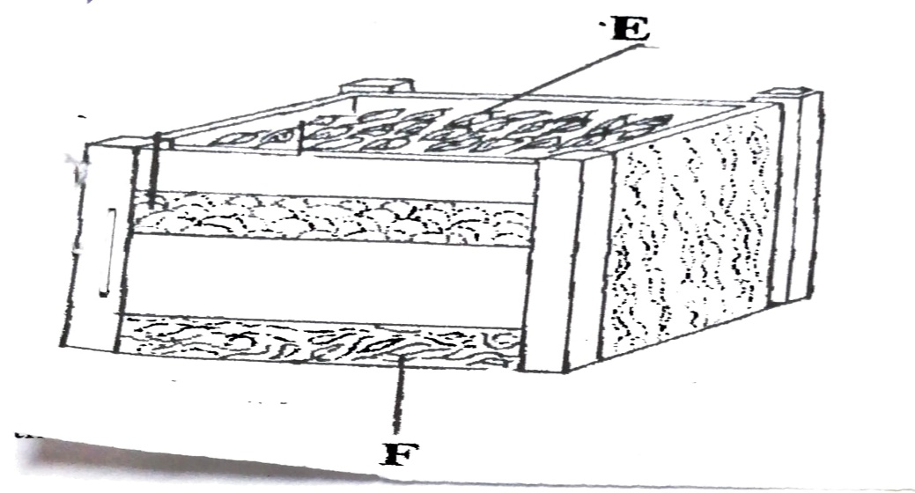

a) Identify the type of manure being prepared (1mk)

______________________________________________________________________

b) Name the parts labelled E and F (2mks)
______________________________________________________________________
______________________________________________________________________

c) Give two disadvantages of organic manures (2mks)

______________________________________________________________________
_____________________________________________________________________
- The diagram below illustrates a cereal crop plant and its produce, study the diagram carefully and answer the question that follow;

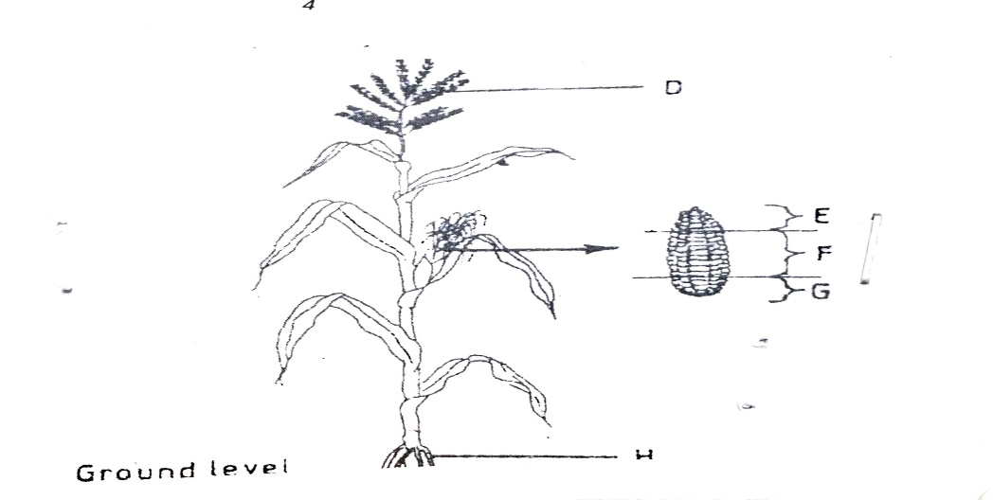

a) Name one disease that attack the part labelled D in the diagram (1mk)

______________________________________________________________________
b) From which section of the produce labelled E, F and G should seed for planting be obtained? (1mk)

______________________________________________________________________

c) Give one reason for the answer given in (B) above (1mk)

______________________________________________________________________

d) State two functions of the part labelled H in the diagram (2mks)
______________________________________________________________________
______________________________________________________________________
- A farmer wishes to change her enterprise form vegetable production to dairy farming. The costs she incurs on vegetables are as follows;
i) Weeding sh. 200
ii) Harvesting sh. 300
iii) Fertilizer sh. 500
iv) Seeds sh. 400

When she changes per enterprise to dairy she incurs the following costs;
Cost of buying cattle sh. 5000
Disease control – sh 200
Salary for milk person –sh 2000
Fencing – sh. 500
The revenue she gets from vegetable is sh 10,000 while in dairy she gets;
i) Milk sales sh 15,000
ii) Manure sales sh 1000

Draw a partial budget and indicate the effect of the proposed changes. (15mks)

- The illustration below shows a type of soil erosion. Study it carefully and answer the question that follow:

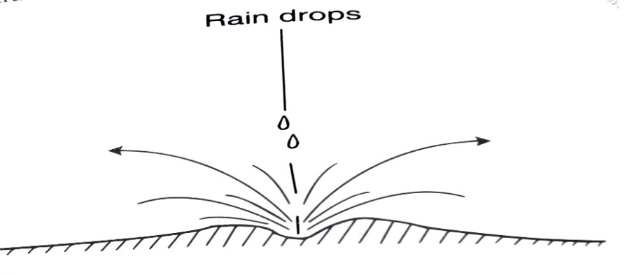

- Identify the type of erosion illustrated above; (1mk) ____________________________________________________________________

- Give three soil factors that influence the rate of soil erosion (3mks)
______________________________________________________________________
______________________________________________________________________
______________________________________________________________________

- Name one agent of soil erosion (1mk)
____________________________________________________________________

SECTION C (40 MARKS)
ANSWER ANY TWO QUESTIONS FROM THIS SECTION
- a) Describe harvesting of sugar cane (4mks)

______________________________________________________________________
______________________________________________________________________
______________________________________________________________________
______________________________________________________________________
______________________________________________________________________
______________________________________________________________________
______________________________________________________________________
______________________________________________________________________

b) Study following information which was extracted from juhudi farm record on 31-12- 95 and answer the question below
Loans payable to bank 300,000
Five milking cows 250,000
400 layers 80,000
20 goats 30,000
Debts payable to co-operative 20,000
Buildings/ structures 60,000
Bonus payable to workers 19,000
Cattle feed in store 10,000
Animal drugs in store 4,000
Debtors receivable 18,000
Breakages to repair 30,000
Cash at hand 20,000
Cash in Bank 30,000
Spray equipment 12,000

Prepare a balance sheet for Juhudi’s farm using the information above; (6mks)

- Describe the function of agricultural marketing (10mks)

______________________________________________________________________
______________________________________________________________________
______________________________________________________________________
______________________________________________________________________
______________________________________________________________________
______________________________________________________________________
______________________________________________________________________
______________________________________________________________________

- a) Describe the procedure of silage making (10mks)

______________________________________________________________________
______________________________________________________________________
______________________________________________________________________
______________________________________________________________________
______________________________________________________________________
______________________________________________________________________
______________________________________________________________________
______________________________________________________________________
______________________________________________________________________
______________________________________________________________________
______________________________________________________________________
______________________________________________________________________
______________________________________________________________________
b) State five effects of winds in crop production (5mks)
______________________________________________________________________
______________________________________________________________________
______________________________________________________________________
______________________________________________________________________
______________________________________________________________________
______________________________________________________________________
______________________________________________________________________

c) Explain five physical methods of pest control (5mks)

______________________________________________________________________
______________________________________________________________________
______________________________________________________________________
______________________________________________________________________
______________________________________________________________________
______________________________________________________________________
______________________________________________________________________

- a) Describe the safety precautions a farmer should take when using herbicides (5mks)

______________________________________________________________________
______________________________________________________________________
______________________________________________________________________
______________________________________________________________________
______________________________________________________________________
______________________________________________________________________
______________________________________________________________________
______________________________________________________________________

b) Explain five factors that influence rooting of cutting (10mks)

______________________________________________________________________
______________________________________________________________________
______________________________________________________________________
______________________________________________________________________
______________________________________________________________________
______________________________________________________________________
______________________________________________________________________

c) Explain five ways through which farmers adjust to risks and uncertainties in farming
(5mks)
______________________________________________________________________
______________________________________________________________________
______________________________________________________________________
______________________________________________________________________
______________________________________________________________________
______________________________________________________________________
______________________________________________________________________

