Name: …………………………………………………………Adm no ……..…...................................

Date: ……………………………………………………………

END OF TERM 1 2023
FORM 3
AGRICULTURE

TIME: 2 HOURS

INSTRUCTIONS TO CANDIDATES:
- Write your name and admission number in the spaces provided above.
- This paper consists of three section A,B and C
- Answer all the questions in section A and B
- Answer any two questions in section C.
- Answers should be written in the spaces provided in this booklet.

For Examiner’s Use Only:
SECTION | QUESTIONS | MAXIMUM SCORE | CANDIDATES SCORE
A |  | 30
B |  | 20
C |  | 20
 |  | 20
 | TOTAL | 90

This paper consists of 8 printed pages. Candidates should check to ascertain that all papers are printed as indicated and that no questions are
missing

SECTION A (30 MARKS)
ANSWER ALL QUESTIONS.

- State two ways in which the foreign exchange earned from agriculture is important to Kenya?
(2mks)
……………………………………………………………………………………….………………………………………………………………………………………………….…………………………………………………………………………………………………………….………………………………………………………………………………………………….…………………………………………………
- State four effects of excessive nitrogenous fertiliser application on tomatoes? (2mks)
……………………………………………………………………………………….………………………………………………………………………………………………….…………………………………………………………………………………………………………….………………………………………………………………………………………………….……………………………………………………
- What is meant by the term preference and choice as used in agricultural economics? (1mk)
……………………………………………………………………………………….………………………………………………………………………………………………….…………………………………………………………………………………………………………….………………………………………………………………………………………………….……………………………………………………
- State four disadvantages of shining cultivation? (2mks)
……………………………………………………………………………………….………………………………………………………………………………………………….…………………………………………………………………………………………………………….………………………………………………………………………………………………….……………………………………………………
- What is meant by the term land tenure reform (1mk)
……………………………………………………………………………………….………………………………………………………………………………………………….…………………………………………………………………………………………………………….………………………………………………………………………………………………….……………………………………………………

- An agronomist recommends 120kg N, 60 kg P₂O₅ and 80 kg K₂O after testing a soil sample. Calculate the amount of urea 46%N, single super phosphate 20% P₂O₅ and potassium oxide 50% K₂O that should be applied on the land (4mks)

- a) Identify the factors that a farmer at Kagumo will consider when choosing the tools
to use when preparing his maize field. (1½ mks)
……………………………………………………………………………………….……………………………………………………………………………………………………….………………………………………………………………………………………………….……………………………………………
b) What is the use of a spoke shave in a farm workshop? (1 x ½ = ½ )
……………………………………………………………………………………….………………………………………………………………………………………………….……………………………………
- a) Classify goat breeds based on purpose for which they are kept. (1½ mks)
……………………………………………………………………………………….………………………………………………………………………………………………….……………………………………
b) Name any three breeds of sheep reared for wool in Kenya. (1½ mks)
……………………………………………………………………………………….………………………………………………………………………………………………….……………………………………
c) Differentiate the morphological characteristics of Dromedary and Bactrian species
of camel. (1½ mks)
……………………………………………………………………………………….………………………………………………………………………………………………….……………………………………
- a) Name any four ectoparasites affecting farm livestock. ( 2mks)
……………………………………………………………………………………….………………………………………………………………………………………………….……………………………………

……………………………………………………………………………………….………………………………………………………………………………………………….……………………………………
b) Identify three ways by which farmers can apply acaricides when controlling ticks in livestock. (1 ½ mks)
……………………………………………………………………………………….………………………………………………………………………………………………….……………………………………
- a) Define the following terminologies as used in livestock breeding.
(i) Close breeding. ( ½ mk)
……………………………………………………………………………………….………………………………………………………………………………………………….……………………………………
ii) Out breeding ( ½ mk)
……………………………………………………………………………………….………………………………………………………………………………………………….……………………………………

b) Identify the different ways by which vaccines can be administered to farm livestock? (2mks)
……………………………………………………………………………………….………………………………………………………………………………………………….……………………………………
……………………………………………………………………………………….………………………………………………………………………………………………….…………………………………
c) Name the chemical used in suppressing the growth of buds in calves. ( 1mk)
……………………………………………………………………………………….………………………………………………………………………………………………….……………………………………
d) Identify the two methods that farmers can use when manuring fishponds. (1mk)
……………………………………………………………………………………….………………………………………………………………………………………………….……………………………………
- a) What name is given where hind legs come out first during parturition. ( ½ mk)
……………………………………………………………………………………….………………………………………………………………………………………………….……………………………………
b) Give three factors that would affect digestibility of food in livestock. (1½ mks)
……………………………………………………………………………………….………………………………………………………………………………………………….……………………………………
……………………………………………………………………………………….………………………………………………………………………………………………….……………………………………

SECTION B (20MARKS)
Answer ALL questions in the section.
- Diagram D and E below are illustrations of workshop tools. Study them and answer the questions that follow.
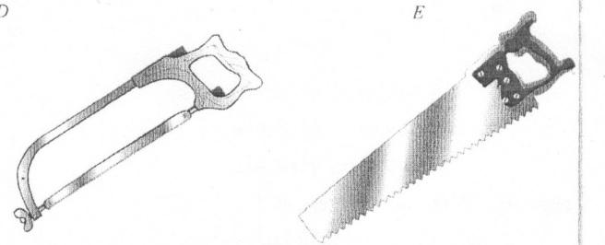
D
E

- Identify the tools marked D and E. (2mks)
D
E
- State one function of each of the tool shown. (2mks)
D
E

- Give one maintenance practice of tool E. (1mk)

- a) Identify the method of drainage shown below. (1mk)

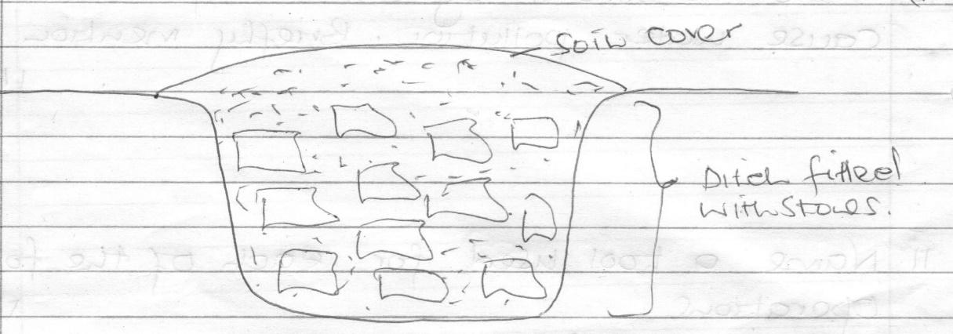
………………………………………………………………………………………………………………

b) Other than the method shown in (a) above list other four methods used in draining farm land. (2mks)

c) Outline four reasons for draining farm land. (2mks)

- The illustrations below represent an experiment to compare the porosity and water holding capacity of three of soils. Carefully study the experiment and then answer the questions that follow.

- Identify the soil in each of the funnel labeled. (3mks)
H
J
K
- b) Which of the three types of soil can be said to have the highest porosity rate? (1mk)

- Which type of soil would be suitable for planting paddy rice? (1mk)

- Below is a diagram of farm equipment. Use it to answer the questions that follows.
- Identify the equipment. (1mk)
- State the use of the equipment. (1mk)
- Name the parts labelled E, F and G. (3mks)
E

F

G

SECTION C (40 MARKS)
Answer any TWO questions in this section.

- a) Describe the management practices that should be carried for a sow and piglets during the
farrowing period. (12mks)
b) Explain reasons why a breeding boar may be culled. (8mks)

- Outline how six biotic factors influence agriculture. (6mks)
- State the four aspects of rainfall that are important for crop growth. (4mks)
- Explain five factors that determine the number of times secondary cultivation is done. (5mks)
- Outline the advantages of minimum tillage. (5mks)
- a) State four importance of water treatment. (4mks)
b) Explain the steps in chemical water treatment process (16mks)

…………………………………………………………………………………….…………………
…………………………………………………………………………………….…………………
…………………………………………………………………………………….…………………
…………………………………………………………………………………….…………………
…………………………………………………………………………………….…………………
…………………………………………………………………………………….…………………
…………………………………………………………………………………….…………………
…………………………………………………………………………………….…………………
…………………………………………………………………………………….…………………
…………………………………………………………………………………….…………………
…………………………………………………………………………………….……………………………………………………………………………………………………….…………………
…………………………………………………………………………………….…………………
…………………………………………………………………………………….…………………
…………………………………………………………………………………….…………………
…………………………………………………………………………………….…………………
…………………………………………………………………………………….…………………
…………………………………………………………………………………….…………………
…………………………………………………………………………………….…………………
…………………………………………………………………………………….…………………
…………………………………………………………………………………….…………………
…………………………………………………………………………………….…………………
…………………………………………………………………………………….…………………
…………………………………………………………………………………….…………………
…………………………………………………………………………………….…………………
…………………………………………………………………………………….…………………
…………………………………………………………………………………….…………………
…………………………………………………………………………………….…………………
…………………………………………………………………………………….…………………
…………………………………………………………………………………….…………………
…………………………………………………………………………………….…………………
…………………………………………………………………………………….…………………
…………………………………………………………………………………….……………………………………………………………………………………………………….…………………
…………………………………………………………………………………….…………………
…………………………………………………………………………………….…………………
…………………………………………………………………………………….…………………
…………………………………………………………………………………….…………………
…………………………………………………………………………………….…………………
…………………………………………………………………………………….…………………
…………………………………………………………………………………….…………………
…………………………………………………………………………………….…………………
…………………………………………………………………………………….…………………
…………………………………………………………………………………….…………………
…………………………………………………………………………………….…………………
…………………………………………………………………………………….…………………
…………………………………………………………………………………….…………………
…………………………………………………………………………………….…………………
…………………………………………………………………………………….…………………
…………………………………………………………………………………….…………………
…………………………………………………………………………………….…………………
…………………………………………………………………………………….…………………
…………………………………………………………………………………….…………………
…………………………………………………………………………………….……………………………………………………………………………………………………….…………………
…………………………………………………………………………………….…………………
…………………………………………………………………………………….…………………
…………………………………………………………………………………….…………………
…………………………………………………………………………………….…………………
…………………………………………………………………………………….…………………
…………………………………………………………………………………….…………………
…………………………………………………………………………………….…………………
…………………………………………………………………………………….…………………
…………………………………………………………………………………….…………………
…………………………………………………………………………………….……………………………………………………………………………………………………….…………………
…………………………………………………………………………………….…………………
…………………………………………………………………………………….…………………
…………………………………………………………………………………….…………………
…………………………………………………………………………………….…………………
…………………………………………………………………………………….…………………
…………………………………………………………………………………….…………………
…………………………………………………………………………………….…………………
…………………………………………………………………………………….……………………………………………………………………………………………………….…………………
…………………………………………………………………………………….…………………
…………………………………………………………………………………….…………………
…………………………………………………………………………………….…………………
…………………………………………………………………………………….…………………
…………………………………………………………………………………….…………………
…………………………………………………………………………………….…………………
…………………………………………………………………………………….…………………
…………………………………………………………………………………….…………………
…………………………………………………………………………………….…………………
…………………………………………………………………………………….…………………
…………………………………………………………………………………….…………………
…………………………………………………………………………………….…………………
…………………………………………………………………………………….…………………
…………………………………………………………………………………….…………………
…………………………………………………………………………………….…………………
…………………………………………………………………………………….……………………………………………………………………………………………………….…………………
…………………………………………………………………………………….…………………
…………………………………………………………………………………….…………………
…………………………………………………………………………………….…………………
…………………………………………………………………………………….…………………
…………………………………………………………………………………….…………………
…………………………………………………………………………………….…………………
…………………………………………………………………………………….…………………
…………………………………………………………………………………….…………………
…………………………………………………………………………………….…………………
…………………………………………………………………………………….……………………………………………………………………………………………………….…………………
…………………………………………………………………………………….…………………
…………………………………………………………………………………….…………………
…………………………………………………………………………………….…………………
…………………………………………………………………………………….…………………
…………………………………………………………………………………….…………………
…………………………………………………………………………………….…………………
…………………………………………………………………………………….…………………

