AGRICULTURE FORM 2 END TERM EXAMS-TERM 1-2023

Name: …………………………….……………....…………………………………………… School: ……………………………………………………………………………… Index no: ………………. Candidate’s signature: ……………… Date: ……………………

AGRICULTURE FORM 2
. TIME; 2HRS
INSTRUCTION
- This paper has two section A and B
- Answer all questions in these sections in the spaces provided after the questions.

SECTION A (70MKS)

1.State two reasons why farmers should be encouraged to practice organic farming(1mk)

……………………………………………………………………………………………………………………

…………….……………………………………………………………………………………………………...

……………………………………………………………………………………………………………………

……………………………………………………………………………………………………………………

2. State main categories of parasites (1mk)

………………………………………………………………………………………………………………………

………………………………………………………………………………………………………………………

……………………………………………………………………………………………………………………….

3. State four importance of water treatment. (2mks)

………………………………………………………………………………………………………………………

………………………………………………………………………………………………………………………

………………………………………………………………………………………………………………………

………………………………………………………………………………………………………………………

……………………………………………………………………………………………………………………….

4. Mention 3 major sources of water on the farm. (3mks)

………………………………………………………………………………………………………………………

………………………………………………………………………………………………………………………

………………………………………………………………………………………………………………………

………………………………………………………………………………………………………………………

5. State four ways in which nitrogen is removed from the atmosphere (2mks)

………………………………………………………………………………………………………………………

………………………………………………………………………………………………………………………

………………………………………………………………………………………………………………………

………………………………………………………………………………………………………………………

……………………………………………………………………………………………………………………….

6. State the intermediate hosts of the following parasites. (2mks) (i) Tapeworm(Taenia spp) …………………………………………………
(ii) Liver fluke ……………………………………………………………

7. State 3 forms of soil water. (3mks)

………………………………………………………………………………………………………………………

………………………………………………………………………………………………………………………

………………………………………………………………………………………………………………………

……………………………………………………………………………………………………………………….

8. State four vector-borne diseases affecting farm animals. (2mks)
………………………………………………………………………………………………………………………

………………………………………………………………………………………………………………………

………………………………………………………………………………………………………………………

………………………………………………………………………………………………………………………

……………………………………………………………………………………………………………………….

9. State the plant part used for vegetative propagation in the following plants. (2mks)
i) Pyrethrum

………………………………………………………………………………………………………………………

……………………………………………………………………………………………………………………….

ii) Sisal
………………………………………………………………………………………………………………………

………………………………………………………………………………………………………………………

iii) Pineapples

……………………………………………………………………………………………………………

……………………………………………………………………………………………………………

iv) Tea
……………………………………………………………………………………………………………

……………………………………………………………………………………………………………

10. State four pests commonly found in tomatoes. (2mks)

……………………………………………………………………………………………………………

……………………………………………………………………………………………………………

……………………………………………………………………………………………………………

……………………………………………………………………………………………………………

……………………………………………………………………………………………………………
11 State four qualities considered when selecting seeds for planting (2mks)

……………………………………………………………………………………………………………….

…………….………………………………………………………………………………………………….

………………………….………………………………………………………………………………………

……………………………………….…………………………………………………………………………

………………………………………………………………………………………………………………….

12 State four advantages of crop rotation (2mks)
………………………………………………………………………………………………………………………

………………………………………………………………………………………………………………………

………………………………………………………………………………………………………………………

………………………………………………………………………………………………………………………

……………………………………………………………………………………………………………………….

13. State any four post-harvest practices in crop production. (2mks)

………………………………………………………………………………………………………………………

………………………………………………………………………………………………………………………

………………………………………………………………………………………………………………………

………………………………………………………………………………………………………………………

……………………………………………………………………………………………………………………….

14. Differentiate between soil texture and soil structure (2mks) Soil texture
………………………………………………………………………………………………………………………

……………………………………………………………………………………………………………………….

Soil structure
………………………………………………………………………………………………………………………

……………………………………………………………………………………………………………………….

15. State four factors influencing soil formation. (2mks)
………………………………………………………………………………………………………………………

………………………………………………………………………………………………………………………

………………………………………………………………………………………………………………………

………………………………………………………………………………………………………………………

………………………………………………………………………………………………………………………

………………………………………………………………………………………………………………………
16. List four factors that influence the rate of respiration in an animal. (2ms)
………………………………………………………………………………………………………………………

………………………………………………………………………………………………………………………

………………………………………………………………………………………………………………………

………………………………………………………………………………………………………………………

……………………………………………………………………………………………………………………….

17. State four factors that influence crop rotation (2mks)
………………………………………………………………………………………………………………………

………………………………………………………………………………………………………………………

………………………………………………………………………………………………………………………

………………………………………………………………………………………………………………………

……………………………………………………………………………………………………………………….

18. Give the term used to describe the following livestock. (4mks) (i) Mature male cattle
………………………………………………………………………………………………………………………

……………………………………………………………………………………………………………………….

(ii) Mature castrated male cattle
………………………………………………………………………………………………………………………

……………………………………………………………………………………………………………………….

(iii) A mature female pig after first parturition
………………………………………………………………………………………………………………………

……………………………………………………………………………………………………………………….

(iv) Mature female bird
………………………………………………………………………………………………………………………

……………………………………………………………………………………………………………………….

19. Differentiate between gapping and rogueing (2mks) Gapping
………………………………………………………………………………………………………………………

………………………………………………………………………………………………………………………

……………………………………………………………………………………………………………………….

Rogueing
………………………………………………………………………………………………………………………

………………………………………………………………………………………………………………………

……………………………………………………………………………………………………………………….
20. State four characteristics of plants used as green manure. (2mks)

………………………………………………………………………………………………………………………

………………………………………………………………………………………………………………………

………………………………………………………………………………………………………………………

………………………………………………………………………………………………………………………

……………………………………………………………………………………………………………………….

21. Differentiate between over-sowing and under-sowing. (2mks) Over-sowing
………………………………………………………………………………………………………………………

……………………………………………………………………………………………………………………….

Under- sowing

………………………………………………………………………………………………………………………

……………………………………………………………………………………………………………………….

22. State four factors that determine spacing in crop production (2mks)
………………………………………………………………………………………………………………………

………………………………………………………………………………………………………………………

……………………………………………………………………………………………………………………….

23. State four divisions of livestock farming. (2mks)

………………………………………………………………………………………………………………………

………………………………………………………………………………………………………………………

………………………………………………………………………………………………………………………

………………………………………………………………………………………………………………………

………………………………………………………………………………………………………………………

………………………………………………………………………………………………………………………

24. (a) State the two classes of phylum Arthropod a with most ecto- parasites (2mks)

………………………………………………………………………………………………………………………

………………………………………………………………………………………………………………………

………………………………………………………………………………………………………………………

……………………………………………………………………………………………………………………….

(b) State four characteristics of an effective acaricide (2mks)
………………………………………………………………………………………………………………………

………………………………………………………………………………………………………………………

………………………………………………………………………………………………………………………

………………………………………………………………………………………………………………………

……………………………………………………………………………………………………………………….

(c) Name two types of labour records. (2mks)
………………………………………………………………………………………………………………………

………………………………………………………………………………………………………………………

………………………………………………………………………………………………………………………

……………………………………………………………………………………………………………………….

(d) Name two minor pests in tomato production (1mk)
………………………………………………………………………………………………………………………

………………………………………………………………………………………………………………………

………………………………………………………………………………………………………………………

25. State the causal organism of the following diseases. (2mks)

a) Mastitis …………………………………………….

b) Rinderpest …………………………………………….. c) Red water ……………………………………………… d)Foot and mouth ……………………………………………

26. a) State four methods of fertilizer application(2mks)

………………………………………………………………………………………………………………………

………………………………………………………………………………………………………………………

………………………………………………………………………………………………………………………

………………………………………………………………………………………………………………………

……………………………………………………………………………………………………………………….

b) Define the term agriculture. (1mk)

………………………………………………………………………………………………………………………

………………………………………………………………………………………………………………………
………………………………………………………………………………………………………………………

……………………………………………………………………………………………………………………….

d) State four factors that determine the type of irrigation (2mks)
………………………………………………………………………………………………………………………

………………………………………………………………………………………………………………………

………………………………………………………………………………………………………………………

………………………………………………………………………………………………………………………

……………………………………………………………………………………………………………………….

e) Differentiate between seed dressing and seed inoculation (2mks)

Seed dressing
………………………………………………………………………………………………………………………

……………………………………………………………………………………………………………………….

Seed inoculation
………………………………………………………………………………………………………………………

……………………………………………………………………………………………………………………….

27. A) Differentiate between mixed farming and agroforestry (2mks) Mixed farming
………………………………………………………………………………………………………………………

……………………………………………………………………………………………………………………….

Agroforestry
………………………………………………………………………………………………………………………

……………………………………………………………………………………………………………………….

b) State four factors within the animal that may pre-dispose it to a disease. (2mks)

………………………………………………………………………………………………………………………

………………………………………………………………………………………………………………………

………………………………………………………………………………………………………………………

………………………………………………………………………………………………………………………

……………………………………………………………………………………………………………………….

c) State the lacking mineral in the following disorders. (2mks) (i) Anaemia in piglets

………………………………………………………………………………………………………………………

……………………………………………………………………………………………………………………….
( ii) Osteomalacia
………………………………………………………………………………………………………………………

……………………………………………………………………………………………………………………….

(iii)Milk fever
………………………………………………………………………………………………………………………

……………………………………………………………………………………………………………………….

(iv)Swayback in lambs
………………………………………………………………………………………………………………………

……………………………………………………………………………………………………………………….

SECTION B (30MKS)
28. A farmer with one hectare of land requires 40kg of n in his farm. He applied CAN
which costs shs 35 per kg. CAN contain 20kg N.
(a) Calculate the amount of C.A.N the farmer requires (2mks)

(b) How much will a farmer with one and a half hectares spend to apply in his farm? (1mk)

(c) Name two types of compound fertilizers used by farmers. (2mks)
………………………………………………………………………………………………………………………

………………………………………………………………………………………………………………………

……………………………………………………………………………………………………………………….

29. Study the diagrams below of farm tools and equipment and answer the questions that follow.

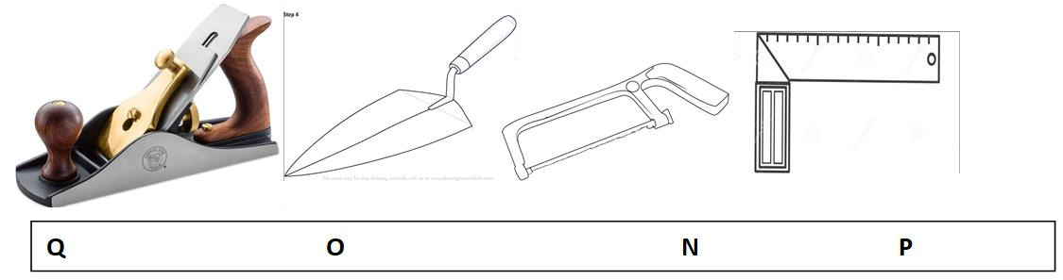
a) Identify tools O and N (2mks)

………………………………………………………………………………………………………………………

………………………………………………………………………………………………………………………

………………………………………………………………………………………………………………………

………………………………………………………………………………………………………………………

b) State the function of tool P (1mk)

………………………………………………………………………………………………………………………

………………………………………………………………………………………………………………………

……………………………………………………………………………………………………………………….

c) State two maintenance practices of tool Q. (2mks)

………………………………………………………………………………………………………………………

………………………………………………………………………………………………………………………

………………………………………………………………………………………………………………………

……………………………………………………………………………………………………………………….

30. The diagram below shows a livestock parasite

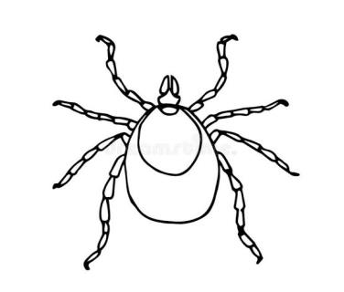
a) Identify the above parasite. (1mk)
………………………………………………………………………………………………………………………

……………………………………………………………………………………………………………………….

b) Name any two diseases transmitted by the parasite. (2mks)
………………………………………………………………………………………………………………………

………………………………………………………………………………………………………………………

………………………………………………………………………………………………………………………

……………………………………………………………………………………………………………………….
c) State the four main stages in its life cycle. (2mks)

………………………………………………………………………………………………………

………………………………………………………………………………………………………

………………………………………………………………………………………………………

………………………………………………………………………………………………………

………………………………………………………………………………………………………

31. Study the diagram below and answer the questions that follow.
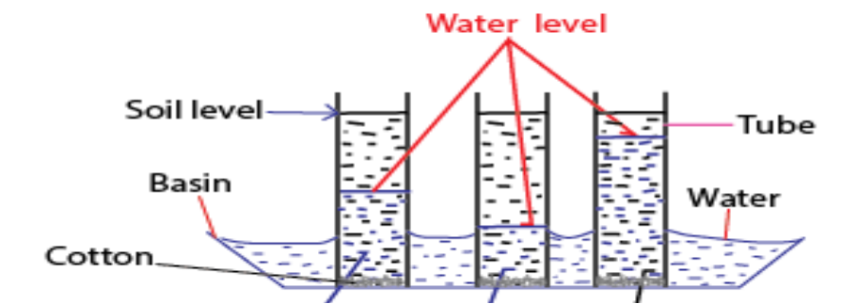

B A C

a) What is the experiment set up above designed to study. (1mk)

………………………………………………………………………………………………………

………………………………………………………………………………………………………

b) Name the three types of soil. (3mks)
………………………………………………………………………………………………………

………………………………………………………………………………………………………

………………………………………………………………………………………………………

………………………………………………………………………………………………………

c) State 3 characteristics of soil A above. (3mks)

………………………………………………………………………………………………………

………………………………………………………………………………………………………

………………………………………………………………………………………………………

………………………………………………………………………………………………………

d) State one method of improving soil C above. (1mk)
………………………………………………………………………………………………………

…………………………………………………………………………………………………………
32(a) What is soil sampling? (1 mark)

............................................................................................................................. ........

........................................................................................................................... ..........

.....................................................................................................................................

(b) Below is a method of soil sampling. Use it to answer the question that follow.

1 7

2 8

3 9

10 4

11 5

12 6
(i) What method of soil sampling is represented above? (1 mark )

……………………………………………………………………………………

……………………………………………………………………………………

(ii) name the other method of soil sampling (1mark)

……………………………………………………………………………………

……………………………………………………………………………………

(iii) Outline four areas which should be avoided during soil sampling. (4 marks )

……………………………………………………………………………………

……………………………………………………………………………………

……………………………………………………………………………………

……………………………………………………………………………………

……………………………………………………………………………………

