Term 1 – 2023 OPENER EXAM
AGRICULTURE (443/2)
PAPER 2
FORM FOUR (4)
TIME: 2 HOURS
Name: …………………………………………………………. Adm No: ……………….
School: ……………………………………………………….. Class: …………………..
Signature: ……………………………………………………..Date: …………………….

INSTRUCTIONS TO THE CANDIDATES
- Write your name, admission number and class in the spaces provided
- Answer all questions in the spaces provided
- Answer all questions in section A and B and two questions in section C
- The exam carries 90 marks

FOR EXAMINERS USE ONLY
SECTION | QUESTION | MAXIMUM SCORE | CANDIDATES SCORE
A | 1 – 16 | 30 MARKS
B | 17– 20 | 20 MARKS
C | 21 | 20 MARKS
 | 22 | 20 MARKS
 | 23 | 20 MARKS
TOTAL |  | 90 MARKS

SECTION A (30 MARKS )
- Give two benefits of providing enough nutrients to livestock for proper health. (1 mark)
(i) ……………………………………………………………………………………………….
(ii) ………………………………………………………………………………………………
- Give two harmful effects of ticks in sheep. (2 marks)
(i) ……………………………………………………………………………………………….
(ii) ………………………………………………………………………………………………
- State four roles of worker bees in a colony. (2 marks)
(i) ……………………………………………………………………………………………….
(ii) ………………………………………………………………………………………………
(iii) ……………………………………………………………………………………………..
(iv). …………………………………………………………………………………………….
- State the role of the crop in digestive system of a hen. (2 marks)
(i) ……………………………………………………………………………………………….
(ii) ………………………………………………………………………………………………
- State four reasons for castration in pig production. (2 marks)
(i) ……………………………………………………………………………………………….
(ii) ………………………………………………………………………………………………
(iii) ……………………………………………………………………………………………..
(iv). …………………………………………………………………………………………….
6. State two benefits of guard rails to piglets in a farrowing pen? (1 mark)
(i) ……………………………………………………………………………………………….
(ii) ………………………………………………………………………………………………
- State the role of a foot bath in a cattle Dip. (1 mark)
(i) ……………………………………………………………………………………………….
(ii) ………………………………………………………………………………………………
- Distinguish between the following practices as used in livestock production.
(a). Crutching and ringing in sheep production. (2 marks)
……………………………………………………………………………………………….
………………………………………………………………………………………………
…………………………………………………………………………………………………………………………………………………………………………………………………..
(b). Cropping and harvesting in fish farming. (2 marks) ……………………………………………………………………………………………..
…………………………………………………………………………………………….
…………………………………………………………………………………………………………………………………………………………………………………………………..
- Give four disadvantages of inbreeding. (2mks)
…………………………………………………………………………………………...
…………………………………………………………………………………………...
…………………………………………………………………………………………..
…………………………………………………………………………………………..
…………………………………………………………………………………………...
…………………………………………………………………………………………...
- Give four factors that a farmer may consider while carrying out culling in livestock production.(2mks)
…………………………………………………………………………………………...
…………………………………………………………………………………………...
…………………………………………………………………………………………..
…………………………………………………………………………………………..
…………………………………………………………………………………………...
…………………………………………………………………………………………...
…………………………………………………………………………………………..
…………………………………………………………………………………………..
…………………………………………………………………………………………...
- State four predisposing factors of pneumonia in lambs (2mks)
…………………………………………………………………………………………...
…………………………………………………………………………………………...
…………………………………………………………………………………………..
…………………………………………………………………………………………..
…………………………………………………………………………………………...
…………………………………………………………………………………………...
…………………………………………………………………………………………..
…………………………………………………………………………………………..
- Name four tools used in dehorning. (2mks)
…………………………………………………………………………………………...
…………………………………………………………………………………………...
…………………………………………………………………………………………..
…………………………………………………………………………………………..
…………………………………………………………………………………………...
…………………………………………………………………………………………...

13 . Give two ways in which infectious diseases can spread from one livestock to another within a farm. (1 marks) …………………………………………………………………………………………………………………………………………………………………………………………………………………….…………………………………………………………………………………………………………………………………………………………………………………………………………………………………………………………………………………………………………………………….………………………………………………………………………………………

14. State four reasons for castration in pig production. (2 marks)
………………………………………………………………………………………………………
………………………………………………………………………………………………………
………………………………………………………………………………………………………
………………………………………………………………………………………………………
………………………………………………………………………………………………………
………………………………………………………………………………………………………
15. State four characteristics of roughage livestock feeds. (2 marks) ………………………………………………………………………………………………………
………………………………………………………………………………………………………
….…………………………………………………………………………………………………
………………………………………………………………………………………………………
………………………………………………………………………………………………………
………………………………………………………………………………………………………
………………………………………………………………………………………………………
16. State four roles of worker bees in a colony. (2 marks) ………………………………………………………………………………………………………
………………………………………………………………………………………………………
………………………………………………………………………………………………………
………………………………………………………………………………………………………
………………………………………………………………………………………………………
………………………………………………………………………………………………………

SECTION B (20MARKS)
17. Study the illustration below and answer the questions that follow.
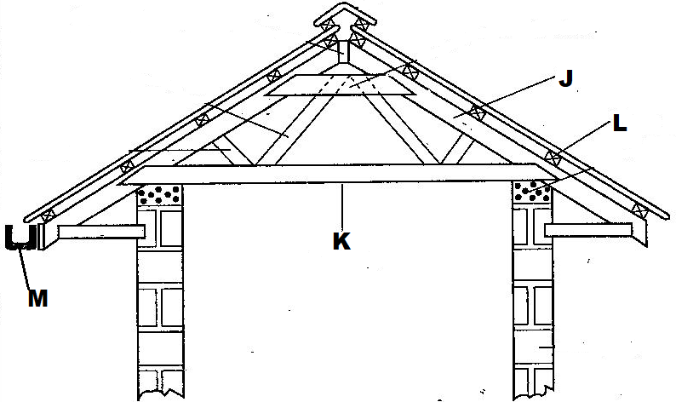
- Identify the parts labeled (2mks).
J ………………………………………………………………………………………………
K ………………………………………………………………………………………………
L ………………………………………………………………………………………………
M……………………………………………………………………………………………………

- State two uses of the part labelled L. (2mk).
………………………………………………………………………………………………………
(c) State one reason why it is important to have the structure labelled M at the edge of the roofing materials. (1mk).
………………………………………………………………………………………………………

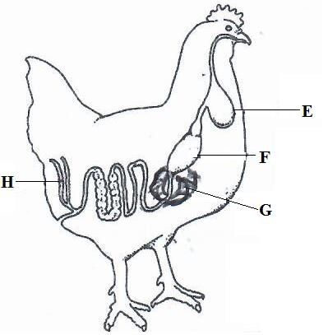
18. The diagram below shows the digestive system in poultry. Use it to answer the following questions.

(a) Name the parts labelled E and H. (2mks)

E:…………………………………………

H:…………………………………………

(b) Give the function of part F. (1mk)

………………………………………………………………………………………………

………………………………………………………………………………………………

(c) State two ways in which the part labelled G is adapted to its function. (2mks)

………………………………………………………………………………………………

………………………………………………………………………………………………

19. The diagrams below represent some farm tools and equipment .Study them and answer the questions that follow .
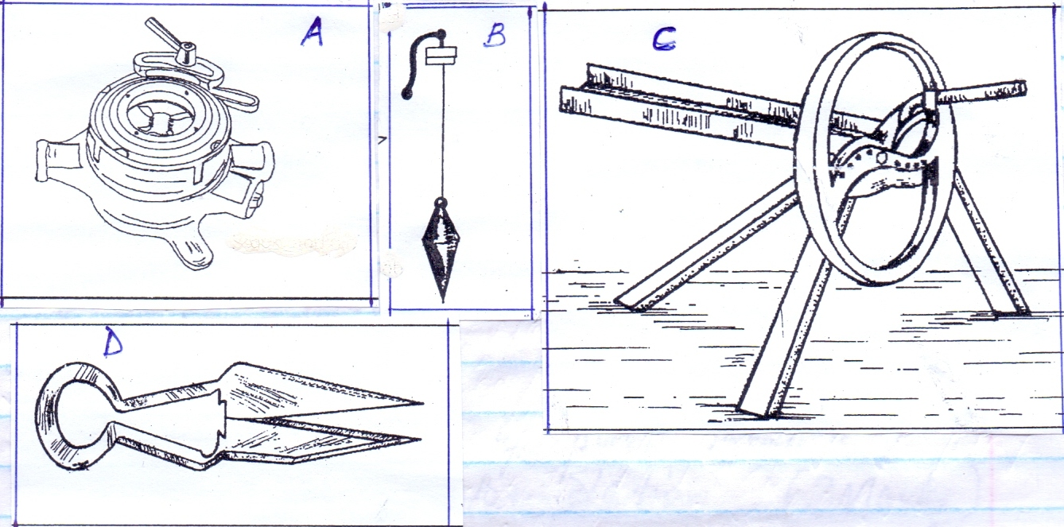
[a]Identify the tools labeled A and B

A……………………………………………………………………………… (1mark)

B………………………………………………………………………………. (1mark)

[b]State one use of each of the tools labeled C and D

C…………………………………………………………………………………………. (1mk)

D…………………………………………………………………………………………. (1mk)

[c] Explain one maintenance practice carried out on tool D . (1mk.)

………………………………………………………………………………………………………

- Study the illustration below and use it to answer the questions below

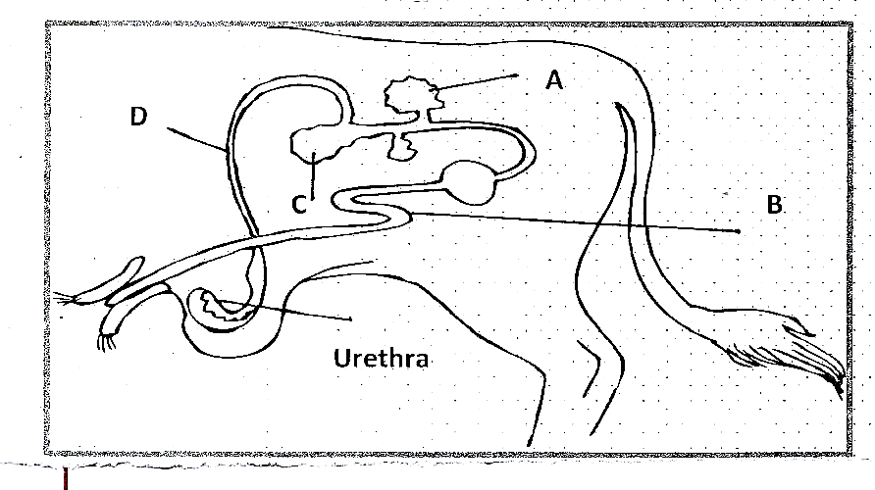

- Label the parts A,B,C and D (2 mks)
………………………………………………………………………………………………………………………………………………………………………………………………………………
………………………………………………………………………………………………………………………………………………………………………………………………………………
- Give the functions of parts B and C (2 mks)
B……………………………………………………………………………………………………………………………………………………………………………………………………………
C……………………………………………………………………………………………………………………………………………………………………………………………………………
- Give the name of the part in the animal affected when the animal is attached by brucellosis (1 mk)
………………………………………………………………………………………………………

………………………………………………………………………………………………………

SECTION C (40 MARKS)
ANSWER ANY 2 QUESTIONS IN THIS SECTION
21. a) Describe brucellosis under the following subheadings:
i) Causal organism (1mark)
ii) Transmission (1mark)
iii) Symptoms (4mks)
iv) Control measures (4mks)
b) State the function of any five parts of a zero grazing unit in dairy farming. (5mks)
c) Explain five factors that should be considered when choosing tools and equipment to use in the farm.(5mks )

- (a) State five functions of water in the body of an animal. (5marks)
(b) Discuss five factors that affect digestibility of feed in livestock. (10marks)
(c)Give five reasons for keeping livestock healthy. (5marks)

- (a) State ten general characteristics of beef cattle.
(10marks)

(b) Discuss five factors that determine the amount of maintenance ration and animal should be given. (10marks)
………………………………………………………………………………………………………………………………………………………………………………………………………………………………………………………………………………………………………………………………………………………………………………………………………………………………………………………………………………………………………………………………………………………………………………………………………………………………………………………………………………………………………………………………………………………………………………………………………………………………………………………………………………………………………………………………………………………………………………………………………………………………………………………………………………………………………………………………………………………………………………………………………………………………………………………………………………………………………………………………………………………………………………………………………………………………………………………………………………………………………………………………………………………………………………………………………………………………………………………………………………………………………………………………………………………………………………………………………………………………………………………………………………………………………………………………………………………………………………………………………………………………………………………………………………………………………………………………………………………………………………………………………………………………………………………………………………………………………………………………………………………………………………………………………………………………………………………………………………………………………………………………………………………………………………………………………………………………………………………………………………………………………………………………………………………………………………………………………………………………………………………………………………………………………………………………………………………………………………………………………………………………………………………………………………………………………………………………………………………………………………………………………………………………………………………………………………………………………………………………………………………………………………………………………………………………………………………………………………………………………………………………………………………………………………………………………………………………………………………………………………………………………………………………………………………………………………………………………………………………………………………………………………………………………………………………………………………………………………………………………………………………………………………………………………………………………………………………………………………………………………………………………………………………………………………………………………………………………………………………………………………………………………………………………………………………………………………………………………………………………………………………………………………………………………………………………………………………………………………………………………………………………………………………………………………………………………………………………………………………………………………………………………………………………………………………………………………………………………………………………………………………………………………………………………………………………………………………………………………………………………………………………………………………………………………………………………………………………………………………………………………………………………………………………………………………………………………………………………………………………………………………………………………………………………………………………………………………………………………………………………………………………………………………………………………………………………………………………………………………………………………………………………………………………………………………………………………………………………………………………………………………………………………………………………………………………………………………………………………………………………………………………………………………………………………………………………………………………………………………………………………………………………………………………………………………………………………………………………………………………………………………………………………………………………………………………………………………………………………………………………………………………………………………………………………………………………………………………………………………………………………………………………………………………………………………………………………………………………………………………………………………………………………………………………………………………………………………………………………………………………………………………………………………………………………………………………………………………………………………………………………………………………………………………………………………………………………………………………………………………………………………………………………………………………………………………………………………………………………………………………………………………………………………………………………………………………………………………………………………………………………………………………………………………………………………………………………………………………………………………………………………………………………………………………………………………………………………………………………………………………………………………………………………………………………………………………………………………………………………………………………………………………………………………………………………………………………………………………………………………………………………………………………………………………………………………………………………………………………………………………………………………………………………………………………………………………………………………………………………………………………………………………………………………………………………………………………………

