NAME………………………………………………….INDEX NUMBER……...............................
CANDIDATE’S SIGNATURE……………………………… DATE……………………………….
443/1 AGRICULTURE PAPER 1-marking scheme
@West practice papers-2021

INSTRUCTIONS TO CANDIDATES
- Write your name and index number in the spaces provided
- Sign and write the date of the examination in the spaces provided above
- This paper consists of three sections; A, B and C
- Answer all the questions in the section A and B
- Answer any two questions in section C
- All the answers should be written in the spaces provided
- Candidates should check the question papers to ascertain that all the pages are printed as indicated and that no questions are missing
- Candidate should answer all questions in English.

For examiner’s use only

section | Question | Maximum  score | Candidate’s  score
A | 1-15 | 30
B | 16-19 | 20
C |  | 20
 |  | 20
TOTAL 90
SECTION A (30 Marks)
Answer all questions in this section in the spaces provided.
1.State four factors determining farming systems (2mks)
-Availability of land for farming
-Environmental factors such as climate
-methods of land ownership
-Farmers choice and preference
-Availability of labour
-Government policy regarding the enterprise
2.State four advantages of extensive farming system (2mks
-It is cheap due to low capital input -Does not require high level of management
-Requires less labour
-Utilizes the marginal areas 3. State four importance of optimum temperature in crop production (2mks)
-Enhances seed germination or emergence
-Promotes soil microbial activities
-Improves quality of crop products
-Enhances high yield
Enhances vigorous growth and development
4.a) Name three physical properties of the soil ( 1¹_{/2}mks)
-soil colour
-Soil texture
-Soil structure
b). State three importance of soil structure on production ( 1¹/₂mks)
-Influences soil aeration
-Influences water infiltration and retention
-Influences plants root penetration and anchorage
-It determines the type of crop to be grown
c). State four reasons why burning of vegetation as a method of land clearing is discouraged ( 2mks)
-Destroys organic matter
-Kills soil living organisms
-Destroys soil structure
-Destroys plant nutrients present in the soil
-Leads to soil erosion
Causes mineral imbalance
5a). State three factor influencing depth of cultivation (1¹/2mks)
-The type of crop to be planted /size of seed
-The implements available
-The type of soil
b) i). What do you understand by the term sub-soiling (¹/2mk)
-This is deep cultivation into the subsoil layer to break up any hardpan which which have developed
ii). State two reasons for sub-soiling (1mk)
-To facilitate drainage
-It brings up leached nutrients to the surface
-increases aeration of the soil
To promote root penetration
-Breaks hard pans
6.State four features of a productive soil (2mks)
-Has good depth
-Has good aeration
-Has good water holding capacity
-Has proper drainage
Has correct soil pH
-Free from excessive soil borne pest and diseases_
7.a) State two deficiency symptoms of iron in crop production ( 1mk)
-Leaf chlorosis
-Yellowing of young leaves
b). Name two roles played by iron in crop production (1mk)
-Involved in synthesis of proteins
-Takes part in oxidation –reduction reactions

8. State four advantages of using inorganic fertilizers over organic fertilizers ( 2mks)
-Not bulky/easy to apply
- Has high amount of nutrients per given volume
-Does not spread diseases
-Nutrients are released very fast
9.a) Name four sites to avoid when carrying out soil sampling (2mks)
-Dead furrows
-Swamps
-Near manure heaps
-Recently fertilized fields
-Ant hills
-Under big trees
-Near fence lines or foot paths
b). State four advantages of using vegetative materials for planting ( 2mks)
-crops originating from vegetative materials mature faster than those from seeds
-crops shows uniformity in such qualities as disease resistance
-is possible to produce many varieties of compatible crops on the same root stock
-It facilitates the propagation of crops which are seedless

10.Complete the table below ( 2mks)
Plant part used for vegetative propagation material | Crop plant
1.splits | Nappier grass, pyrethrum
2.Bulbils | sisal
3.Suckers | Pineapples, bananas ,sisal
4.Crowns | pineapples
.
11.i) State four advantages of using certified seeds in crop production ( 2mks)
-They have high germination percentage

-They are free of pests and diseases/healthy
-They are free from weed seeds
-They are vigorous in growth
-They are high -yielding
ii)State four characteristics of a good vegetable seedlings ( 2mks)
-should be free from pests and diseases
-Should be free from physical deformities
-Should be vigorous-growing
- Should have 4-6 true leaves /10-15cm high

SECTION B (20 Marks)
12.Study the diagram below carefully and answer the questions that follows

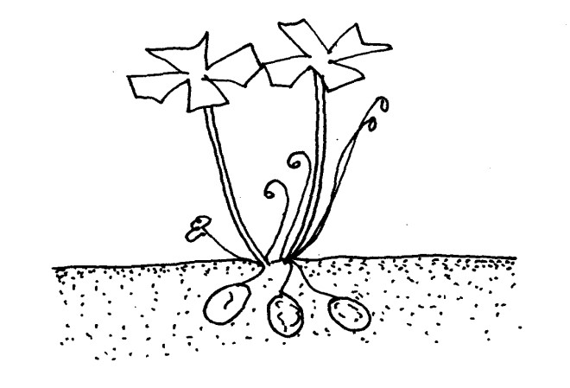

a). Identify the weed above (1mk)
-Oxalis (sorrel)

b). State two factors which contributes to the competitive ability of above weed ( 2mks)
-Ability to produce large qualities of seeds
-weed seeds remain viable in the soil for a long period of time waiting for conducive germination condition
-Some have ability to propagate vegetative
c).State two harmful effects of the weed named in a) above (2mks)
-Lowers the quality of agricultural produced
-Competes with crops for nutrient, space light and soil crops
d).Name one basis in which weed above is classified (1mk)
-Annual weed
-
13.Two maize pests are shown in the diagram below. Study them and answer the questions that follow.
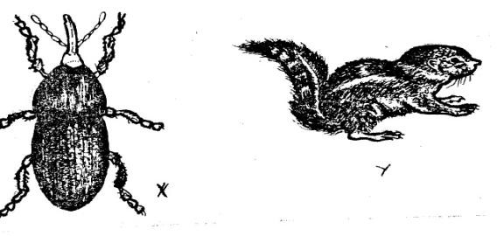
X

Y

a). Identify the pests in the diagrams labelled X and Y ( 2mks)
X-weevil
Y-squirrel
b.At what stage of maize production does each pest damage the crop ( 2mks)
X-storage pest
y-field pest
c). Give two way of controlling each of the pests in the field (2mks)
x-Applying appropriate pesticide
y-using of traps
14.(a) The diagram below shows a method of forage preservation
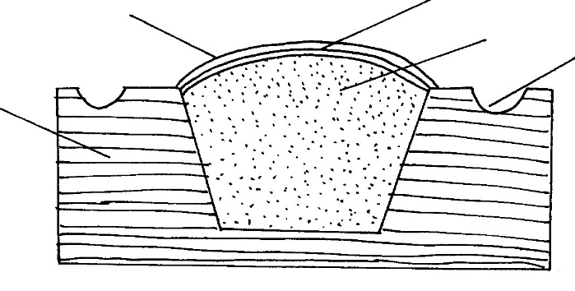
Ground

Soil Layer

Drainage

Forage material

Polythene sheet

a.) Identify the structure illustrated above (1mk)
-Trench silo

b) State the form in which the forage is preserved as illustrated above. (1mk)
-Fermentation/silage
c)Name two other method of forage preservation apart from above
-Hay
-Standing forage
15.i. Define the following terms as used in agroforestry
a). coppicing (1mk)
-Is the cutting the tree crop down to its stump and allowing it to re-grow
b) pollarding
-It is the cutting off the tree crop at its crown leaving it to send out new branches the top of the remaining stem
ii). Name any two forms of agroforestry ( 2mks)
Agrosilviculture
-Silvopastoral
Agrosilvopastoral

SECTION C(40Marks)
Answer any two questions from this section in the spaces provided after question 15
16.a) Explain five human factors influencing agriculture
1. Health
It affects the strength the vigour vision and determines to work e.g. the HIV and AIDS Pandemic
2.Economy
Collapse of agricultural cooperatives has affected the marketing of farm produce farmers produce and purchase of farm inputs.
Liberalization has led to increased unfair competition in the agricultural produce markets and the farm input available in the market are of low quality
3.Market forces
Demand and supply forces affect s the commodities in a free market, demand increases, the quantities of commodities supplied in market decreases
4. Transport and communication
Good means of transport facilitates easy movement of produce from production point to consumers cheaply, fast and efficiently
b) Describe the methods used to prepare planting materials before they are planted
-Breaking the seed dormancy
-seed dressing
-Seed inoculation
-chitting
c)Describe the use of any three materials used in building/grafting

I,) grafting tape-used to tie the scion and the root stock
Ii), grafting wax-used on the grafted part and is water repellent, this prevents water from entering the union part which might bring about rotting
Iii)Grafting knife-used to shape the scion and the root stock

7a) Describe the importance of vegetable crop

i)source of vitamins such as vitamins A, B and C
ii)supply minerals like calcium, iron phosphorus and potassium
iii)source of food e.g. cabbages, kales tomatoes
iv)Offers self-employment to farmers
v)source of foreign exchange through export of horticultural products
iv)source of raw materials for industries dealing with vegetables processing

b) Explain the cultural methods of pest control
-Using healthy planting materials
-practising the field hygiene e.g. burning of diseased crop residues
-proper seedbed preparation
-proper spacing to control damping off disease in cabbage seedling
-Heat treatment
-proper drying of cereals
-use of disease resistant varieties

c). Describe seven biological methods of soil and water conservation
-Grass strips/ Filter strips
-Cover cropping
-Contour Farming
-mulching
-Cropping systems
-Strip cropping
-Vegetated waterways

18.a). State seven reasons for pruning coffee
i)To remove old, unproductive or diseased, damaged parts
ii)To regulate the height of coffee bushes
iii). To control bearing to avoid overbearing in one season
iv)to control pests for example antestia
v)To facilitate easy picking or harvesting of berries.
vi)To economize on use of chemicals
vii)Facilitates easy penetration of the chemical sprays
b) Highlight seven effects of land fragmentation
-Time is wasted while travelling from one holding to another
-proper and effective control of weeds and pests become very difficult since fragments are surrounded by the farmer’ holdings
-Difficulties of following a sound farm plan arising from distance between fragments and the farmers home
-Difficult in controlling of of livestock parasites and diseases
-Difficult in carrying out various soil conservation measures
-Difficult in offering agricultural extension services/advise
-Agricultural productivity remains poor resulting in low standards of living
c) Explain the basic concepts of economics
a) Scarcity
Is a situation whereby the resources are limited in supply relative to demand, it implies that there is no time man can have enough resources to satisfy all his need or desires
b) Choice/preference
preference- is an act of making choice among alternatives given that the resources are limited in order to satisfy the needs
choice-is an act of deciding which resources should be allocated to meet production needs and satisfy the consumer’s needs.
c)Opportunity cost-is the value of the best foregone alternative or is the revenue forgone from the best alternative

