443/1

AGRICULTURE
PAPER 1
TIME: 2 HOURS

NAME_________________________ADM_____________INDEX NO___________________

2022 TRIAL 1 MAY INTERNAL EXAMINATION

Kenya Certificate of Secondary Education

Instructions:
- Write your name and index number in the space provided at the top of this page .
- Sign and write the date of the examination in the space provided above
- This paper consist of three section A, B, and C
- Answer all questions in section A and B
- Answer any two questions in section C
- All answers should be written in the spaces provided
- Candidate should check the question paper to ascertain that all pages are printed as indicated and that no questions are missing .
- Candidate should answer the question in English
FOR EXAMINERS USE ONLY
SECTION | QUESTION | MAXIMUM SCORE | CANDIDATE SCORE
A | 1-16 | 30
B | 17-20 | 20
C |  | 20
 |  | 20
 | TOTAL SCORE | 90

SECTION A (30 MRKS)
Answer all question in this section in the space provided
- Differentiate between olericulture and pomoculture as used in crop production .(1mrk) .................................................................................................................................................................................................................................................................................................................................................................................................................................................................................................................................
- List the physical weathering agents in soil formation process (1 ½ mrks)
.................................................................................................................................................................................................................................................................................................................................................................................................................................................................................................................................
- Give four method of farming (2mrks)
.................................................................................................................................................................................................................................................................................................................................................................................................................................................................................................................................
......................................................................................................................................................................................................................................................................................................................................................
- Give two examples for each of the following types of cost incurred in broiler production .
- Variable cost ( 2 marks)
.................................................................................................................................................................................................................................................................................................................................................................................................................................................................................................................................
- fixed cost (2 marks)
.................................................................................................................................................................................................................................................................................................................................................................................................................................................................................................................................
- Give four advantages of crop rotation .(2mrk)
.................................................................................................................................................................................................................................................................................................................................................................................................................................................................................................................................
......................................................................................................................................................................................................................................................................................................................................................
- State four factors that that should be considered when classifying crop pest (2mrks)
.................................................................................................................................................................................................................................................................................................................................................................................................................................................................................................................................
......................................................................................................................................................................................................................................................................................................................................................
- Give three reasons why a water logged soil is unsuitable for most crops(1 ½ )
.................................................................................................................................................................................................................................................................................................................................................................................................................................................................................................................................
8. Give four advantages of tissue culture (2mrks)
.................................................................................................................................................................................................................................................................................................................................................................................................................................................................................................................................
................................................................................................................................................................................................................................................................................................................................................................................................................................................................................................................................
- Outline four observable indictors of economic development of a nation (2mrks)
.................................................................................................................................................................................................................................................................................................................................................................................................................................................................................................................................
................................................................................................................................................................................................................................................................................................................................................................................................................................................................................................................................
- Outline four indicators of well decomposed manure (1 ½)
....................................................................................................................................................................................................................................................................................................................................................................................................................................................................................................................................................................................................................................................................................................................................................................................................................................................
- Give two conditions where opportunity cost does not exist (2mrks)
............................................................................................................................................................................................................................................................................................................................................................................................................................................................................................................
............................................................................................................................................................................................................................................................................................................................................................................................................................................................................................................
- Give four management practice that promote high herbage yields in pasture production (2mrks)
............................................................................................................................................................................................................................................................................................................................................................................................................................................................................................................
............................................................................................................................................................................................................................................................................................................................................................................................................................................................................................................
- Give three reasons why primary cultivation should be done early before the onset of the rains(1 ½ )
............................................................................................................................................................................................................................................................................................................................................................................................................................................................................................................
........................................................................................................................................................................................................................................................................................................................................

- Give two examples of farm records that are general in nature .(1mrk)
............................................................................................................................................................................................................................................................................................................................................................................................................................................................................................................
- Give four role of nitrogen in plants (2mrks)
............................................................................................................................................................................................................................................................................................................................................................................................................................................................................................................
............................................................................................................................................................................................................................................................................................................................................................................................................................................................................................................
- Give four benefits of possessing a land title deed (2mrks)
............................................................................................................................................................................................................................................................................................................................................................................................................................................................................................................
............................................................................................................................................................................................................................................................................................................................................................................................................................................................................................................
SECTION B (20 MRKS)
Answer all the questions in this section in the spaces provided
- The diagram below illustrates a feature observed after digging the soil several metres deep Study the diagram carefully and answer the question that follow
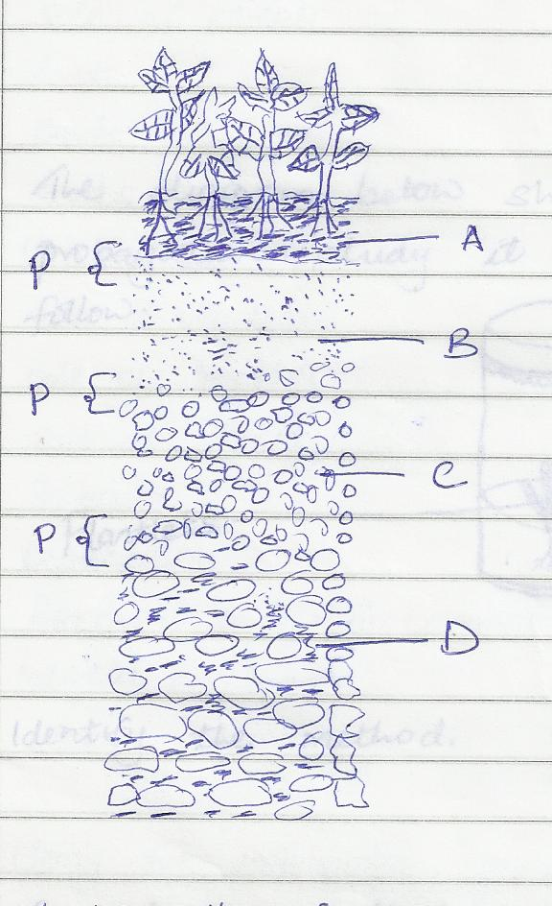

- Identify the feature that the diagram above represents in the study of soil (1mrk)
............................................................................................................................................................................................................................................................................................................................................................................................................................................................................................................
- What is the name given to the part labeled p(1mrk)
............................................................................................................................................................................................................................................................................................................................................................................................................................................................................................................

- Give a reason why part b is also reffered to as layer of accumulation (1mrk)
............................................................................................................................................................................................................................................................................................................................................................................................................................................................................................................
....................................................................................................................................................................
- State two ways in which the knowledge of the above feature would be of benefit to farmer (2mrks)
............................................................................................................................................................................................................................................................................................................................................................................................................................................................................................................
.................................................................................................................................................................................................................................................................................................................................................................................................................................................................................................................................
18The diagram below shows a method of crop propagation .Study it and answer the questions that follow
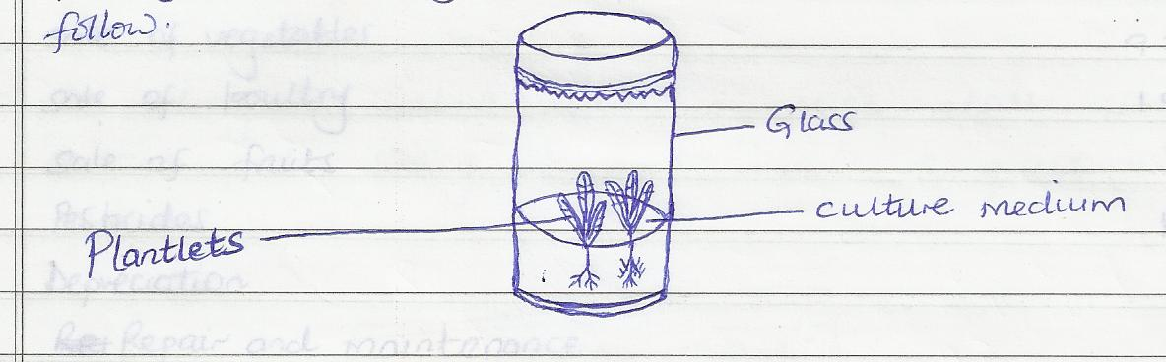
- Identify the method (1mrk)
.................................................................................................................................................................................................................................................................................................................................................................................................................................................................................................................................
b Name two crops that can be propagated using this method.(1mrk)
.................................................................................................................................................................................................................................................................................................................................................................................................................................................................................................................................
c. Give three ingredients used when preparing the tissue culture.(1 ½ )
.................................................................................................................................................................................................................................................................................................................................................................................................................................................................................................................................
19.The following information was obtained from the records of Mr Juma’s farm for the year ended on 31st march 2011
Particulars kshs
Opening Valuation 100,000
Calves 72,000
Hired Labour 21,000
Sales of milk 13,000
Sales of cereals 33,000
Rent 9,000
Feed 5,300
Seed 1,700
Fertilizers 4,700
Sales of Vegetables 9,300
Sales of poultry 1,800
Sales of fruits 700
Pesticides 1,250
Depreciation 650
Repair and Maintenance 950
Interest on loans 200
Closing Valuation 9,0000

- using the information given above , prepare a profit and loss account for Mr Juma’s farm for the year ended 31st March (7mrks)

- Giving a reason, State whether Mr. Juma’s farm made a profit or loss ( ½ mark )
.................................................................................................................................................................................................................................................................................................................................................................................................................................................................................................................................
20) The diagram below shows a maize stalk infected by a certain pest .Study it and answer the questions that follow .
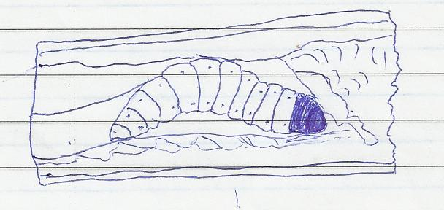
- Indentify the pest (1/2)
......................................................................................................................................................................................................................................................................................................................................................
- Apart from maize, name another crop attacked by the pest named above ( ½ mark)
......................................................................................................................................................................................................................................................................................................................................................
- Give three cultural measures that can be applied to control the pest (3mrks)
.................................................................................................................................................................................................................................................................................................................................................................................................................................................................................................................................
.................................................................................................................................................................................................................................................................................................................................................................................................................................................................................................................................
SECTION C ( 40MARKS)
Answer any two questions in this section in the spaces provided
21a) Describe six advantages of rotational grazing (6mrks)
.................................................................................................................................................................................................................................................................................................................................................................................................................................................................................................................................
......................................................................................................................................................................................................................................................................................................................................................
......................................................................................................................................................................................................................................................................................................................................................
.................................................................................................................................................................................................................................................................................................................................................................................................................................................................................................................................

- Explain eight ways in which soil fertility can be maintained (8mrks)
.................................................................................................................................................................................................................................................................................................................................................................................................................................................................................................................................
.................................................................................................................................................................................................................................................................................................................................................................................................................................................................................................................................
......................................................................................................................................................................................................................................................................................................................................................
................................................................................................................................................................................................................................................................................................................................................................................................................................................................................................................................
- Explain six factors considered when drawing a farm plan (6mrks)
.................................................................................................................................................................................................................................................................................................................................................................................................................................................................................................................................
.................................................................................................................................................................................................................................................................................................................................................................................................................................................................................................................................
.................................................................................................................................................................................................................................................................................................................................................................................................................................................................................................................................

22a) Explain the factors that influence the type of irrigation to be used in a farm (8mrks)
.................................................................................................................................................................................................................................................................................................................................................................................................................................................................................................................................
.................................................................................................................................................................................................................................................................................................................................................................................................................................................................................................................................
.................................................................................................................................................................................................................................................................................................................................................................................................................................................................................................................................
.................................................................................................................................................................................................................................................................................................................................................................................................................................................................................................................................
- Explain six reasons for pruning coffee.(6mrks)
.................................................................................................................................................................................................................................................................................................................................................................................................................................................................................................................................
.................................................................................................................................................................................................................................................................................................................................................................................................................................................................................................................................
.................................................................................................................................................................................................................................................................................................................................................................................................................................................................................................................................
..........................................................................................................................................................................................................................................................................................................................................................................................................................................................................................................................
- Describe 6 ways in which lab our productivity can be improved on a farm (6mrks)
.................................................................................................................................................................................................................................................................................................................................................................................................................................................................................................................................
.................................................................................................................................................................................................................................................................................................................................................................................................................................................................................................................................
.................................................................................................................................................................................................................................................................................................................................................................................................................................................................................................................................
.................................................................................................................................................................................................................................................................................................................................................................................................................................................................................................................................

23a) Describe five importance of agro -forestry in soil and water conservation (6mrks)
.................................................................................................................................................................................................................................................................................................................................................................................................................................................................................................................................
.................................................................................................................................................................................................................................................................................................................................................................................................................................................................................................................................
.................................................................................................................................................................................................................................................................................................................................................................................................................................................................................................................................
- Describe the procedure of silage making (10mrks)
.................................................................................................................................................................................................................................................................................................................................................................................................................................................................................................................................
.................................................................................................................................................................................................................................................................................................................................................................................................................................................................................................................................
.................................................................................................................................................................................................................................................................................................................................................................................................................................................................................................................................
.................................................................................................................................................................................................................................................................................................................................................................................................................................................................................................................................
................................................................................................................................................................................................................................................................................................................................................................................................................................................................................................................................
- Describe five effect of over application of nitrogenous fertilizer(5mrks)
.................................................................................................................................................................................................................................................................................................................................................................................................................................................................................................................................
.................................................................................................................................................................................................................................................................................................................................................................................................................................................................................................................................
......................................................................................................................................................................................................................................................................................................................................................
......................................................................................................................................................................................................................................................................................................................................................
......................................................................................................................................................................................................................................................................................................................................................
......................................................................................................................................................................................................................................................................................................................................................

