END-TERM EXAM
TERM ONE FORM FOUR
AGRICULTURE PAPER 1
TIME: 2 HOURS
NAME……………………………………………….. ADM……………….. CLASS……...

SECTION A: (30 MARKS)
Answer ALL the questions in this section in the spaces provided
1. What is the meaning of seed dressing? (1mk)

2. Give four advantages of row planting. (2mks)

3. List four factors to be considered when choosing site for tomato nursery. (2mks)

4. State three reasons of treating water in the farm. (1 ½ mks)

5. Give three ways through which HIV/AIDS affect agriculture. (1 ½ mks)

6. State four advantages of overhead irrigation. (2mks)

7. State three ways of conveying water in the firm. (2mks)

8. A farmer in Premier was advised to apply 150kg C.A.N/ha while top dressing the maize crop. CAN, contains 21% N. Calculate the amount of nitrogen applied per ha. (2mks)

9. Give two reasons why opportunity cost is zero. ( lmk )

10. Give three importance of tissue culture in crop production. (2mks)

11. State four principles which govern agricultural economics. (2mks)

12. Highlight four problems facing the marketing of cabbages. (2mks)

13. State four variable costs in maize production. (2mks)

14. State four constituents of soil. (2mks)

15. Give four types of product -product relationships. (2mks)

16. Differentiate between topping and top-dressing as used in pastures. (lmk)

17. State five factors which influence the spacing of crops. (2mks)

SECTION B (20 MKS)
Answer ALL Questions in this section
18. Below are illustrations of common weeds. Study them and answer the questions that follow

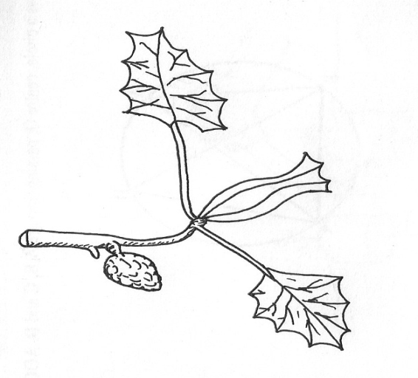
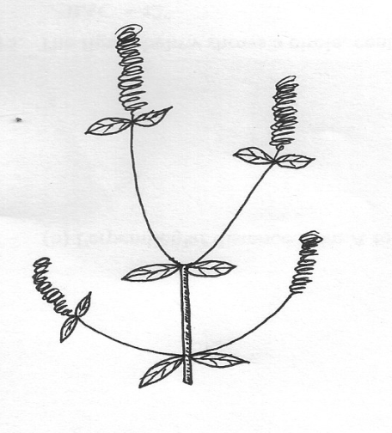

A
B

(a) Identify the weeds (2mks)
A…………………………………………….
B…………………………………………….
(b) State the harmful effects of the weed B above (1mk)
………………………………………………………………………………………………
(c) Give four advantages of leasehold tenure systems (2mks)
………………………………………………………………………………………………
………………………………………………………………………………………………
……………………………………………………………………………………………
……………………………………………………………………………………………

19. Describe the procedure which should be followed when spraying a crop of onions using a
fungicide in powder form, water and a knapsack sprayer (5mks)
………………………………………………………………………………………………
………………………………………………………………………………………………
………………………………………………………………………………………………
………………………………………………………………………………………………
………………………………………………………………………………………………
20. The diagram below illustrates a nursery practice carried out on tree seedlings before transplanting. Study it carefully and then answer the questions below
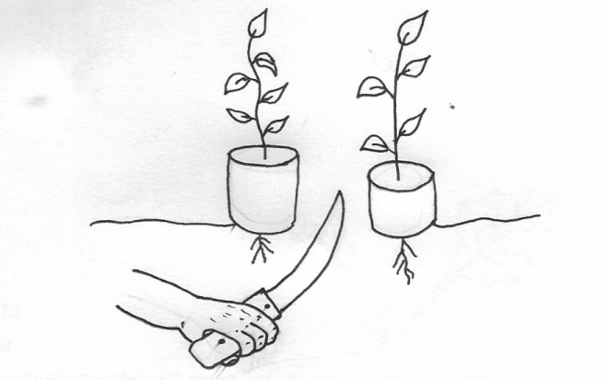

Polythene sleeves
Ground level

(a) Identify the practice being carried out on the diagram (1mk)
……………………………………………………………………………………………
(b) Give three reasons why the practice is encouraged when raising tree seedlings (3mks)
………………………………………………………………………
……………………………………………………………………………………
……………………………………………………………………………
(c) Give two reasons why the polythene sleeves are used in the nursery bed as shown in the diagram (2mks)
………………………………………………………………………………
………………………………………………………………………
21. (a) Calculate the elasticity of demand when 20 bags of potatoes are demanded at a price of Kshs.1000 while 22 bags were demanded at Kshs.800. (4mks)

(b) Identify the type of elasticity of demand resulting from the situation above (1mk)
…………………………………………………………………………………………

SECTION C (40MKS)
Answer any two Questions in this section
22. (a) Describe harvesting of pyrethrum under the following sub-headings
(i) Procedure (4mks)
(ii) Precautions (6mks)
(b) Describe the safety measures observed when handling farm herbicides (10mks)
23. Describe the production of Rhodes grass (Chloris gayana) under the following sub-headings
(a) Land preparation (5mks)
(b) Pasture establishment (8mks)
(c) Maintenance (7mks)
24. (a) State four major questions a farm manager needs to ask and answer while preparing a partial budget (4mks)
(b) Under what conditions is partial budget an appropriate tool for planning (4mks)
(c) Mzee mkulima has 5 hectare of arable land which is under maize. He wishes to know whether replacing 0.3 ha of maize with beans the following season would be worthwhile. The fertilizer rate would have to be increased from 2 bags per hectare for maize to 2.5 bags per hectare, for beans and an extra 40 man days of casual labour per hectare would be necessary as a result of the change. Average yield of maize and beans are 56 and 90 bags per hectare respectively. The prices are ksh 1200 per bag of maize and ksh 300 per bag of beans. Seed costs are ksh 1350 per 10 kg of maize ksh 200 per 50 kg beans DAP fertilizer costs ksh 1400 per 50 kg bag. Labour is paid at ksh 150 per man day . he would require ten bag of beans seed and 1 bag of maize seed to caver 0.3 of ha.

Draw up a partial budget and indicate the effects of the change (12mks)

