Name: ………………………………….ADM No: ………CLASS…………....
AGRICULTURE (443/2)
FORM THREE
PAPER 2
2 HOURS

Instructions to candidates.

- Write your name and admission number in the spaces provided.
- This paper consists of three sections A, B and C.
- Answer ALL the questions in section A and B and any two questions in section C.
- All answers must be written in the spaces provided.
- Do not remove any pages from the question paper.

For Examiner`s use only

Section | Questions | Maximum score | Candidates score
A | 1-16 | 30
B | 17-19 | 20
C |  | 20
 |  | 20
 | Total Score | 90

SECTION A (30 marks)
Answer all questions in this section in the spaces provided

- Give two uses of the roof of cattle dip tank. (1mk)
............................................................................................................................................................................................................................................................................................................
- State Four dairy goat breeds reared in a farm. (2mk)
............................................................................................................................................................................................................................................................................................................
- Give four signs of farrowing in a sow. (2mks)
........................................................................................................................................................................................................................................................................................................................................................................................................................................................................................................................................................................................................................
- State four maintenance practices carried out on a knapsack sprayer. (2mks)
........................................................................................................................................................................................................................................................................................................................................................................................................................................................................................................................................................................................................................
- Give three factors that a farmer may consider while carrying out culling in livestock production. (2¹/_{2MKS})
..................................................................................................................................................................................................................................................................................................................................................................................................................................................................
- a. state two factors considered when siting a fishpond (1mk)
……………………………………………………………………………………………………………………………………………………………………………………………………
State four categories of individual land tenure system (2mks)
…………………………………………………………………………………………………………………………………………………………………………………………………………………………………………………………………………………………………………………………………………………………………………………………………………

- State two ways of caponisation in poultry. (2mks)
..................................................................................................................................................................................................................................................................................................................................................................................................................................................................
- State four reasons why inbreeding may be useful in livestock production. (2mks)
........................................................................................................................................................................................................................................................................................................................................................................................................................................................................................................................................................................................................................
- Give two effects of Tsetse flies on livestock. (1mk)
............................................................................................................................................................................................................................................................................................................
- Name two types of rabbit houses. (1mk)
............................................................................................................................................................................................................................................................................................................
- List four types of vaccines used in livestock production. (2mks)
..................................................................................................................................................................................................................................................................................................................................................................................................................................................................
- Name four types of pests that affect bees. (2mks)
........................................................................................................................................................................................................................................................................................................................................................................................................................................................................................................................................................................................................................
- Outline three reasons why farmers dehorn cattle. (1¹/2mks)
..................................................................................................................................................................................................................................................................................................................................................................................................................................................................
- (a. Differentiate between cropping and harvesting as used in fish production. (1mk)
............................................................................................................................................................................................................................................................................................................
b. Name two species of fresh warm water fish. (1mk)
............................................................................................................................................................................................................................................................................................................
- Give four reasons for steaming up dairy cattle. (2mks)
........................................................................................................................................................................................................................................................................................................................................................................................................................................................................................................................................................................................................................
- Name four factors to consider while choosing construction materials in the farm. (2mks)
........................................................................................................................................................................................................................................................................................................................................................................................................................................................................................................................................................................................................................

SECTION B (20 Marks)
Answer all questions in this section in the spaces provided.
- Below is a diagram illustrating a beehive. Study carefully an answer the questions that follow.
- Name the type of beehive shown (1mk)

- Name the parts labeled H and K (2mk)
H
K
- Give two importance of part G (2mks)

- Give two tools used for detaching honey combs during honey harvesting. (2mks)

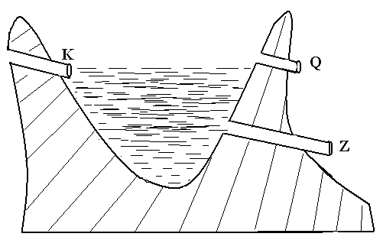
- The illustration below is a farm structure.

- Identify the structure. (1 mark)

- Name the parts labeled K, Q and Z. (3 marks)
K
Q
Z
- Give four maintenance practices carried out on the above structure. (2marks)

- Study the farm structure shown below and answer questions that follow.

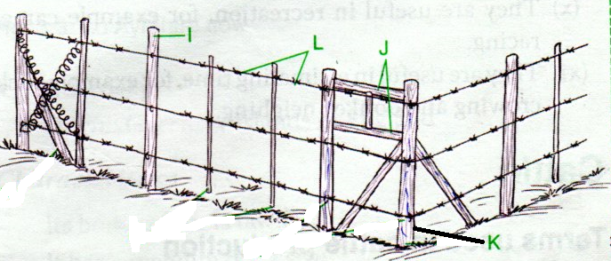
- . Identify the structure shown above. (1mk)

(b). Name the parts labeled I, J, K and L. above. (4mks)
I
J
K
L

(c). Give two disadvantages of using the structure above in pasture fields. (2mk)

SECTION C (20 Marks
Answer any TWO questions in this section in the spaces provided.

- (a)state three fat soluble vitamins (3marks)
b) Give five functions of vitamins in livestock production. (5 marks)
c) State reasons for absconding of bees (7 marks)
d) Outline five advantages of embryo transplant technology in cattle management.
(5 marks)
21. a) Describe five features of an ideal calf pen (5mks)
b) Describe the general uses of a fence in the farm (10mks)
c) Outline five reasons for keeping livestock healthy (5mks)

22. a) Outline ten factors to consider when selecting gilt for breeding stock. (10 marks)
b) Explain the economic importance of parasites to livestock. (10 marks)

