Term 2 - 2022
AGRICULTURE (443/2)
PAPER 2
FORM FOUR (4)
Time: 2 Hours

Name: …………………………………………………………. Adm No: ……………….
School: ……………………………………………………….. Class: …………………..
Signature: …………………………………………………….. Date: …………………...

INSTRUCTIONS TO CANDIDATES:
- Write your name and index number in the spaces provided.
- Sign and write the date in the spaces provided above
- This paper consists of three section A, B and C
- Answer all the questions in section A and B
- Answer any two questions in section C.
- Answers should be written in the spaces provided in this booklet.

For Examiner’s Use Only:
SECTION | QUESTIONS | MAXIMUM SCORE | CANDIDATES SCORE
A |  | 30
B |  | 20
C |  | 20
 |  | 20
 | TOTAL | 90

This paper consists of 12 printed pages. Candidates should check to ascertain that all papers are printed as indicated and that no questions are
missing

SECTION A. (30 MARKS)
Answer ALL the questions in this section in the spaces provided.
1. State four maintenance practices of a forked jembe. (2mks)
……………………………………………………………………………………………………………………………………………………………………………………………………………………
……………………………………………………………………………………………………………………………………………………………………………………………………………………
2. Fill in the origin for the breeds of livestock shown in the table below. (2mks)
Livestock breed | Origin
Friesian cattle
Aberdeen Angus cattle
Large white pig
Boer goat

3. State the importance of keeping livestock healthy. (2mks)
……………………………………………………………………………………………………………………………………………………………………………………………………………………
……………………………………………………………………………………………………………………………………………………………………………………………………………………
4. Give the functional difference between a pruning knife and a pruning saw. (1mk)
……………………………………………………………………………………………………………………………………………………………………………………………………………………
5. Name any two dual purpose breeds of sheep. (1mk)
……………………………………………………………………………………………………………………………………………………………………………………………………………………

6. List any four pre-disposing factors of livestock diseases. (2mks)
………………………………………………………………………………………………………………………………………………………………………………………………………………………….
…………………………………………………………………………………………………………….…………………………………………………………………………………………………………….

7. Differentiate between the terms breed and type of animal. (1mk)
…………………………………………………………………………………………………………………………………………………………………………………………………………………………

8. Give the factors that determine the amount of water taken by an animal. (3mks)
…………………………………………………………………………………………………………………………………………………………………………………………………………………………
…………………………………………………………………………………………………………………………………………………………………………………………………………………………
…………………………………………………………………………………………………………………………………………………………………………………………………………………………
9. List any four causes of livestock diseases. (2mks)
…………………………………………………………………………………………………………………………………………………………………………………………………………………………
………………………………………………………………………………………………………………………………………………………………………………………………………………………….
10. Give the reasons for breeding in livestock. (2mks)
…………………………………………………………………………………………………………………………………………………………………………………………………………………………
…………………………………………………………………………………………………………………………………………………………………………………………………………………………
11. List the materials used in making walls of farm buildings. (2mks)
…………………………………………………………………………………………………………………………………………………………………………………………………………………………
…………………………………………………………………………………………………………………………………………………………………………………………………………………………
12. What is the meaning of the term immunity as used in livestock health. (1mk)
…………………………………………………………………………………………………………………………………………………………………………………………………………………………

13. State the measures that prevent egg eating in poultry. (2mks)
…………………………………………………………………………………………………………………………………………………………………………………………………………………………
…………………………………………………………………………………………………………………………………………………………………………………………………………………………
14. State the signs of heat in pigs. (3mks)
………………………………………………………………………………………………………………………………………………………………………………………………………………………….
…………………………………………………………………………………………………………………………………………………………………………………………………………………………
…………………………………………………………………………………………………………………………………………………………………………………………………………………………
15. Give one use of a screen in a fish pond. (1mk)
…………………………………………………………………………………………………………….
…………………………………………………………………………………………………………….
16. State two methods of service in livestock. (1mk)
…………………………………………………………………………………………………………………………………………………………………………………………………………………………
17. Give the advantages of wall fence. (1mk)
…………………………………………………………………………………………………………………………………………………………………………………………………………………………
18. List the factors considered in sorting and grading eggs for market. (1mk)
…………………………………………………………………………………………………………….…………………………………………………………………………………………………………….

SECTION B. (20 MARKS)
Answer ALL the questions in this section in the spaces provided.
19. The diagram X and Y below show the hooves of sheep.
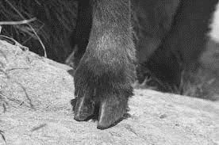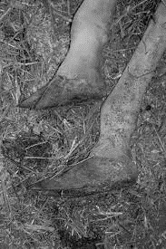
X Y

a) Which one of the two hooves would be more susceptible to foot-rot disease. (1mk)
…………………………………………………………………………………………………………
b) What routine management practice is required on the hoof to control foot rot? (1mk)
…………………………………………………………………………………………………………

c) State four symptoms of hoof rot. (2mks)
………………………………………………………………………………………………………………………………………………………………………………………………………………………….
…………………………………………………………………………………………………………………………………………………………………………………………………………………………………………………………………………………………………………………………………………………………………………………………………………………………………………………….
…………………………………………………………………………………………………………………………………………………………………………………………………………………………

20. a) The illustrations below labeled V, W, and X show three different ways some hens were
debeaked.
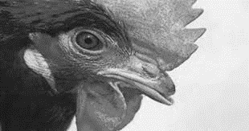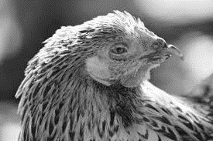
I II III
i) Which hen was correctly debeaked? (1mk)
…………………………………………………………………………………………………………
ii) State two reasons for your choice in (i) above. (1mk)
……………………………………………………………………………………………………………………………………………………………………………………………………………………………………………………………………………………………………………………………………………………………………………………………………………………………………………………

b) Name any two tools which would be used for debeaking. (2mks)
……………………………………………………………………………………………………………………………………………………………………………………………………………………………………………………………………………………………………………………………………………………………………………………………………………………………………………………

21. Below are diagrams illustrating the behaviour of chicks in various brooders. Study the diagrams and answer the questions that follow:

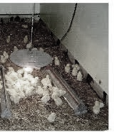
A
HEAT SOURCE
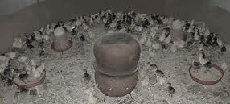
B
F
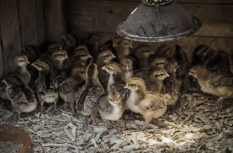
C

a) State the environmental problem in each brooder as illustrated by the behaviour of the chicks. (3mks)
A ………………………………………………………………………………………….
B ………………………………………………………………………………………….
C ………………………………………………………………………………………….
b) State one way of solving the problem in B. (1mk)
…………………………………………………………………………………………………………
…………………………………………………………………………………………………………

22. Below is a diagram of a male goat.
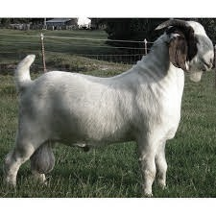
F
a) What operation is carried out on the part labeled F. (1mk)
…………………………………………………………………………………………………………
b) Why is it necessary to carry out the operation. (2mks)
……………………………………………………………………………………………………………………………………………………………………………………………………………………
……………………………………………………………………………………………………………………………………………………………………………………………………………………
c) Give any two suitable methods of carrying out the operation in (a) above. (1mk)
……………………………………………………………………………………………………………………………………………………………………………………………………………………

23. Below is a diagram of a two-stroke engine cylinder.
M
N
L

a) Name any one farm machine where the above engine is used. (1mk)
…………………………………………………………………………………………………………
b) Identify the parts labeled M, L, and N. (3mks)
L …………………………………………………….
M …………………………………………………….
N …………………………………………………….

SECTION C (40 MARKS)
Answer any TWO questions in this section in the spaces provided after question 26.
24. a) Describe the feeding management of broiler chicks from one day old to slaughtering. (10mks)
b) Describe the routine management practices in dairy calves. (6mks)
c) Describe the factors that affect milk composition. (4mks)
25. a) Describe a blue tick (Boophilus decolaratus) under the following sub-headings.
i) Diseases transmitted. (2mks)
ii) Preferred site of attachment. (3mks)
iii) Non-chemical control measures. (5mks)
b) Discuss mastitis disease under the following sub-headings:
i) Predisposing factors. (5mks)
ii) Control and treatment. (5mks)
26. a) Describe the functions of each of the following parts of a plunge dip. (7mks)
i) Foot bath
ii) Entrance race
iii) Roof
iv) Drainage race
v) Jump
vi) Dip tank
vii) Exit steps.

b) i) Describe the disadvantages of animal power. (5mks)
ii) State the advantages of four-strokes engine over two stroke engines. (3mks)
c) Describe the factors that influence the amount of concentrate a lactating animal would be
given. (5mks)

…………………………………………………………………………………………………………………………………………………………………………………………………………………………
…………………………………………………………………………………………………………………………………………………………………………………………………………………………
…………………………………………………………………………………………………………………………………………………………………………………………………………………………
…………………………………………………………………………………………………………………………………………………………………………………………………………………………
…………………………………………………………………………………………………………………………………………………………………………………………………………………………
…………………………………………………………………………………………………………………………………………………………………………………………………………………………
…………………………………………………………………………………………………………………………………………………………………………………………………………………………
………………………………………………………………………………………………………………………………………………………………………………………………………………………….
…………………………………………………………………………………………………………………………………………………………………………………………………………………………
…………………………………………………………………………………………………………………………………………………………………………………………………………………………
…………………………………………………………………………………………………………………………………………………………………………………………………………………………
…………………………………………………………………………………………………………………………………………………………………………………………………………………………
…………………………………………………………………………………………………………………………………………………………………………………………………………………………
…………………………………………………………………………………………………………………………………………………………………………………………………………………………
……………………………………………………………………………………………………………………………………………………………………………………………………………………………………………………………………………………………………………………………………………………………………………………………………………………………………………………
…………………………………………………………………………………………………………………………………………………………………………………………………………………………
…………………………………………………………………………………………………………………………………………………………………………………………………………………………
…………………………………………………………………………………………………………………………………………………………………………………………………………………………
……………………………………………………………………………………………………………………………………………………………………………………………………………………………………………………………………………………………………………………………………………………………………………………………………………………………………………………
…………………………………………………………………………………………………………………………………………………………………………………………………………………………
……………………………………………………………………………………………………………………………………………………………………………………………………………………………………………………………………………………………………………………………………………………………………………………………………………………………………………………
………………………………………………………………………………………………………………………………………………………………………………………………………………………….
…………………………………………………………………………………………………………………………………………………………………………………………………………………………
…………………………………………………………………………………………………………………………………………………………………………………………………………………………
…………………………………………………………………………………………………………………………………………………………………………………………………………………………
…………………………………………………………………………………………………………………………………………………………………………………………………………………………
…………………………………………………………………………………………………………………………………………………………………………………………………………………………
…………………………………………………………………………………………………………………………………………………………………………………………………………………………
……………………………………………………………………………………………………………………………………………………………………………………………………………………………………………………………………………………………………………………………………………………………………………………………………………………………………………………
…………………………………………………………………………………………………………………………………………………………………………………………………………………………
…………………………………………………………………………………………………………………………………………………………………………………………………………………………
…………………………………………………………………………………………………………………………………………………………………………………………………………………………
……………………………………………………………………………………………………………………………………………………………………………………………………………………………………………………………………………………………………………………………………………………………………………………………………………………………………………………
…………………………………………………………………………………………………………………………………………………………………………………………………………………………
…………………………………………………………………………………………………………………………………………………………………………………………………………………………

