Term 2 - 2022
AGRICULTURE (443/1)
PAPER 1
FORM FOUR (4)
Time: 2 Hours

Name: …………………………………………………………. Adm No: ……………….
School: ……………………………………………………….. Class: …………………..
Signature: …………………………………………………….. Date: …………………...
Instruction to candidates
- Write your name and index number in the space provided at the top of this page .
- Sign and write the date of the examination in the space provided above
- This paper consists of three section A, B, and C
- Answer all questions in section A and B
- Answer any two questions in section C
- All answers should be written in the spaces provided
- Candidates should check the question paper to ascertain that all pages are printed as indicated and that no questions are missing .
- Candidate should answer the questions in English
FOR EXAMINERS USE ONLY
SECTION | QUESTION | MAXIMUM SCORE | CANDIDATE SCORE
A | 1-16 | 30
B | 17-20 | 20
C |  | 20
 |  | 20
 | TOTAL SCORE | 90

SECTION A (30 MRKS)
Answer all question in this section in the space provided
- Differentiate between olericulture and pomoculture as used in crop production .(1mrk) .................................................................................................................................................................................................................................................................................................................................................................................................................................................................................
- List the physical weathering agents in soil formation process (1 ½ mrks)
.................................................................................................................................................................................................................................................................................................................................................................................................................................................................................
- Give four methods of farming (2mrks)
.................................................................................................................................................................................................................................................................................................................................................................................................................................................................................
......................................................................................................................................................................................................................................................................................................................
- Give two examples for each of the following types of cost incurred in broiler production .
- Variable cost ( 2 marks)
.................................................................................................................................................................................................................................................................................................................................................................................................................................................................................
- fixed cost (2 marks)
.................................................................................................................................................................................................................................................................................................................................................................................................................................................................................
- Give four advantages of crop rotation .(2mrk)
.................................................................................................................................................................................................................................................................................................................................................................................................................................................................................
......................................................................................................................................................................................................................................................................................................................
- State four factors that should be considered when classifying crop pest (2mrks)
.................................................................................................................................................................................................................................................................................................................................................................................................................................................................................
......................................................................................................................................................................................................................................................................................................................

- Give three reasons why a water logged soil is unsuitable for most crops(1 ½ )
.................................................................................................................................................................................................................................................................................................................................................................................................................................................................................
8. Give four advantages of tissue culture (2mrks)
.................................................................................................................................................................................................................................................................................................................................................................................................................................................................................
.................................................................................................................................................................................................................................................................................................................................................................................................................................................................................
- Outline four observable indictors of economic development of a nation (2mrks)
.................................................................................................................................................................................................................................................................................................................................................................................................................................................................................
.................................................................................................................................................................................................................................................................................................................................................................................................................................................................................
- Outline four indicators of well decomposed manure (1 ½mks)
.........................................................................................................................................................................................................................................................................................................................................................................................................................................................................................................................................................................................................................................................................................................................................................................
- Give two conditions where opportunity cost does not exist (2mrks)
...............................................................................................................................................................................................................................................................................................................................................................................................................................................................
...............................................................................................................................................................................................................................................................................................................................................................................................................................................................
- Give four management practice that promote high herbage yields in pasture production (2mrks)
...............................................................................................................................................................................................................................................................................................................................................................................................................................................................
...............................................................................................................................................................................................................................................................................................................................................................................................................................................................

- Give three reasons why primary cultivation should be done early before the onset of the rains(1 ½ mrks )
...............................................................................................................................................................................................................................................................................................................................................................................................................................................................
..........................................................................................................................................................................................................................................................................................................

- Give two examples of farm records that are general in nature .(1mrk)
............................................................................................................................................................................................................................................................................................................................................................................................................................................................................................................
- Give four roles of nitrogen in plants (2mrks)
...............................................................................................................................................................................................................................................................................................................................................................................................................................................................
...............................................................................................................................................................................................................................................................................................................................................................................................................................................................
- Give four benefits of possessing a land title deed (2mrks)
...............................................................................................................................................................................................................................................................................................................................................................................................................................................................
...............................................................................................................................................................................................................................................................................................................................................................................................................................................................

SECTION B (20 MRKS)
Answer all the questions in this section in the spaces provided
- The diagram below illustrates a feature observed after digging the soil several metres deep Study the diagram carefully and answer the question that follow
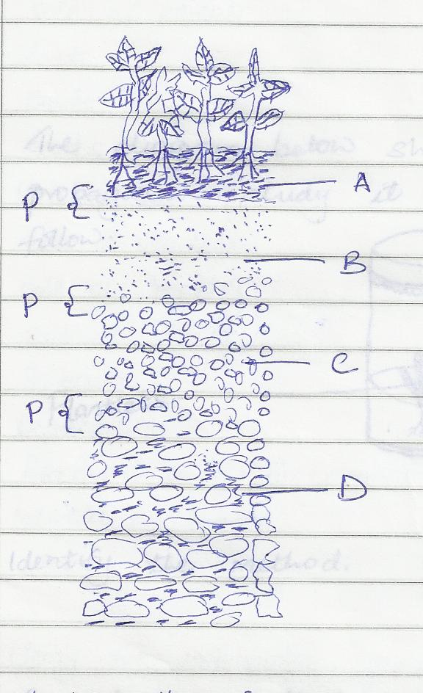

- Identify the feature that the diagram above represents in the study of soil (1mrk)
...............................................................................................................................................................................................................................................................................................................................................................................................................................................................
- What is the name given to the part labeled p(1mrk)
...............................................................................................................................................................................................................................................................................................................................................................................................................................................................

- Give a reason why part b is also referred to as layer of accumulation (1mrk)
...............................................................................................................................................................................................................................................................................................................................................................................................................................................................
..................................................................................................................................................... State two ways in which the knowledge of the above feature would be of benefit to farmer (2mrks)
...............................................................................................................................................................................................................................................................................................................................................................................................................................................................
.................................................................................................................................................................................................................................................................................................................................................................................................................................................................................

18.The diagram below shows a method of crop propagation .Study it and answer the questions that follow
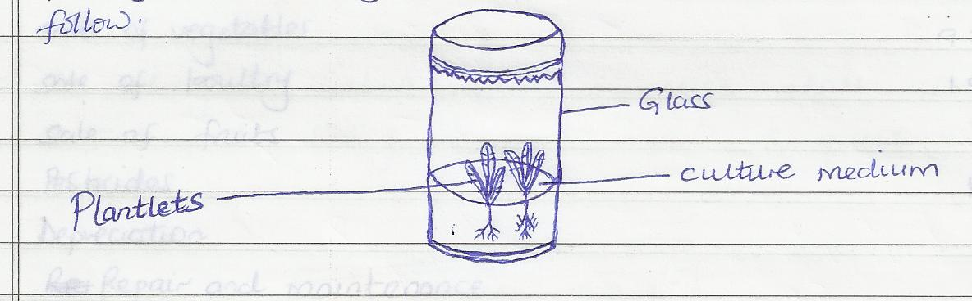
- Identify the method (1mrk)
.................................................................................................................................................................................................................................................................................................................................................................................................................................................................................
b Name two crops that can be propagated using this method.(1mrk)
.................................................................................................................................................................................................................................................................................................................................................................................................................................................................................
c. Give three ingredients used when preparing the tissue culture.(1 ½ )
......................................................................................................................................................................................................................................................................................................................
...........................................................................................................................................................

19.The following information was obtained from the records of Mr Juma’s farm for the year ended on 31st march 2011
Particulars kshs
Opening Valuation 100,000
Calves 72,000
Hired Labour 21,000
Sales of milk 13,000
Sales of cereals 33,000
Rent 9,000
Feed 5,300
Seed 1,700
Fertilizers 4,700
Sales of Vegetables 9,300
Sales of poultry 1,800
Sales of fruits 700
Pesticides 1,250
Depreciation 650
Repair and Maintenance 950
Interest on loans 200
Closing Valuation 9,0000

- using the information given above , prepare a profit and loss account for Mr Juma’s farm for the year ended 31st March (7mrks)
…………………………………………………………………………………………………………………………………………………………………………………………………………………………………………………………………………………………………………………………………………………………………………………………………………………………………………………………………………………………………………………………………………………………………………………………………………………………………………………………………………………………………………………………………………………………………………………………………………………………………………………………………………………………………………………………………………………………………………………………………………………………………………………………………………………………………………………………………………………………………………………………………………………………………………………………………………………………………………………………………………………………………………………………………………………………………………………………………………………………………………………………………………………………………………………………………………………………………………………………………………………………………………………………………………………………………………………………………………………………………………………………………………………………………………………………………………………………………………………………………………………………….

- Giving a reason, State whether Mr. Juma’s farm made a profit or loss ( ½ mark )
.................................................................................................................................................................................................................................................................................................................................................................................................................................................................................

20) The diagram below shows a maize stalk infected by a certain pest. Study it and answer the questions that follow .
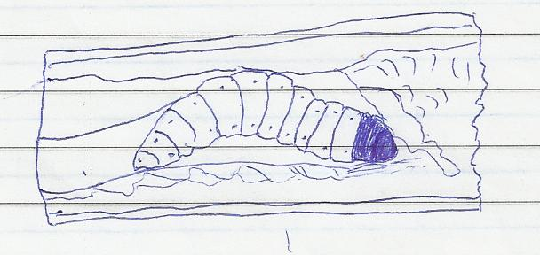
- Indentify the pest (1/2 mk)
......................................................................................................................................................................................................................................................................................................................
- Apart from maize, name another crop attacked by the pest named above ( ½ mark)
......................................................................................................................................................................................................................................................................................................................
- Give three cultural measures that can be applied to control the pest (3mrks)
.................................................................................................................................................................................................................................................................................................................................................................................................................................................................................
.................................................................................................................................................................................................................................................................................................................................................................................................................................................................................

SECTION C ( 40MARKS)
Answer any two questions in this section in the spaces provided
21a) Describe six advantages of rotational grazing (6mrks)
.................................................................................................................................................................................................................................................................................................................................................................................................................................................................................
......................................................................................................................................................................................................................................................................................................................
......................................................................................................................................................................................................................................................................................................................
.................................................................................................................................................................................................................................................................................................................................................................................................................................................................................

- Explain eight ways in which soil fertility can be maintained (8mrks)
.................................................................................................................................................................................................................................................................................................................................................................................................................................................................................
.................................................................................................................................................................................................................................................................................................................................................................................................................................................................................
......................................................................................................................................................................................................................................................................................................................
.................................................................................................................................................................................................................................................................................................................................................................................................................................................................................
- Explain six factors considered when drawing a farm plan (6mrks)
.................................................................................................................................................................................................................................................................................................................................................................................................................................................................................
.................................................................................................................................................................................................................................................................................................................................................................................................................................................................................
.................................................................................................................................................................................................................................................................................................................................................................................................................................................................................

22a) Explain the factors that influence the type of irrigation to be used in a farm (8mrks)
.................................................................................................................................................................................................................................................................................................................................................................................................................................................................................
.................................................................................................................................................................................................................................................................................................................................................................................................................................................................................
.................................................................................................................................................................................................................................................................................................................................................................................................................................................................................
.................................................................................................................................................................................................................................................................................................................................................................................................................................................................................

- Explain six reasons for pruning coffee.(6mrks)
.................................................................................................................................................................................................................................................................................................................................................................................................................................................................................
.................................................................................................................................................................................................................................................................................................................................................................................................................................................................................
.................................................................................................................................................................................................................................................................................................................................................................................................................................................................................
.................................................................................................................................................................................................................................................................................................................................................................................................................................................................................
- Describe 6 ways in which lab our productivity can be improved on a farm (6mrks)
.................................................................................................................................................................................................................................................................................................................................................................................................................................................................................
.................................................................................................................................................................................................................................................................................................................................................................................................................................................................................
.................................................................................................................................................................................................................................................................................................................................................................................................................................................................................
.................................................................................................................................................................................................................................................................................................................................................................................................................................................................................
23. a) Describe the importance of agro forestry in soil and water conservation (6mks)
…………………………………………………………………………………………………………………………………………………………………………………………………………………………………………………………………………………………………………………………………..
…………………………………………………………………………………………………………………………………………………………………………………………………………………………………………………………………………………………………………………………………..
…………………………………………………………………………………………………………………………………………………………………………………………………………………………………………………………………………………………………………………………………..
…………………………………………………………………………………………………………………………………………………………………………………………………………………………………………………………………………………………………………………………………..
…………………………………………………………………………………………………………………………………………………………………………………………………………………………………………………………………………………………………………………………………..
…………………………………………………………………………………………………………………………………………………………………………………………………………………………………………………………………………………………………………………………………..
…………………………………………………………………………………………………………………………………………………………………………………………………………………………………………………………………………………………………………………………………..
- Describe the process of silage making (8mks)

…………………………………………………………………………………………………………………………………………………………………………………………………………………………………………………………………………………………………………………………………..
…………………………………………………………………………………………………………………………………………………………………………………………………………………………………………………………………………………………………………………………………..
…………………………………………………………………………………………………………………………………………………………………………………………………………………………………………………………………………………………………………………………………..
…………………………………………………………………………………………………………………………………………………………………………………………………………………………………………………………………………………………………………………………………..
…………………………………………………………………………………………………………………………………………………………………………………………………………………………………………………………………………………………………………………………………..
…………………………………………………………………………………………………………………………………………………………………………………………………………………………………………………………………………………………………………………………………..
…………………………………………………………………………………………………………………………………………………………………………………………………………………………………………………………………………………………………………………………………..
…………………………………………………………………………………………………………………………………………………………………………………………………………………………………………………………………………………………………………………………………..
- Describe the effects of over application of nitrogenous fertilizers (6mks)

…………………………………………………………………………………………………………………………………………………………………………………………………………………………………………………………………………………………………………………………………..
…………………………………………………………………………………………………………………………………………………………………………………………………………………………………………………………………………………………………………………………………..
…………………………………………………………………………………………………………………………………………………………………………………………………………………………………………………………………………………………………………………………………..
…………………………………………………………………………………………………………………………………………………………………………………………………………………………………………………………………………………………………………………………………..
…………………………………………………………………………………………………………………………………………………………………………………………………………………………………………………………………………………………………………………………………..
…………………………………………………………………………………………………………………………………………………………………………………………………………………………………………………………………………………………………………………………………..
…………………………………………………………………………………………………………………………………………………………………………………………………………………………………………………………………………………………………………………………………..

