Term 2 - 2022
AGRICULTURE
(QUESTION PAPER I)
FORM FOUR
TIME: 2 HOURS

INSTRUCTIONS TO CANDIDATES:
- Write your name and index number in the space provided.
- Sign and write the date of examination in the space provided
- This paper consists of three section A, B and C.
- Answer all questions in section A and B.
- Answer any two questions in section C
- All the questions should be answered in the spaces provided.

FOR EXAMINERS USE ONLY
SECTION | QUESTINS | MAX SCORE | CANDIDATES SCORE
A | 1-16 | 30
B | 17-20 | 20
C | 21 | 20
 | 22 | 20
 | 23 | 20
TOTAL |  | 90

SECTION A (30MARKS)
Answer all the questions in this section in the space provided.
- Give four advantages of intensive farming. (2mks)
…………………………………………………………………………………………………………………………………………………………………………………………………………………………………………………………………………………………………………………………………………………………………………………………………………………..
- State four benefits of agroforestry to a maize crop. (2mks)
………………………………………………………………………………………………………………………………………………………………………………………………………………………………………………………………………………………………………………………………………………………………………………………………
- Name the plant part used for vegetative propagation of each of the following plants.
- Sisal (½ mk)
………………………………………………………………………………………
- Pyrethrum (½ mk)
………………………………………………………………………………………
- Sweet potatoes (½ mk)
………………………………………………………………………………………
- Sugar cane (½ mk)
………………………………………………………………………………………
- State four cultural ways of controlling couch grass (2mks)
……………………………………………………………………………………………………………………………………………………………………………………………………………………………………………………………………………………………………………………………………………………………………………………………....
- Name three sources of underground water (1½mks)
………………………………………………………………………………………………………………………………………………………………………………………………………………………………………………………………………………………………
- State three causes of blossom end of rot in tomatoes (1½mks)
………………………………………………………………………………………………………………………………………………………………………………………………………………………………………………………………………………………………
- Give three qualities of a good green manuring plant (1½mks)
……………………………………………………………………………………………………………………………………………………………………………………………………………………………………………………………………………………………....
- State four reasons for practicing minimum tillage. (2mks)
………………………………………………………………………………………………………………………………………………………………………………………………………………………………………………………………………………………………………………………………………………………………………………………………
- Name four farm records that should be kept by a poultry farmer. (2mks)
………………………………………………………………………………………………………………………………………………………………………………………………………………………………………………………………………………………………………………………………………………………………………………………………
- Give three ways in which pastures are classified (1½mks)
………………………………………………………………………………………………………………………………………………………………………………………………………………………………………………………………………………………………
- State four ways in which land reforms can be implemented in Kenya. (2mks)
………………………………………………………………………………………………………………………………………………………………………………………………………………………………………………………………………………………………………………………………………………………………………………………………

- State four factors that determine the stage at which a crop is harvested. (2mks)
………………………………………………………………………………………………………………………………………………………………………………………………………………………………………………………………………………………………………………………………………………………………………………………………………….…………
- Give four beneficial effects of weeds to a farmer. (2mks)
…………………………………………………………………………………………………………………………………………………………………………………………………………………………………………………………………………………………………………………………………………………………………………………………….………………………
- Give four advantages of practicing crop rotation. (2mks)
…………………………………………………………………………………………………………………………………………………………………………………………………………………………………………………………………………………………………………………………………………………………………………………………………………………………………………………………………………………………………………………………
- Name four methods of controlling pests. (2mks)
……………………………………………………………………………………………………………………………………………………………………………………………………………………………………………………………………………………………………………………………………………………………………………………………………………………
- Distinguish between intensive hedgerow and border planting forms of agroforestry (2mk)
……………………………………………………………………………………………………………………………………………………………………………………………………………………………………………………………………………………………………………………………………………………………………………………………………………………
………………………………………………………………………………………………………………………………………………………………………………………………………………………………………………………………………………………………………………
…………………………………………………………

SECTION B (20 MARKS)
Answer all the questions in this section in the spaces provided.
- The following illustrations show different production function curves in agricultural economics. Study them and answer the questions which follows;
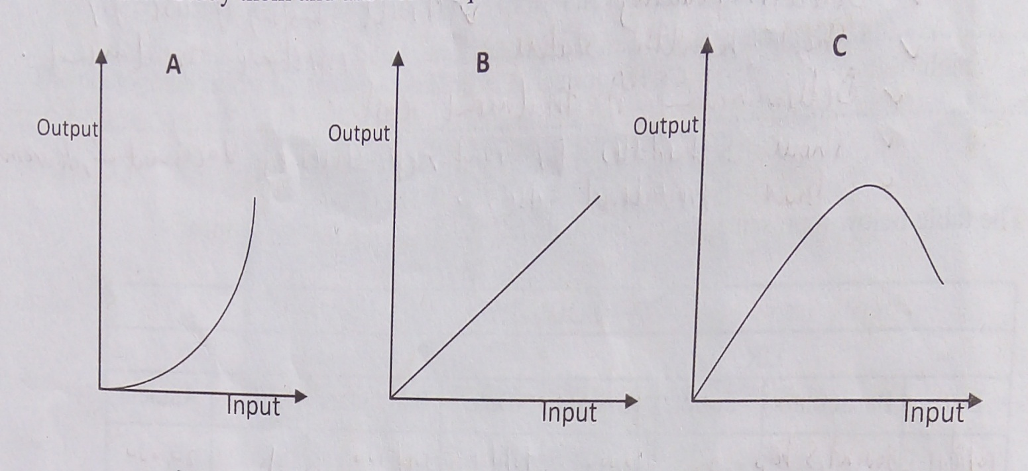

- Identify the production function curves labeled A, B and C
A …………………...………………………………………………………….. (1mk)
B ……………………….……………………………………………………… (1mk)
C. ………………………………………………………………………………. (1mk)
- What does the law derived from the production function labeled C state? (1mk)
………………………………………………………………………………………………

- Which one of the three production functions curves is rare in Agriculture (1mk)
…………………………………………………………………………………………………..
- Give a reason for your answer in (i) above (1mk)
…………………………………………………………………………………………………..

- The table below shows the population and gross domestic products of countries A and B
Country | Gross Domestic product (million Ksh) | Population (million)
A | 1800 | 36
B | 1200 | 15

- Calculate the per capita income for each country show your working (2mks)
…………………………………………………………………………………………………………………………………………………………………………………………………………………………………………………………………………………………………………………………………………………………………………………...………….
- Which of the two countries is more developed economically (1mk)
…………………………………..…………………………………………………………..
- Give a reason for your answer in (b) above (1mk)
………………………………………………………………………………………………………………………………………………………………………………………………
- How can agriculture increase the gross domestic product of a country (1mk)
…………………………………………………………………………………………………………………………..………………………………………………………………….
- The diagram below illustrate investigation on a property of soil using soil samples labeled J, K and L.
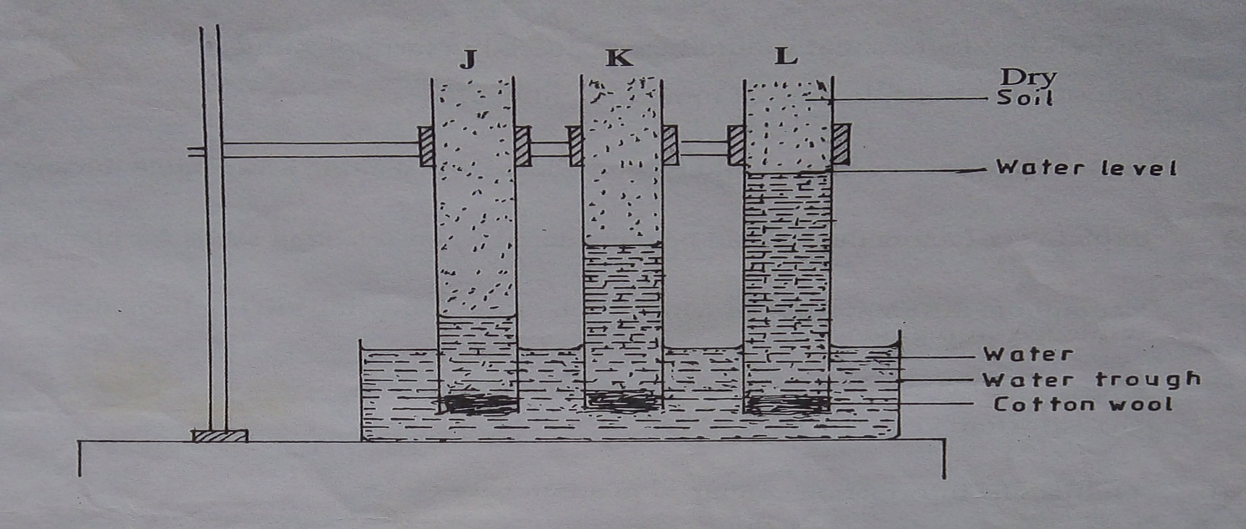

- Name the property of soil being investigated (1mk)
…………………………………………………………………………………………………………………………………………………………………………………….
- What is the relationship between the soil property above and the size of soil particles? (1mk)
……………………………………………………………………………………………………………………………………………………………………………………………..
- Which soil sample would be suitable for growing paddy rice? (1mk)
…………………………………..………………………………………………………
- Give a reason for your answer in (c) above (1mk)
…………………………………………………………………………………………..
- The following is a list of nutrients: copper, calcium, nitrogen, molybdenum, zinc, phosphorus, carbon, sulphSSSSSur, iron and magnesium. Which of the above nutrients are;
- Macro – nutrients (1mk)
…………………………………………………………………………………………..
- Micro – nutrient (1mk)
…………………………………………………………………………………………..
- Fertilizer elements (1mk)
…………………………………………………………………………………………..
- Liming elements (1mk)
………………………………………………………………………………………….
- Primary macro nutrients (1mk)
…………………………………………………………………………………………

SECTION C
Answer any two questions in this section in the spaces provided after question.

- Explain five functions of a live fence in a farm. (5mks)
- Describe various risks and uncertainties in crop farming (10mks)
- State five functions of young farmers clubs in Kenya (5mks)

- Explain five factors that should be considered in farm planning (10mks)
- Explain the different ways in which each of the following environmental factors influence crop production.
- Wind (5mks)
- Temperature (5mks)

- Outline the information contained in a purchase order. (5mks)
- Describe the harvesting of tea (7mks)
- Explain the cultural methods of controlling soil erosion (8mks)

