OPENER EXAM
FORM FOUR AGRICULTURE
TERM 1 2023
TIME: 1 ¹/₂ HOURS
NAME ………………………..……………………………ADM…………………………..CLASS…
Answer all the questions in the spaces provided.(50marks)
1. Define the term caponisation (1mk)

2. List six routes through which pathogens can enter the body of an animal. (3mks)

3. State two methods of controlling Rinderpest disease in cattle. (2mks)

4. A dairy farmer is required to prepare 200 kg of dairy meal containing 20% Digestible Crude Protein (D.C.P.). Using the Pearson's Square Method, calculate the quantity of soya bean (40% D.C.P.) and rice (16% D.C.P.) the farmer requires for the dairy meal. (5 marks)

5. State four predisposing factors to the occurrence of mastitis in dairy cattle (4mks)

6. Name the causal agents for each of the following disease (2mks)
i) Coccidiosis

ii) Black quarter
7. i) State two predisposing factors of foot rot in sheep. (2mks)

ii)Give three symptoms of anaplasmosis disease. (3mks)

8. Give four measures that can control egg eating by hens in a deep litter system (4mks)

9. a) State four observations on the behaviour of chicks which would indicate that the temperature of a brooder is too high. (4mks)

10. Diagrams Q and R below illustrate livestock deficiency. Study the diagrams and answer the questions that follow.
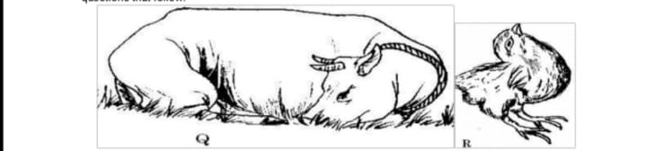

a). Identify the disease in cattle with the symptoms shown in Q. (1 mk)

b). Name the deficient nutrients in Q and R (2 mks)
Q

R

c). List two symptoms of the disease illustrated in Q above. (2 mks)

11.State five disadvantages of using live fences on a farm (5 mks)

12. Below is a diagram showing maize comb affected by a crop disease
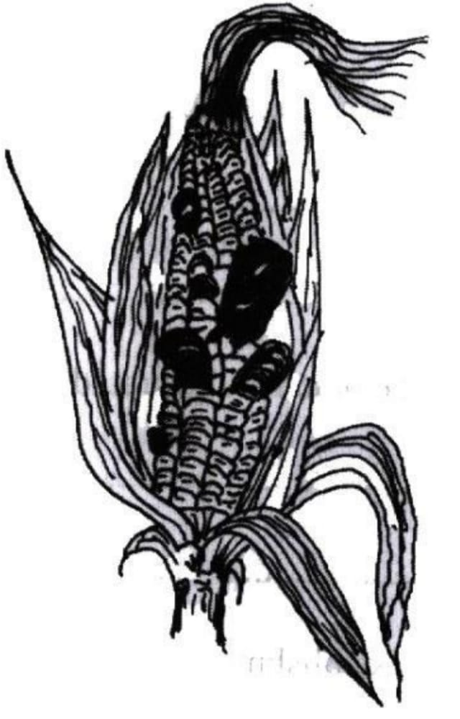
(a). Identify the crop disease (1 mk)

(b). State three control measures for the crop disease. (3mks)

( c). Name the category in which the crop disease is classified. (1mk)
13. Name three forms of horticulture in Kenya (3mks)

14. State two roles of worker bees in a colony. (2mks)

