OPENER EXAM
FORM THREE AGRICULTURE
TERM 1 2023
TIME: 1 ¹/₂ HOURS
NAME ………………………..……………………………ADM…………………………..CLASS…
Answer all the questions in the spaces provided.(50mks)
- Give one way in which crossbreeding improves livestock production. (2mks)

- State four signs that are likely to be observed when a cow is on heat (4mks)

- State four disadvantages of natural mating as a method of breeding in dairy cattle management (2mks)

- Explain the term hybrid vigour as used in livestock production. (2mks)

- (a) Define the following terms as used in livestock breeding. (2mks)
(i) Inbreeding

(ii) Out crossing

(b) Outline three disadvantages of artificial insemination in cattle management (3mks)

- Describe the life cycle of a three- host tick. (8mks)

- (a) What is crop rotation? (1mk)

(b) State three advantages of crop rotation. (3mk)

- (c) State three factors considered when designing a crop rotation programme (3mks)

- Calculate the plant population per hectares of a maize crop planted at a spacing of 100cm x 50cm. Show your working (3mks)

- Name two crop production practices carried after planting to achieve optimum plant population. (2mks)

- State four qualities of the mother plant which should be considered when selecting vegetative materials for planting. (4mks)

- Study the diagram below then answer the questions that follow.
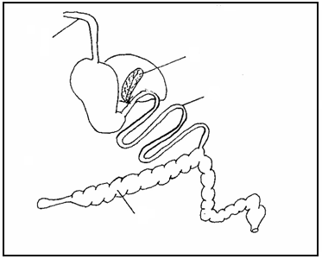
A
B
C
D

(i) Name one farm animal which has the above digestive system. (1 mark)

(ii) Label the following parts. (2mks)
A

B
(iii) Give the functions of each of the parts named: ( 2mks)

C
D

- State three reasons of treating water in the farm. (3mks)

- Give three ways through which HIV/AIDS affect agriculture. (3mks)

