MECS CLUSTER JOINT EXAMINATION
Kenya Certificate of Secondary Education
Form Four End of Term 2 examination 2022

511/3 - MUSIC - Paper 3

DEC. 2022 - 2½ hours
Name …………………………………………… Index Number …………………………

Candidate’s Signature ……………………… Date ……………………………………

Instructions to candidates

(a) Write your name and index number in the spaces provided
(b) Sign and write the date of the examination in the spaces provided above
(c) Answer all the questions in this paper
(d) In question 4 choose any two parts of the questions numbered (a), (b), (c) and (d)
(e) All answers must be written in the spaces provided
(f) This paper consists of 10 printed pages
(g) Candidates should check the question paper to ensure that all the pages are printed as indicated and that no questions are missing
(h) Candidates should answer the questions in English

For Examiner’s Use Only

Total Score
Section | Question | Maximum Score | Candidate’s  Score
A | 1 | 15
 | 2 | 15
B | 3 | 14
 | 4 | 14
 | 5 | 10
 | 6 | 10
 | 7 | 6
C | 8 | 16
 |  | 100

SECTION A: BASIC SKILLS (30 marks)

Answer all questions in this section

- Melody
- Starting with the given opening, compose a melody of sixteen bars for voice, modulating to the relative minor and returning to the tonic. Incorporate syncopation and appropriate tempo variation. (9 marks)
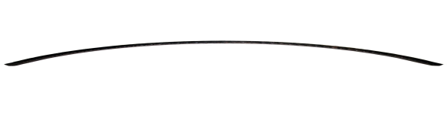
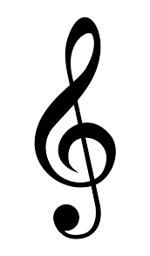

(b) Compose a melody and set it to the text given below. Use the treble stave and a key signature of your choice. (6mks)

Kuwatunza ni lazima
Watoto watashukuru

- Harmony

Harmonize the soprano melody below for SATB. Choose appropriate chords from I, II, IV, V and VI.
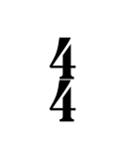

SECTION B: HISTORY OF MUSIC (54 marks)
Answer all the questions in this section except in question 4 where
you should choose any two parts of the question numbered (a), (b), (c), (d).
- African Music
a) Identify the communities that traditionally perform the following dances. (3 mks) Madzumbano
Ohangla
Kamabeka
Kilumi
Mwomboko
Cheptilet
b) Outline any four roles of music and dance during traditional African worship. (4 mks)

c) State three different ways in which the solo-choral response style is used in the performance of anAfrican traditional folk song. (3 mks)

d) List any four vocal techniques used to embellish a traditional folk performance. (4 mks)

- Prescribed Western Composers
Answer any two of the following questions: (a), (b), (c) and (d)
- Thomas Morley
- Name his nationality. (1mk)

- State any three characteristics of the Renaissance ballet (3mks)

- What types of compositions are the following works by Morley? (3 mks)
Now is the month of maying
April is my mistress face
Sing we and chant it
- State two characteristic features of Morley’s vocal music (2mark)

- Name any two contemporaries of Morley. (2mk)

- List down any three major contributions of Morley towards renaissance music.(3mks)

- Domenico Scarlatti
- Name the musical period that Giuseppe Domenico Scarlatti belong to. 1mk)

- Outline any three factors that influenced Scarlatti as a popular music composer (3mks)

- Identify any three characteristics of Scarlatti's sonatas. 3mks

- State any three contributions that Domenico made to the keyboard playing technique. (3 mks)

- Identify any two great musicians known to have trained Domenico Scarlatti. (2mks)

- Outline any two musical duties of Scarlatti in Madrid from 1729 (2mks)

- Felix Mendelssohn
- For what media was a midsummer Night’s dream op.61 by Felix Mendelssohn? (1mk)

- Why is Mendelssohn not a typical Romantic composer? (1mk)

- Explain how he treated his overture in composition. (5mks)

- Name his two composed vocal music. (2mks)

- State any three characteristics of Harmony during Romantic period music. (3mks)

- Identify any two instrumental works while in Britain (2mk

- Ralph Vaughan Williams
- What type of work is the wasp? (1 mk)

- Outline any four musical characteristics of the period in which Vaughan Williams lived. (4mks)

- Name two operas by Vaughan Williams. (2mks)

- State any three characteristics behavior of Vaughan Williams’ compositions. (3mks)

- Name any two major contributions of Vaughan Williams towards the music of England. (2mks)

- Identify any two characteristics of Vaughan’s symphonies. (2mks)

- Analysis of Prescribed African Music
Siriri-Folk Music of East Africa
- Identify any three characteristics of African folk song used in this performance. (3mks)

- Describe the musical elements of the opening section (2mks)

- State any three relationships between the voice and the first fiddle. (3mks)

- Explain the relationship in performance between the first and second fiddle (2mks)

- Analysis of Prescribed Western Music

Septet Op 20-Movement 4
( Tema Con Variazioni )
- In which music period was the work composed? (1mk)

- Explain the form in the the ‘theme’ section 2mks

- Briefly explain the texture of Variation 1. 2mks

- Identify any two musical techniques used in the introduction at bars 1-4 and 4-8. 2mks

- State any three musical devices used by the viola in the whole work. (3mks)

- Analysis of Unprepared Work
- Study the music extract below and answer the questions that follow.
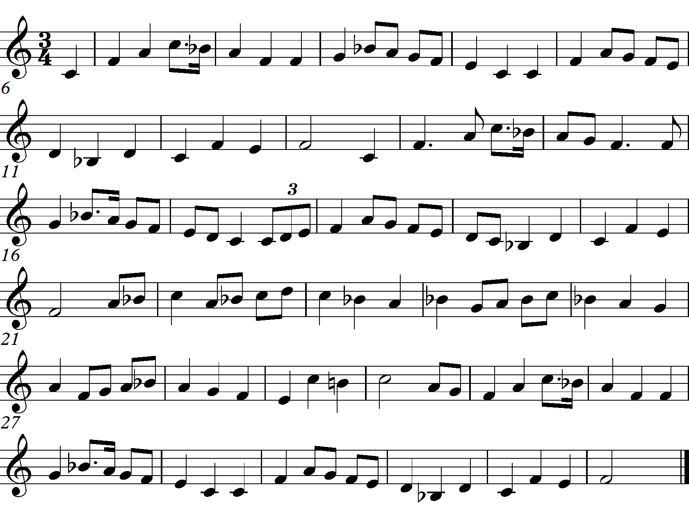
- Describe citing the bar numbers the form In which form is the melody written? ( 3marks)
…………………………………………………………………………………………
- Identify two devices used to create rhythmic variety in the melody. (2 marks)
……………………………………………………………………………………………………………………………………………………………………………………………………
- (i) State the tonality of the melody. (1 mark)
…………………………………………………………………………………………………
(ii) In which key does the melody modulate before returning to the tonic and at which bar? (2marks)

…………………………………………………………………………………………………
- (i) State the texture of this melody. (1 mark)
………………………………………………………………………………………………….
(ii) Explain your answer in d(i) above. (1 mark)
…………………………………………………………………………………………………………………………………………………………………………………………………
SECTION C: GENERAL MUSIC KNOWLEDGE (16 marks)
- (a) Name any three instruments used in Sengenya dance. (3mks)

- Translate the following into staff notation. Doh is A flat (5mks)
:s,/ m:-:de/f:-re/d:-:t,/d:-//

- Name any three instruments of the wood-wind section of the orchestra. (3mks)

- Transpose the following melody a minor third down in bass clef. (5mks)

