TRIAL EXAMINATIONS 2021
Kenya Certificate of Secondary Education (KCSE)

451/1 - COMPUTER STUDIES - Paper 1
(THEORY)
Dec. 2021 – 2 ½ hours

Name: ………………………………………..……...… Index No: ……….……………….
Stream: ……………… Candidate’s Signature: …….……………….... Date: …..………

Instructions to candidates
- Write your Name and Index Number in the spaces provided above.
- Sign and write the date of examination in the spaces provided above.
- This paper consists of two sections: A and B
- Answer ALL questions in section A
- Answer question 16 and any other three from section B
- All answers should be written in the spaces provided in the question paper
- This paper consists of 11 printed pages
- Do not remove any page from this booklet.
- Candidates should check the question paper to ascertain that all the pages are printed as indicated and that no questions are missing.
- Candidates must answer the questions in English

For Examiner’s use only.

Section | Question | Candidate’s Score
A | 1 – 15
B | 16
 | 17
 | 18
 | 19
 | 20
 | Total Score

SECTION A (40 marks)
Answer all the questions in this section.
- Identify the transmission mode used when communicating with the devices listed below. (2marks)
- Public address system
_______________________________________________________________________________________
- Phone chat via WhatsApp
_______________________________________________________________________________________
- Describe the evolution of computers based on the following (3marks)
- Memory capacity
______________________________________________________________________________________________________________________________________________________________________________
- Processing capability
______________________________________________________________________________________________________________________________________________________________________________
- Physical size
______________________________________________________________________________________________________________________________________________________________________________
- Beryl does not understand why computers are said to be Automatic at the same time they have No Intelligent Quotient (IQ) (2marks)
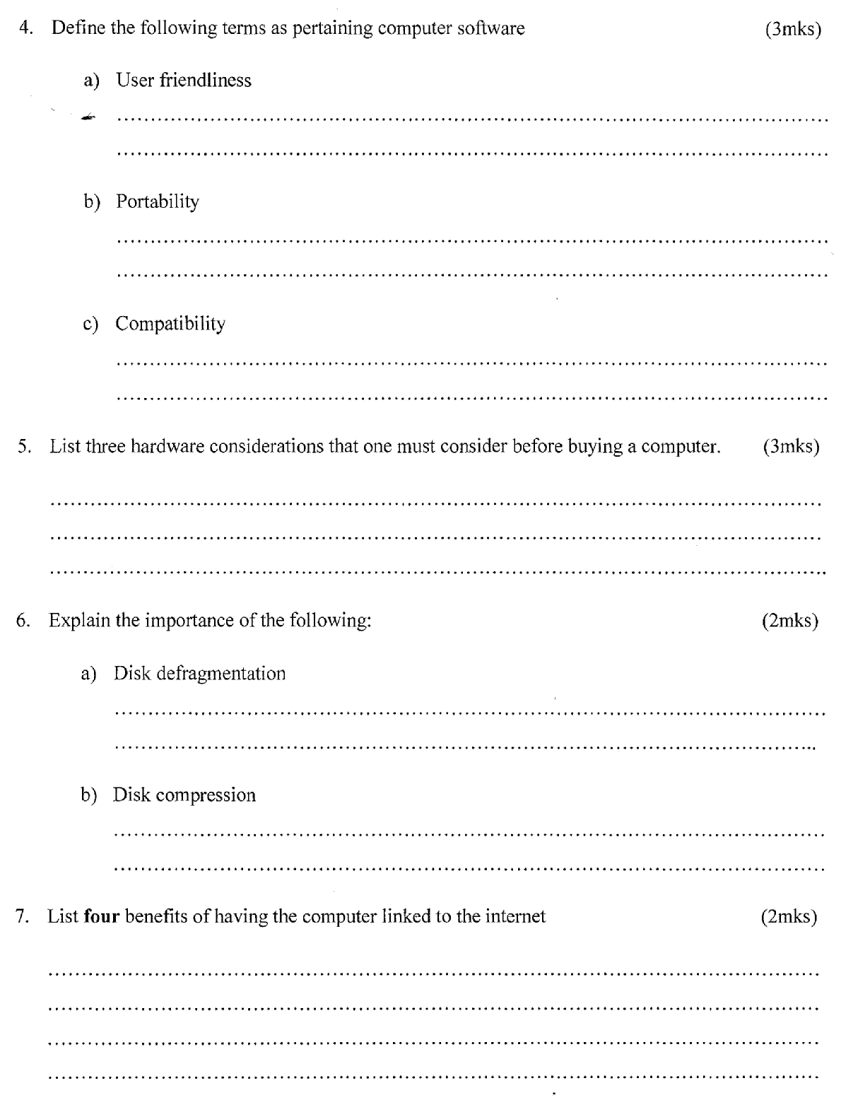
_____________________________________________________________________________________________________________________________________________________________________________________________________________________________________________________________________
- Vero a student from Nyamira Girls lives in a house with full internet access. She spends most of her time on phone and Desktop computer. State any three social issues associated with doing this. (3 marks)
______________________________________________________________________________________________________________________________________________________________________________
______________________________________________________________________________________________________________________________________________________________________________
- Computers are known to have created jobs to many people. Below are duties and responsibilities of different computer professionals. State the professionals who undertakes the duties and responsibilities listed below. (3marks)
- Troubleshooting Computer hardware and software related problems
_______________________________________________________________________________________
- Developing Training Reference materials
_______________________________________________________________________________________
- Reengineer computer components to enhance its functionality and efficiency
_______________________________________________________________________________________
- Give three reasons that might have necessitated the development of Second generation computers. (3 marks)
_____________________________________________________________________________________________________________________________________________________________________________________________________________________________________________________________________
- Millicent wrote a program but it did not behave as expected. Describe two types of errors that may hinder the program from running or run but give invalid results. (2marks)
_____________________________________________________________________________________________________________________________________________________________________________________________________________________________________________________________________
- Describe two password options that Ms-Word employ to protect its documents. (2marks)
____________________________________________________________________________________________________________________________________________________________________________________________________________________________________________________________________________________________________________________________________________________________
- Mention two limitations of using counterfeit software. (2marks)
_____________________________________________________________________________________________________________________________________________________________________________________________________________________________________________________________________
- Name the computer parts listed below. (2marks)
Diagram | 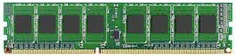  Figure 1 | 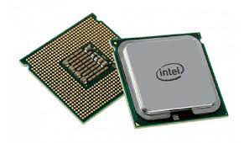  Figure 2
Name

- Describe the following functions of the operating system. (3marks)
- Network Management
______________________________________________________________________________________________________________________________________________________________________________
- Security
______________________________________________________________________________________________________________________________________________________________________________
- Interrupt Handling
______________________________________________________________________________________________________________________________________________________________________________
- State three ways in which computer virus infection can be prevented other than through restricting the usage of removable storage media (3marks)
____________________________________________________________________________________________________________________________________________________________________________________________________________________________________________________________________________________________________________________________________________________________

- Define the term normalization. (l mark)
______________________________________________________________________________________________________________________________________________________________________________
- State a reason to justify why database administrators usually perform normalization when creating a database for an organization. (2marks)
______________________________________________________________________________________________________________________________________________________________________________
- Mention three factors to consider when choosing a file organization method. (3marks)
____________________________________________________________________________________________________________________________________________________________________________________________________________________________________________________________________________________________________________________________________________________________
- What are the four challenges experienced in implementing e-learning in Kenya. (4marks)
__________________________________________________________________________________________________________________________________________________________________________________________________________________________________________________________________________________________________________________________________________________________________________________________________________________________________________________________________________________________________________________________________________
SECTION B (60 marks)
Answer questions 16 and any other three questions from this section.

- Describe the following qualities of an algorithm. (2marks)
- Definiteness
______________________________________________________________________________________________________________________________________________________________________________
- Finiteness
______________________________________________________________________________________________________________________________________________________________________________
- The table below shows the monthly charges applicable to different amount of water consumed by clients in a particular town
Volume of Water consumed  in m³ | Consumption in  Kshs
0 – 10 | 200
10 - 20 | 350
20 – 30 | 500
Over 30 | 1000
In addition to the consumption, the amount of the water bill will consist of a standing charge of Kshs 200 and a sewerage fee equivalent to 20% of the consumption.
- Write a pseudo code for a program that prompts a user to enter the volume of water consumed per month. The program then computes and output the amount of the water bill in a year. (7 marks)

- Draw a flowchart for the pseudo code. (6marks)

- The table below is an extract from a spreadsheet use it to answer the questions that follow
 | A | B | C | D | E | F
1 | Customer  Number | Product  Name | Quantity | Unit  Cost | Total | Type  Remark
2 | 145321 | Malomalo | 20 | 100 | 2000 | Bronze
3 | 143561 | Kisambo | 40 | 200 | 8000 | Silver
4 | 156784 | Weeti | 40 | 400 | 16000 | Gold
5 | 123454 | Wheat | 20 | 50 | 1000 | Bronze
6 | 453218 | Nyozi | 10 | 10 | 100 | Bronze
 | GRAND TOTAL |  |  |  | 27100
- Identify the Ms-Excel feature that is used in cell A1 and B1 to enable the texts appear the way they are. (1mark)
_______________________________________________________________________________________
- Name the data type in cell E4 and F3. (2marks)
______________________________________________________________________________________________________________________________________________________________________________
- Use absolute reference to represent a formula that is used to calculate total for wheat (2 marks)
______________________________________________________________________________________________________________________________________________________________________________
- Suggest how named reference can be used to calculate the GRAND TOTAL. (3marks)
______________________________________________________________________________________________________________________________________________________________________________
- Write a formula that will classify product type base on the total as shown in the table below. (2 marks)
Total | Type
0-5000 | Bronze
5001-10000 | Silver
10001 and Above | Gold
_____________________________________________________________________________________________________________________________________________________________________________________________________________________________________________________________________
- State the difference between Cc and Bcc. (2marks)
_____________________________________________________________________________________________________________________________________________________________________________________________________________________________________________________________________
- Mention three factors to consider when choosing an ISP. (3marks)
____________________________________________________________________________________________________________________________________________________________________________________________________________________________________________________________________________________________________________________________________________________________

- What is the binary equivalent of ${12}/{32}$ base 10. (3marks)
___________________________________________________________________________________________________________________________________________________________________________________________________________________________________________________________________________________________________________________________________________________________________________________________________________________________________________________
- Determine the Hexadecimal equivalent of 4446₈. (3marks)
___________________________________________________________________________________________________________________________________________________________________________________________________________________________________________________________________________________________________________________________________________________________________________________________________________________________________________________
- Subtract 11001₂ from 19₁₀ using twos complement and write your answer in decimal notation. (4marks)
__________________________________________________________________________________________________________________________________________________________________________________________________________________________________________________________________________________________________________________________________________________________________________________________________________________________________________________________________________________________________________________________________________
c) Evaluate 101101101+10101- 1011110. (3marks)
___________________________________________________________________________________________________________________________________________________________________________________________________________________________________________________________________________________________________________________________________________________________________________________________________________________________________________________
d) With reference to DTP describe the following terms. (2marks)
- Gutter
_____________________________________________________________________________________________________________________________________________________________________________________________________________________________________________________________________
- Stroke
_____________________________________________________________________________________________________________________________________________________________________________________________________________________________________________________________________

- State three circumstances under which a system analyst may prefer to use questionnaire instead of observation during facts finding. (3marks)
____________________________________________________________________________________________________________________________________________________________________________________________________________________________________________________________________________________________________________________________________________________________
- Mention three operational factors that a system analyst need to consider when sourcing for hardware and software to be used with the proposed system. (3marks)
___________________________________________________________________________________________________________________________________________________________________________________________________________________________________________________________________________________________________________________________________________________________________________________________________________________________________________________
- Describe three advantages of parallel changeover. (3marks)
__________________________________________________________________________________________________________________________________________________________________________________________________________________________________________________________________________________________________________________________________________________________________________________________________________________________________________________________________________________________________________________________________________
- Define the following terms as used in Networking
- Ionosphere (1mark)
_____________________________________________________________________________________________________________________________________________________________________________________________________________________________________________________________________

- Line of sight (1mark)
_____________________________________________________________________________________________________________________________________________________________________________________________________________________________________________________________________
- Identify the OSI layer in which the following communication devices operates
- Router (1mark)
_______________________________________________________________________________________
- NIC (1mark)
_______________________________________________________________________________________
- Describe two factors to consider when choosing a transmission media. (2marks)
___________________________________________________________________________________________________________________________________________________________________________________________________________________________________________________________________________________________________________________________________________________________________________________________________________________________________________________

- The following records were entered in a database
Date | Class | Registration No
1/1/2007 | East | 1425-A
1/1/2008 | North | 1426-A
12/1/2008 | North | 1426-B
- Suggest a validation rule for date given that it should be not before 1/1/2006 (2marks)
____________________________________________________________________________________
- List the records that will be displayed after running the following criteria? (2marks)
- <>#1/1/2008 on date
______________________________________________________________________________________________________________________________________________________________________________
- 1426-A on class
_______________________________________________________________________________________
- Write the input mask for registration No (1mark)
_______________________________________________________________________________________
- Choose the most appropriate data type for Date and Registration No (2marks)
______________________________________________________________________________________________________________________________________________________________________________
- Explain the following terms as used in Word Processing (3marks)
- Word Wrap
______________________________________________________________________________________________________________________________________________________________________________
- Orientation
______________________________________________________________________________________________________________________________________________________________________________
- Indenting
______________________________________________________________________________________________________________________________________________________________________________
- A Student typed Genge Ni Salima uta Do during a practical lesson. State how the text will appear (5marks)
____________________________________________________________________________________________________________________________________________________________________________________________________________________________________________________________________________________________________________________________________________________________

THIS THE LAST PRINTED PAGE

