SUNRISE EVALUATION EXAM FORM FOUR END TERM 2 -2022

COMPUTER MARKING SCHEME

    - ComputerStudiesPaper1(451/1)
 | SECTIONA(40 marks)
QNS | RESPONSES |  | MARKS
1. | Function of:-
 | (a)Hardware: To perform tasks of inputting, storage, outputting, processing
 | during data processing and communication. |  | 1
 | (b)Software:-Instructs the hardware/computer on what to do during data |  | 1
 | Processing.
 | -Provides interface between hardware and live ware.
 | -Accept functions of software based category i.e. system/
 | application/ working/uses. |  | 1
 | (c)Live ware: Meant to design or operate a computer.
2. | Problems arising from use of unsuitable computer desk.  √ It could lead to back problems if the desk is of an unrealistic height.  √ If it does not provide good positioning of the monitor, it could result in  eyestrain.  √ Wrist problems will arise if the key board and mouse seating positions are  bad.  √ Injury as a result of falling computer components due to weak computer  desks/ small size.  (First 2 x 2) |  | 4
3. | Categories of system software  √ Firmware;  √ Networking software;  √ Operating system;  √ Utilities. | (First 2 x¹)  2 | 1
4. | Two factors to consider when evaluating warranty  √ Period/duration/scope of cover: The warranty should specify the duration of  time covered.  √ Service agreement/level: The warranty should indicate the type of service to  be provided.  √ Cost implication/ liability agreement: Cost sharing between the dealer and the  buyer in the event of any loss or malfunction.  √ Call out response.  (First 2 x 2) |  | 4

5. | Three ways of using computers in electing school captain  √ Registering voters/(faster);  √ Voter identification(accurate);  √ Actual voting;  √ Tallying process (speedy).  (Any3 x 1) | 3
6. | Figure1:Bring to front or bring to back  Used when the target graphic is hidden by other objects. When clicked, the target graphic is brought to the front.  Figure2:Textwrap  It is used when a graphic is placed within the text area and the user needs to  define how the text flows around the graphic. | 1  1
7. | Distinction of GUI and command line operating systems  (Any2 x 2 ) | 4
GUI | Command line
Makes use of emerging software/ and hardware technologies  Their interfaces have:  - ribbons  - control buttons  - scrollbars  - menus  - can process complex graphics The user interacts by:  - clicking  - scrolling  - mouse over More user friendly. | Hardly makes use of emerging hardware/software technologies. Their interfaces have:  - typed commands  - prompt  - editor window  - cannot process complex graphics Users interact by typing in commands  Less user friendly.

8. | A system flow chart symbols  (a)  Report or documentation  (b)  Disk/master file/database | 1  1
9. | Ways of adjusting a document to fit a page  √change page orientation.  √change the font;  √decrease font size;  √reduce margin size;  √reduce character spacing;  √reduce line height.  √change font style eg. bold/italic  (Any3 x 1) | 3
10. | Role of network administrator  √to confirm that the network services are running;  √to confirm that the user is granted appropriate privilege to access the  Network services/password/authentication;  √to confirm that the network infrastructure is in good condition;  √to confirm that the files sought are inexistence.  (First 3 x 1) | 3
11. | Impact of mobile phones  √Users no longer queue in the bank in order to deposit or withdraw money;  √Easy acquisition of financial statements;  √Easy payment of bills;  √Online banking is possible;  √Money transfer is fast.  √Safer transfer of money.  √Provides wide coverage.  √Can offer services anywhere anytime.  √Cheaper money transfer services.  √Increase in fraud.  (First 3 x 1) | 3

12. | Items that an email must have:  √the email address of the recipient;  √the content or message being communicated. | 2
13. | Direct input methods  √OBR  √MICR  √OCR;  √OMR;  √Image scanner;  √Magnetic strip technology;  √Image recognition/face recognition/fingerprint.  (First4#¹)  2 | 2
14. | Insecurity arising from hardware failure  √Data loss due to total system failure e.g. HD crash;  √The experts called upon to repair can access critical/ valuable information;  √Data recovery software may be used to make unauthorized backups.  (First 2 x 1) | 2
15. | Nibbles-4  Bytes - 2 | 1  1
 | SECTIONB(60marks)
16. | - Advantages of using low-level language  √program execution is immediate;  √they require no compilation, no interpretation/translation hence they are  faster;  √hardware optimization is extensive;  √program developed takes less memory space;  √suitable for micro devices;  √easy to design electronic device.  (First 2 x 1)  - Three tools that can be used to develop an algorithm  √Decision table  √pseudo code;  √natural language;  √top down charts;  √flowcharts.  √DFD/context diagram  √ERD  √decision tree  (First 3 x 1) | 2  3

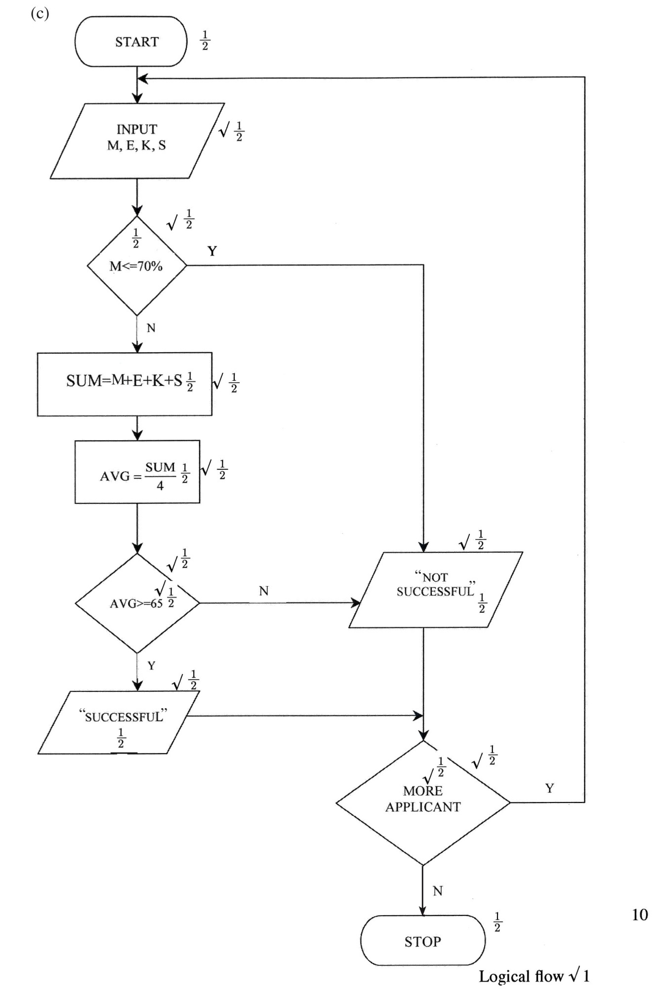

17.

Time-sharing mode

This is a processing mode in which a central processor serves two or more users with different requirements. The processor time is divided equally among the tasks in the queue. A user whose task requirements are more than is apportioned is send back to the queue. For example, four jobs requiring
times t1, t2, t3and t4to complete is apportioned equal time in each round until
when they are done. 3

INPUT
Job 4time=t1
Job 3time=t2
Job 2Time=t3
Job 1Time=t4
PROCESSOR
Output

Incomplete job back to the queue 2

Factors to consider when selecting data processing mode

√The optimization of processing time;
√The time factor required for decision arising from the processed data;
√The ease of development, use and maintenance;
√The control over the resources e.g. files, I/O devices e.t.c;
√The need for the shared resources among several users who may afford purchasing their own facilities as in time sharing configuration;
√The volume of work involved;
√The cost of acquiring the relevant hardware, software, media e.t.c and the
cost of maintenance;
√The nature of the task to be processed.
(First 4 x 1) 4

(i)Purpose of user manual
It is a documentation whose purpose is to help a user to use the system
With little guidance. 2

Purpose of sample data
Before the system is implemented, it has to be confirmed that it is
functional. Sample data is meant to be used to test whether the system is
giving desired output. 2

Purpose of table descriptions
They are details of table structures that the system will require for the
purpose of designing the actual tables. 2

18. (a)(i)Repeater
A device used to re-construct data signal during data transmission to its
Original strength/amplify/boost/regenerate. 1

 | - Router  - It is a device used to facilitate movement of data or packets between two  Or more LANS of different configuration (expansion of networks).  - Delivers a packet/data directly to destination computers.  - Interconnects different networks/provides network services. | 1
 | (b)(i)The component P is the terminator. | 1
 | (ii)Terminatorinabackboneisusedtopreventdatasignalfrombouncingback/absorbsignals. | 2
 | (c)Use of internet in environmental conservation club  √Source of knowledge on environmental matters;  √Collaboration with peers from other schools or organizations;  √Dissemination of information on what the club is doing;  √Seeking for funding from sponsors.  (First 3 x 1) | 3
 | (d)(i)Benefits of linking branch B and C  √Speed of communication between B and C is increased since the traffic  between the two branches can be re-routed through the link BC;  √If either AC or AB is down, the three branches can still communicate;  √If the HQ systems fail, the two branches Band C can communicate  using this link.  (First 2 x 2) | 4
 | (ii)Ways to protect company network from hackers  √Changing password frequently  √Use of encryption;  √Use of data proxies;  √Use of firewalls to filter unwanted packets;  √User restriction e.g. passwords/ biometrics.  √Use of complex password.  (Any3 x 1) | 3
19. | (a)Formats applied  Bold, strikethrough, underline, italics, centre alignment, dropcap, bulleted list, line height / spacing, 2 column paragraph, column break, casing, font type, left alignment, column separator.  (First 6 ×1)  2 | 3

 | (b)Tools for proofreading  √ Spellchecker and grammar/ dictionary;  √ Auto complete;  √ Autocorrect;  √ Thesaurus.  (Any3 x 1) | 3
 | (c)(i) =@ or + Count if (B2: B6, “>10,000”)(B2:B6)Argument range√ 1(>10,000) Criteria √ 1  AllFormulacorrect√1  (ii)AtD3  Formula is  $ B3 * C$2√ 1  = 16000#2  =32, 000√ 1 | 3  2
 | (d)  SCHOOLEXAMINATION  SCIENCES LANGUAGES  HUMANITIES  Any4 entities each1  STUDENTS 2  Any4 connectors 4 each x1  2 | 4
20. | (a)Characteristics of octal number system.  √each symbol is represented by 3bits.  √The number is made of8 symbols0, 1, 2, 7;  √Maximum value of a single digit is7 (one less than the value of the base);  √This numbersystemusesbase8.  (Any2 x 1) | 2

 | (b)(i)111.1012to decimal |  | 210  111=1#2²+1#2¹+1#2⁰  =4 + 2 + 1 = 710  1012= 1#2+0#2+ 1#2  -1 -2 -3  =1#1+0#1+1#12 4 8  =0.5 + 0 + 0.125 = 0.62510  `111.101=7.625  2
 | 111=710√1
 | 0.101= 1+0+1=5√1 OR
 | 2 4 8 8
 | =0.625
 |  |  |  | 3
 | 111.1012= 7.62510or7.625 √ 1
 | (ii)14.687510to binary
 | 1410= 11102√ 1
 | 0.6875#2=1.375
 | 0.375#2=0.75
 | 0.75#2=1.5
 | 0.5#2=1.0 √ 1
 | Decimal portion=0.1011√1
 | Numberis1110.10112√1 |  |  | 4
 | (c)(i) 1710= 10001 or 100012√1  10010001√ 1  binary equivalent of 17Signbit for negative. |  |  | 2
 | (ii) 1710= 10001  In 8 bit 00010001  Reverse bits 1 1 1 0 1 1 1 0√1  + 1  1 1 1 0 1 1 1 1  Number is 11 1 0 11 1 12√ |  |  | 2
 | (d) | 110.112+11.0112
 |  | 1 1 0.1 1 0
 |  | +0 1 1.0 1 1√ 1
 |  | 1 0 1 0 . 0 0 1√ 1 |  | 2

